Post-Harvest Garlic Trial Year One Results
Ask five garlic growers about the best way to dry garlic and you are likely to receive five different answers. Some techniques are based on tradition, some are based on West-coast industry techniques, and some simply make use of the available resources, such as hay mows or even the occasional tobacco barn. There has been little information available on which of these techniques is the best for growers in New York, or in the northeast in general. With the support of a Northeast SARE Research and Education Grant, we set up on-farm trials in three locations to begin answering this question during the 2012 growing season.
The treatments: The following treatments were included in the trial, both separately and in combination: tops cut; roots cut; washed; high-tunnel dried; and open-air dried (Table 1). Each treatment was applied to either an eight foot section of the bed or to a ten pound sample of uncut green garlic, for an average of 46 heads per sample. All three sites used German White exclusively in this trial. All treatments were applied at all three sites, but the top trimming was done with a sickle-bar mower prior to harvest at one site and with pruning shears directly after harvest at another sites. The open-air structures also varied depending on the site, with one farm using a hay mow, and two others using rain-resistant open-air sheds. Garlic was washed with a garden hose and a standard nozzle, not with a pressure washer. Roots were pruned using razor-blade anvil pruners or a knife. All treatments were applied within 3 hours of harvest. The high tunnels used at each site had one to two layers of shade cloth over sections where garlic was located (Image 1). Temperatures in the high tunnel only averaged 5 degrees F warmer in the tunnel than outside due to liberal use of fans. The highest temperature recorded in the high tunnel was 102 degrees F.

Results:

High Tunnel vs. Open Air: Across the three trials, garlic in high tunnels dried an average of three days faster than in open air structures. Garlic dried in high tunnels had slightly better wrapper quality (tighter, less discoloration) at one site. Garlic dried in tunnels also had slightly lower disease incidence (Aspergillus and Embellisia) in two of the three sites, though disease was not severe in any site or treatment. No garlic treatments showed damage from being dried in the high tunnel.

Roots trimmed vs. roots untrimmed: No statistically significant differences were observed between these treatments in regards to bulb quality, weight, or disease incidence.

Tops trimmed vs. tops untrimmed: Trimming the tops mechanically in the field greatly increased the speed of harvest, and reduced the space needed for drying. Top trimming did not have a significant effect on disease incidence in cured bulbs, but there were differences in bulb weight at two of the farms, with un-cut bulbs being slightly heavier (Table 2). It is unclear if this difference is due to weight loss or to double bulbs, since the number of bulbs is greater in the treatments with lower average weights. Bulb quality was comparable between treatments.

Washed vs. unwashed: Washed garlic looked very good initially, but became more discolored than the unwashed garlic during the drying and curing process. Most discoloration could be removed by removing 1-3 wrapper leaves, but this extra step is time consuming (Image 2). Disease incidence, particularly Aspergillus and Embellisia, was slightly higher in washed garlic.
Discussion:
Drying garlic in the 2012 season was relatively simple regardless of the method due to the hot, dry weather our region experienced during July. Thus, nearly all treatments yielded moderately high-quality garlic. This year’s trials were nonetheless very valuable because they allowed us to demonstrate the effects of relatively high drying temperatures, of top pruning, of root pruning, and of washing. The absence of damage or increased disease incidence in these treatments is encouraging, and each will be further examined during the 2013 growing season. By the end of next year, we will have recommended best practices for garlic drying in the Northeast, and will then focus on best practices for longer-term storage.
During the next growing season we will extend top pruning to include a 2 inch trim, and we will increase the temperature in the high tunnel to 110 degrees Fahrenheit. We will be purchasing relative humidity monitors for the drying structures to further examine differences between the high tunnel and the open air structure.
The complete year one report, including pictures of treatments, is available on our website: cdvsfp.cce.cornell.edu.
Image 2: Garlic immediately after washing (far left) and after curing with no wrapper leaves removed (0), one wrapper leaf removed (1) and two wrapper leaves removed (2).
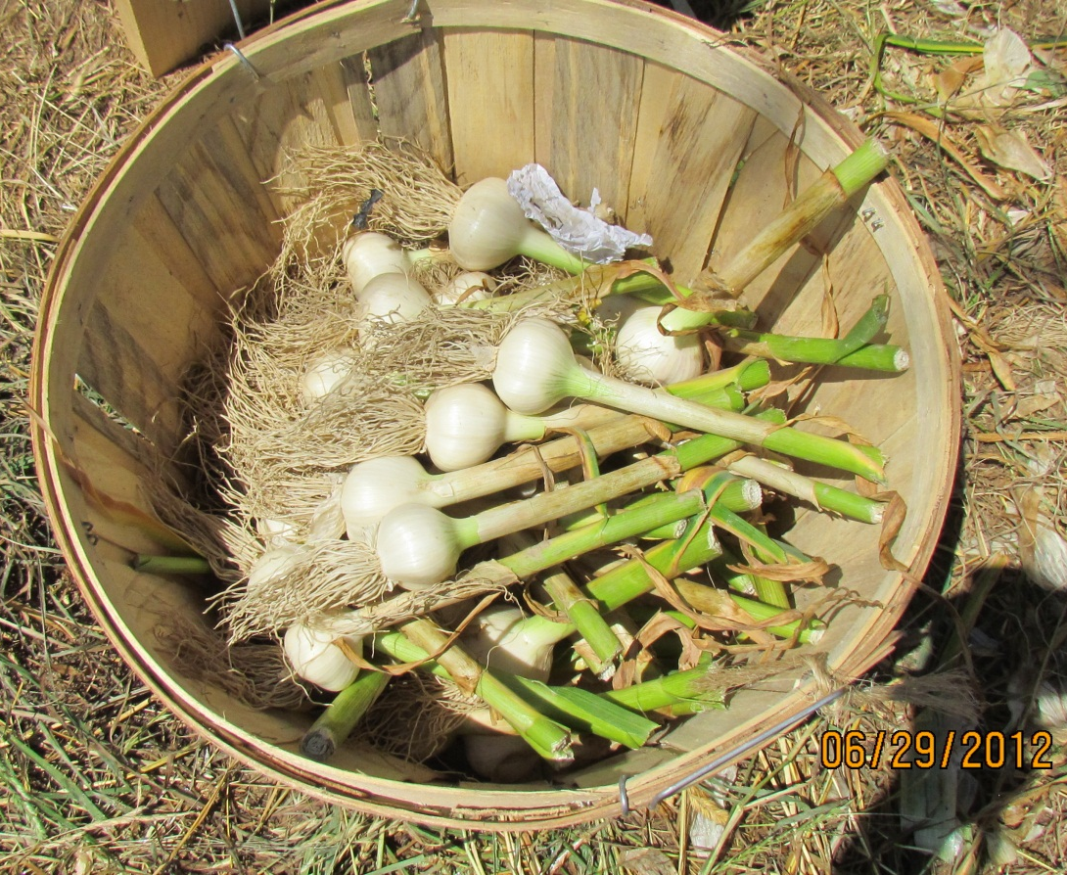
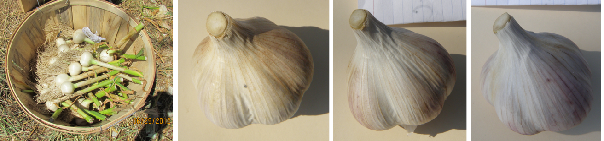
1
2
3
Garlic immediately after washing (far left), and after curing with no wrapper leaves removed, (0), one wrapper leaf removed (1) and two wrapper leaves removed(2).
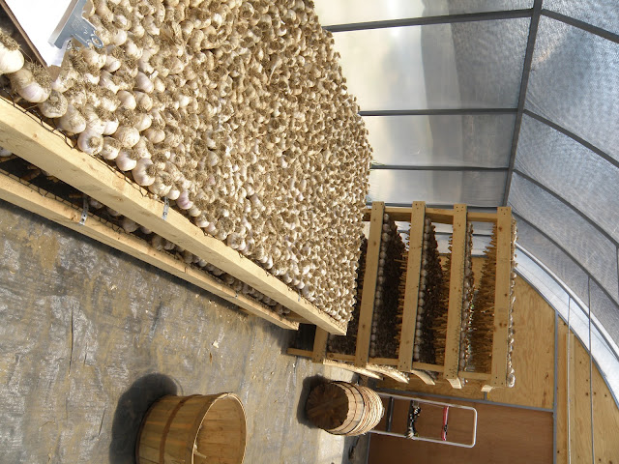
Image 1: Garlic with tops trimmed curing in the high tunnel.
