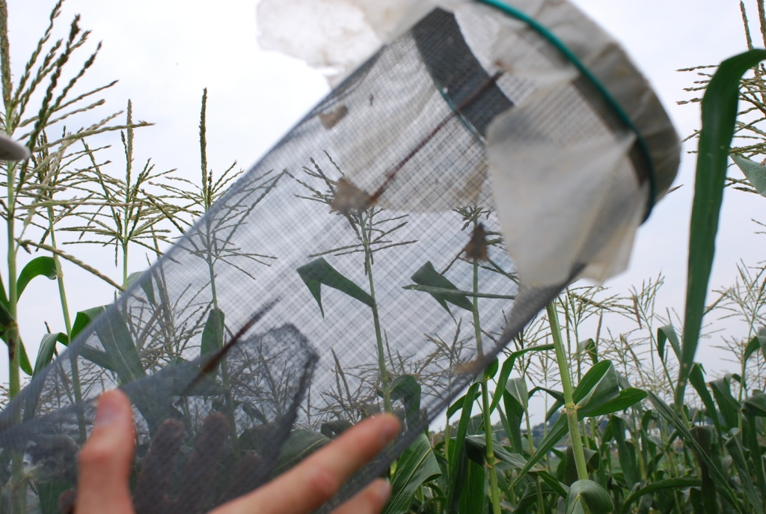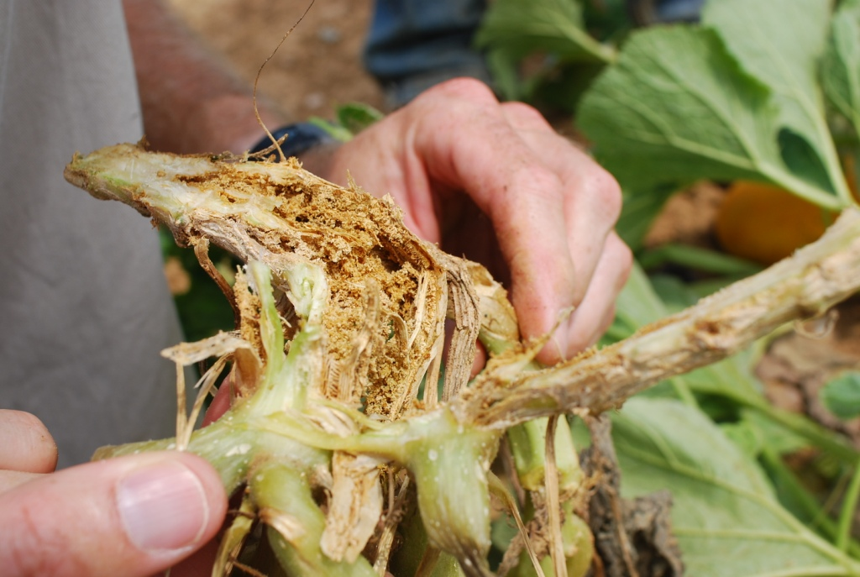
Pheromone trap for monitoring sweet corn pests. Damage on winter squash from squash vine borer.
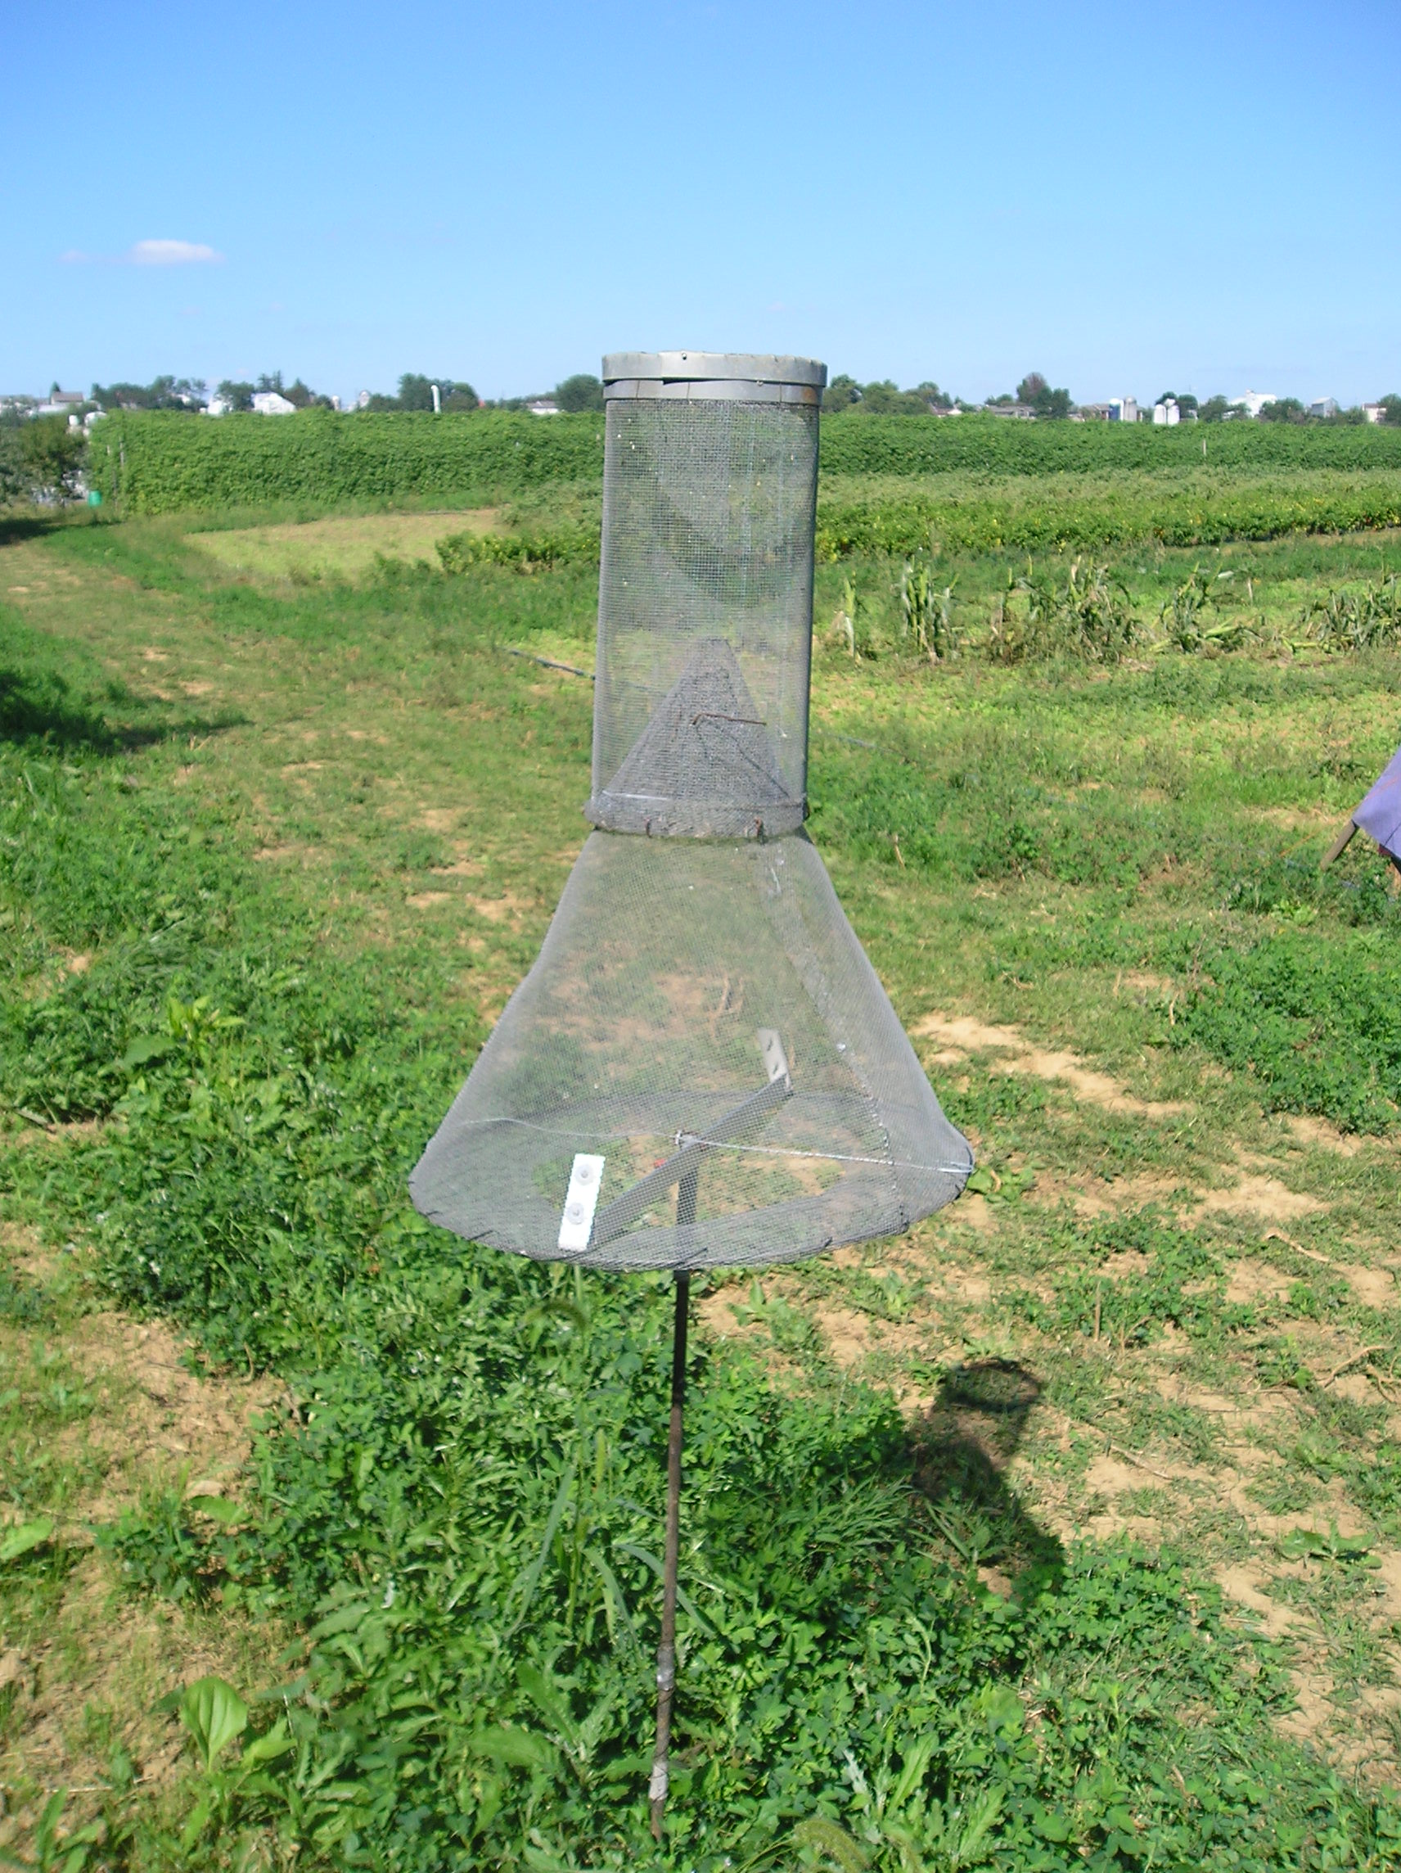
Pheromone trap for monitoring sweet corn pests.
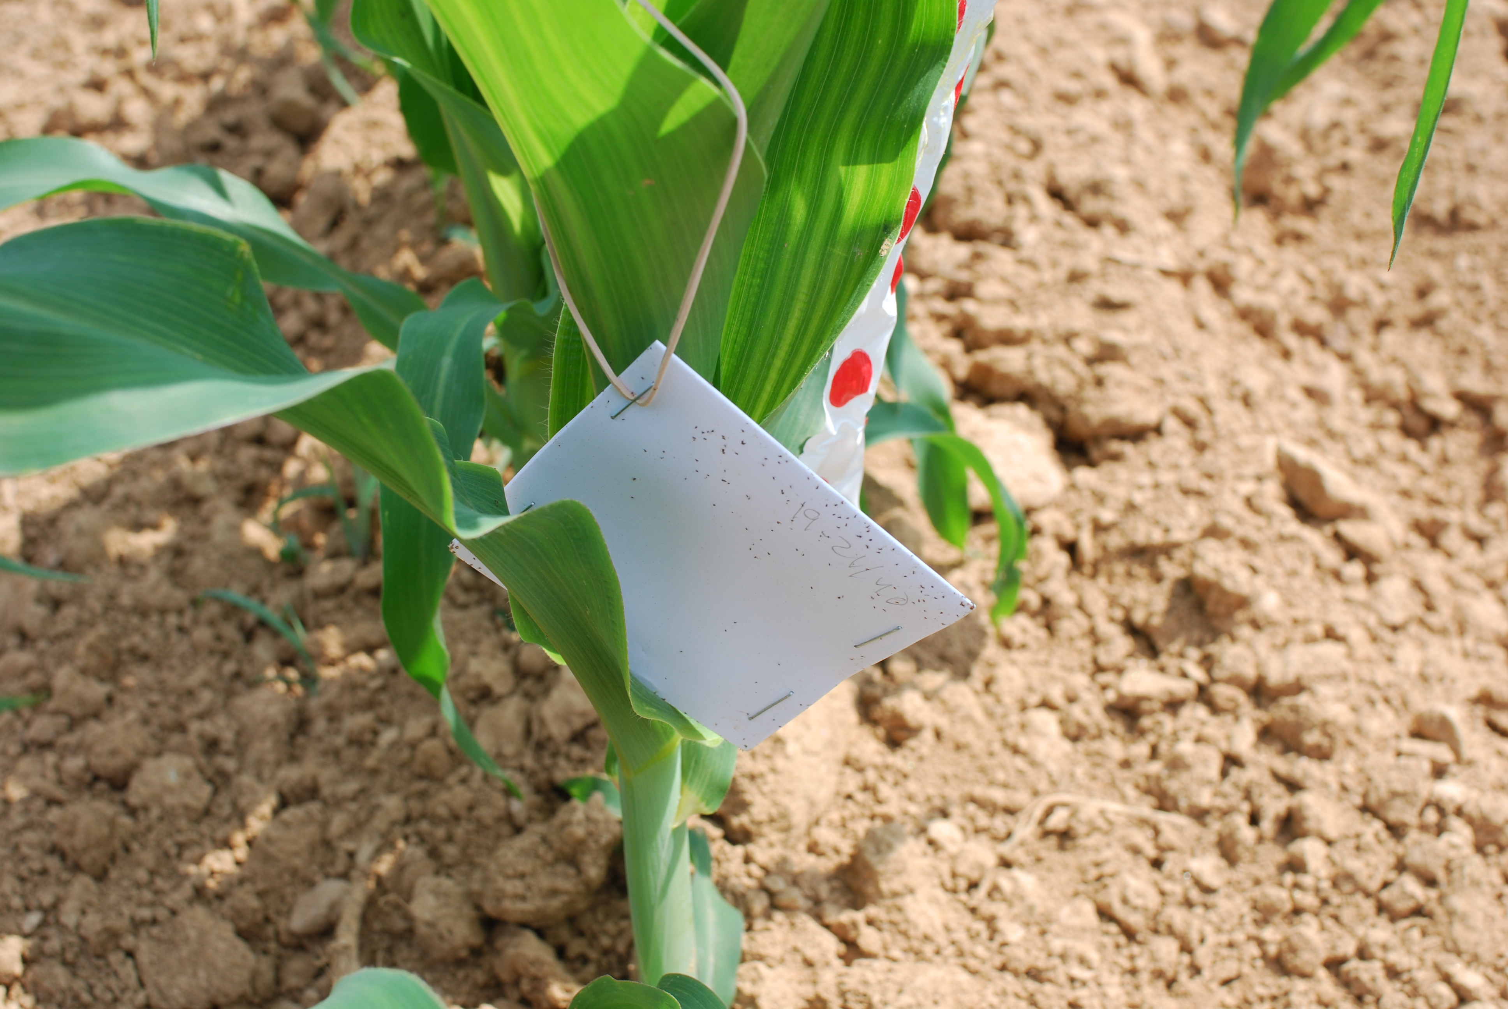
Trichogramma ostriniae to control European corn borer in early sweet corn

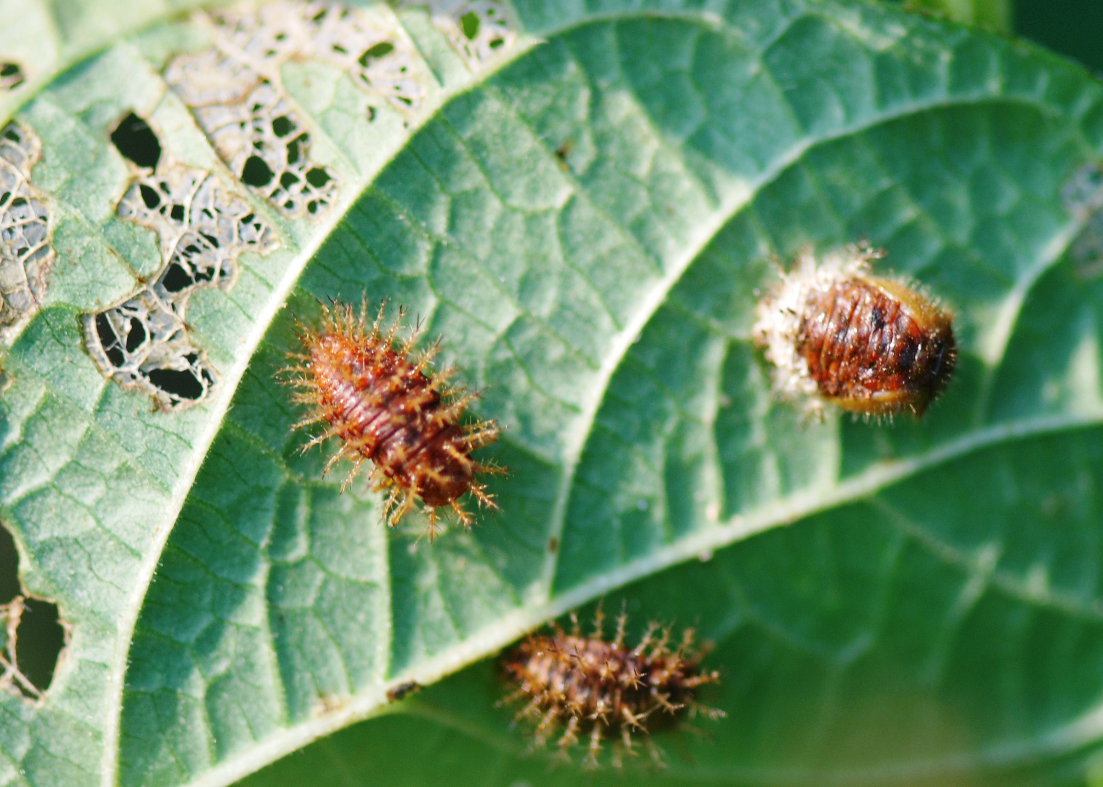
Pediobius foveolatus, introduced to control Mexican bean beetle in snap beans

