CARROT VARIETY AND STORAGE TRIALS

With Funding provided by the Northeast SARE foundation the UMass Extension Vegetable Program has been studying way to increase the sale and harvest of vegetable crops in during the winter months (defined as November through April) for the past two years. In response to increasing demand for local vegetables through the winter months, growers are expanding their production of root vegetables for winter storage. Carrot is a widely grown storage crop that suffers from declining quality in sub-optimum storage conditions. Growers in New England are using a wide range of harvest and post-harvest practices for carrots.
Published studies suggest that changing simple factors such as washing, variety, and maturity at harvest may affect the prospects for long-term storage. We used carrots as a model crop to study handling and storage options for long-term storage, over the 2010-11 and 2011-12 seasons. Below are some findings from our study of nine different varieties of storage carrots.

In response to increasing demand for local vegetables through the winter months, growers are expanding their production of root vegetables for winter storage. Carrot is a widely grown storage crop that suffers from declining quality in sub-optimum storage conditions. Growers in New England are using a wide range of harvest and post-harvest practices for carrots. Published studies suggest that changing simple factors such as washing, variety, and maturity at harvest may affect the prospects for long-term storage. We used carrots as a model crop to study handling and storage options for long-term storage, over the 2010-11 and 2011-12 seasons.

METHODS

For the 2010-2011 season, we selected six storage carrot varieties (Bastia, Berlanda, Bolero, Canada, Carson, Sugarsnax) with varying maturity dates. Carrots (untreated, not pelleted) were seeded on June 28, using a Clean Seeder, in double rows 18 inches apart, hand weeded, and thinned to 1 inch on July 28 . Trickle irrigation was surface-applied along each row as needed. We harvested carrots on four dates (September 29th, October 12th, October 27th, November 10th). At harvest, carrots were sorted into marketable and unmarketable, based on the USDA United States Standards for Grades of Topped Carrots U.S. No.1 and U.S. No.2. Unmarketable carrots included those that were too small, had insect damage, had splits or forking, were misshapen, or were hairy (excessive root growth). We measured wholesale marketable weights, and counted marketable carrots and culls. We evaluated flavor by using a taste-test to determine bitterness (0=not bitter, 1=bitter, but marketable, 2=unmarketable), and by measuring sugar content using the Brix test.
All carrots were placed into storage at 32 degrees F and RH>95% immediately after harvest. From December through March, we continued to sample Brix values and water loss of stored carrots.

For the 2011-12 season, we used six carrot varieties (Berlanda, Brest, Bolero, Carson, Deep Purple, Florida). Carrots were seeded July 26th and thinned to 1 inch on August 24th. We harvested carrots on three dates (November 3rd, November 14th, November 28th). We measured wholesale and direct sale marketable weight, counted culls, and measured dimensions of carrots (length, width, pith width). Those that were in good condition but too small or moderately misshapen were included in direct sale marketable weights. We measured Brix score at the time of harvest, and again after 6 months of storage. For three of the varieties (Berlanda, Bolero, Brest), we stored half of the carrots washed and half unwashed. We then evaluated staining, presence of rot, and top sprouting, after 6 months of storage.

GENERAL RESULTS & DISCUSSION

2010-11
At Harvest: Weight of marketable carrots appeared to increase across harvest dates for most varieties, indicating that carrots continued to grow late into the season without compromising quality from insects, disease, or other factors. Quality of Berlanda and Bastia, however, may have started to decline at the end of the harvest period. Brix score (sweetness) varied across harvest dates, and the date of highest sugar content varied with variety. Bitterness was lowest in the intermediate harvest dates for most carrots. See the variety descriptions below for more information on marketable weights, culls, and reason for culling.
Storage: Overall, Brix score (sweetness) appeared to increase during storage for the first several months and then decline rapidly. In our carrots, Brix score peaked at the beginning of February, after 3-4 months of storage. Water loss continued at low levels throughout the storage period, and averaged 5-11% between harvest and March 1.

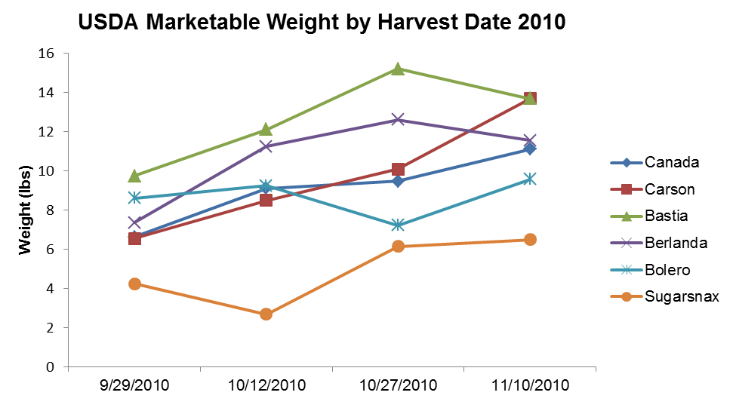

Figure 1. Weight of marketable carrots by variety for harvest dates in 2010 and 2011.

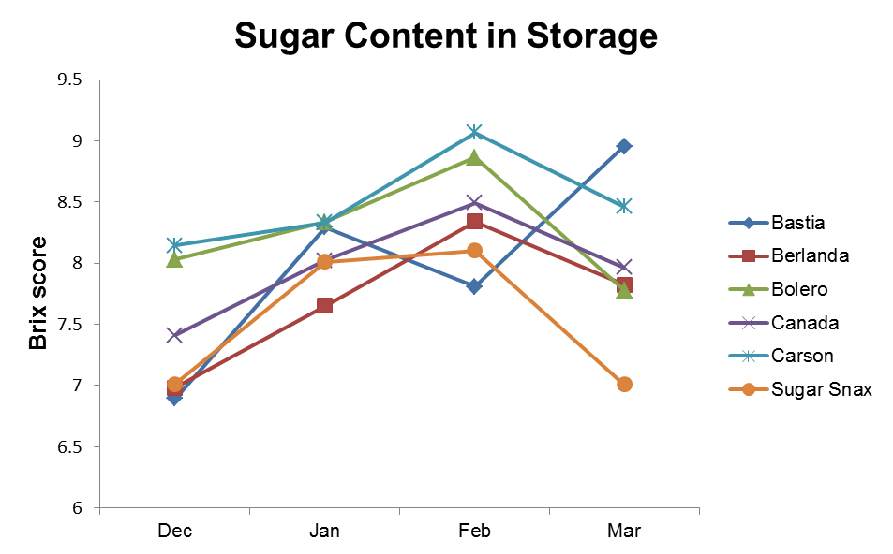
Figure 2. Brix scores by variety over the course of four months of storage.

2011-12
At Harvest: Brix score was higher for the two later harvests (November 14th, November 28th) compared to the first. Marketable weights were also higher for the later harvests.
Storage: Stored carrots were sampled in April for rot, staining, and top sprouting (an indication that they are becoming biologically active). After six months of storage, they no longer retained flavor and were unmarketable. However, their reaction to extended storage serves as a good indication of how they would react to storage over shorter periods. We found that washed carrots were more than twice as likely as unwashed carrots to show signs of rot (35% versus 14%), although rot damage was quite minor in all carrots. We saw no differences in top sprouting between washed and unwashed carrots. Unwashed carrots did show minor to moderate staining, and did not wash completely “clean.” However, washed carrots that were not kept perfectly clean (i.e. not all dirt was washed off pre-storage, small amount of dirt left in bag) also showed minor staining. We saw differences between varieties in terms of levels of staining, rot, and top sprouting (see variety descriptions below). There were no significant differences in Brix score between washed and unwashed carrots.

Variety Trials
In 2010-11 trials, Bastia had the highest number of marketable carrots, followed by Bolero and Carson. Sugarsnax had the highest number of culls, particularly forked and misshapen carrots. In 2011-12 trials, Berlanda was the highest yielding variety, both in terms of numbers and weight of wholesale marketable carrots. Brest, Bolero, and Florida were also high producers. Carson and Deep Purple did not fare as well, with Deep Purple producing less one third the marketable weight of Berlanda. These low yielding varieties produced approximately an equal weight in direct sale marketable carrots. Higher yielding varieties produced additional direct-sale carrots equal to about 2/3 of wholesale weights, and were still by far the best producers even for direct sales.
With regards to response to long-term storage, Brest had the lowest levels of staining when stored unwashed, but high levels of minor rot, and sprouting of tops. Berlanda showed the highest levels of staining, but only modest levels of rot. Bolero showed very low levels of top sprouting.

BERLANDA (85 days) Dark orange, cylindrical, 9" Berlikum with good tops. Source: Bejo.

Bitterness: 0.25 Marketable weight: 2010-50%, 2011-48%
Brix score: 7.27 Misshapen: 19%
Staining: moderate Forked: 2010 -18%, 2011-5%
Top sprouts: 92% Insect damage: 8%
Low-level rot: 17% Too small: 2011-13%, 2012-32%
Pith ratio: 0.59

BOLERO (75 days) Medium-long, 7-8" roots are uniform, thick, slightly tapered, and blunt, with a medium core and average internal color. This Nantes has good taste fresh, and after long-term storage. Resistant to Alternaria and Cercospora blight. Heavy, tall tops. Source: Johnny’s.

Bitterness: 0.23 Marketable weight: 2010-42%, 2011-47%
Brix score: 7.89 Misshapen: 13%
Staining: low-moderate Forked: 2010-27%, 2011-7%
Top sprouting: 19% Insect damage: 8%
Low-level rot: 19% Too small: 2010-4%, 2011-43%
Pith ratio: 0.47

CARSON (90 days) Early Chantenay, 7 1/2" deep orange, conical roots, with broad shoulder, blunt tip, and strong, tall tops. Source: Bejo.

Bitterness: 0.25 Marketable weight: 2010-53%, 2011-25%
Brix score: 8.03 Misshapen: 7%
Pith ratio: 0.55 Forked: 2010-10%, 2011-6%
Insect damage: 13%
Too small: 2010-23%, 2011-61%

BASTIA (85 days) Smooth jumbo Flakee with deep orange color, 9" roots. Strong tops, stores well. Source: Bejo.

Bitterness: 0.25 Marketable weight: 54%
Brix score: 7.27 Misshapen: 13%
Forked: 18%
Insect damage: 4%
Too small: 8%

CANADA (95 days) Dark orange, conical, 9" Chantenay with broad shoulder, strong tops, and long blunt tip. Source: Bejo.

Bitterness: 0.16 Marketable weight: 53%
Brix score: 7.62 Misshapen: 12%
Forked: 11%
Insect damage: 6%
Too small: 24%

SUGARSNAX (68 days) Smooth, deep orange Imperator has 9" tapered roots with strong, medium-tall tops resistant to Alternaria, Cercospora, and Pythium diseases. Tender and sweet. Source: Johnny’s.

Bitterness: 0.27 Marketable weight: 28%
Brix score: 7.65 Misshapen: 17%
Forked: 31%
Insect damage: 16%
Too small: 5%

BREST (90 days) Dark orange, full season slicer, with cylindrical to slight taper. 9" roots carry weight to the tips. Excellent tops for mechanical harvest. Source: Bejo.

Staining: low Marketable weight: 42%
Top sprouting: 90% Forked: 3%
Low-level rot: 38% Too small: 43%
Pith ratio: 0.54

DEEP PURPLE (80 days) Dark purple, 7-8" tapered roots with sweet flavor, similar to Purple Haze. Tall, strong, healthy tops. Color fades when cooked. Source: Bejo.

Pith ratio: 0.57 Marketable weight: 25%
Forked: 40%
Too small: 21%

FLORIDA (95 days) Cylindrical, orange 9" roots are sweet, with good tops for mechanical harvest. Very productive. Source: Seedway.

Pith ratio: 0.50 Marketable weight: 46%
Forked: 1%
Too small: 25%

