Developing Inoculum to Increase Anaerobic Digestion Efficiency in Winter Months.
NESARE Project (GNE11-030) Annual Report 2012
Appendix B

Figure 1: Cumulative methane (mL CH4/mL soil) for the specific methanogenic activity (tests) conducted on soils from 4 wetland sites, where:

Site 1: A tidal freshwater marsh located within the Jugbay Wetland Sanctuary adjacent to the Patuxent River, Maryland, USA (approximate coordinates: 38°46'51.36"N, 76°42'26.61"W).
Site 2: A tidal freshwater marsh located within the Jugbay Wetland Sanctuary adjacent to the Patuxent River, Maryland, USA (approximate coordinates: 38°46'49.63"N, 76°42'45.75"W).
Site 3: A beaver pond located within the Patuxent Wetland Park, in close proximity to the Jugbay Wetland Sanctuary, and adjacent to the Patuxent River, Maryland, USA (approximate coordinates: 38°48'34.99"N, 76°42'33.48"W).
Site 4: Open water pond located in a housing community in Culvert County, Maryland, USA (approximate coordinates: 38°44'45.94"N, 76°40'52.05"W).

Figure 2: Changes in headspace percent methane during specific methanogenic methane (SMA) tests of landfill leachates obtained from 5 different locations.
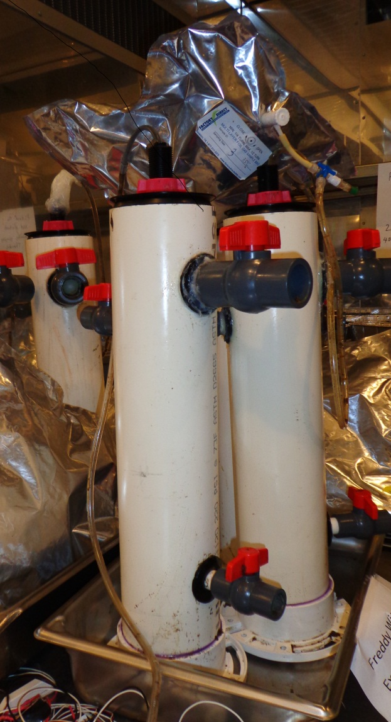
Figure 3: Reactors (approximately 4L in volume) were constructed to incubate the inocula from various sources.

Figure 4: Cumulative methane (mL/g of volatile solids (VS)) measured during the incubation of inocula (wetland site 1 (approximate coordinates: 38°46'51.36"N, 76°42'26.61"W) soil, wetland site 2 (approximate coordinates: 38°46'49.63"N, 76°42'45.75"W) soil, Stafford County landfill leachate, Charles County landfill leachate, and Beltsville Agricultural Research Center (BARC) anaerobic digestate) at 15°C.

Figure 5: Cumulative methane (mL/g of volatile solids (VS)) measured during the incubation of inocula (wetland site 1 (approximate coordinates: 38°46'51.36"N, 76°42'26.61"W) soil, wetland site 2 (approximate coordinates: 38°46'49.63"N, 76°42'45.75"W) soil, Stafford County landfill leachate, Charles County landfill leachate, and Beltsville Agricultural Research Center (BARC) anaerobic digestate) at 25°C.

Figure 6: Cumulative methane (mL/g of volatile solids (VS)) measured during the incubation of inocula (wetland site 1 (approximate coordinates: 38°46'51.36"N, 76°42'26.61"W) soil, wetland site 2 (approximate coordinates: 38°46'49.63"N, 76°42'45.75"W) soil, Stafford County landfill leachate, Charles County landfill leachate, and Beltsville Agricultural Research Center (BARC) anaerobic digestate) at 35°C.

Figure 7: Cumulative Methane (mL/g Manure) for the biochemical methane potential (BMP) test conducted at 15°C using various types inocula (wetland site 1 (approximate coordinates: 38°46'51.36"N, 76°42'26.61"W) soil, Stafford County landfill leachate, and Beltsville Agricultural Research Center (BARC) anaerobic digestate) that had been previously incubated for three months at 15°C and differing inoculum to substrate ratio (50% (w/w), 35%, 20%, and 0%). Values are average of replicates.

Figure 8: Cumulative Methane (mL/g Manure) for the biochemical methane potential (BMP) test conducted at 25°C using various types inocula (wetland site 1 (approximate coordinates: 38°46'51.36"N, 76°42'26.61"W) soil, Stafford County landfill leachate, and Beltsville Agricultural Research Center (BARC) anaerobic digestate) that had been previously incubated for three months at 25°C and differing inoculum to substrate ratio (50% (w/w), 35%, 20%, and 0%). Values are average of replicates.

Figure 9: Cumulative Methane (mL/g Manure) for the biochemical methane potential (BMP) test conducted at 35°C using various types inocula (wetland site 1 (approximate coordinates: 38°46'51.36"N, 76°42'26.61"W) soil, Stafford County landfill leachate, and Beltsville Agricultural Research Center (BARC) anaerobic digestate) that had been previously incubated for three months at 35°C and differing inoculum to substrate ratio (50% (w/w), 35%, 20%, and 0%). Values are average of replicates.

