Campaign 13 (lower disturbance) | Campaign 14 (higher disturbance)
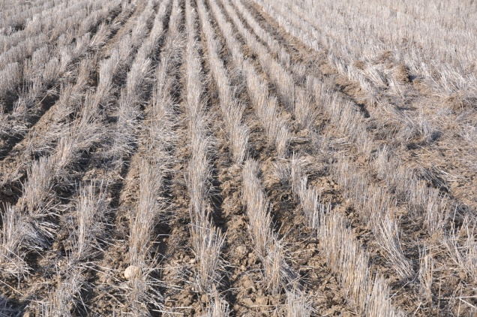
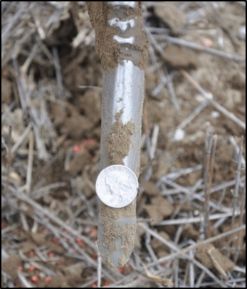
Figure 1. Disturbance created by the air-drill differed considerably at the two sites where a similar narrow style opene was used at Campaigns 13 and 14.

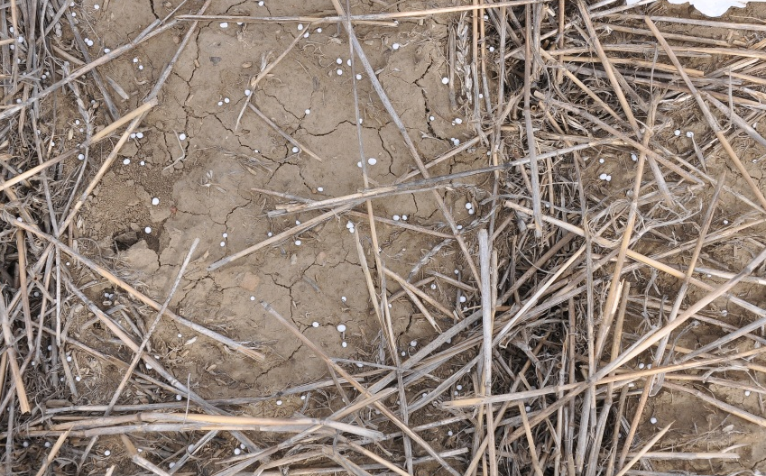 |  | 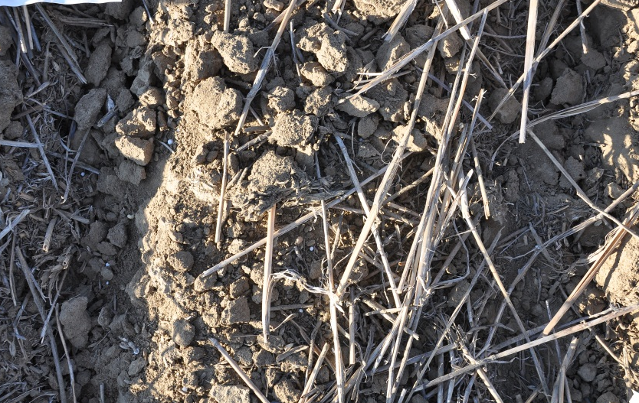
Figure 2. Seeding into dry soil conditions at a field site near Kremlin, Montana. September 16, 2011. Campaign 17. Soil disturbance at this site was insufficient to cover urea prills and protect against volatility losses. A narrow style opener was used at this field site. Photographs above show prills on surface before (left) and after (top) seeding from the same microsite in the field.
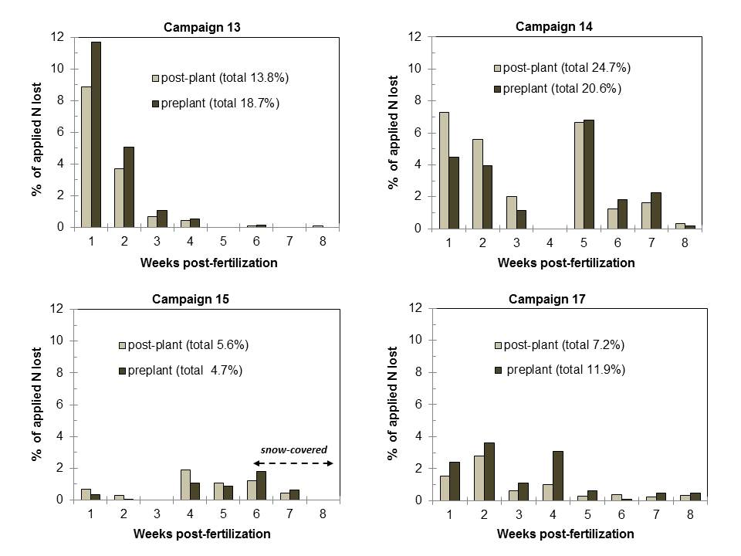

Figure 3. Weekly NH₃ losses from urea applied pre-plant and post-plant at north Havre (Campaign 13), Kremlin (Campaign 14), northwest Havre (Campaign 15), and Kremlin (Campaign 17) following fertilization on 15-September 2011, 27-September 2011, 07-October 211, and 16-September 2012, respectively.

Figure 4. Soil water content (2.5 cm depth) vs. d post-fertilization during Campaign 13. Precipitation events and magnitude indicated by arrows.

March 2, 2011 – fertilization application date |  | March 9, 2011
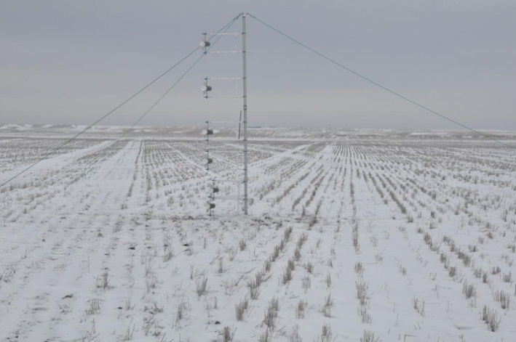 |  | 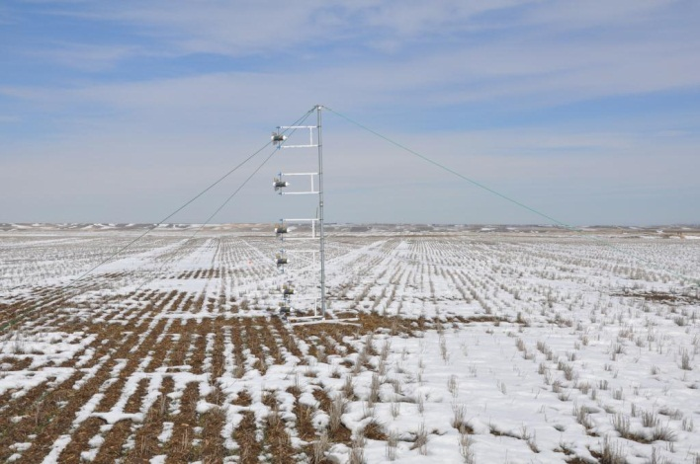
Figure 5. Urea was surface-applied to a snow-covered (0.89 cm water) winter wheat field site near Denton, Montana on March 2, 2011 (left). Field site 1-wk post-fertilization on March 9, 2011 (right).
February 28, 2012 – fertilization application date | March 6, 2012
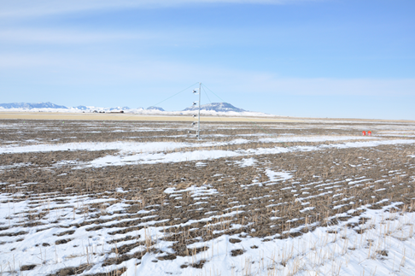 | 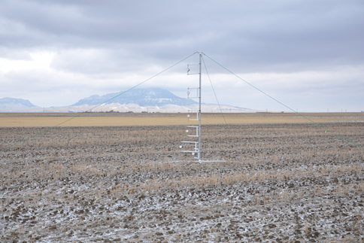
Figure 6. Urea was surface-applied to a winter wheat field site with intermittent snow cover near Denton, Montana on February 28, 2012. Field site 1-wk post-fertilization on March 6, 2012 (right).

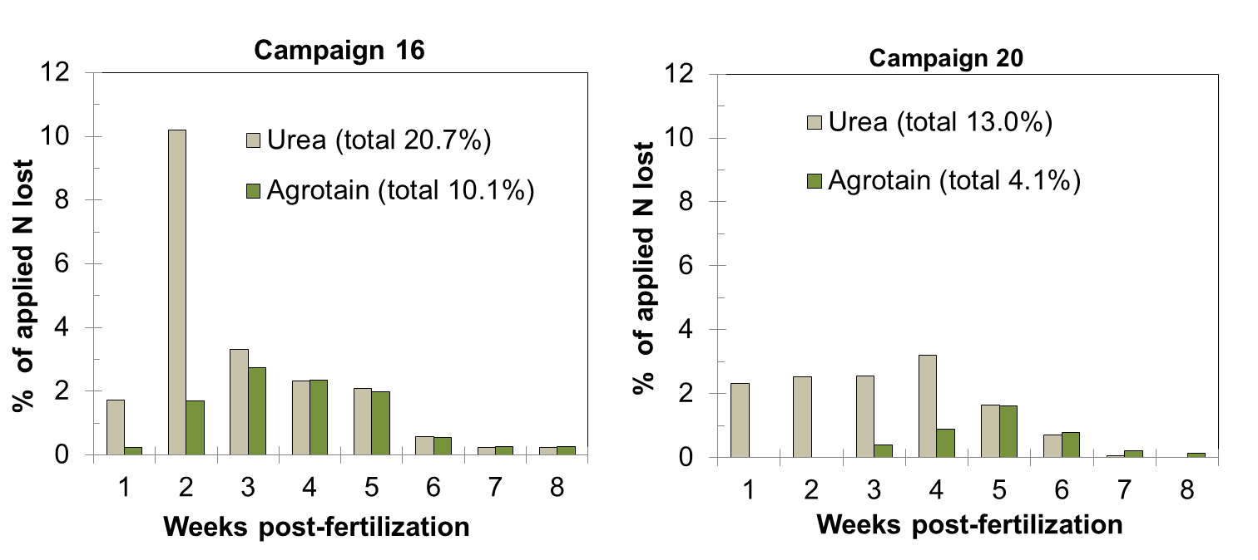
Figure 7. Weekly NH₃ losses (expressed a percentage of applied N) from surface-applied urea and Agrotain-coated urea at field sites near Denton, Montana. Fertilizer was applied on 02-March 2011 and 28-February 2012 for Campaign 16 and 20, respectively.

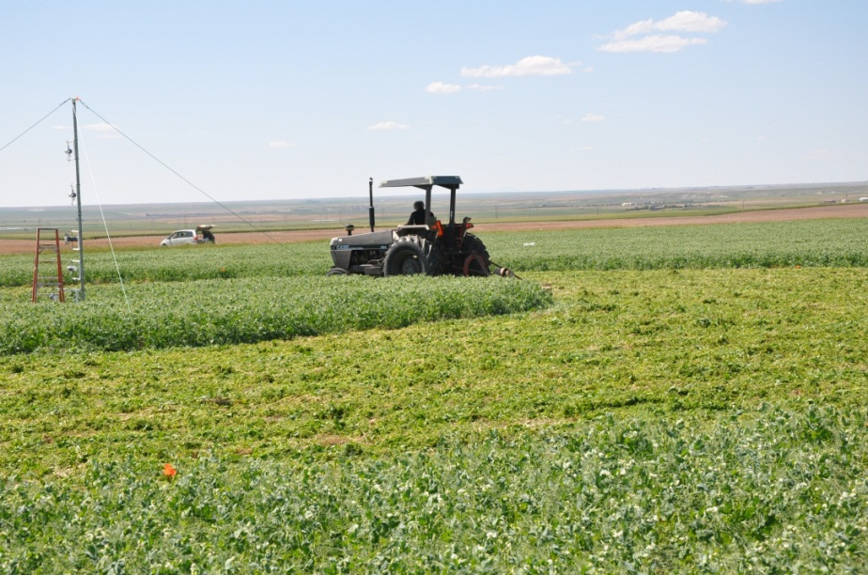

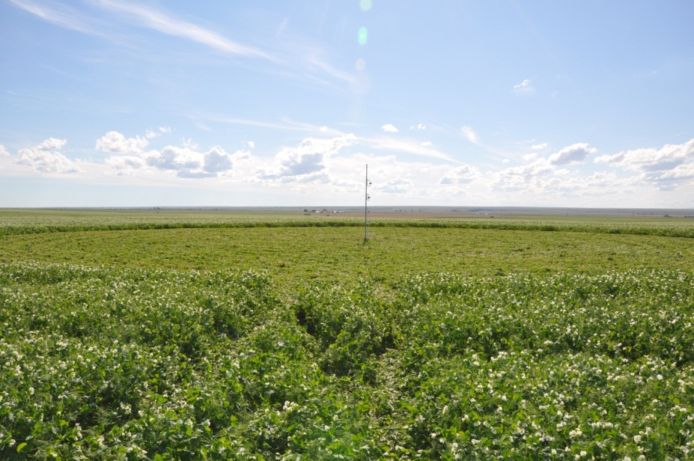
Figure 8. Field peas were terminated at the early-pod stage in 2011 (top) and flowering in 2012 (bottom) at field sites near Havre, Montana. A mast with Leuning samplers was erected inside of the circular plots to trap NH₃ loss according to the integrated horizontal flux method.

