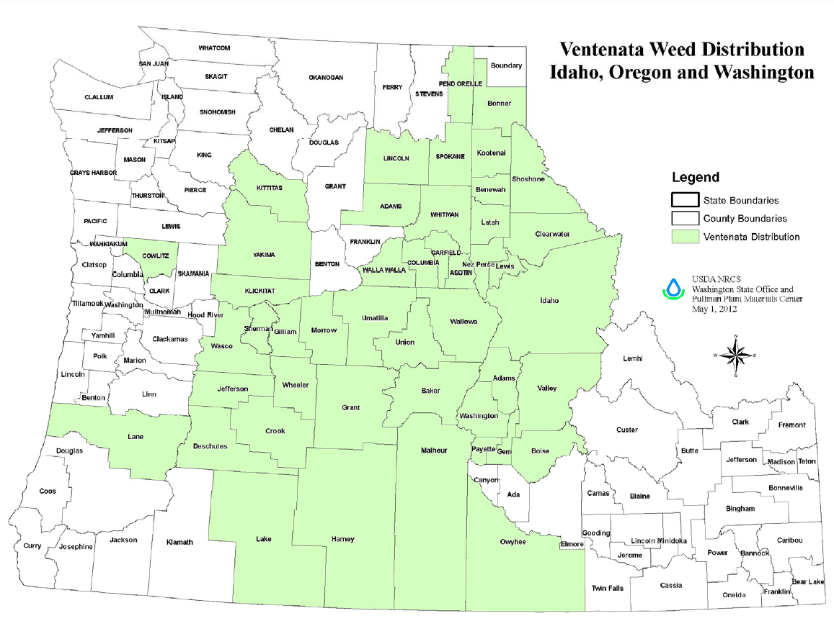Figure 1. Distribution of ventenata, reports of presence by county is maintained by Pamela Pavek, NRCS Plant Materials Center, Pullman WA.



Figure 2. Emergence patterns of ventenata in CRP, hay, pasture and range sites.



Figure 3. Onset of germination is influenced by soil moisture and temperature. Soil water appears adequate once 2 cm of rainfall has been received.

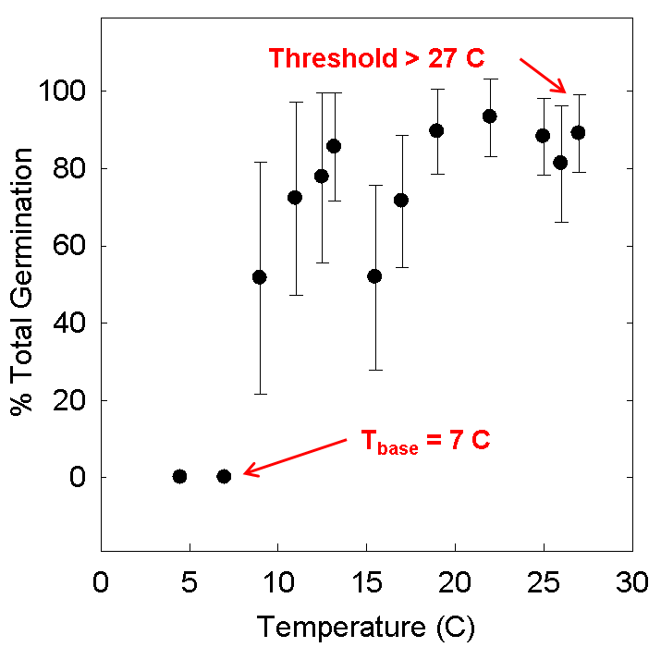

Figure 4. Base temperature at which ventenata germination initiates.

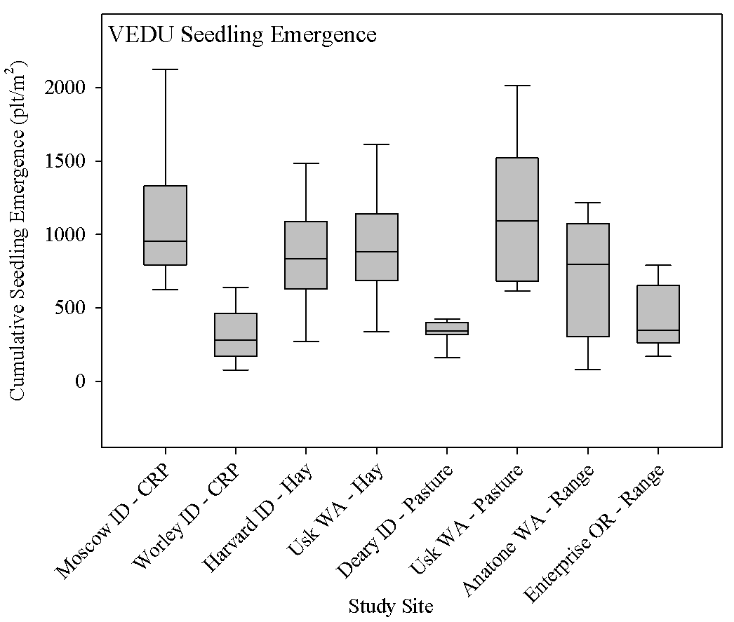

Figure 5. Range of emergence was 100 to over 2000 plants per square meter and the average density was over 200 to approximately 1200 depending with the least variability in hay production followed by rangeland.

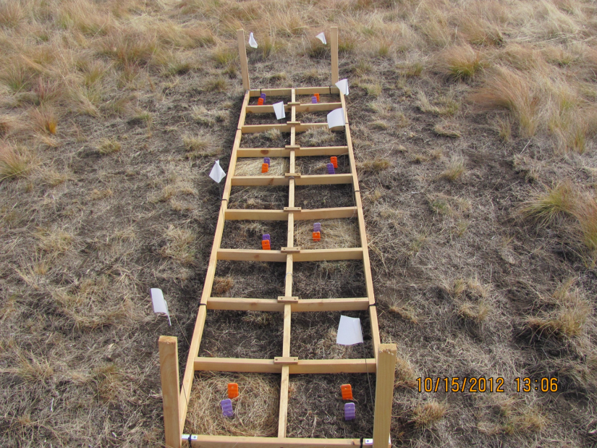  
  
Figure 6. Nitrogen cycling is being studied in small plots within a CRP planting.

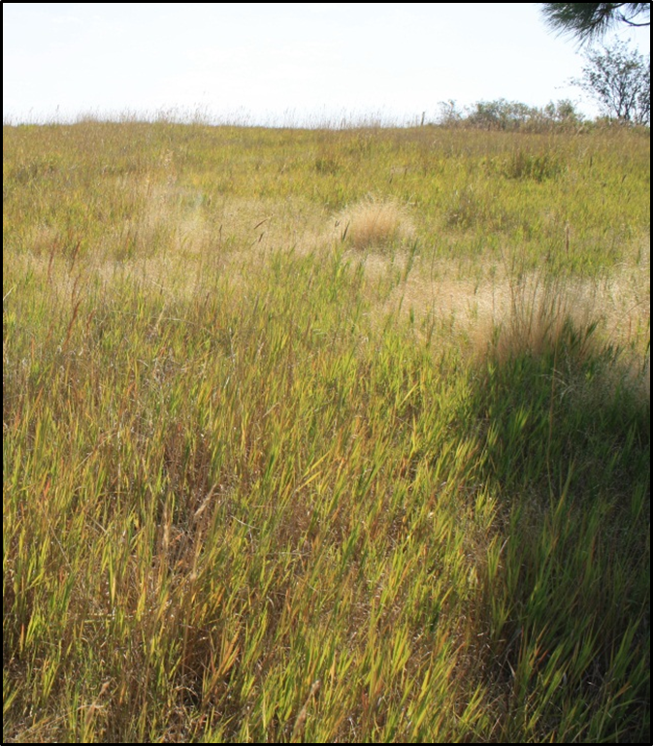

Figure 7. Example of an experimental site with a low infestation of ventenata (light, tan color). Experiments for a decision tool are established in low infestation and high infestation sites.

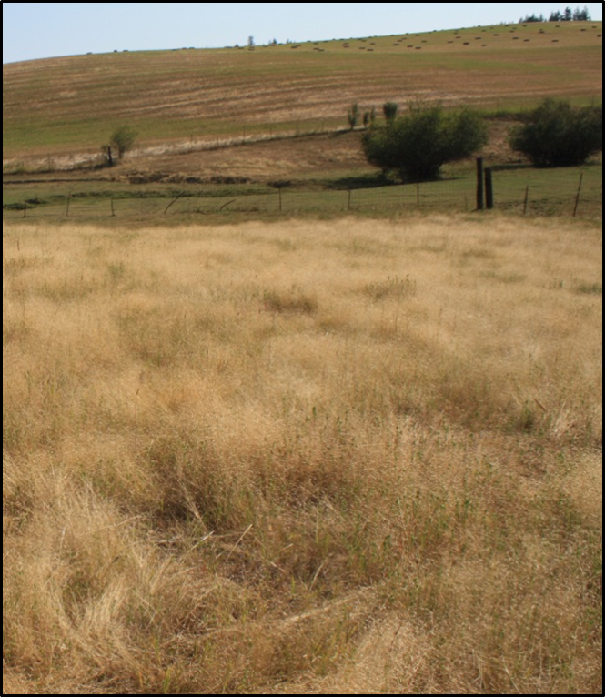

Figure 8. Example of an experimental site within high ventenata cover in support of our effort to create an IPM decision tool (ventenata is light, tan color above).

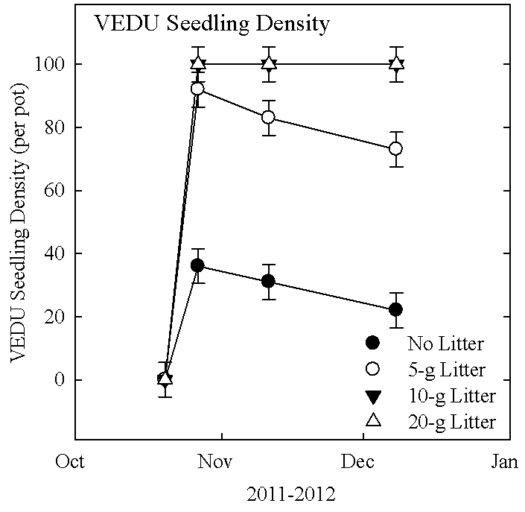

Figure 9. Litter of 20 g per pot that covered 99% of pot surface protected emerging ventenata seedlings but without litter seedling density decreased by up to 80%.

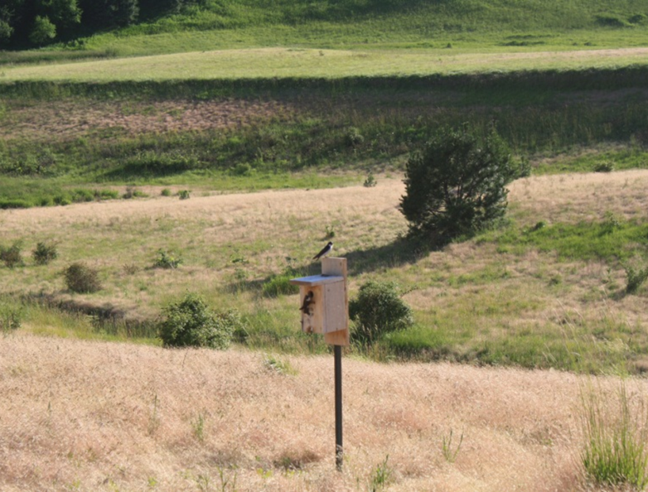

Figure 10. Bird boxes were placed in high and low ventenata infestations to attract cavity nesting birds. Swallows dominated the boxes.

Table 1. Nest success as a function of high or low ventenata infestation in Conservation Program Lands.

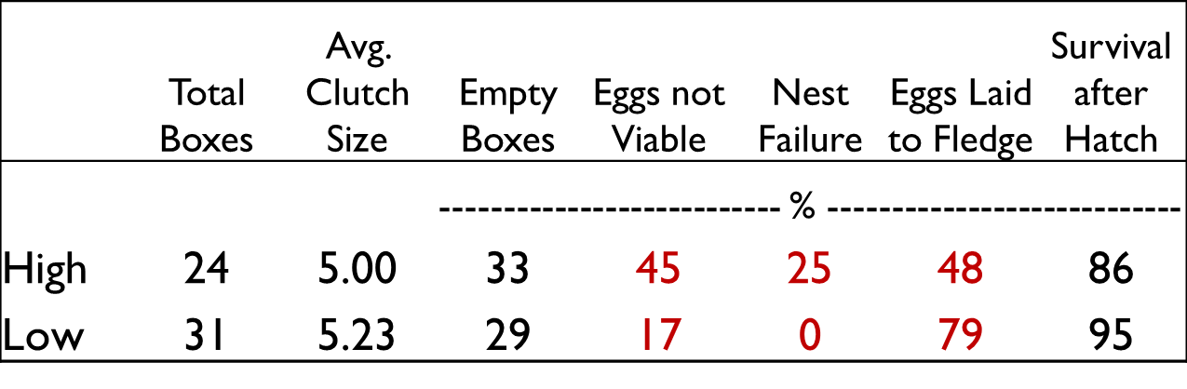

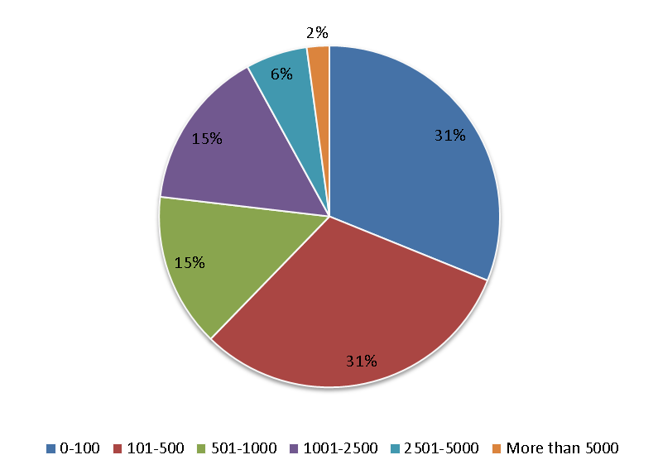

Figure 11. Approximately 2/3 of agricultural producers surveyed had under 500 acres in production.

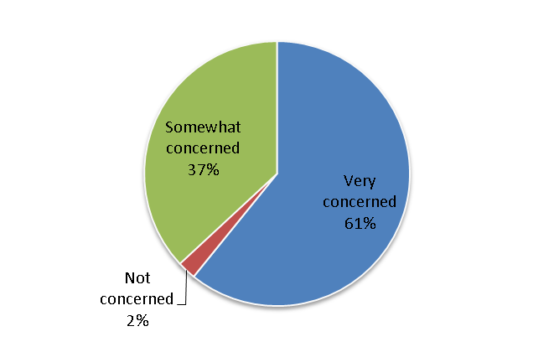

Figure 12. The majority of farmers were very concerned about ventenata impacting their farm production.

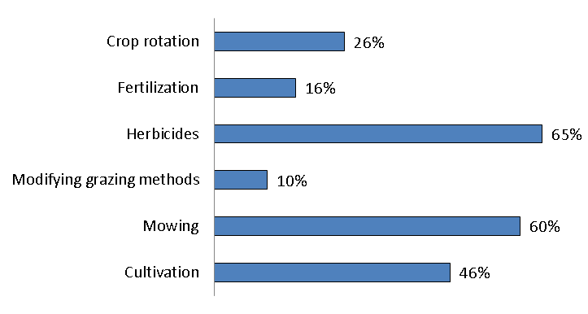

Figure 13. Methods used to control ventenata are diverse.

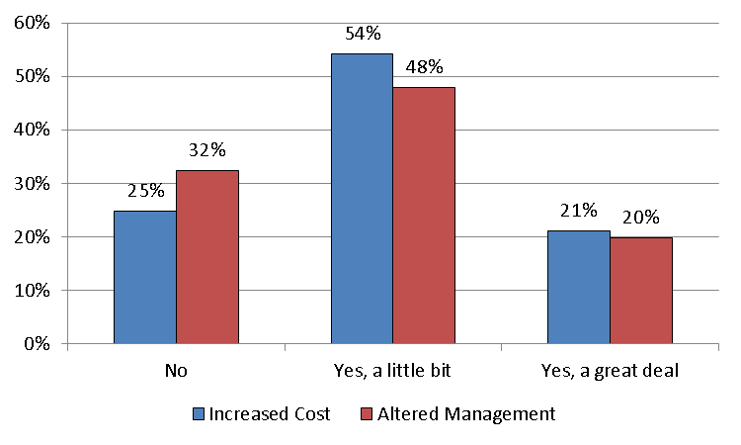

Figure 14. Farmers reported increased costs of production because of ventenata and many had altered their management to respond to the problem.