Understanding Small Landowners’ Perspectives on Adoption of Goat-Agroforestry Land Management System

SARE Grant -- RD309-109/4786396 LS10-237 GYAWALI

Final Technical Report

Submitted to

Southern Region Sustainable Agriculture Research & Education
Professional Development Program
The University of Georgia - Griffin Campus
1109 Experiment Street
Griffin, GA 30223

Buddhi R. Gyawali,
Alabama A&M University, Frankfort, Kentucky
Nar Gurung, Tuskegee University, Tuskegee, Alabama

February 22, 2013

Understanding Small Landowners’ Perspectives on Adoption of Goat-Agroforestry Land Management System

Photos

Workshop participants in Thomaston Alabama
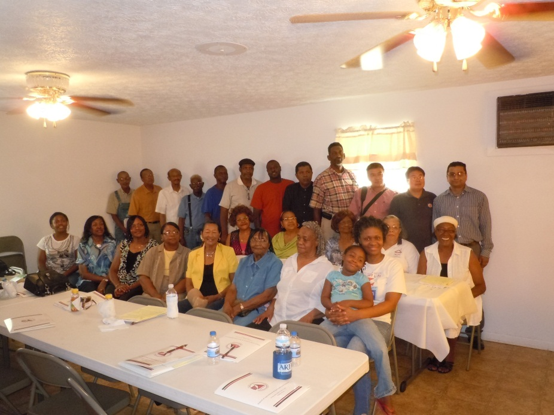

Workshop participants in Luverne, Alabama
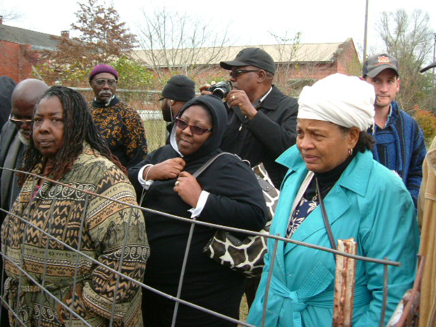
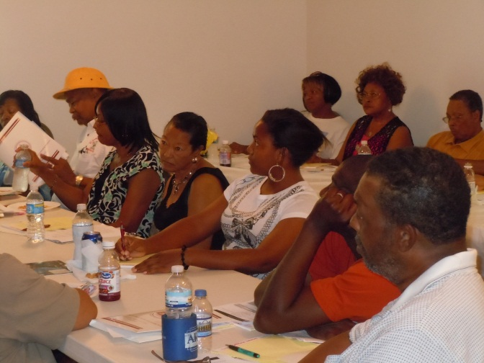
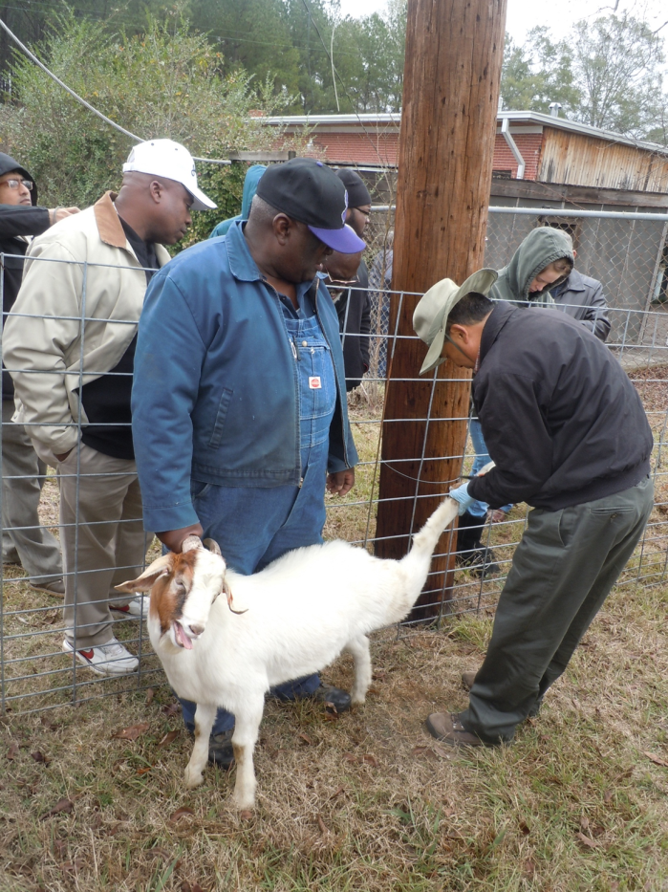
Dr. Nar Gurung, Tuskegee University and Mr. Andrew Williams, a retired NRCS specialist demonstrated hoof trimming procedure
Participants in the focus group discussion, Luverne, Alabama

Participants observing hoof trimming demonstration in Thomaston, Alabama

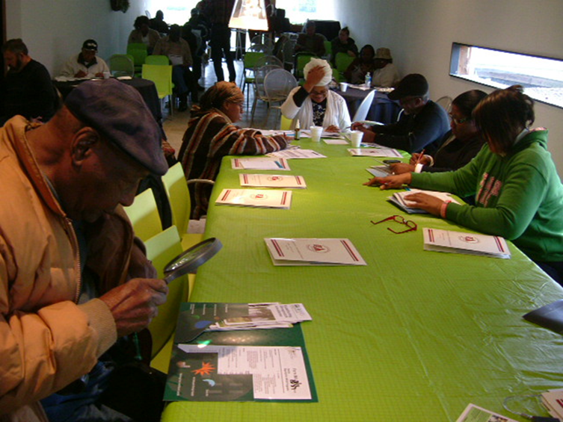
Participants in the focus group discussion in Thomaston Alabama

The focus group participants indicated that the participatory approach adopted by the project was instrumental in learning how to manage and diversify farmlands in innovative ways for higher farm income. Some participants showed interest in working with the local agencies and Alabama A&M University (AAMU) and Tuskegee University to develop producers' grants for establishing agroforestry demonstration farms in their property. AAMU students (Ms. Bonita Gill, graduate student and Mr. Ryan McCloud, undergraduate student) stated that they were highly benefitted from the workshop for understanding current issues facing minority landowners and pretesting/interviewing landowners.

