

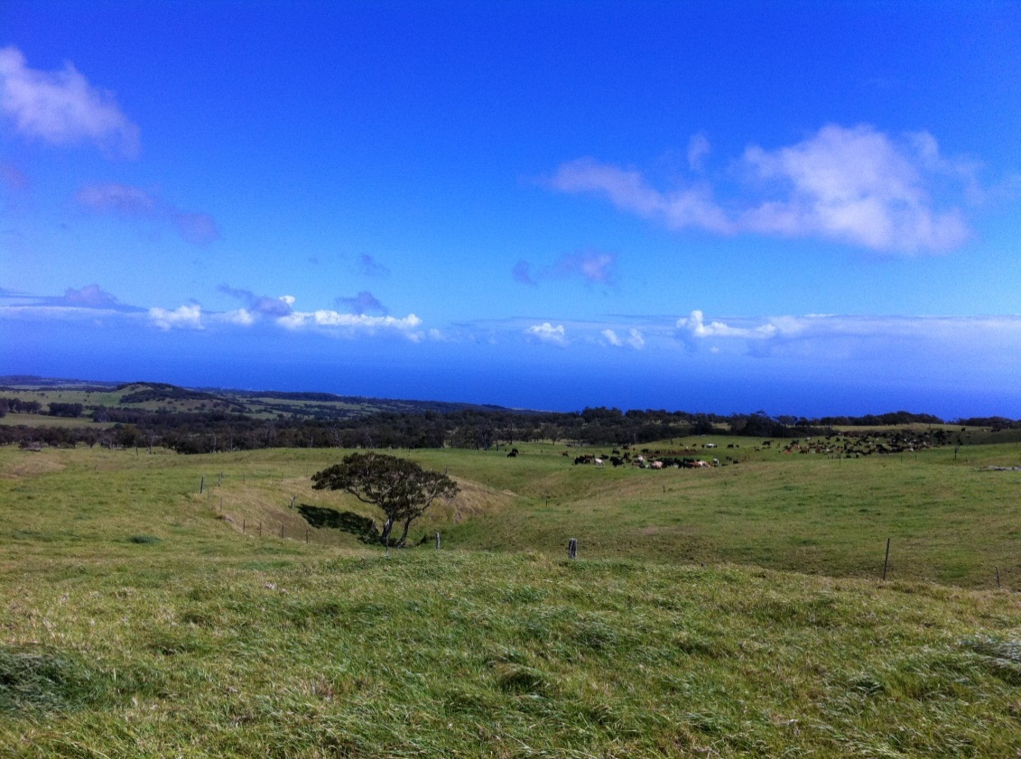

Secondary Compounds of Common Pasture Weeds of Hawaii

This project was funded by a grant from the Western Sustainable Agriculture Research and Education Program.

University of Hawaii at Mānoa

College of Tropical Agriculture and Human Resources

Table of Contents

**Acacia mearnsii (Black Wattle) ……………………………………………….…… 3**

**Argeratum consoides (Argeratum) ……………………………………………….4**

**Amaranthus spinosus (Spiny Amaranth) ……………………………………… 5**

**Andropogan refractus (Barbwire grass) …………………………………..……6**

**Asclepias physocarpa (Milkweed, Japanese lantern)………………..……7**

**Axonopus fissifolius (Carpet grass) ………………………………………….……8**

**Lanatana camara (Lantana) ………………………………………………….………9**

**Leonotis nepetifolia (Lions Ear) ………………………………………………..…10**

**Paspalum conjugatum (Hilo grass) ………………………………………………11**

**Psidium cattleianium (Waiwi) ……………………………………………………..12**

**Psidium guajava (Guava) ……………………………………………………..……..13**

**Ricinius communis (Castor Bean) ………………………………………………..14**

**Salsola tragus (Tumble Weed) ………………………………………………….…15**

**Schinus terelinthifolius (Christmas berry) ……………………………………16**

**Senna occidentalis (Coffe senna) …………………………………………………17**

**Solanum linnaeanum (Apple of Sodom) ………………………………………18**

**Sporobolus elongatus (Rat tail) ……………………………………………………19**

**Stachytaroheta dichotoma (Joee weed) ………………………………………20**

**Sysgium cumini (Java Plum)………………………………………………………….21**

**Xanthium strumarium (Cocklebur, kikania) .…………………………………22**

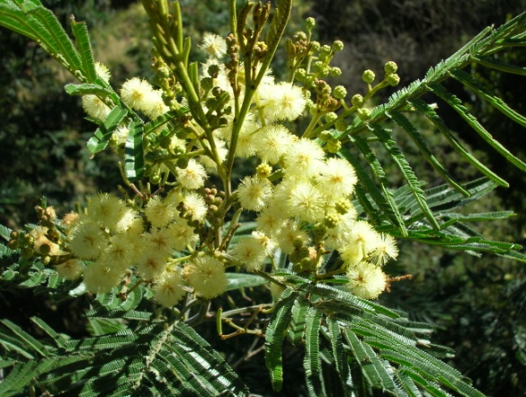

*Acacia mearnsii*

Black Wattle

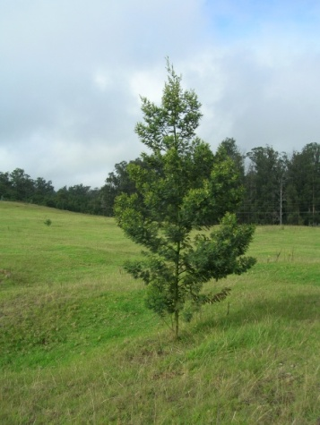

# 1Common Forest Trees of Hawaii, *USDA Agriculture Handbook No. 67, Elbert L. Little Jr. and Roger G. Skolmen, 1989*

© Forest & Kim Star

© Forest & Kim Star

Secondary Compounds:

Tannins

Uses:

Wood has been used for turnery, fuel and bark for tannin, but has not been used in Hawai’i.1

Habitat:

These trees inhabit the islands of Hawai’i and Maui, particularly Kula and are a native of Australia1.

Description:

An introduced tree with a crown of finely divided leaves. Cluster of small yellow balls of flowers and narrow flat seed pods. Trunk diameter ranges from 10 inched to 40 feet. Brown to gray with a inner bark of light yellow color with brown streaks.

*Argeratum consoides*

Ageratum

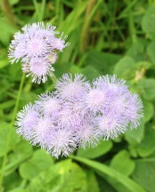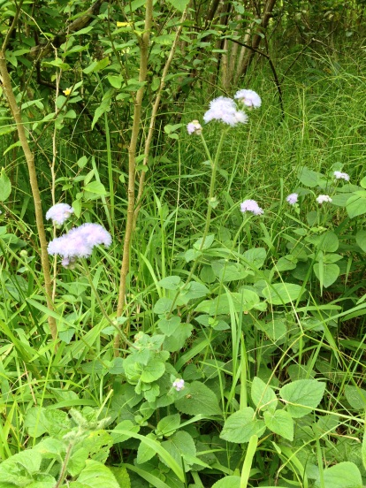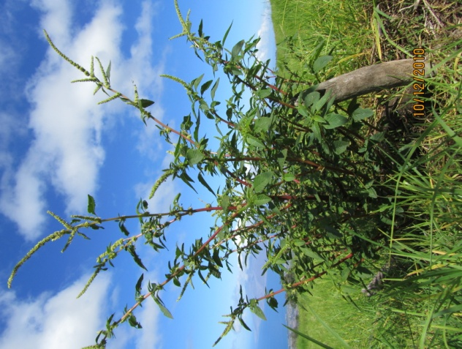

Habitat:

Seeds are photoblastic and viable for approximately 12 months. This plant can be found in several countries in the tropical and sub-tropical regions.

Secondary Compounds:

Flavonoids, alkaloids, cumarins, essential oils and tannins.2

Uses:

Description:

An herbaceous annual plant with fine white hairs that cover the stem; 30-80 cm tall. Cluster of bluish to purple flowers. Fruit is an achene easily dispersed by the wind.

Description: Annual herbaceous shrub standing about 3-4 feet high. Leaves are alternate and oval shaped, semi-triangular in shape. The stem is hairy and red – purplish in color with spines at most nodes which can be hidden by the leaves. Monoecious flowers are green, dense at spikes and form pannicles 3-8 inches long.

Secondary Compounds:

Oxalate, saponins, Phenolics, nitrates

Uses:

Habitat:

Well distributed in the tropics and warm temperate regions. Commonly found in disturbed areas such as roads, animal corrals and along roadsides.

*Amaranthus* *spinosus*

Spiny Amaranth

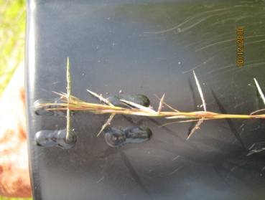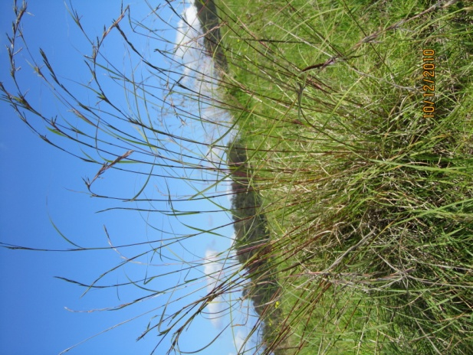

*Andropogan refractus*

Barbwire grass

Description: Perennial bunch grass. Identifiable from its “barbed wire” like seed heads. Plants are upright and average about 3-4 feet in height normal conditions. Leave have a strong lemon scent when crushed.

Habitat:

Established on many Pacific islands. Can be wide spread in poor or low nutrient soils,

Secondary Compounds & Uses:

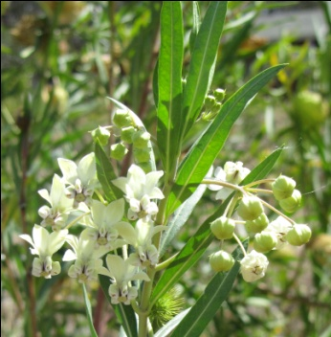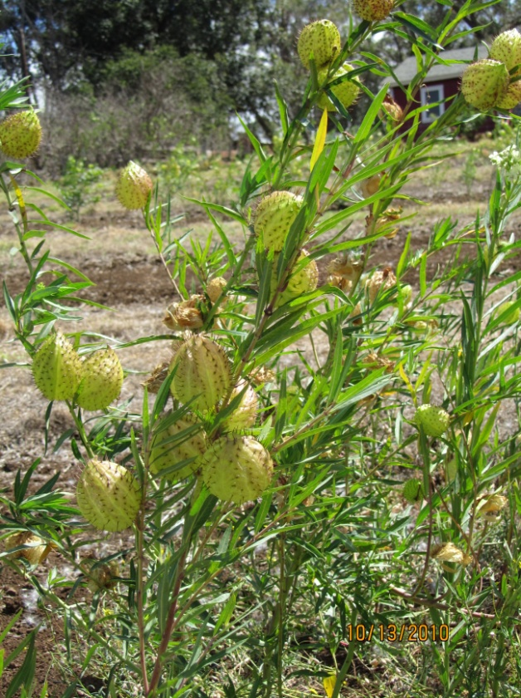

*2Weeds of Hawai‘i’s Pastures and Natural Areas; An Identification and Management Guide*, P. Motooka et al.

©2003, College of Tropical Agriculture and Human Resources, University of Hawai‘i at Mänoa.

Secondary Compounds & Uses:

Habitat:

Native plant of southeast Africa. Commonly found in the lower elevation dryer areas of all islands except Ni’ihau. 2

Description:

Perennial pasture weed with “ballon” shaped fruit cover in rough hairs and white flower clusters that hang at the axils. The fruit burst at maturity to expose thistles that easily spread in the wind. Leaves are elongated and narrow; 3-4 inches long. Stems and leaves have a milky sap.

*Asclepia physcarpa*

Milkweed, Japanese lantern

© Forest & Kim Star

Description:

Low growing mat type grass.

*Axonopus fififolius*

Common Carpet grass

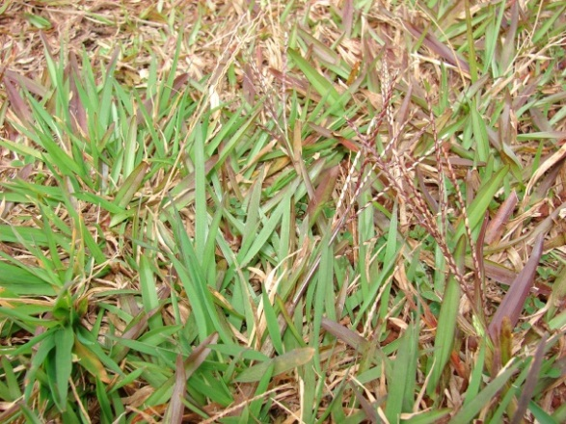

Secondary Compounds & Uses:

Habitat:

*3Carpetgrasss, J. Smith and H. Vaenzuel*.

©2003, College of Tropical Agriculture and Human Resources, University of Hawai‘i at Mänoa.

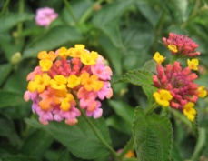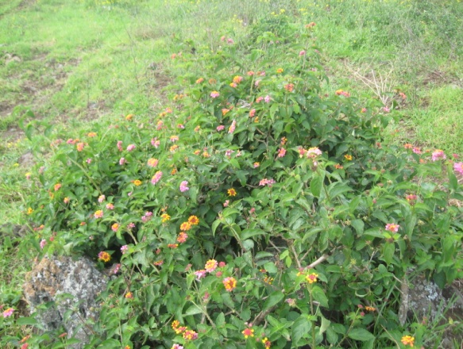

*3http://www.cbif.gc.ca/pls/pp/ppack.info?p_psn=232&p_type=all&p_sci=sci&p_x=px*

Description:

Woody perennial shrub, spike covered branches that can stand up to 10 feet tall. Leaf margins are serrated. Yellow, orange and pink flower clusters. Fruits are green when immature and darken to a black to dark blue color when mature. Invasive plant in pastures that is potentially toxic.

Secondary Compounds:

Lantadene A & B are compounds found in lantana. The leaves and fruit have known to be the toxic parts of the plant.3

Uses:

Habitat:

Found on all Hawaiian Islands. A pest of pastures and forest in dry to moist areas. Originated from the West Indies and has since occupied eastern and south Africa, South Asia and the Pacific islands. The dense shrubs that grow can crowd out native and desirable plant species. Branches are brittle and easily break when trampled by grazing animals.

*Lantana camara*

Lantana

*Leonotis neptifolia*

Lions Ear

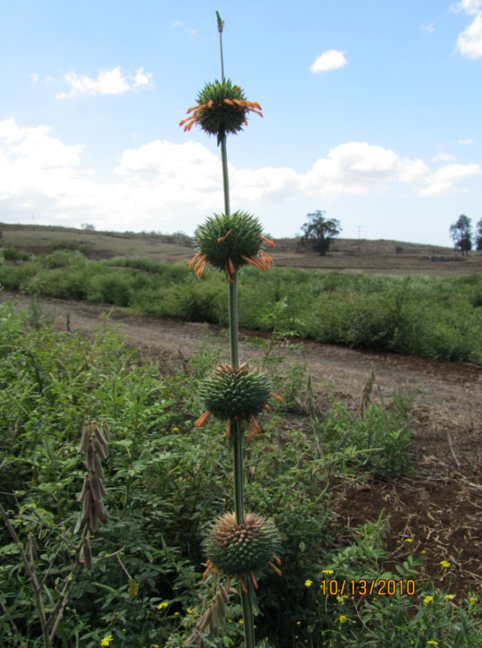

Secondary Compounds:

Labdane diterpenes and phenolic compounds. Nepetaefolin most abundant and may be primary source of toxicity.

Uses:

Habitat:

Commonly found heavily disturbed areas such as roadsides, overgrazed pastures and river banks where dense thickets may form. This can cause displacement of native plants in that area. Established in drier low elevation areas.

Description:

Tall single stemmed annual herb with spiny sphere like balls about every 2-4 in along the stem. The plant can reach up to 8 feet tall. The spheres are the flowering portion that contain thin, tubular flowers, reddish to orange color, that seem to encircle the single stemmed plant.

Secondary Compounds & Uses:

Habitat:

Description:

*Paspalum conjugatum*

Hilo grass

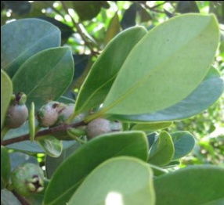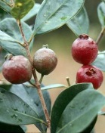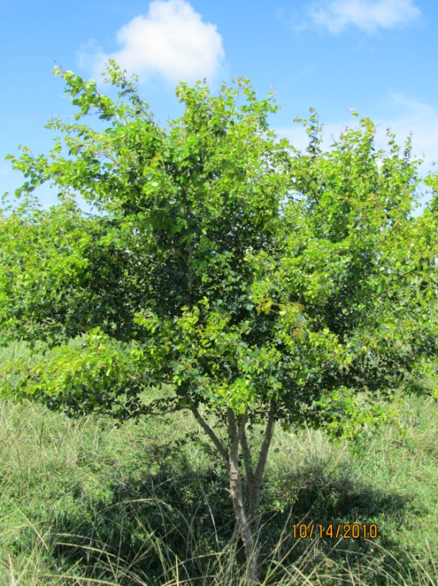

Secondary Compounds & Uses:

Habitat:

Occurs in sub-tropical to tropical areas, dry to moist forests and tolerates a wide range of environments. Seeds are widely disturbed by feral pigs and birds. Dense spreads in pastures and rainforest can form and be a pest for these areas. Has a high rate of germination but low viability (2).

Description:

Tall shrub or tree, can reach up to 20 ft. tall. Leaves have a shiny leathery appearance, opposite, ovate and variable size of 2.5 inches wide to 5 inches long. Flowers are whitish, leaf axil with many stamens. Fruits are red with white inner flesh; 1 inch diameter.

*Psidium cattleianium*

Strawberry Guava, Waiwi

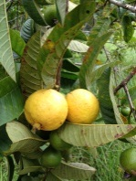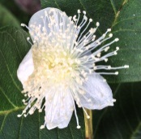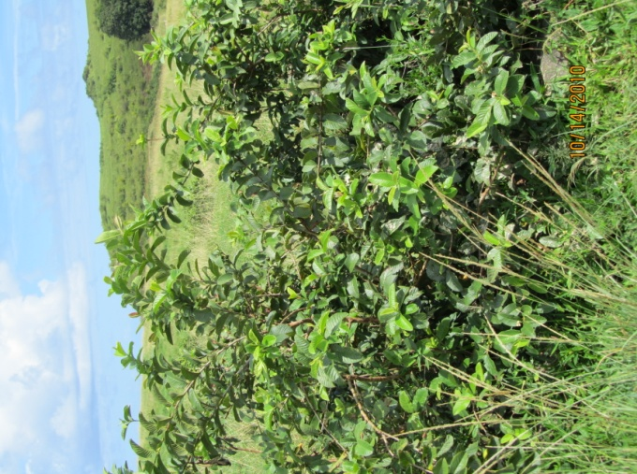

Secondary Compounds:

Flavonoids, tannins, saponins

Uses:

Description:

A branched tree, up to 25 ft tall, smooth bark, reddish brown color. Flowers are white with many stamens. Fruit is round, yellow when mature with pinkish color flesh, seeds are yellowish. Leaves are ovate, shiny on top with parallel rows of secondary veins evolving from the mid-vein.

Habitat:

This is a weed of pastures and forest and is widely spread throughout the tropics, common in wetter areas. Introduced in the early 19th century this plants occurs on all inhabited islands (2).

*Psidium guajava*

Guava

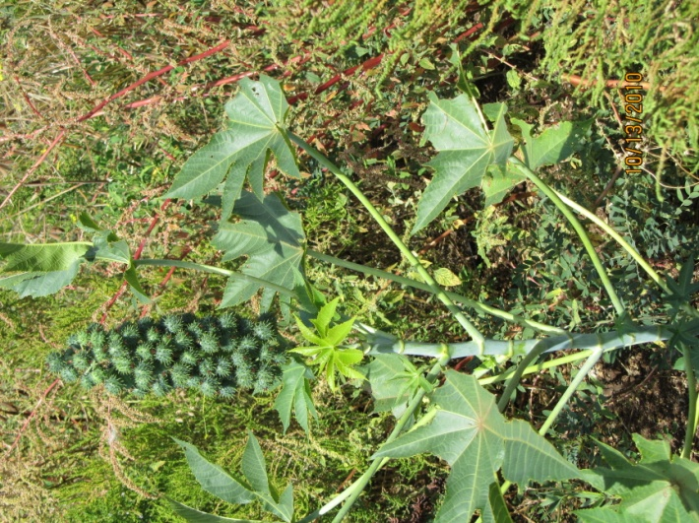

Description:

Shrub or brush; can reach up to 10 ft in height. Wide leaves about 2 ft long with 6-7 lobes and the stems are attached at back. Flowers formed in small white clusters below fruit. Spiny round shaped fruit form vertical clusters at top of central stem. Spotted seeds spread when fruit burst.

*4http://www.cbif.gc.ca/pls/pp/ppack.info?p_psn=135&p_type=all&p_sci=comm&p_x=px*

Secondary Compounds:

Ricin is a simple protein found in seeds. Toxicity occurs if seeds are chewed and ingested (4).

Uses:

Castor oil, castor bean used to make soap, margarine, lubricants, paints, inks, plastics and linoleum (2).

Habitat:

Found on all main Hawaiian Islands in dry-mesic disturbed areas. Originally from Africa, it is a problem in the wastelands, roadsides, and riverbanks (1).

*Ricinius communis*

Castor Bean

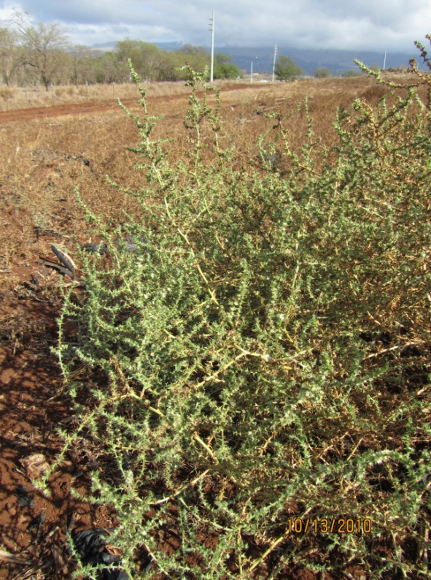

*Salsola targas*

Tumble weed

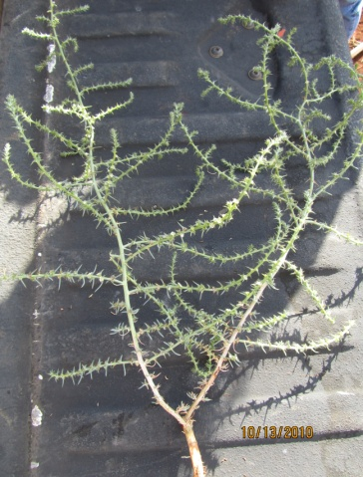

Secondary Compounds & Uses:

Habitat:

Description:

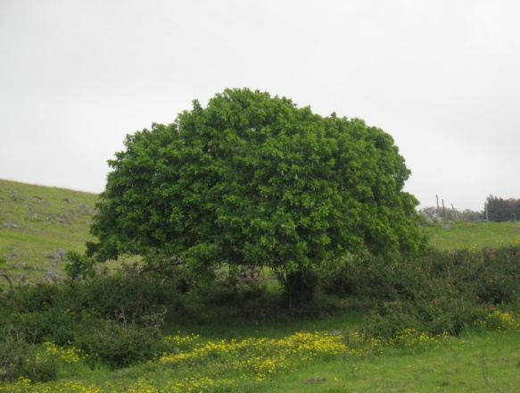

*Schinus terelinthefplius*

Christmas berry

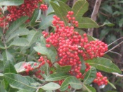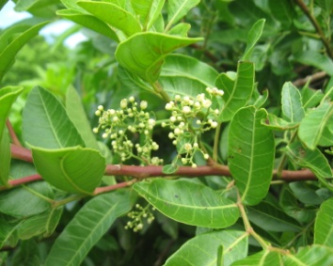

Secondary Compounds & Uses:

Habitat:

Description:

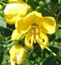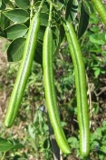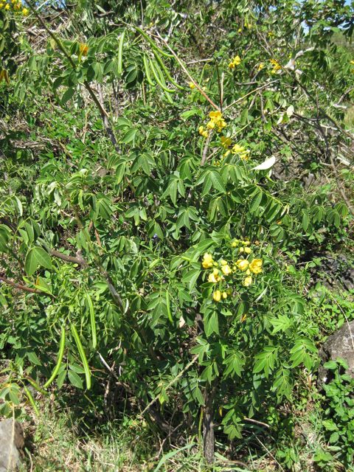

Description:

Secondary Compounds & Uses:

Habitat:

*Senna occidentalis*

Coffe senna

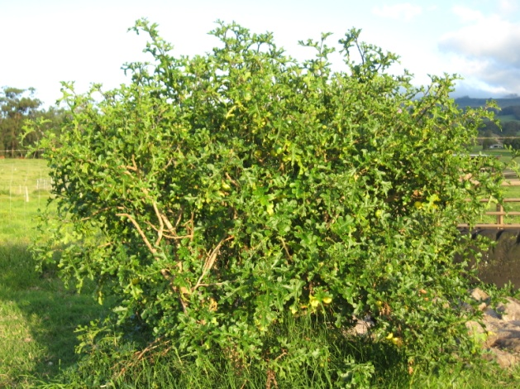

Description:

*Solanum linnaeanum*

Apple of Sodom

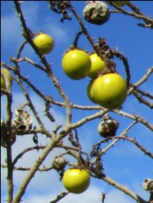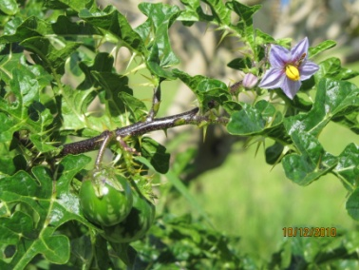

Secondary Compounds & Uses:

Habitat:

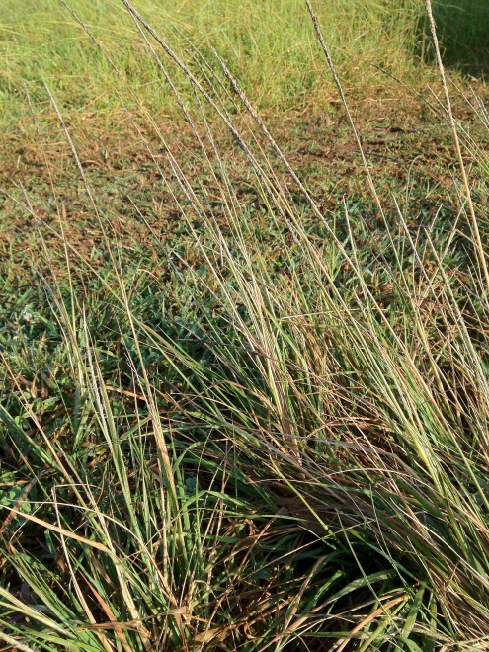

*Sprobolus elongatus*

Rat tail

Castor Bean

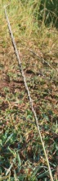

Secondary Compounds & Uses:

Habitat:

Description:

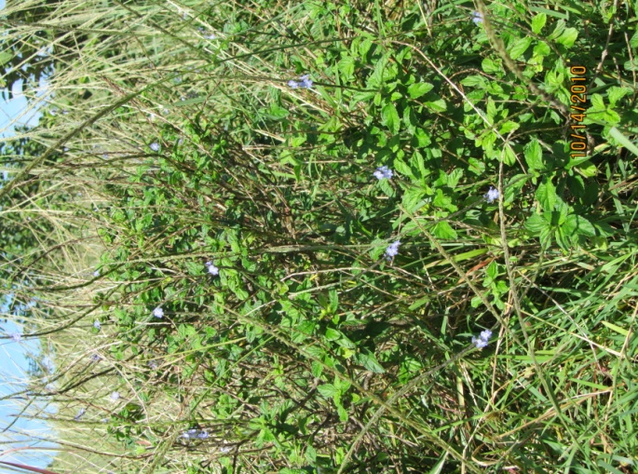

Description:

Secondary Compounds & Uses:

Habitat:

Description:

*Stachytarpheta dichotoma*

Joee weed

*Syzgium cumini*

Java Plum

Description:

Secondary Compounds & Uses:

Habitat:

*Xanthium strumarium*

Cocklebur (kikania)

Secondary Compounds & Uses:

Habitat:

Description: