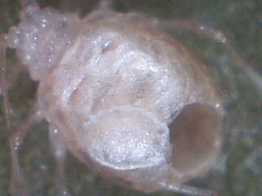
Super close-up of parasitized aphid from a parasitic wasp
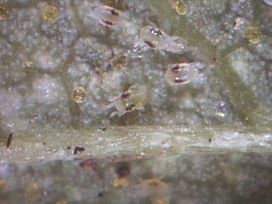
Adult spider mites on the underside of a hop leaf
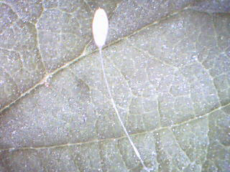
One of many lacewing eggs we found in the 15
acre commercial hop yard

