Table 1. ANOVA results (P-values) for Canada thistle main stem shoot height, main stem biomass, flower number, side shoot number, and root biomass as affected by Hadroplontus litura weevils, common sunflower presence, soil nutrient levels, and their interactions.
 | Canada thistle responses
Treatment | Main stem shoot height | Main stem shoot biomass | Flower number | Side shoot number | Root biomass
Wª | 0.028 | NS | 0.039 | NS | NS
CS^{b} | <0.001 | <0.001 | <0.001 | <0.001 | <0.001
SN^{c} | <0.001 | <0.001 | <0.001 | <0.001 | NS
W x CS | NS^{e} | NS | NS | NS | NS
W x SN | NS | NS | NS | NS | NS
CS x SN | NS | NS | 0.053 | NS | NS
W x CS x SN | NS | NS | NS | NS | NS
ª W = Weevil (H. litura) (presence, absence)
^{b} CS = Common sunflower (Helianthus annuus) (presence, absence)
^{c} SN = Soil nutrient level (low, high)
^{d} NS indicates not significant at 5% confidence level

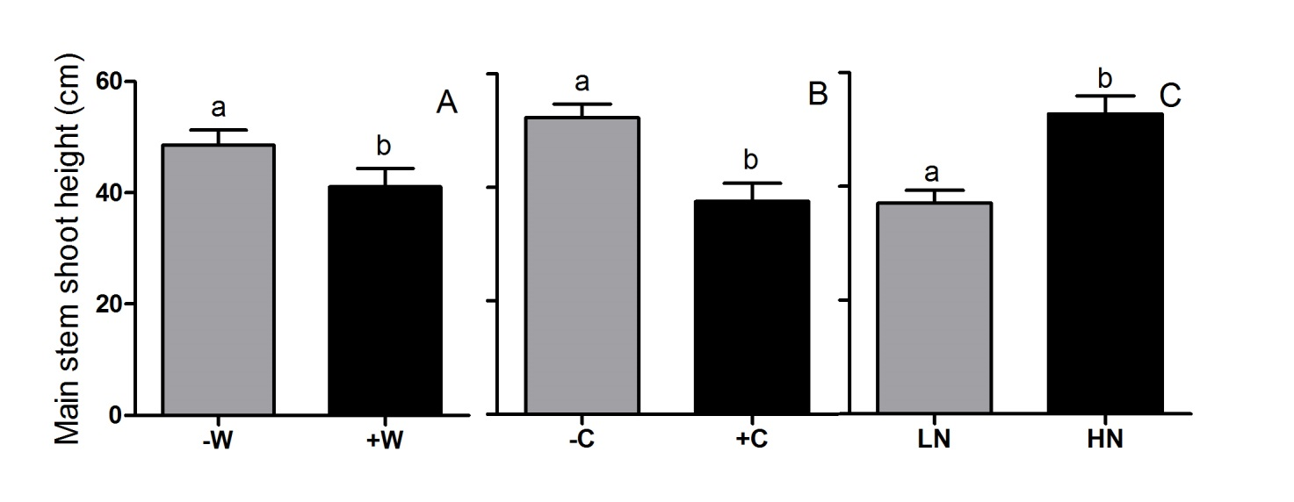
Figure 1. Effects of Hadroplontus litura weevil attack (A; -W and + W designate no weevil attack and weevil attacked, respectively), common sunflower plant competition (B; -C and +C designate no competition and competition, respectively), and soil nutrient levels (C; LN and HN designated low soil nutrients and high soil nutrients, respectively) on mean Canada thistle main stem shoot height. Bars indicate mean values plus standard errors of the mean. Means labeled with different letters differed and means labeled NS did not differ (95% confidence level).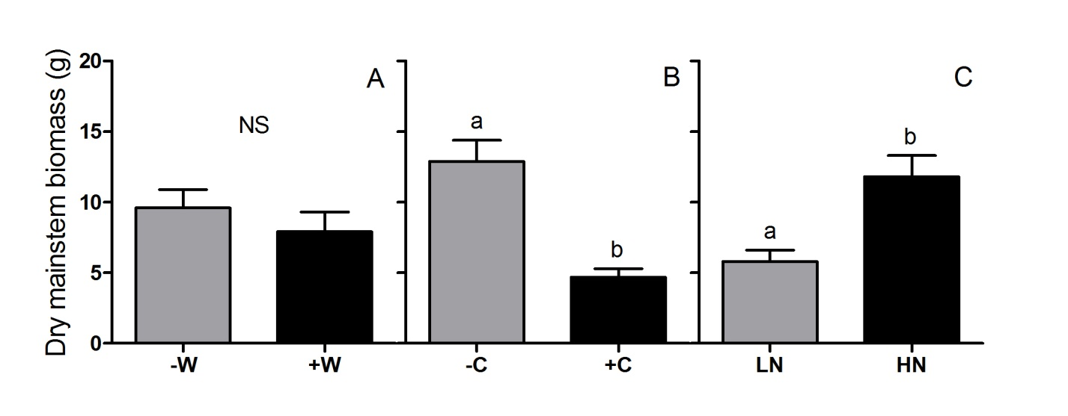
Figure 2. Effects of Hadroplontus litura weevil attack (A; -W and + W designate no weevil attack and weevil attacked, respectively), common sunflower plant competition (B; -C and +C designate no competition and competition, respectively), and soil nutrient levels (C; LN and HN designated low soil nutrients and high soil nutrients, respectively) on mean Canada thistle dry main stem shoot biomass. Bars indicate mean values plus standard errors of the mean. Means labeled with different letters differed and means labeled NS did not differ (95% confidence level).
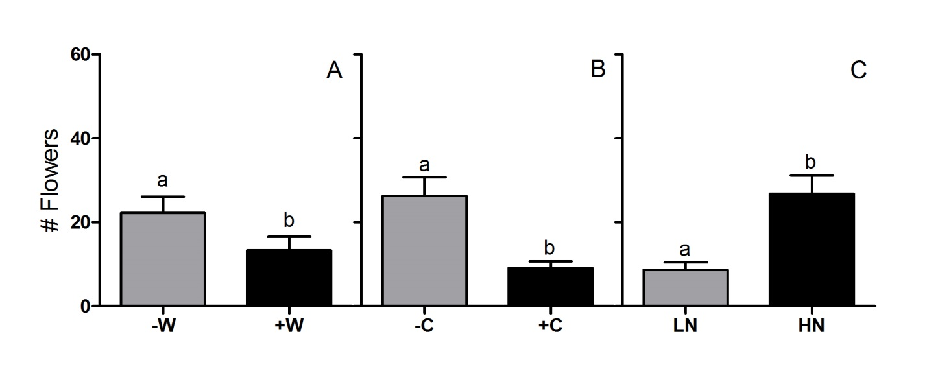Figure 3. Effects of Hadroplontus litura weevil attack (A; -W and + W designate no weevil attack and weevil attacked, respectively), common sunflower plant competition (B; -C and +C designate no competition and competition, respectively), and soil nutrient levels (C; LN and HN designated low soil nutrients and high soil nutrients, respectively) on mean numbers of flowers produced per thistle plant. Bars indicate mean values plus standard errors of the mean. Means labeled with different letters differed and means labeled NS did not differ (95% confidence level).
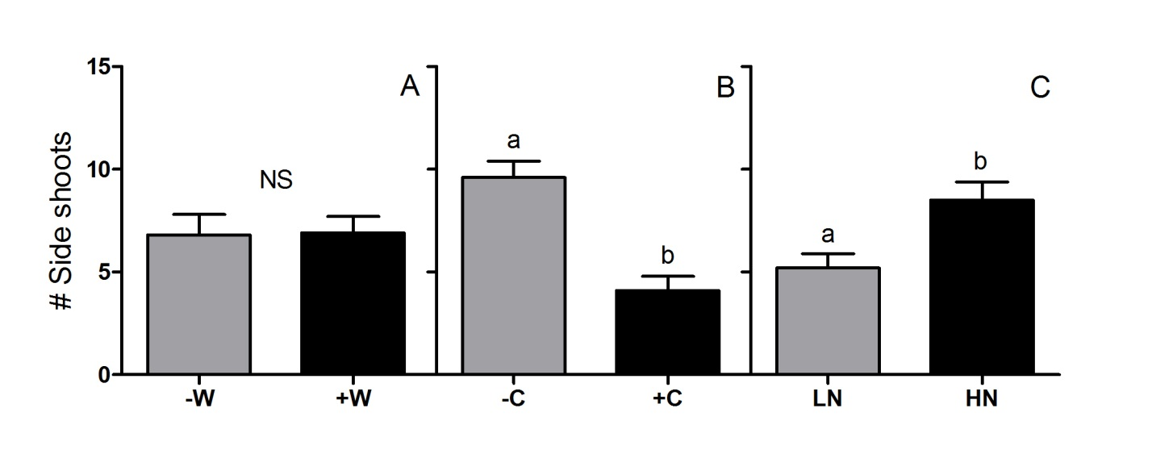
Figure 4. Effects of Hadroplontus litura weevil attack (A; -W and + W designate no weevil attack and weevil attacked, respectively), common sunflower plant competition (B; -C and +C designate no competition and competition, respectively), and soil nutrient levels (C; LN and HN designated low soil nutrients and high soil nutrients, respectively) on mean Canada thistle side shoot number. Bars indicate mean values plus standard errors of the mean. Means labeled with different letters differed and means labeled NS did not differ (95% confidence level).
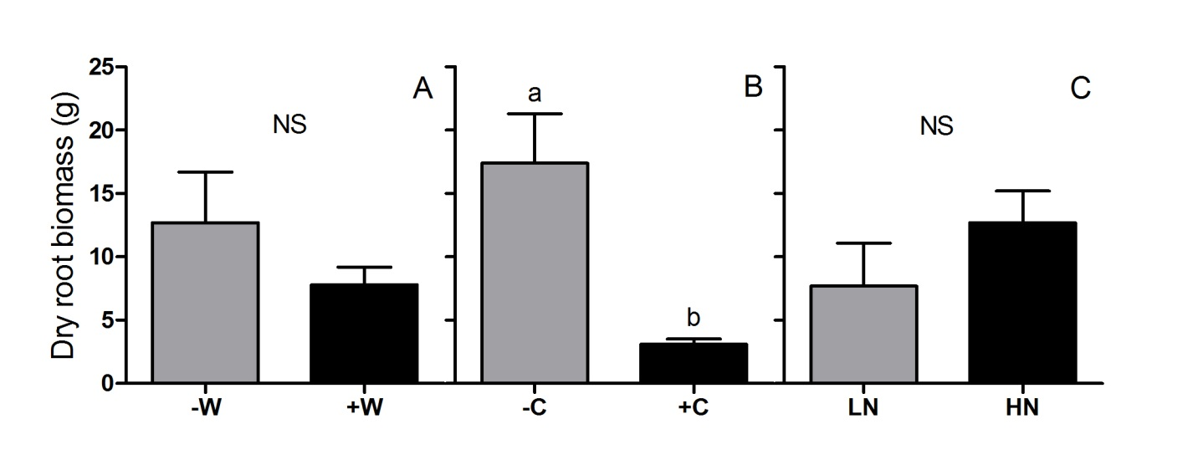
Figure 5. Effects of Hadroplontus litura weevil attack (A; -W and + W designate no weevil attack and weevil attacked, respectively), common sunflower plant competition (B; -C and +C designate no competition and competition, respectively), and soil nutrient levels (C; LN and HN designated low soil nutrients and high soil nutrients, respectively) on mean Canada thistle dry root biomass. Bars indicate mean values plus standard errors of the mean. Means labeled with different letters differed and means labeled NS did not differ (95% confidence level).

