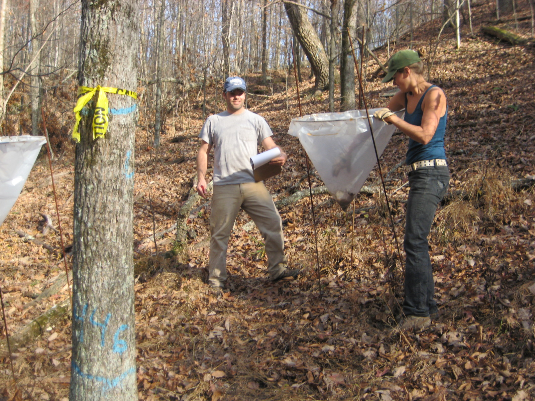

Photo 1: Setting out Mast traps.