PROGRESS REPORT

PROJECT TITLE:

Nutrient Optimization for Sustainable Goat Production
Systems in the Southeastern USA

Agency: UGA/USDA/SARE Agency Number: RD309-105/4690178
Project # LS09-223

COLLABORATING INSTITUTIONS: Department of Agricultural and Environmental Sciences, Tuskegee University, AL

Department of Animal Sciences
Auburn University, AL

Department of Veterinary Sciences
Fort Valley State University

Department of Food Sciences
Mississippi State University

COLLABORATING SCIENTISTS:

Byeng R. Min, Project Manager, Tuskegee University Nar Gurung, Project Coordinator, Tuskegee University Nii O. Tackie, Project Coordinator, Tuskegee University
Sandra Solaiman, Project Coordinator, Tuskegee University Jason Behrends, Project Coordinator, Mississippi State University Christy Bratcher, Project Coordinator, Auburn University
Mehdi Mobini, Project Coordinator, Fort Valley State University
Oct. 1, 2011-Drc. 30, 2012
III. Accomplishments/Milestones

Objective 1. Determine pasture quality changes using multi-culture grasses, and grasses in combination with legumes

For this objective, 6 forage combinations (grasses/legumes), for winter gazing were planted in duplicates on 12 pasture paddocks of 0.5 acres each during 2011 and 2012, and has been successfully completed. Six different forage combinations were shown in Table 1. However, grazing Exp. for summer forages have not been conducted because continuously failed of seedling due to severe drought. Therefore, we has been changed our forage species with drought resistance summer forage in year 2013.

New forage legume Sunn hemp (Crotalaria juncea L) grows well during drought and on marginal soils with a pH between 5.0 and 7.5. Sunn hemp is an excellent choice for a summer cover crop for Southern USA because it returns nitrogen to the soil, suppresses weeds and nematodes, improves soil tilt and water holding capacity, and reduces erosion in fields otherwise left without plant cover. Sunn hemp forms a symbiotic relationship with soil bacteria that remove nitrogen (N) gas from the atmosphere and transforms N to plant-available forms.

Table 1. Year-round foraging systems

Paddock # rep Multi-forage system Seeding rate (lbs)/acre
---------------------------------------------------------------------------------------------------------------
Winter grazing (2011 and 2012)-completed
1-2 | 2 | RW + big berseem clover (BC) | 100 + 33
3-4 | 2 | RW + Austria winter pea (AP) | same as above
5-6 | 2 | RW + HV + AP | Same as above + 33 each
7-8 | 2 | RW + HV+AP+BC | Same as above + 33 each
9-10 | 2 | RW+ Hairy vetch (HV) | Same as above + 33
11-12 | 2 | Rye grass/wheat (RW) | 100

Summer Forages (2011 and 2012)- not completed
7 | 2 | Bermuda grass (BG) | 20
8 | 2 | Sericea lespedeza (SL) | 30
9 | 2 | BG + SL | 30
10 | 2 | BG + Soybean (SB) | 100
11 | 2 | BG + brown top millet (BTM) | 30
12 | 2 | BG+ SB + BTM | 100 + 30
Modified Summer Forages-currently conducting this exp. (2013)
7 | 2 | Bermuda grass (BG) | 20
8 | 2 | Sericea lespedeza (SL) | 50
9 | 2 | Sunn Hemp (SH) | 30
10 | 2 | Forage soybean | 30
Annual rye grass/wheat (RW).

Data Collection

Forage mass (kg DM/ha), botanical composition and forage chemical composition were measured on February and March 2012 for winter grazers. On each occasion four random quadrates per paddock were cut using a hand-clipper for biomass. The forage samples were then oven-dried at 90 oC for 18 h, and weighed. For laboratory analysis, four quadrates of herbage on offer were cut to ground level from each paddock. Samples were combined for each paddock, mixed, and divided, with the first part used for botanical composition assessments and the second part for chemical analysis.

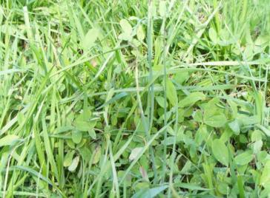
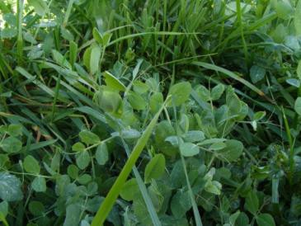
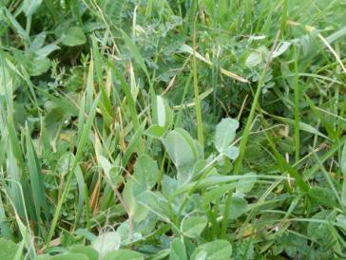
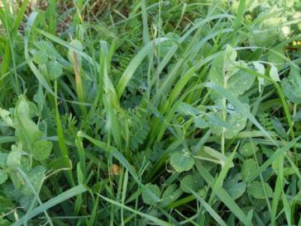
(1) RW + Berseem Clover (BC) (2) RW+ Australian pea (AP)

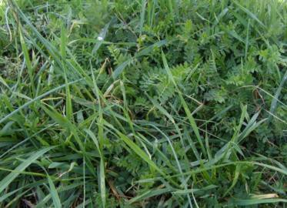
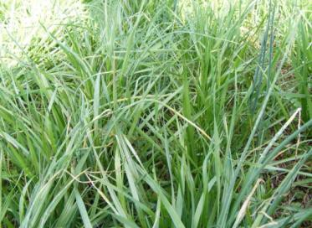
(3) RW + AP+ Hairy vetch (HV) (4) RW+AP+HV+BC

(5) RW + HV (6) RW

Figure 1. Multi-cultural forage system during winter and spring, 2012, Tuskegee, AL. Annual rye grass/wheat (RW) + Berseem clover (BC), (2) RW + Australian pea (AP), (3) RW + Hairy vetch (HV) + AP, (4) RW + HV + AP + BC, (5) RW + HV, and (6) annual rye grass/wheat (RW),

Statistical analysis

All data were analyzed as repeated measure with production system included in the model as a fixed effect using the Proc GLM procedure of SAS (SAS Inst. Inc., Carry, NC). Differences among means, for all analysis, were determined by least square means procedure with the protected F-test (P < 0.05).

Results

Forage biomass changes

The benefit of using multiple species on the same pasture comes from the fact that different animals have different plant preferences. Multi-culture forage dry matter (DM) production (Figures 2) in February and March 2012 was higher for RW+AP and RW + AP + HV
+ BC than other forage combinations. However, forage DM production in RW was significantly lower than other combinations.

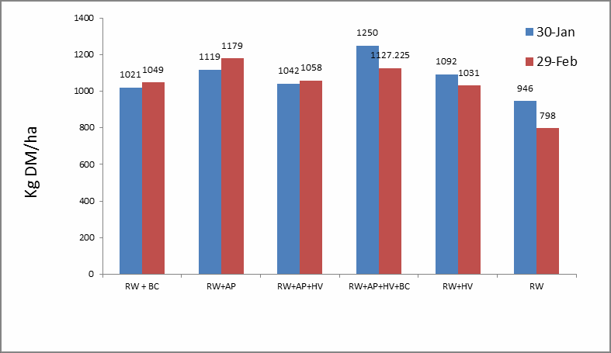

Figure 2. Winter forage biomass production (DM/kg) with multi-grasses with legumes combinations, 2012, and voluntary summer forage production. RW= Rye and wheat; AP = Australian pea; HV = hairy vetch; BC = Berseem clover

Objective 2) Determines animal performance, animal health and carcass quality of goats when grazing multi-culture grasses, and grasses in combination with legumes;

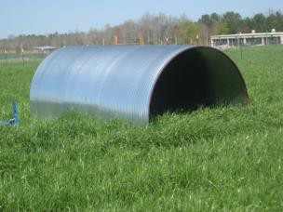
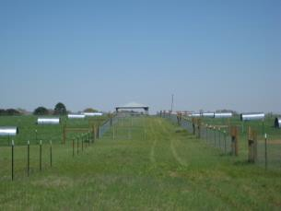

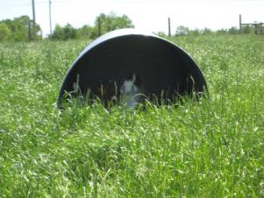
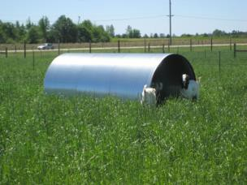

Figure 3. SARE 12 paddocks, Tuskegee University, winter grazing, 2011-2012

Animal Body Weight Gain, carcass quality of goats

This objective was fully investigated by 2011 and it is the second year of this progress report. Goats were placed in each of the two 1½ acre plots (n = 5 and 2 replicates) and spent approximately 3 month in each plot (Figure 4). Multi-culture forage ADG responses (Figure 3) in March and April 2012 were higher in RW + berseem clover combination groups than other forage combinations. According to our results shown that that animal ADG changes was different (P=0.07) in the following order: Wheat and rye (WR) + BC > WR + AP + HV > WR + AP+ HV > WR+HV > WR and WR+AP combinations (Figure 3).

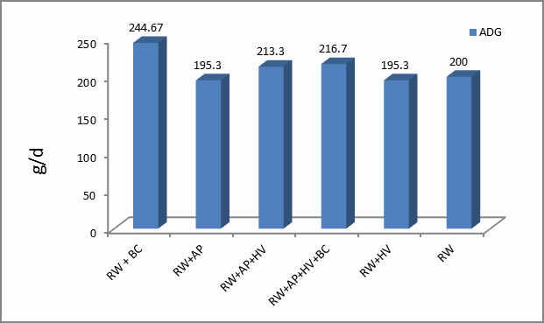

Figure 4. The ADG in multi-forage system. WR=wheat and rye; AP = Australian pea; HV =
hairy vetch; BC = Berseem clover.

This objective is fully investigated by this project and it is one of the main contributions of this progress report. Forty-eight cross breed goats were placed on 12 paddocks, 4 goats each (the two ½ acre plots of each forage combination replicated twice) and spent approximately 45 days in each plot. Finding goats for winter grazing a challenge in AL and maybe southeast. We could not locate 48 uniform young stockers until first week of March. Therefore goats were placed very late on paddocks and only grazed for 45 days. Goats were quarantined for 3 weeks and placed on the paddocks by March 29 and after grazing for 45 days they were removed from pastures by May 17. After grazing period, goats were transported to Mississippi State University Meat lab and were slaughtered according to the USDA guidelines and carcass characteristics and traits were determined. Animal body weight (BW) changes in multi-forage system in March, April, and May are presented in Figure 5 and animal performance and average daily gain are presented in Table 2, while carcass characteristics and traits are presented in Table 3. Carcass fatty acids profiles are presented in Tables 4, 5, and 6. Multi-culture forage BW responses (Figure 5 and Table 2) in March, April and May 2011 and shoulder weights were higher in three forage combination groups (RW+ HV + AP) than other forage combinations. Average daily gain was highest (P < 0.01; ADG =225 g) for goats grazing on RW+AP+HV and was lowest (ADG =
108 g) for goats on all four forage combinations (RW+AP+HV+BC) and RW alone (ADG = 128 g). According to our results animal BW changes were different (P = 0.07) in the following order: RW + AP + HV > RW + AP > RW + HV > RW and WR+HV+AP+BC combinations (Figure 5).

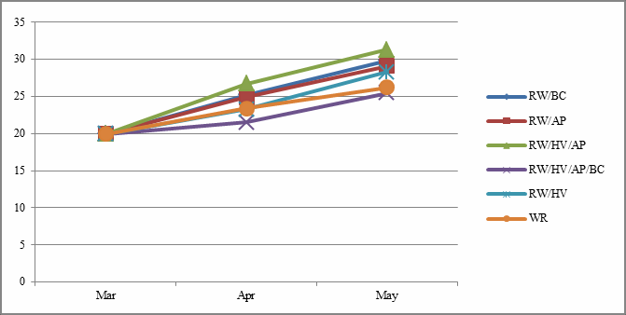

Figure 5. Monthly animal body weight (BW) changed in multi-forage system. WR=wheat and rye; AP = Australian pea; HV = hairy vetch; BC = Berseem clover. Animal BW has been covariate by initial BW (March 2011).

Table 2. Monthly animal body weight (BW) changed in multi-forage system.

Items RW/BC RW/AP RW/HP/AP RW/HV/AP/BC RW/HV RW SEM P-value

Mar1 | 19.6 | 19.6 | 19.6 | 19.6 | 19.6 | 19.6 - | -
Apr | 25.2a | 24.9ab | 26.7a | 21.5b | 23.3ab | 23.4ab 1.32 | 0.05
May | 29.9ab | 29.1ab | 31.1a | 25.5b | 28.3ab | 26.2ab 1.88 | 0.02
ADG (g/d)2 197.5ab 182.3ab 225.1a 108.2b 164.0ab 121.9ab 3.85 0.01

RW= Rye and wheat; AP = Australian pea; HV = hairy vetch; BC = Berseem clover.

1Animal BW has been covariate by initial BW (March 2011).

2 ADG was calculated from March 29 to May 17, 2011 (49 days).

Table 3. Carcass traits (kg/head) of goats grazing in multi forages system in winter 2011.

Item RW+BC RW+AP RW+HV+AP RW+AP+HV+BC RW+HV RW SEM P-value

Carcass | 12.2a | 11.6ab | 12.6a | 10.5b | 11.8ab | 10.2b | 0.73 | 0.02
Shoulder | 2.6 | 2.3 | 2.6a | 2.2 | 2.1b | 2.0b | 0.27 | 0.05
Ribs | 0.98 | 0.97 | 1.03 | 0.81 | 0.84 | 0.81 | 0.08 | 0.08
Loin | 0.85 | 0.85 | 0.91 | 0.76 | 0.77 | 0.74 | 0.07 | 0.31
Sirloin | 0.93a | 0.78 | 0.87 | 0.74 | 0.74 | 0.66b | 0.08 | 0.04
Leg | 2.04 | 1.91 | 2.08a | 1.69 | 1.93 | 1.67b | 0.12 | 0.03
Hind shank
0.47 |  | 0.46 | 0.53 | 0.46 | 0.61 | 0.46 | 0.07 | 0.07

Trim | 0.34 | 0.31 | 0.35 0.27b | 0.37a 0.31 | 0.04 | 0.04

Table 3 Continued. Carcass traits (kg/head) of goats grazing in multi forages system in winter
2011.

Bones | 0.39 | 0.35 | 0.35 | 0.34 | 0.42 | 0.30 | 0.03 0.05
Kidney fat
 | 0.09 | 0.09 | 0.10 | 0.07 | 0.12 | 0.07 | 0.034 0.24

Animal Health and Parasite Load

As an indication of animal health, fecal egg counts for animals were measured for months of February and March, 2012. Mean fecal egg count (FEC) of Haemonchus for growing goats was higher for RW+AP+HV+BC than for other combination (Figure 6 a,b), but Coccidia number was higher for the RW+BC than for the other combinations. These results indicated that legume forage combinations could not affected to growing goats during winter/spring period. This is probably mainly due to the carry over effect from previous farm.

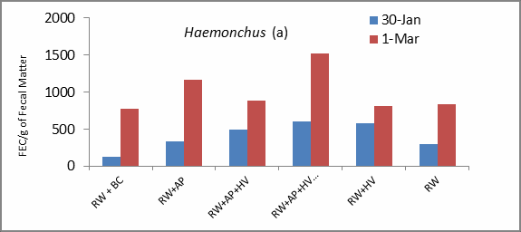

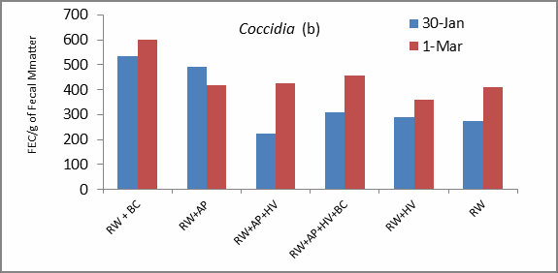

Figure 6. Fecal egg count (FEC) for Haemonchus (a) and Coccidia (b) in multi-forage system. RW = Rye and wheat; AP = Australian pea; HV = hairy vetch; BC = Berseem clover.

Fatty acids profile in carcass

Fatty acids are the major component of lipids and affect meat quality. The fatty acid composition of fats determines its degree of saturation, and therefore, significantly affects its quality. Twenty-four Kiko-cross meat goats (Capra hircus; 27.46 kg) were used to quantify fatty acid profile of goats consuming grasses or legume forages during 83 d experimental period. Experimental treatments included: the grasses-based diet (winter wheat/rye grass) vs. mixed legumes (hairy vetch + Australian peas+ big bersim clover) forage diets. Goats grazed on grasses-based diet, saturated fatty acids (SFA) and polyunsaturated fatty acids (PUFA) were higher in intramuscular fat content (P < 0.01), but were lower in mescentric kidney fat (MKF) and subcutaneous fat (P < 0.05-0.01) compared to legume forage-based diets (Tables 4, 5, and 6). Goats grazed on grasses-based diet, omega-3 and -6 fatty acids were higher in intramuscular fat content (P < 0.05-0.08), but were lower in subcutaneous fat (P < 0.05-0.01) compared to legume forage-based diets. Mono unsaturated fatty acids (MFA) were not affected by diets. These results indicated that goats receiving legume forage-based diets produced carcasses with more PUFA and higher omega-3 and -6 fatty acids in sub-cutaneous fat from Kiko-crossbred male goats.

Table 4. Effects of legume forage on fatty acids composition (mg/g of tissue) of intramuscular fat from Kiko crossbred male goat kids

 | Wheat & | Diets  Legume
Item | Rye | forage | SEM | P-value

Number of animals | 12 | 12
C10 | 226.6 | 33.5 | 163.90 | 0.53
C11 | 140.2 | 155.5 | 65.67 | 0.87
C12 | 99.0 | 122.07 | 38.1 | 0.78
C13 | 187.4 | 284.7 | 114.76 | 0.32
C14 | 185.3 | 198.6 | 167.86 | 0.48
C14:1 | 78.0 | 84.9 | 49.95 | 0.94
C15 | 68.6 | 141.4 | 58.81 | 0.73
C15:1 | 234.0 | 76.8 | 68.86 | 0.24
C16:0 | 141.4 | 65.3 | 49.9 | 0.33
C16:1 | 36.3 | 20.4 | 18.18 | 0.57
C17:0 | 193.6 | 173.6 | 57.3 | 0.38
C17:1 | 79.8 | 109.9 | 44.60 | 0.66
C18:0 | 116.5 | 82.4 | 40.45 | 0.54
C18:1n9c | 244.8 | 175.4 | 0.39 | 0.39
C18:1n9t | 169.3 | 175.4 | 110.80 | 0.92
C18:2n6c | 111.5 | 101.6 | 30.90 | 0.83
C18:2n6t | 14.9 | 64.6 | 23.18 | 0.15
C18:3n3c | 24.5 | 34.5 | 14.70 | 0.66

C18:3n6 | 193.4 | 56.8 | 79.68 | 0.28
C19 | 65.4 | 74.0 | 5.60 | 0.33
C20 | 84.4 | 28.4 | 18.8 | 0.07
C20:1 | 70.6 | 86.5 | 33.21 | 0.75
C20:3n3 | 27.9 | 19.5 | 11.24 | 0.61
C20:3n6 | 79.4 | 55.5 | 36.41 | 0.67
C20:4n6 | 32.7 | 27.4 | 20.071 | 0.86
C20:5n3 | 432.4 | 161.4 | 178.21 | 0.33
C21 | 44.5 | 55.8 | 17.63 | 0.07
C22 | 47.3 | 175.7 | 44.55 | 0.08
C22:2 | 257.4 | 240.2 | 98.70 | 0.91
C22:6n3 | 779.6 | 692.8 | 282.1 | 0.84
C23 | 73.5 | 23.5 | 24.22 | 0.19
C24 | 377.5 | 315.8 | 191.71 | 0.83
C24:1 | 878.6 | 418.9 | 322.4 | 0.36
SFA | 527.6 | 374.7 | 29.01 | 0.01
MFA | 564.5 | 547.2 | 36.9 | 0.71
PUFA | 916.7 | 521.3 | 33.11 | 0.05
PUFA/SFA | 1.74 | 1.39 | 0.35 | 0.18
Total omega-3 | 1204.4 | 908.2 | 180.77 | 0.08
Total omega-6 | 352.4 | 250.4 | 133.6 | 0.05

SFA= saturated fatty acid =(C14:0+C16:0+C18:0+C20:0). MFA=Monounsaturated fatty acid = (C17:1+C18:1+C20:1).
PUFA- polyunsaturated fatty acid = (C18:2+C18:3+C20:2+C20:3+C20:4+C22:4).

Table 5. Effects of legume forage on fatty acids composition (mg/g of tissue) of mescentric kidney fat (MKF) from Kiko crossbred male goat kids

 | Wheat & | Diets  Legume
Item | Rye | forage | SEM | P-value

Number of animals | 12 | 12
C10 | 150.7 | 73.6 | 51.11 | 0.30
C11 | 465.8 | 193.1 | 201.7 | 0.33
C12 | 333.6 | 258.3 | 191.9 | 0.78
C13 | 398.0 | 316.9 | 180.30 | 0.75
C14 | 500.1 | 322.7 | 188.64 | 0.60
C14:1 | 177.2 | 254.9 | 120.74 | 0.61
C15 | 206.7 | 164.1 | 79.9 | 0.76
C15:1 | 60.3 | 81.1 | 25.34 | 0.03
C16 | 880.1 | 894.5 | 267.3 | 0.96

C16:1 | 189.5 | 101.1 | 18.18 | 0.35
C17 | 77.3 | 388.8 | 98.3 | 0.04
C17:1 | 114.6 | 135.4 | 44.60 | 0.63
C18 | 1387.4 | 2129.7 | 600.20 | 0.32
C18:1n9c | 1252.3 | 1524.3 | 424.80 | 0.61
C18:1n9t | 231.5 | 221.6 | 71.9 | 0.92
18:2n6c | 139.3 | 264.1 | 51.40 | 0.01
C18:2n6t | 27.4 | 82.9 | 41.50 | 0.03
C18:3n3 | 99.2 | 34.4 | 30.9 | 0.20
C18:3n6 | 170.3 | 123.8 | 67.15 | 0.02
C19 | 74.0 | 78.2 | 3.50 | 0.66
C20 | 64.9 | 183.1 | 96.15 | 0.001
C20:1 | 171.1 | 39.2 | 85.1 | 0.69
C20:3n3 | 23.1 | 11.9 | 8.01 | 0.88
C20:3n6 | 49.7 | 32.8 | 29.2 | 0.037
C20:4n6 | 60.3 | 60.1 | 24.4 | 0.68
C20:5n3 | 80.6 | 161.4 | 178.21 | 0.33
C21 | 144.5 | 51.5 | 42.63 | 0.01
C22 | 47.3 | 175.7 | 44.55 | 0.08
C22:2 | 148.9 | 142.4 | 55.70 | 0.39
C22:6n3 | 530.5 | 425.7 | 116.76 | 0.71
C23 | 31.9 | 76.0 | 47.4 | 0.39
C24 | 32.7 | 238.2 | 92.51 | 0.001
C24:1 | 449.1 | 303.1 | 81.86 | 0.95
SFA | 2832.5 | 3530.0 | 362.11 | 0.01
MFA | 1769.5 | 1920.5 | 359.00 | 0.29
PUFA | 649.9 | 771.4 | 25.03 | 0.05
Total omega-3 | 733.4 | 633.4 | 110.23 | 0.11
Total omega-6 | 419.6 | 480.8 | 115.4 | 0.24

SFA= saturated fatty acid =(C14:0+C16:0+C18:0+C20:0). MFA=Monounsaturated fatty acid = (C17:1+C18:1+C20:1).
PUFA- polyunsaturated fatty acid = (C18:2+C18:3+C20:2+C20:3+C20:4+C22:4).

Table 6. Effects of legume forage on fatty acids composition (mg/g of tissue) of sub-cutaneous fat from Kiko crossbred male goat kids

 | Wheat & | Diets  Legume
Item | Rye | forage | SEM | P-value

Number of animals | 12 | 12
C10 | 91.1 | 30.9 | 25.28 | 0.20
C11 | 46.9 | 66.5 | 21.1 | 0.67
C12 | 122.4 | 62.9 | 48.95 | 0.28
C13 | 59.4 | 275.8 | 124.8 | 0.36
C14 | 217.9 | 421.4 | 121.1 | 0.22
C14:1 | 156.0 | 374.1 | 227.52 | 0.47
C15 | 31.4 | 283.9 | 119.42 | 0.28
C15:1 | 818.2 | 503.1 | 489.51 | 0.89
C16 | 509.9 | 902.7 | 215.04 | 0.21
C16:1 | 334.7 | 344.4 | 129.31 | 0.72
C17 | 45.4 | 157.4 | 39.94 | 0.18
C17:1 | 591.5 | 623.8 | 534.55 | 0.76
C18 | 568.5 | 1080.4 | 383.22 | 0.16
C18:1n9c | 1060.1 | 2622.6 | 342.7 | 0.05
C18:1n9t | 2689.2 | 288.4 | 281.70 | 0.002
18:2n6c | 233.4 | 235.9 | 92.8 | 0.93
C18:2n6t | 180.2 | 67.7 | 82.8 | 0.12
C18:3n3 | 13.4 | 166.5 | 62.91 | 0.27
C18:3n6 | 75.1 | 123.3 | 95.04 | 0.51
C19 | 74.0 | 78.2 | 3.50 | 0.66
C20 | 4.9 | 232.2 | 44.61 | 0.05
C20:1 | 44.3 | 131.5 | 85.3 | 0.15
C20:3n3 | 3.6 | 130.9 | 34.71 | 0.05
C20:3n6 | 44.4 | 205.4 | 96.8 | 0.09
C20:4n6 | 7.8 | 61.7 | 29.7 | 0.06
C20:5n3 | 65.1 | 75.1 | 39.56 | 0.81
C21 | 75.4 | 84.5 | 23.5 | 0.84
C22 | 165.3 | 368.7 | 104.6 | 0.05
C22:2 | 73.1 | 143.4 | 31.54 | 0.05
C22:6n3 | 263.3 | 1292.4 | 116.76 | 0.05
C23 | 39.1 | 44.4 | 18.8 | 0.95
C24 | 139.9 | 58.1 | 43.32 | 0.24
C24:1 | 506.7 | 353.1 | 216.99 | 0.75
SFA | 1301.2 | 2636.7 | 190.99 | 0.01
MFA | 4385.1 | 3666.3 | 311.06 | 0.29
PUFA | 623.1 | 1066.5 | 66.78 | 0.05

Total omega-3 | 345.4 | 1664.9 | 63.48 | 0.01
Total omega-6 | 540.9 | 694.0 | 79.42 | 0.05

SFA= saturated fatty acid =(C14:0+C16:0+C18:0+C20:0). MFA=Monounsaturated fatty acid = (C17:1+C18:1+C20:1).
PUFA- polyunsaturated fatty acid = (C18:2+C18:3+C20:2+C20:3+C20:4+C22:4).

Objective 3) Determine soil quality changes using multi-culture grasses, and grasses in combination with legumes;

We know that soil changes as affected by sources of forages growing on the soil may be slow and need long term studies. Soil quality in RW+ BC was significantly higher for the OM (%), Nitrate-N, base Ca, Ca, Mg, Fe, Al and S than for the other treatments (Table 7). Soil pH was higher for the RW+AP than for the other combination. Soil mineral contents in RW+AP+HV+BC were higher for the P, Zn, and Mn contents. There was no significantly different between forage combination treatments in Mg (base), K and Cu contents. Soil mineral content in RW was the lowest level compared to other forage combinations, except Mn content.

Table 7. Soil nutrient composition in multi forages system in winter 2012.

Item RW+BC RW+AP RW+HV+AP RW+AP+HV+BC RW+HV RW SEM P- value

OM, % | 1.45a | 1.01c | 1.29b | 1.26b | 1.0c | 1.23b | 0.19 | 0.03
Nitrate-N | 9.0a | 0.0 | 0.0 | 3.0b | 3.0b | 3.25 | 3.10 | 0.01
Base-Ca | 47.4a | 31.7b | 27.8b | 36.3ab | 21.3c | 26.6c | 10.70 | 0.04
Base-Mg | 19.55 | 17.45 | 19.25 | 18.27 | 12.3 | 13.32 | 5.06 | 0.29
Base-K | 2.4b | 3.2 | 3.6 | 3.3 | 4.6a | 3.5 | 2.07 | 0.05
Base total | 69.7a | 52.4 | 50.6 | 57.9 | 38.8b | 43.6b | 14.7 | 0.10
Buffer pH | 6.28 | 6.29a | 6.26 | 6.25 | 6.23 | 6.19b | 0.98 | 0.05
Ppm  Ca | 437.7a | 173.2b | 167.2b | 257.0b | 112.5c | 160.5b | 99.1 | 0.02
P | 98.5a | 78.7b | 59.2b | 115.5a | 99.7a | 96.5ab | 18.43 | 0.007
Mg | 106.2a | 57.2b | 67.7b | 78.5ab | 40.5c | 49.7b | 25.3 | 0.02

K | 40.5 | 33.2 | 39.0 | 44.0 | 45.2 | 40.5 | 11.08 | 0.71
Fe | 100.7a | 42.0c | 30.0c | 54.2b | 42.5c | 56.2b | 9.63 | 0.001
Zn | 2.4ab | 1.1b | 0.95b | 3.27a | 2.0ab | 3.1a | 1.03 | 0.02
Cu | 0.07ab | 0.07ab | 0.1ab | 0.15a | 0.02b | 0.02b | 0.06 | 0.12
Mn | 46.9a | 37.1b | 38.8b | 57.8a | 45.2a | 55.6a | 8.29 | 0.01
Al | 646a | 463b | 485b | 600ab | 516b | 535b | 52.2 | 0.008
S | 8.75a | 2.75c | 4.50c | 6.25b | 2.50c | 4.00c | 1.41 | 0.0001

Objective 4) Identify and assess economic characteristics and optimum economic return of different goat production (grazing/browsing) systems.

More data is needed to assess optimum economic returns of multi-culture pasture (grass and legumes) vs. grass only. Total crude protein output from each treatment combination will be calculated after completed summer grazing trial in year 2013. This data along with soil nitrogen and organic matter improvement will be factored in determining optimum forage system. Animal performance data as well as length of pasturing will also affect profitability and economic feasibility of the system.

Objective 5) Evaluate adaptability on an experiment station with goats and demonstrate applicability to an integrated year round forage system using commercial goats.

For this objective one producer (Ms. Sandra Simon, Talladega County, AL) has been identified and is currently working with our team. The year 2012 was a particularly difficult year for goat producers because of widespread drought, which affected pasture production for Ms. Simone. We will continue working with this farmer to adopt summer and winter grazing.

Report prepared by Nii O. Tackie, PhD, Professor, DAES/GWCAES/CEP, Tuskegee University
Sandra Simone resides in Alpine, Talladega County, and is a goat and organic vegetable farmer. At the beginning of the year, we delivered 5 Kiko-Boer crosses (female does) for herd improvement as well as provided general technical advice.
I later visited the farm, and went over her record-keeping data for 2011 (calendar year) with her, and also explained and demonstrated how to use the marketing plan template/format. There was also a visit to assess her operational needs regarding goat production. Following this, I delivered to her minerals for her goats, and gave technical assistance on record-keeping.
Later, Tuskegee University and this farmer signed a memorandum of understanding (MOU) that Tuskegee University will provide assistance and the farmer will allow her farm to be designated a research and Extension farm (i.e., she will provide Tuskegee University with certain data). I, subsequently, delivered to her12 bags of minerals, 3 bags of lespedeza (a type of

legume) seeds, 36 bags of fertilizer, 3 feeders, 2 shades, 40 fencing posts, 8 fencing wire rolls, and 1 chain saw to use for her goat operation in spring year 2012.
It is worthwhile to make several comments about these items: (1) the lespedeza was planted on a one-acre plot cordoned off for improved pasture. However, because of the drought it failed to germinate; (2) the feeders are being used for feeding minerals to the goats (see below for testimonial); the shades are on two different sites on the farm; (4) the fencing materials are yet to be used; and (5) the fertilizer has been partially used. Note: A testimonial from farmer is provided.

Testimonial:

Good morning Dr. Hill,

Summer harvest is over, the goats are in their respective pastures, and I get a chance to thank you! Tuskegee University has been so important in supporting my efforts to raise quality meat goats here at Huckleberry Hills Farm.

From the beginning in 2003 until this day, The College of Agricultural, Environmental and Nutrition Sciences, professors and staff, have provided me with invaluable support. They have provided me with information in much needed areas such as: herd management; pasture maintenance; nutrition; parasite control and health issues; educational opportunities; record keeping; research programs and more. This means so much to small farmers as myself. There are many challenges which provide opportunities for doubts and failure. Without the information and assistance such as I have received, the success rate of a small farmer is truly limited.

My sincere appreciation….I am thankful.

Testimonial Dated Friday, November 2, 2012

IV. Impacts and Contributions/Outcomes

We feel using proper forages for winter grazing followed by summer forages can provide for year-round foraging system. However, combination of forages used for grazing should be selected to optimize animal performance, enhance the soil property and reduce methane or ammonia emission from feces while reducing dependency on petrochemical fertilizer. We are hoping that combining legume forages with grasses will increase protein output as well as restore N in soil, thus reducing dependency on petroleum-based fertilizer.

V. Added Component

We are concerned about human health as well. Proper ratios of omega-3 and -6 fatty acids are important in human diet. We have collected different fat tissues, depot, mesenteric, and subcutaneous from pastured goats, to determine fatty acid profile of carcasses as affected by feeding RW vs. RW + legume combinations. Our data indicated that goats receiving legume forage-based diets produced carcasses with more unsaturated fatty acids and higher omega-3 and
-6 fatty acids in sub-cutaneous fat from Kiko-crossbred male goats.

