Chart 2: Mas-d-Tec/EC correlated to SCC scores with Pathogens. R = 0.02429.

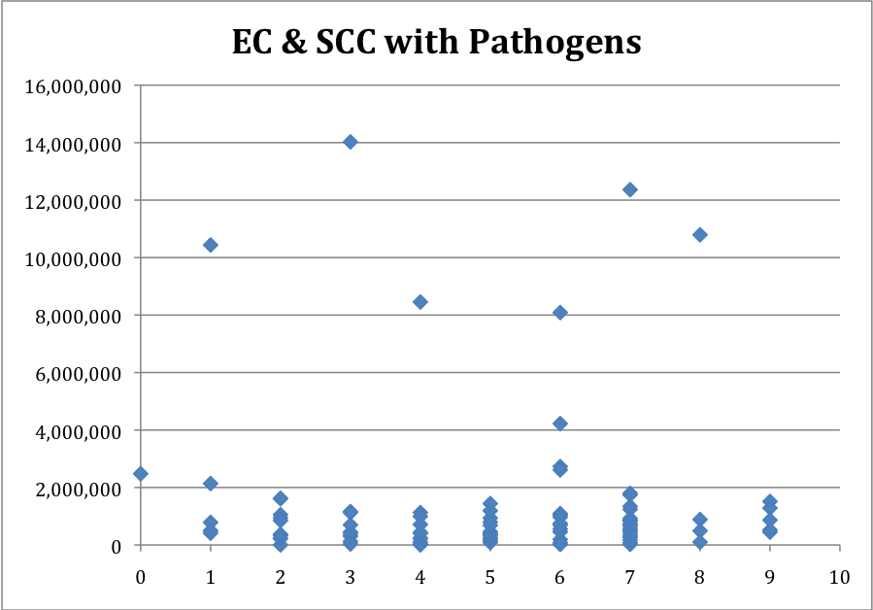
SCC
EC: Mas-d-tec

