Interseeder Research Update 2012
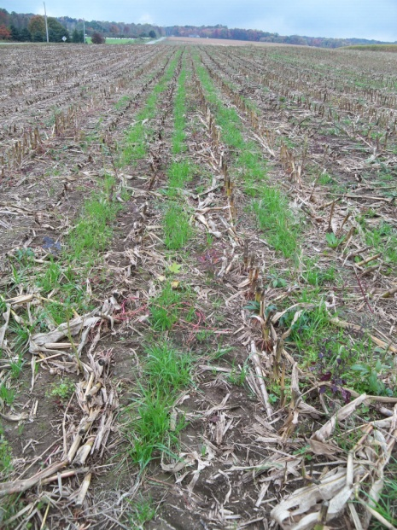
In 2012 we conducted a number of evaluations of the Penn State Interseeder around the state and on the Rock Spring research farm. Our goal has been to evaluate strategies for improving establishment success with the interseeder. We have evaluated herbicides, planting dates, seed treatments and various species. At each trial, this year we came away with one or more ideas to use in the future.
Figure 1. Ryegrass establishment in early October at the Woods farm in Crawford County.
We conducted two trials in Northwest PA with Bob Buhl in Erie County and Stephen Woods in Crawford County. At the Erie County site conditions were dry for most of the season which is unusual for Erie County. Under these conditions, the mixes seeded with Crimson Clover seemed to persist well, while the grass establishment was very limited. At the Woods farm, we compared annual ryegrass to an Italian ryegrass/Crimson Clover blend. Here the grasses established well but the clover did not. At this farm, we found that planting into a manured rye cover crop residue made for a good seedbed for the cover crop, so this could be a long term goal. This field had long straight rows that were easy to interseed in as well.
We also conducted two trials in Northeast PA in Bradford and Sullivan County. At the Bradford County site, a relatively dry summer limited establishment of both ryegrasses and clover. At this site a short residual herbicide program using Resolve gave good season long weed control in corn following alfalfa, which will be useful for future work. At the Sullivan County site, we had success with a number of species, including tillage radish. This field was a high residue no-till field that was planted later in May.
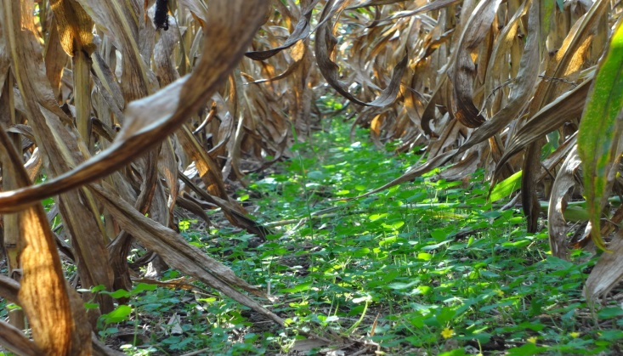
We continued our work on herbicides on the research farm and we noticed that with the right peremergent herbicides we can still have some good clover or ryegrass establishment. Cover crop establishment in these trials was good for both the ryegrass and red clover. These should help us target some low residual herbicide programs for various cover crops.
Figure 2. Red Clover establishment in the 2012 Rock Springs herbicide research trial.

In Centre County, we had two trials our where we evaluated the potential of a seed treatment called “Yellow Jacket” on the establishment of an Italian Ryegrass blend. Our preliminary conclusions are that we were not able to improve establishment with the seed treatment. Establishment at both of these sites was variable in the field. In some areas of the field establishment was good while in others it was spotty. We have noticed improved growth through the fall on these sites and are interested to see what they look like following harvest.
During this year, we also began to realize the economic potential for a system with interseeding every year in continuous corn. If an interseeded clover crop could be terminated before planting corn and supply 50 pounds of N per acre and boost cost yields by 7% or 10 bushels per acre, then this could result in a benefit of $35/acre for the N and $70/acre for the additional yield at current prices. If two of the trips for sidedressing ($10/acre), spraying ($10/acre) or notill cover crop seeding ($19/acre) could be eliminated for one trip with the interseeder ($25/acre) then this would result in an additional $14/acre savings. In some years, forage could be grazed and this would result in additional income. And at the same time the field would have reduced erosion and runoff and more food for soil organisms and wildlife.
Because of this potential, we will be continuing to evaluate strategies for using the interseeder in the future. We will also be evaluating increased seeding rates, alternative species, and timing of establishment to improve success. We have also surveyed our cooperators for ideas on new prototypes. We are also finding it can also be used to establish wildlife plots in existing hay fields without tillage. If you are interested in learning more about the interseeder, contact Greg Roth at gwr@psu.edu.
Partial funding for the work reported here was provided by the USDA Sustainable Agriculture Research and Education Program.
Prepared by: Greg W. Roth, William S. Curran, Corey Dillon, Christian Houser and W.S Harkcom, Department of Crop and Soil Sciences

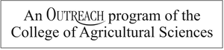

Penn State College of Agricultural Sciences research, extension, and resident education programs are funded in part by Pennsylvania counties, the Commonwealth of Pennsylvania, and the U.S. Department of Agriculture.

This publication is available in alternative media on request.
extension.psu.edu

© The Pennsylvania State University 2012

