The effect of two levels of cluster thinning on crop yield and quality for Cabernet Sauvignon and Cabernet Franc grown in the Eastern US
Lawrence Coia*, Daniel Ward**
Abstract
Cabernet Sauvignon and Cabernet Franc are important grape varieties, which can produce excellent wine grapes and wine in the East but optimal yields through cluster thinning have not been established. In this trial we tested the hypotheses that there is no difference in wine grape quality or in wine quality with one cluster per shoot versus two clusters per shoot for each of these varieties during the three-year study period of 2010 through 2012. This approach simplifies the potentially complex issues associated with the determination of optimal yield and optimal canopy area to crop weight ratio so that it instead becomes an examination of the effects of two commonly used levels of cluster thinning on grape and wine quality. Yields decreased by 36% by cluster thinning but there was no increase in cluster weight. The effect of cluster thinning on wine grape and wine quality was limited. Only in the “wet” year of 2011 when cluster weights and yields were relatively high did cluster thinning provide any benefit to wine or grape quality. This benefit was limited to a reduction in TA. This study suggests that high quality grapes and wines can be made from these varieties under various climatic conditions and without the necessity of economically unsustainably low yields that can result from cluster thinning.

*owner Coia Vineyards, LLC, **Associate Extension Specialist, Rutgers/New Jersey Agriculture Experiment Station, Rutgers Agricultural Research and Extension Center, 121 Northville Road, Bridgeton, N.J.
This study was supported by a grant from the Sustainable Agriculture Research and Education in the National Institute of Food and Agriculture, U.S. Dept. of Agriculture, Award 2010-38640-20820. Any opinions, findings, conclusions, or recommendations expressed in this publication are those of the authors and do not necessarily reflect the view of the US Dept. of Agriculture. This study also was supported by Coia Vineyards, the Outer Coastal Plain Vineyard Association and Rutgers/NJAES.
Introduction
Cabernet Sauvignon and Cabernet Franc are important wine grape varieties, which can produce excellent wine grapes and wine in the East. However, there is great variability in quality from winery to winery and year to year in wine produced from these grape varieties. There are many factors that affect wine grape quality, many of which are climate related and not readily controllable. However, one important factor that is largely controllable is crop yield. Over a limited range, the crop yield is generally inversely correlated with measures of wine grape and wine quality. Furthermore, the yield of the vine must be in balance with the vigor of the vine. Specifically, there is an optimal range of the ratio of canopy leaf area to crop weight for quality wine grape production. Overcropping, i.e. when crop yield exceeds vine capacity, can result in delayed fruit maturity and inferior quality grapes. It is possible to produce quality wine grapes at relatively high crop levels if vine capacity and fruit crop are in good balance, however it is generally recognized that yields of five or more tons per acre for these varieties using an undivided canopy management system like vertical shoot positioning (VSP) is not likely to result in high quality wine grapes. Undercropping, that is when crop yields are less than the vines capacity to produce quality grapes, can result in overly vigorous vines and may be economically unsustainable. Wineries may nonetheless insist that crop levels be low as they may think that lower crop levels result in higher quality grapes. In particular, at the lower level of yield range we do not know what the optimum crop level is for high quality fruit from these varieties grown in the East with a common training system such as VSP. The answer to this question could greatly aid the winegrowers of the East in the sustainable production of high quality wine. Furthermore, since the current pricing of wine grapes is largely based on yield for a given variety of grapes then information regarding optimal yield range is crucial to economically sustainable winegrowing in the Eastern U.S.
In this trial, we tested the hypotheses that there is no difference in wine grape quality or in wine quality with one cluster per shoot versus two clusters per shoot for each of these varieties during the three-year study period of 2010 through 2012. This approach simplifies the potentially complex issues associated with the determination of optimal yield and optimal canopy area to crop weight ratio so that it instead becomes an examination of the effects of two commonly used levels of cluster thinning on grape and wine quality.

Methods and Measurements
Vines and Management
This three-year trial included the harvests of 2010, 2011 and 2012. The vines involved in this study were located at Coia Vineyards, Vineland, New Jersey in the Outer Coastal Plain, AVA. Coia Vineyards, a commercial vineyard, has been growing Cabernet Sauvignon since 1976 and Cabernet Franc since 1995. 1000- vine plots of each of these two varieties were planted in 2006 and have been commercially bearing since 2008. Vines are spaced at 717 per acre at 10 feet between rows and 6 feet between vines in the row. Vines are trained to bilateral cordons, spur pruned and are vertical shoot positioned. Shoot thinning to the level of four to six shoots per linear foot of trellis is accomplished through an initial thinning in May and subsequent light thinning in June. The cluster thinning standard at this vineyard for these varieties has been two clusters per shoot and removal of clusters which are touching. However, these vines usually only produce two clusters per shoot, thus those vines which had two clusters per shoot will be referred to as “unthinned” vines. Additional clusters produced later in the season at the top of the canopy are “green harvested” and represent less than one cluster per ten shoots. Green harvested clusters were not considered as part of this cluster thinning trial. The height of the vine canopy averages 52 inches and the canopy area per vine at this vineyard is approximately 4.8 square meters. The vine growth is uniform and canopy area is relatively constant. Historically the yield per vine for these varieties has varied at this site from 3 to 5 kg (2.4 to 3.9 tons/acre) and canopy area/crop weight ratios have ranged from 0.9 to 1.6. These ratio values fall within the range of interest for commercial grape and wine production from these varieties. In this trial higher canopy area to crop weight values were expected with further restrictions in crop yield through additional cluster thinning to one cluster per shoot.
Vines in this trial were located within the vineyard’s current commercial plots but were flagged so that cluster thinning and harvest of these vines were performed separately from commercial operations (Figure 1). All other vine management was performed by Coia Vineyards in the same way and at the same time as the non-trial grapes. Rutgers personnel assisted in the harvest and weighing of the trial grapes.

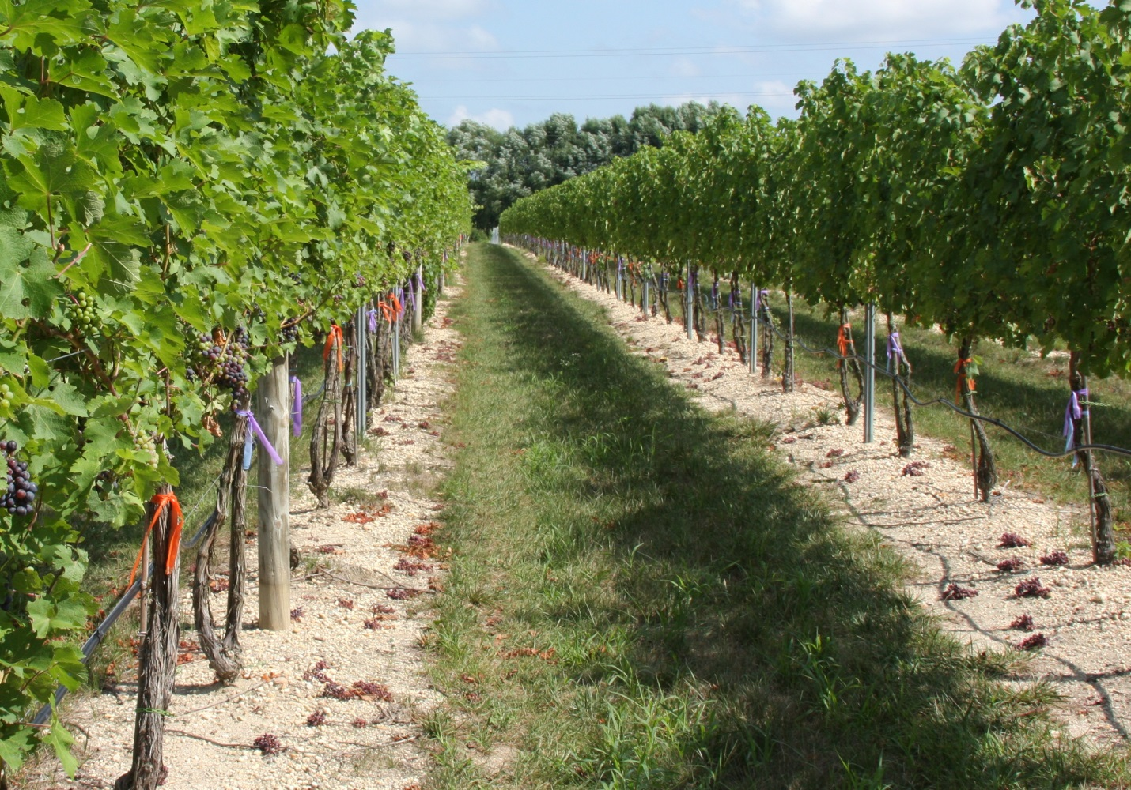
Figure 1. Cabernet Sauvignon vines (left) and Cabernet Franc vines (right) at Coia Vineyards randomly flagged for cluster thinning. This photo was taken at veraison in early August approximately 2 weeks after cluster thinning (see clusters on the vineyard floor).
Sixty vines of each variety for a total of 120 vines were devoted to this trial. Of these, half were cluster thinned to one cluster per shoot while the other half were thinned to two clusters per shoot. (Figure 2).Vines of a given variety in the same row were randomly assigned to one or the other thinning level and two different color flags were used for the two different levels of thinning. The rows chosen for each variety in this trial were located adjacent to each other. Cluster thinning was performed after lag phase and before veraison (typically between July 15th and July 28th). Vines with shoots greater than 2 feet were thinned to either two clusters or one cluster depending on random assignment. Shoots less than 2 feet were thinned to one cluster regardless of assignment.
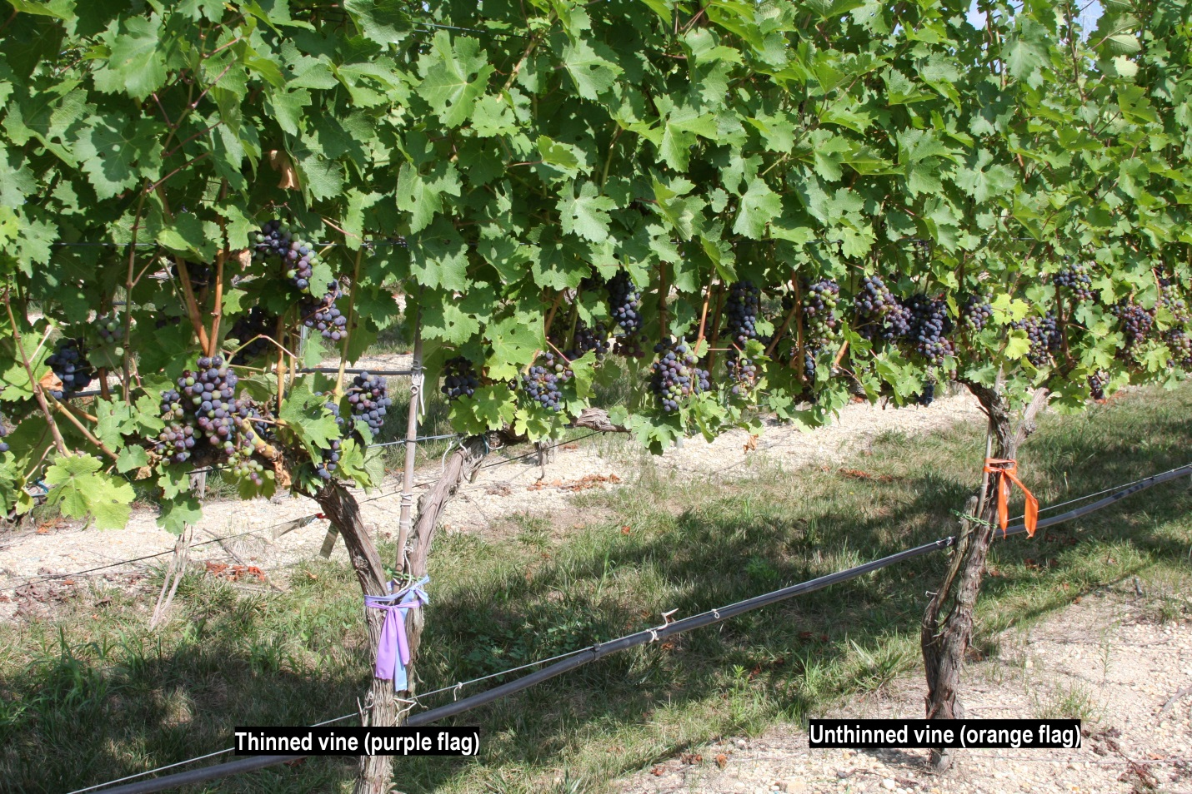
Figure 2. Example experimental Cabernet Sauvignon vines either thinned (left, purple flag) or unthinned (right, orange flag) at Coia Vineyards. This photo was taken at veraison in early August approximately 2 weeks after cluster thinning.

Standard canopy management practices were used on all vines in this trial. These included cordon training, spur pruning, shoot thinning, vertical shoot positioning, leaf pulling, one or two hedgings per season, cluster thinning and green harvesting. Standard weed, IPM and nutritional management practices were also used.
Growing degree days base 50°F (GDD₅₀) and rainfall of the 2010, 2011 and 2012 Vintages
There were significant weather differences in the vintage years of this trial. (Table 1). For this region, the average GDD₅₀ is 3580 and the average rainfall sum for the combined months of August and September is 8.0 inches. 2010 was characterized as much warmer (GDD₅₀ = 3930) and much drier than average (Aug/Sept rain = 2.6 inches). 2011, while also relatively warm (GDD₅₀ = 3932) had the highest rainfall for August and September (17.2 inches) in the history of the region. 2012 was characterized by average GDD₅₀ (3583) and relatively average rainfall for August and September (7.4 inches).
Table 1. Climate conditions at Coia Vineyards location (39.30N,-74.56W) in Vineland, New Jersey.
Year | Growing Degree Days  (April-Oct., base=50°F) | Rainfall  (Aug-Sept,inches)
Average | 3580 | 8.0
2010 | 3930 | 2.6
2011 | 3932 | 17.2
2012 | 3583 | 7.4

Measurements
Pruning weights per vine were obtained in the winter following harvest and were used as a baseline measure of vine vigor. Canopy measures include canopy area (calculated as = canopy height (m) X vine spacing (m) X 2) as well as total shoots per vine and shoots per vine greater than 2 feet in length. As canopy area was full in each growing season and area was constant as the canopy height was kept the same each season for each variety at 52 inches (132.1 cm) for both varieties by top hedging. Canopy growth was uniform during each of the growing seasons and no significant diseases or pest damage existed on fruit or foliage.
Harvest occurred on the same date for each level of thinning and differed for each variety. Cabernet Sauvignon typically matured one to two weeks after Cabernet Franc (average harvest dates of October 5^{rth} versus September 25th). Date of harvest was chosen to coincide with the date of commercial harvest but generally was one to seven days earlier. The date of the harvest was determined by weekly measures of °Brix, pH, and total acidity, as well as measures of seed color and texture and skin color and taste. There was no rot at the time of the harvests. Harvest measurements included number of clusters per vine and total weight of crop per vine as well as weight per cluster.
Grape quality at harvest was measured by laboratory analysis of total soluble solids (TSS) and total acidity (TA) performed independently by Rutgers.
Wine for this trial was produced at Coia Vineyards annually. Two five- gallon lots were produced for both levels of cluster thinning and for each of the two varieties for a total of eight 5-gallon lots annually. Wine samples from each of the eight 5-gallon lots were submitted for laboratory analyses after completion of primary and malolactic fermentations. Laboratory analysis included total phenolics, total anthocyanins, copigmented anthocyanins, hue and intensity through a phenol/color panel performed by the Enology Service Laboratory at Virginia Tech.
Wines were also evaluated by blinded preference (one versus two clusters) and quality score by an independent wine tasting group organized by Scientific Marketing Services. Bottling of the wine was performed three months after completion of fermentation and no filtering or barrel aging took place. All wines underwent tasting analysis in April 2013, thus the wines tasted from the 2010 vintage were over two years of age, the 2011 vintage over one year of age and the 2012 vintage were approximately seven months of age. Wines were judged by an eight-member panel who were blinded to the level of cluster thinning used to produce each wine but not to year of harvest or variety of grape. There were 12 rounds of tasting including four wines from each of the three years with each round including only two wines of the same variety and vintage but with two different levels of cluster thinning. Judges had two tasks in comparing the two wines at each round- the first was to determine which of the two wines they preferred and the second was to give a score to each of the two wines (the Davis 20 point scale was used for this score).

Statistical Analysis
Wine grape and wine quality parameters were compared for the two clusters and one cluster per shoot treatments. Each quality parameter was analyzed for significant differences between the two treatments within a variety and a year. For the wine preferences, Fisher’s Exact test was used and for all other measured responses Student's t-test was used.
Results
Yield versus thinning
As expected, the vines that were thinned to one cluster per shoot produced significantly less yield than those that retained two clusters per shoot (Table 2). For Cabernet Franc the yield of the cluster-thinned vines was an average of 63% of the unthinned over the three-year trial period and for Cabernet Sauvignon the yield of the cluster-thinned vines was an average of 64% of the unthinned. The yields per vine ranged from 2.1 to 7.0 kg/vine (1.6 to 5.5 tons/acre). Over the 3 years of the trial for the unthinned Cabernet Franc the yield per vine averaged 4.8 kg (3.7 tons/acre) and for the Cabernet Sauvignon 3.8 kg (3.0 tons/acre).

Table 2. Fruit yield of Cabernet Franc and Cabernet Sauvignon grapes grown in southern New Jersey and either unthinned or thinned to one cluster per shoot during lag phase of fruit growth by variety, year, and thinning level.

Variety | Year | Cluster thinning | Yield (kg/vine) | Yield (tons/acre)
Cab. Franc | 2010 | None | 3.3 | 2.6
 |  | Thinned | 2.1 | 1.6
 |  | P-value^{z} | <0.001
 | 2011 | None | 7.0 | 5.5
 |  | Thinned | 4.6 | 3.6
 |  | P-value | <0.001
 | 2012 | None | 4.1 | 3.2
 |  | Thinned | 2.4 | 1.9
 |  | P-value | <0.001
Cab. Sauvignon | 2010 | None | 3.5 | 2.7
 |  | Thinned | 2.2 | 1.7
 |  | P-value | <0.001
 | 2011 | None | 4.9 | 3.8
 |  | Thinned | 2.9 | 2.3
 |  | P-value | <0.001
 | 2012 | None | 3.0 | 2.3
 |  | Thinned | 2.1 | 1.7
 |  | P-value | 0.002
^{z} P-values based on Student’s t-test comparing thinning levels within a variety and year.

Cluster weights at harvest versus thinning
There were no significant differences in cluster weights between those vines that were thinned versus those which were not thinned for either variety in any of the three years of the trial (Table 3).Cluster weights varied greatly by vintage. Cabernet Franc cluster weight ranged from 84 to 141 g (in 2010 and 2011 respectively). Cabernet Sauvignon cluster weight ranged from 83 to 91 g (in 2010 and 2011 respectively).
Juice Total Soluble Solids (Brix) versus thinning
There were no significant differences in TSS between those vines that were thinned versus those which were not thinned for either variety in any of the three years of the study (Table 3). TSS varied greatly with vintage. Cabernet Franc TSS ranged from 20.5 to 24.5 (in 2011 and 2010 respectively) while Cabernet Sauvignon TSS ranged from 18 to 23 (in 2011 and 2010 respectively).
Juice Total Acidity versus Thinning
The effect of thinning on total acidity varied by year (Table 3). In 2010 there was no significant effect of thinning on TA for either variety. In 2011 total acidity was significantly decreased by thinning for both varieties, while in 2012 total acidity was significantly increased by thinning for both varieties.
Table 3. Summary fruit and juice quality measures of Cabernet Franc and Cabernet Sauvignon grapes grown in southern New Jersey and either unthinned or thinned to one cluster per shoot during lag phase of fruit growth by variety, year, and thinning level.

Variety | Year | Cluster thinning | Cluster wt.^{z} | °Brix | TTA^{y}
Cab. Franc | 2010 | None | 86.2 | 24.7 | 2.50
 |  | Thinned | 90.3 | 24.7 | 2.49
 |  | P-value^{z} | ns | ns | ns
 | 2011 | None | 139.6 | 20.2 | 3.79
 |  | Thinned | 146.1 | 20.6 | 3.52
 |  | P-value | ns | ns | 0.0013
 | 2012 | None | 99.5 | 21.8 | 5.94
 |  | Thinned | 100.5 | 21.8 | 6.20
 |  | P-value | ns | ns | 0.050
Cab. Sauvignon | 2010 | None | 85.3 | 22.3 | 3.74
 |  | Thinned | 81.9 | 23.0 | 3.66
 |  | P-value | ns | ns | ns
 | 2011 | None | 91.7 | 17.8 | 6.30
 |  | Thinned | 91.2 | 17.6 | 5.78
 |  | P-value | ns | ns | 0.016
 | 2012 | None | 84.5 | 17.6 | 8.15
 |  | Thinned | 82.6 | 17.8 | 8.95
 |  | P-value | ns | ns | 0.044
^{z} Cluster weight (g)
^{y} Total titratable acidity (g/l tartaric acid equivalents)
^{x} P-values based on Student’s t-test comparing thinning levels within a variety and year.

Wine Phenolics versus Thinning
There were no significant differences in total phenolics, total anthocyanins, copigmented anthocyanins, hue or intensity by thinning for either variety in any year except 2011 (Table 4). In 2011 the wines from the thinned vines of both Cabernet Franc and Cabernet Sauvignon had higher levels of total anthocyanins but not other measures in the phenol/color panel.
Wine Tasting Scores and Wine Preference versus Thinning
There were no significant differences in the scores of wine quality for wines produced by thinned versus unthinned vines for either variety for any year of the trial (Table 4). There were no differences in preference between the wine produced by thinned or unthinned vines in 2010 or 2012. In 2011 there was a significant preference for both the Cabernet Franc (P=0.010) and the Cabernet Sauvignon (P<0.0001) wines produced from the unthinned compared to the thinned vines (Table 4).
Table 4. Summary wine quality measures of Cabernet Franc and Cabernet Sauvignon wines made from grapes grown in southern New Jersey and either unthinned or thinned to one cluster per shoot during lag phase of fruit growth by variety, year, and thinning level.

Variety | Year | Cluster thinning | Total phenolics^{z} | Total anthocyanins^{y} | Wine score^{x} | Wine preference^{w}
Cab. Franc | 2010 | None | 1656 | 3.66 | 15.9 | 50
 |  | Thinned | 1645 | 3.61 | 15.9 | 50
 |  | P-value^{v} | ns | ns | ns | ns
 | 2011 | None | 822 | 0.635 | 14.6 | 88
 |  | Thinned | 884 | 0.710 | 13.5 | 12
 |  | P-value | ns | ns | ns | 0.010
 | 2012 | None | 1416 | 0.685 | 11.2 | 50
 |  | Thinned | 1328 | 0.760 | 11.5 | 50
 |  | P-value | 0.041 | ns | ns | ns
Cab. Sauvignon | 2010 | None | 1697 | 4.21 | 14.2 | 75
 |  | Thinned | 1683 | 3.75 | 13.0 | 25
 |  | P-value | ns | .0366 | ns | ns
 | 2011 | None | 1150 | 1.07 | 15.2 | 100
 |  | Thinned | 1186 | 1.18 | 14.0 | 0
 |  | P-value | ns | ns | 0.011 | <0.0001
 | 2012 | None | 1254 | 1.105 | 12.8 | 50
 |  | Thinned | 1248 | 1.120 | 12.5 | 50
 |  | P-value | ns | ns | ns | ns
^{z} Average total phenolics (mg/l gallic acid equivalents)
^{y} Average total anthocyanins (mg/l)
^{x} Average wine score based on 20-point UC Davis scale
^{w} Percentage of the eight expert tasters that preferred the wine from the thinned or unthinned treatment within a variety and year.
^{v} P-values based on Fisher’s Exact test (for wine preference) or Student’s t-test (for all other responses) comparing thinning levels within a variety and year.

Canopy Area to Crop Weight Ratio versus Thinning
Canopy area was constant and measured 4.8 m2 annually for each variety. Crop weights per vine were shown in Table 2. The ratio of canopy area to crop weight is shown in Table 5 and ranges from a low of 0.7 for unthinned Cabernet Franc in 2011 to a high of 2.3 for both thinned Cabernet Franc in 2010 and thinned Cabernet Sauvignon in 2012.
Table 5. Ratios of canopy area to crop weight and of crop weight to pruning weight by year variety and thinned (T) or unthinned (UT) treatment.
 | Canopy Area(m²)/Crop Weight(kg) |  |  |  | Crop Weight/Pruning Weight^{z}
 | Cab. Franc |  | Cab. Sauv. |  | Cab. Franc |  | Cab. Sauv.
Year | T | UT | T | UT | T | UT | T | UT
2010 | 2.3 | 1.4 | 2.2 | 1.3 | - | - | - | -
2011 | 1.0 | 0.7 | 1.7 | 1.0 | 2.5 | 4.1 | 2.3 | 3.7
2012 | 2.0 | 1.2 | 2.3 | 1.6 | 5.8 | 8.6 | 2.5 | 4.4
^{z}2011=Ratio of crop weight of 2010 to pruning weight of 2011, and 2012=Ratio of crop weight of 2011 to pruning weight of 2012

Ratio of Crop Weight to Pruning Weight
Pruning weights per vine were obtained in 2011 and 2012 and were relatively uniform over the three years of the study for each variety with an average of .82 kg/vine for Cabernet Franc and 1.1kg /vine for Cabernet Sauvignon. Pruning weights did not differ significantly for thinned or unthinned vines for either variety for either year. The ratio of the previous year’s crop weight to subsequent year’s pruning weight (for example 2010 crop weight to pruning weight in early spring of 2011) ranged from 2.5 to 8.6 for Cabernet Franc and from 2.3 to 4.4 for Cabernet Sauvignon (Table 5).
Discussion
Cluster thinning
This trial demonstrates that for Cabernet Sauvignon and Cabernet Franc varieties grown in the East on VSP the effect of cluster thinning on wine grape and wine quality is limited. Only in the “wet” year of 2011 when cluster weights and yields were relatively high did we find any benefit to wine or grape quality. This benefit was limited to a reduction in TA of juice from the thinned wines. Note however that in 2012 the cluster-thinned vines produced juice with a significantly higher TA. The timing of cluster thinning was during the lag phase pre-veraison and did not affect cluster weights. Cluster thinning at bloom or during the post bloom log phase has been shown to increase cluster weights and/or cluster compactness and is therefore undesirable (1). Removing clusters post-veraison in an attempt to improve quality was not studied here. Since rainfall in August and September cannot be predicted well at the time of cluster thinning performed in this trial one might consider post-veraison cluster thinning in years where excessive rainfall occurs in August or September. Post-veraison cluster thinning has been done for other purposes such as providing a tartaric acid source for subsequent use in wine production but its effect on grape and wine quality is not likely to be large.

Yields
Decreasing the yield can be accomplished by several different methods. One of the simplest is the use of cluster thinning. Decreased yield can diminish or eliminate grower profits since wine grapes are often sold at an agreed upon price per ton. It is generally recognized that yields from these varieties should be less than 5 tons per acre for quality wine grape production. What we do not know is whether quality continues to improve with yields of less than 4 tons per acre and if it does, what yield level results in maximum quality.
This study did not directly examine the range of yields from which high quality grapes and wine can be produced from these varieties, however some observations can be made about that range. First, we generally did not find any difference in wine quality in any given vintage regardless of the yield despite a yield reduction of approximately 36% with cluster thinning. Second, only in 2011 when the yield was 5.5 tons/acre for Cabernet Franc and 3.8 tons/acre for Cabernet Sauvignon in the unthinned vines was there a small difference in grape quality (a decrease in acidity) in favor of the thinned vines and lower yields. Third, and perhaps most importantly, we did not find that the lower yields of less than 2 tons per acre in thinned vines produced superior fruit to the higher yields of over 3 tons per acre. This information is consistent with an optimal yield range of between 3 and 4 tons per acre for these varieties.
Canopy to Crop weight ratio
An optimal ratio of canopy area to crop weight of 0.8 to 1.2 has been suggested by research from California-based viticulture by Kliewer et al. (2). This ratio is currently representative of common viticulture practices in the East. However, the question arises as to whether this ratio value is optimum for these varieties under the growing conditions and viticulture practices in Eastern US wine production regions. Furthermore, such research has largely relied on measures of soluble sugars for wine grape quality assessment. Others have suggested expanded measures including, for example, total phenol content may be useful in assessing quality of wine (3,4). Also, studies examining optimization of canopy area to crop weight ratio which use assessments of wine quality rather than only grape quality are largely lacking in the East. However, studies using expanded quality measures done in some regions of Europe where growing conditions may be more similar to the East than those of California indicate that the optimum canopy area to crop weight ratio may be higher at between 1.5 and 2.5. While this study did not establish an optimum ratio for canopy area to crop weight we found that there was no improvement in any vintage by increasing this ratio by 58% attained through cluster thinning. Specifically, ratios greater than 1.5 were not superior to ratios between 1 and 1.4. Again only in 2011 was there a limited grape quality improvement. In 2011 the superior canopy to crop weight ratios were 1.0 for thinned Cabernet Franc and 1.7 for thinned Cabernet Sauvignon. This information would suggest that the optimum canopy to crop ratios for these varieties are close to those observed in California and that there may be little or no benefit to ratios greater than 1.5
The most common trellising and training methods in the East for these varieties is low to mid cane or cordon with vertical shoot positioning. To increase the canopy area to crop yield ratio generally requires that either the canopy area be increased or the yield be decreased. Canopy area can be increased with a divided canopy system, but the crop weight also increases. Innovative methods of increasing canopy area have included the Smart-Dyson and Geneva Double curtain methods of divided canopy (3). These methods can result in both increased canopy area and increased yields without sacrificing quality. While some growers have found these methods to be useful, they have not become standard practices for these varieties. (Note also that the ratio value of 1.2 or higher for quality has not been found to be appropriate for divided canopy systems, where the accepted ratio is lower at 0.8).
Crop weight to pruning weight ratio
Kliewer et al. (2) described the optimal crop yield to pruning weight for single canopy systems like VSP to range from four to ten. These values correspond to the values obtained for the unthinned vines of our trial while our thinned vine results fell below these optimal levels.
Wine quality measures
Cluster thinning did not produce changes in basic wine composition or increases in total phenols in these varieties, however anthocyanins were higher in 2011 with cluster thinning. Prjitna et al. (4) also found that cluster thinning of Chambourcin did not affect basic wine composition except pH but did produce higher levels of total phenols and anthocyanins. They also increased free resveratrol and its glycoside derivatives and suggested possible increased health benefits from the increase in antioxidant activity. Guidoni et al. (5) also found increased anthocyanins with cluster thinning in Nebbiolo grape berry skin. Kliewer et al. (2) using a sensory analysis panel found differences in wine quality as a function of type of canopy management and described optimal ratios of leaf area to crop weight for the production of high quality wine. Zoeklein et al. (3) found differences in wine composition with differing canopy management techniques as well. While canopy management techniques were held constant during this study we still were able to examine differences in wine quality with cluster thinning and the subsequent changes in canopy area to crop weight resulting from such thinning.
The preference of our eight expert tasters for the wines from the unthinned vines in both varieties in one year was an interesting and unexpected result. Given the small number of tasters used and the inconsistency across years, we believe that it is likely an anomaly not indicative of a true effect of thinning in decreasing the preference for the wine.
It is important to note that this study was not designed to examine juice or wine quality differences between vintages as vintage certainly plays an important role in juice and wine quality. Also, note that in 2012 the harvest of Cabernet Sauvignon due to labor constraints occurred prior to full grape maturity, approximately 7 days prior to commercial harvest at Coia Vineyards. Thus, the TTA was above eight for both thinned and unthinned Cabernet Sauvignon juice.
Sustainable benefits for winegrowers and wineries
While the levels of cluster thinning were standard for winegrowers, the careful comparisons of the quality of wine grapes and wine at these low yields per vine are indeed useful (6,7). The fact that grape and wine quality parameters were largely unaffected by cluster thinning, even in a wet year like 2011, was not anticipated. The results of this trial will help winegrowers with the following:
- Winegrowers vary in the amount of cluster thinning they perform. Both one and two clusters per shoot methods are acceptable currently. We have demonstrated no significant benefit to cluster thinning to one cluster per shoot for these varieties. Since cluster thinning and harvest require different labor inputs for each level of thinning this should factor into business expense and labor considerations.
- Wine grape prices are largely determined by grape variety and are expressed in terms of dollars per ton. In this study, lower crop yields of less than 2 tons per acre did not result in higher quality suggesting that price per ton when yields are less than 2 tons/acre do not need to be adjusted upwards. On the high yield side, yields greater than 5 tons per acre may be associated with lower quality grapes and wine but this study did not study such high yields. This is a major consideration for winegrower-winery relations where the data on quality and yield are largely lacking for these varieties in the East.
- Determination of the optimum ratio of canopy area to crop yield for these varieties could assist in the production of consistently high quality grapes from grower to grower and season to season. This is an important factor for many winegrowing regions of the East that are just now establishing a favorable identity for their region. Increasing the consistency of quality wine production by developing guidelines on crop yield and wine grape quality would enhance the image of Eastern viticulture and the lives of its winegrowers. There is probably no benefit to canopy area to crop weight ratios exceeding 1.5 for these varieties grown in the East.
- There is controversy regarding the value of high density planting (>1000 vines/acre) versus more standard density generally used in the Eastern US (<1000 vines/acre). High density planting greatly increases the cost of establishing a vineyard but the wines produced from such vineyards have often been of high quality. The yield per vine is generally much lower with high-density plantings than for standard density. Is this low yield per vine responsible for the high quality? This trial did not directly examine the effect of planting density on wine quality but rather examined the effect of cluster thinning. It suggests that lowering of yields per vine at a standard density planting to less than 5 kg might only play a limited role in wine grape quality. Furthermore, high quality wine can be made at planting densities of less than 1000 vines per acre. This information could be helpful to those who are considering the establishment of a vineyard as either a high density planting (which requires much greater input and specialized equipment) or a standard density planting which is currently the norm in the East.
- The Outer Coastal Plain AVA, (OCP), is one of the largest AVA’s in the country and is one of several regions in the East where Cabernet Sauvignon can be grown successfully despite its requirement for a long growing season and its moderate susceptibility to low temperature winter injury. Cabernet Franc can be grown in the OCP as well as in a large number of locations in the East as it has lesser requirements for growing season length and tolerates lower winter minimum temperatures. This study suggests that quality grapes and wines can be produced from these varieties under various climatic conditions and without the necessity of economically unsustainable low yields (GDD₅₀ range 3580-3932, Aug-Sept rainfall (2.6-17”).

References
(1)Zabadal, Thomas J, Crop Control in Grapevines- A report from the Southwest Michigan Research and Extension Center, Michigan State University, SWMREC Report #17
(2)Kliewer, W and Dokoozlian, N, Leaf area/Crop weight ratios of grape vines: Influence on fruit composition and wine quality. 2005. Am .J. Enol. Vitic. 56:170-181
(3)Zoeklein, B, Wolf,T, Pelanne, L, Miller, M, and Birkmaier, S, Effect of vertical shoot positioned, Smart-Dyson, and Geneva double curtain training systems on Viognier grape and wine composition. 2008. Am. J. Enol. Vitic. 59:11-21
(4) Prajitna, A et al Influence of Cluster thinning on phenolic composition, resveratrol, and antioxidant capacity in Chambourcin wine. 2007. Am. J. Enol. Vitic. 58:346-350
(5) Guidoni,S, Allaria, P and Schubert, A.2002. Effect of Cluster thinning on berry skin anthocyanin composition of Vitis vinifera cv. Nebbiolo. 2002 . Am. J. Enol. Vitic. 53:224-226
(6) Dami,I, Feree,D, Prajitna,A and Scurlock, D, A five year study on the effect of cluster thinning on yield and fruit composition of Chambourcin grapevines 2006. HortScience. 41(3)586-588
(7) Myers,J, Wolpert,J and Howell,S, Effect of shoot number on 2008 leaf area and crop weight relationship of young Sangiovese grapevines.2008. Am. J. Enol. Vitic. 59:422-424

