Title Page
Anita: Show 4 logos located on last page here as well.
Cluster thinning effects on crop yield and quality of Cabernet Sauvignon and Cabernet Franc grown in the Eastern US
Lawrence Coia*, Daniel Ward**
*owner Coia Vineyards, LLC, **Associate Extension Specialist, Rutgers/New Jersey Agriculture Experiment Station, Rutgers Agricultural Research and Extension Center, 121 Northville Road, Bridgeton, N.J.
This study was supported by a grant from the Sustainable Agriculture Research and Education in the National Institute of Food and Agriculture, U.S. Dept. of Agriculture, Award 2010-38640-20820. Any opinions, findings, conclusions, or recommendations expressed in this publication are those of the authors and do not necessarily reflect the view of the US Dept. of Agriculture. This study also was supported by Coia Vineyards, the Outer Coastal Plain Vineyard Association and Rutgers/NJAES.

Cluster thinning effects on crop yield and quality of Cabernet Sauvignon and Cabernet Franc grown in the Eastern US
Lawrence Coia*, Daniel Ward**
Summary-Cabernet Sauvignon and Cabernet Franc are important grape varieties, which can produce excellent wine grapes and wine in the East, but optimal yields through cluster thinning have not been established. In this trial, we tested the hypotheses that there is no difference in wine grape quality or in wine quality with one cluster per shoot versus two clusters per shoot for each of these varieties during the 3-year study period of 2010 through 2012. This approach simplifies the potentially complex issues associated with the determination of optimal yield and optimal canopy area to crop weight ratio so that it instead becomes an examination of the effects of two commonly used levels of cluster thinning on grape and wine quality. Yields decreased by 36% by cluster thinning but there was no increase in cluster weight. The effect of cluster thinning on wine grape and wine quality was limited. Only in the “wet” year of 2011 when cluster weights and yields were relatively high did cluster thinning provide any benefit to wine or grape quality. This benefit was limited to a reduction in TA from the thinned vines. This study suggests that high quality grapes and wines can be made from these varieties under various climatic conditions and without the necessity of economically unsustainably low yields that can result from cluster thinning.

*owner Coia Vineyards, LLC, **Associate Extension Specialist, Rutgers/New Jersey Agriculture Experiment Station, Rutgers Agricultural Research and Extension Center, 121 Northville Road, Bridgeton, N.J.
This study was supported by a grant from the Sustainable Agriculture Research and Education in the National Institute of Food and Agriculture, U.S. Dept. of Agriculture, Award 2010-38640-20820. Any opinions, findings, conclusions, or recommendations expressed in this publication are those of the authors and do not necessarily reflect the view of the US Dept. of Agriculture. This study also was supported by Coia Vineyards, the Outer Coastal Plain Vineyard Association and Rutgers/NJAES.

Introduction
Cabernet Sauvignon and Cabernet Franc are important wine grape varieties, which can produce excellent wine grapes and wine in the East. However, there is great variability in quality from winery to winery and year to year in wine produced from these grape varieties. There are many factors, which affect wine grape quality, many of which are climate related and not readily controllable. However, one important factor that is largely controllable is crop yield. Over a limited range, the crop yield is generally inversely correlated with measures of wine grape and wine quality. Furthermore, the yield of the vine must be in balance with the vigor of the vine. Specifically, there is an optimal range of the ratio of canopy leaf area to crop weight for quality wine grape production. Overcropping, i.e. when crop yield exceeds vine capacity, can result in delayed fruit maturity and inferior quality grapes. It is possible to produce quality wine grapes at relatively high crop levels if vine capacity and fruit crop are in good balance, however it is generally recognized that yields of 5 or more tons per acre for these varieties using an undivided canopy management system like vertical shoot positioning (VSP) is not likely to result in high quality wine grapes. Undercropping, that is when crop yields are less than the vines capacity to produce quality grapes, can result in overly vigorous vines and may be economically unsustainable. Wineries may nonetheless insist that crop levels be low as they may think that lower crop levels result in higher quality grapes. In particular, at the lower level of yield range we do not know what the optimum crop level is for high quality fruit from these varieties grown in the East with a common training system such as VSP. The answer to this question could greatly aid the winegrowers of the East in the sustainable production of high quality wine. Furthermore, since the current pricing of wine grapes is largely based on yield for a given variety of grapes then information regarding optimal yield range is crucial to economically sustainable winegrowing in the Eastern U.S.
In this trial, we tested the hypotheses that there is no difference in wine grape quality or in wine quality with one cluster per shoot versus two clusters per shoot for each of these varieties during the 3-year study period of 2010 through 2012. This approach simplifies the potentially complex issues associated with the determination of optimal yield and optimal canopy area to crop weight ratio so that it instead becomes an examination of the effects of two commonly used levels of cluster thinning on grape and wine quality.
Trial design and execution
Vines and Management. This 3-year trial included the harvests of 2010, 2011 and 2012. The vines involved in this study were located at Coia Vineyards, Vineland, New Jersey in the Outer Coastal Plain, AVA. Coia Vineyards, a commercial vineyard, has been growing Cabernet Sauvignon since 1976 and Cabernet Franc since 1995. 1000- vine plots of each of these two varieties were planted in 2006 and have been commercially bearing since 2008. Vines are spaced at 717 per acre at 10 feet between rows and 6 feet between vines in the row. Vines are trained to bilateral cordons, spur pruned and are vertical shoot positioned. Shoot thinning to the level of 4 to 6 shoots per linear foot of trellis is accomplished through an initial thinning in May and subsequent light thinning in June. The cluster thinning standard at this vineyard for these varieties has been two clusters per shoot and removal of clusters that are touching. However, these vines usually only produce 2 clusters per shoot, thus those vines that had 2 clusters per shoot will be referred to as “unthinned” vines. Additional clusters produced later in the season at the top of the canopy are “green harvested” and represent less than one cluster per 10 shoots. Green harvested clusters were not considered as part of this cluster thinning trial. The height of the vine canopy averages 52 inches (1.32 m) and the canopy area per vine at this vineyard is approximately 4.8 square meters. The vine growth is uniform and canopy area is relatively constant. Historically the yield per vine for these varieties has varied at this site from 3 to 5 kg (2.4 to 3.9 tons/acre) and canopy area/crop weight ratios have ranged from 0.9 to 1.6. These ratio values fall within the range of interest for commercial grape and wine production from these varieties. In this trial higher canopy area to crop weight values were expected with further restrictions in crop yield through additional cluster thinning to one cluster per shoot.
Vines in this trial were located within the vineyard’s current commercial plots but were flagged so that cluster thinning and harvest of these vines were performed separately from commercial operations. (Figure 1). All other vine management was performed by Coia Vineyards in the same way and at the same time as the non-trial grapes. Rutgers personnel assisted in the harvest and weighing of the trial grapes.

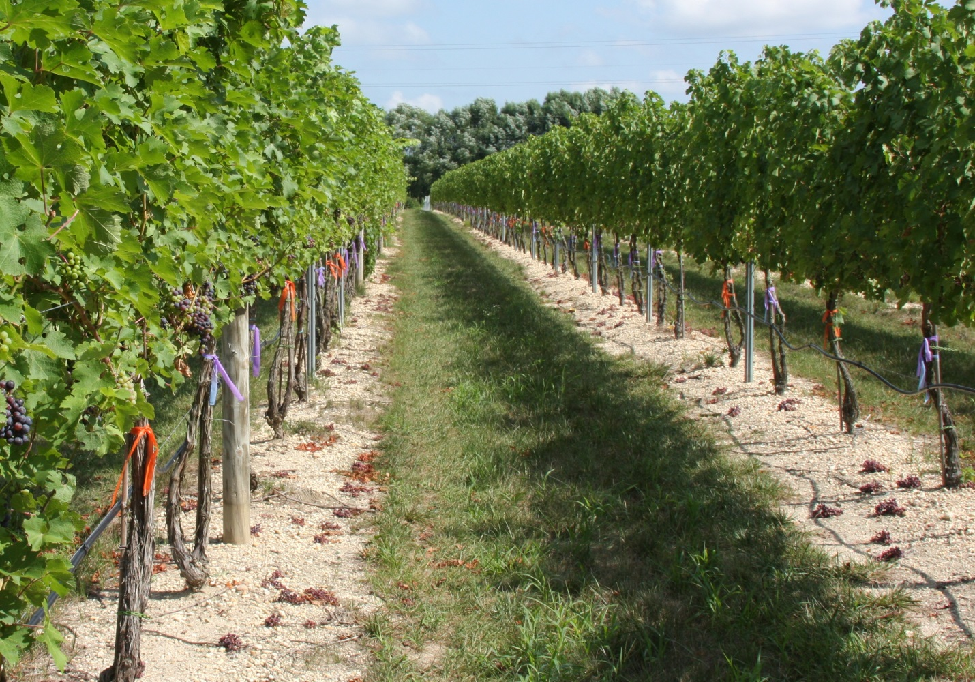
Figure 1. Cabernet Sauvignon vines (left) and Cabernet Franc vines (right) at Coia Vineyards randomly flagged for cluster thinning. This photo was taken at veraison in in early August approximately 2 weeks after cluster thinning (see clusters on the vineyard floor).
Sixty vines of each variety for a total of 120 vines were devoted to this trial. Of these, half were cluster thinned to one cluster per shoot while the other half were thinned to two clusters per shoot. (Figure 2).Vines of a given variety in the same row were randomly assigned to one or the other thinning level and 2 different color flags were used for the 2 different levels of thinning. The rows chosen for each variety in this trial were located adjacent to each other. Cluster thinning was performed after lag phase and before veraison (typically between July 15th and July 28th). Vines with shoots greater than 2 feet were thinned to either two clusters or one cluster depending on random assignment. Shoots less than 2 feet were thinned to one cluster regardless of assignment.
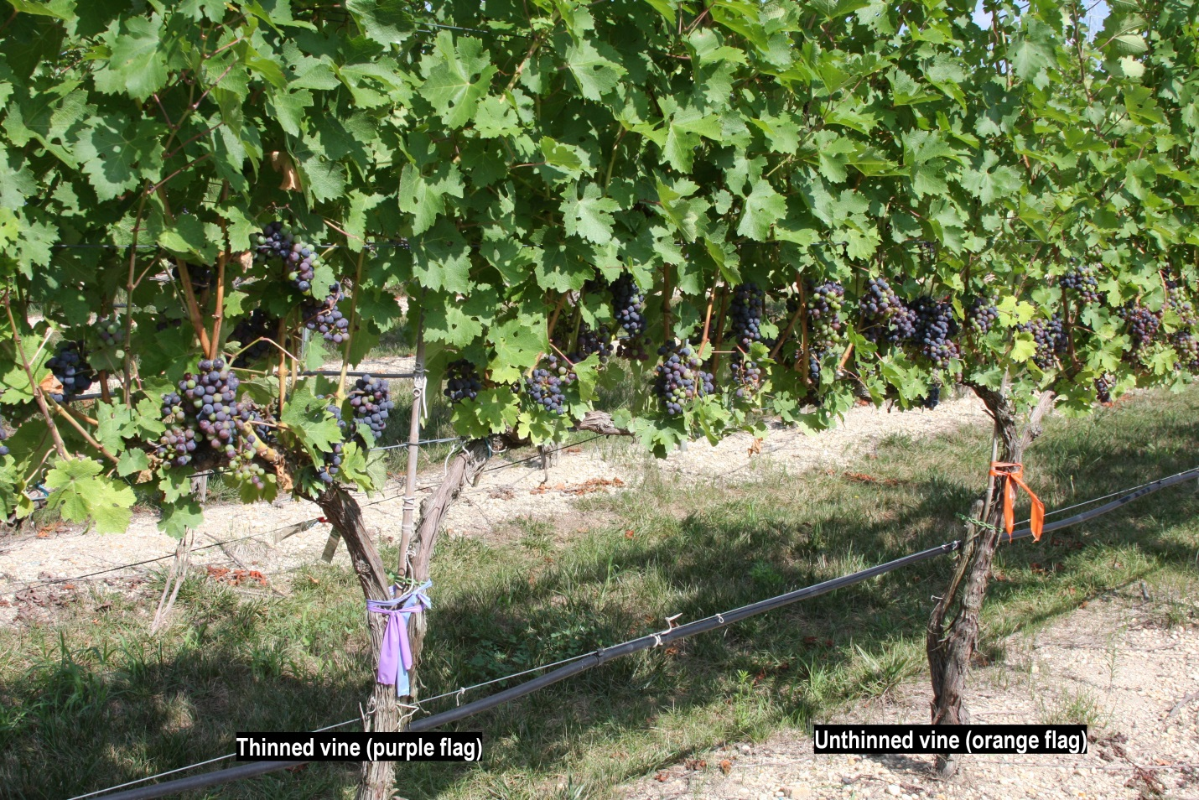
Figure 2. Example experimental Cabernet Sauvignon vines either thinned (left, purple flag) or unthinned (right, orange flag) at Coia Vineyards. This photo was taken at veraison in early August approximately 2 weeks after cluster thinning.
Standard canopy management practices were used on all vines in this trial. These included cordon training, spur pruning, shoot thinning, vertical shoot positioning, leaf pulling, one or two hedgings per season, cluster thinning and green harvesting. Standard weed, IPM and nutritional management practices were also used.
Growing degree days base 50°F (GDD₅₀) and rainfall of the 2010, 2011 and 2012 Vintages
There were significant weather differences in the vintage years of this trial. (Table 1). For this region the average GDD₅₀ is 3580 and the average rainfall sum for the combined months of August and September is 8.0 inches. 2010 was characterized as much warmer (GDD₅₀ = 3930) and much drier than average (Aug/Sept rain = 2.6 inches). 2011, while also relatively warm (GDD₅₀ = 3932) had the highest rainfall for August and September (17.2 inches) in the history of the region. 2012 was characterized by average GDD₅₀ (3583) and relatively average rainfall for August and September (7.4 inches).
Table 1. Climate conditions at Coia Vineyards location (39.30N,-74.56W) in Vineland, New Jersey.
Year | Growing Degree Days  (April-Oct., base=50°F) | Rainfall  (Aug-Sept,inches)
Average | 3580 | 8.0
2010 | 3930 | 2.6
2011 | 3932 | 17.2
2012 | 3583 | 7.4

Measurements and Statistical analysis
Pruning weights per vine were obtained in the winter following harvest and were used as a baseline measure of vine vigor. Canopy measures include canopy area (calculated as = canopy height (m) X vine spacing (m) X 2) as well as total shoots per vine and shoots per vine greater than 2 feet in length. As canopy area was full in each growing season and area was constant as the canopy height was kept the same each season for each variety at 52 inches (1.32 m) for both varieties by top hedging. Canopy growth was uniform during each of the growing seasons and no significant diseases or pest damage existed on fruit or foliage.
Harvest occurred on the same date for each level of thinning and differed for each variety. Cabernet Sauvignon typically matured one to two weeks after Cabernet Franc (average harvest dates of October 5^{rth} versus September 25th). Date of harvest was chosen to coincide with the date of commercial harvest but generally was 1 to 7 days earlier. The date of the harvest was determined by weekly measures of °Brix, pH, and total acidity, as well as measures of seed color and texture and skin color and taste. There was no rot at the time of the harvests. Harvest measurements included number of clusters per vine and total weight of crop per vine as well as weight per cluster.
Grape quality at harvest was measured by laboratory analysis of total soluble solids (TSS) and total acidity (TA) performed at Rutgers Agricultural Research and Extension Center.
Wine for this trial was produced at Coia Vineyards annually. Two five- gallon lots were produced for both levels of cluster thinning and for each of the two varieties for a total of eight five-gallon lots annually. Wine samples from each of the eight five-gallon lots were submitted for laboratory analyses after completion of primary and malolactic fermentations. Laboratory analysis included total phenolics, total anthocyanins, copigmented anthocyanins, hue and intensity through a phenol/color panel performed by the Enology Service Laboratory at Virginia Tech.
Wines were also evaluated by blinded preference (one versus two clusters) and quality score by an independent wine tasting group organized by Scientific Marketing Services. Bottling of the wine was performed 3 months after completion of fermentation and no filtering or barrel aging took place. All wines underwent tasting analysis in April 2013, thus the wines tasted from the 2010 vintage were over 2 years of age, the 2011 vintage over 1 year of age and the 2012 vintage were approximately 7 months of age. Wines were judged by an 8-member panel who were blinded to the level of cluster thinning used to produce each wine but not to year of harvest or variety of grape. There were 12 rounds of tasting including four wines from each of the 3 years with each round including only two wines of the same variety and vintage but with two different levels of cluster thinning. Judges had two tasks in comparing the two wines at each round- the first was to determine which of the two wines they preferred and the second was to give a score to each of the two wines (the Davis 20-point scale was used for this score).
Wine grape and wine quality parameters were compared for the two clusters and one cluster per shoot treatments within a variety and a year. For the wine preferences, Fisher’s Exact test was used and for all other measured responses Student's t-test was used.

Results
Details are summarized in Tables 2 through Table 5 below.
Over the 3 years of the trial the yield for both varieties when cluster thinned averaged approximately 63% that of the unthinned vines. For the unthinned Cabernet Franc the yield per vine averaged 4.8 kg (3.7 tons/acre) and for unthinned Cabernet Sauvignon 3.8 kg (3.0 tons/acre).

Table 2. Fruit yield of Cabernet Franc and Cabernet Sauvignon grapes grown in southern New Jersey and either unthinned or thinned to one cluster per shoot during lag phase of fruit growth by variety, year, and thinning level.

Variety | Year | Cluster thinning | Yield (kg/vine) | Yield (tons/acre)
Cab. Franc | 2010 | None | 3.3 | 2.6
 |  | Thinned | 2.1 | 1.6
 |  | P-value^{z} | <0.001
 | 2011 | None | 7.0 | 5.5
 |  | Thinned | 4.6 | 3.6
 |  | P-value | <0.001
 | 2012 | None | 4.1 | 3.2
 |  | Thinned | 2.4 | 1.9
 |  | P-value | <0.001
Cab. Sauvignon | 2010 | None | 3.5 | 2.7
 |  | Thinned | 2.2 | 1.7
 |  | P-value | <0.001
 | 2011 | None | 4.9 | 3.8
 |  | Thinned | 2.9 | 2.3
 |  | P-value | <0.001
 | 2012 | None | 3.0 | 2.3
 |  | Thinned | 2.1 | 1.7
 |  | P-value | 0.002
^{z} P-values based on Student’s t-test comparing thinning levels within a variety and year.

Table 3. Summary fruit and juice quality measures of Cabernet Franc and Cabernet Sauvignon grapes grown in southern New Jersey and either unthinned or thinned to one cluster per shoot during lag phase of fruit growth by variety, year, and thinning level.

Variety | Year | Cluster thinning | Cluster wt.^{z} | °Brix | TTA^{y}
Cab. Franc | 2010 | None | 86.2 | 24.7 | 2.50
 |  | Thinned | 90.3 | 24.7 | 2.49
 |  | P-value^{z} | ns | ns | ns
 | 2011 | None | 139.6 | 20.2 | 3.79
 |  | Thinned | 146.1 | 20.6 | 3.52
 |  | P-value | ns | ns | 0.0013
 | 2012 | None | 99.5 | 21.8 | 5.94
 |  | Thinned | 100.5 | 21.8 | 6.20
 |  | P-value | ns | ns | 0.050
Cab. Sauvignon | 2010 | None | 85.3 | 22.3 | 3.74
 |  | Thinned | 81.9 | 23.0 | 3.66
 |  | P-value | ns | ns | ns
 | 2011 | None | 91.7 | 17.8 | 6.30
 |  | Thinned | 91.2 | 17.6 | 5.78
 |  | P-value | ns | ns | 0.016
 | 2012 | None | 84.5 | 17.6 | 8.15
 |  | Thinned | 82.6 | 17.8 | 8.95
 |  | P-value | ns | ns | 0.044
^{z} Cluster weight (g)
^{y} Total titratable acidity (g/l tartaric acid equivalents)
^{x} P-values based on Student’s t-test comparing thinning levels within a variety and year.

Table 4. Summary wine quality measures of Cabernet Franc and Cabernet Sauvignon wines made from grapes grown in southern New Jersey and either unthinned or thinned to one cluster per shoot during lag phase of fruit growth by variety, year, and thinning level.

Variety | Year | Cluster thinning | Total phenolics^{z} | Total anthocyanins^{y} | Wine score^{x}
Cab. Franc | 2010 | None | 1656 | 3.66 | 15.9
 |  | Thinned | 1645 | 3.61 | 15.9
 |  | P-value^{w} | ns | ns | ns
 | 2011 | None | 822 | 0.635 | 14.6
 |  | Thinned | 884 | 0.710 | 13.5
 |  | P-value | ns | ns | ns
 | 2012 | None | 1416 | 0.685 | 11.2
 |  | Thinned | 1328 | 0.760 | 11.5
 |  | P-value | 0.041 | ns | ns
Cab. Sauvignon | 2010 | None | 1697 | 4.21 | 14.2
 |  | Thinned | 1683 | 3.75 | 13.0
 |  | P-value | ns | .0366 | ns
 | 2011 | None | 1150 | 1.07 | 15.2
 |  | Thinned | 1186 | 1.18 | 14.0
 |  | P-value | ns | ns | 0.011
 | 2012 | None | 1254 | 1.105 | 12.8
 |  | Thinned | 1248 | 1.120 | 12.5
 |  | P-value | ns | ns | ns
^{z} Total phenolics (mg/l gallic acid equivalents)
^{y} Total anthocyanins (mg/l)
^{x} Wine score based on 20-point UC Davis scale
^{w} P-values based on Student’s t-test comparing thinning levels within a variety and year.

Table 5. Ratios of canopy area to crop weight and of crop weight to pruning weight by year variety and thinned (T) or unthinned (UT) treatment.
 | Canopy Area(m²)/Crop Weight(kg) |  |  |  | Crop Weight/Pruning Weight^{z}
 | Cab. Franc |  | Cab. Sauv. |  | Cab. Franc |  | Cab. Sauv.
Year | T | UT | T | UT | T | UT | T | UT
2010 | 2.3 | 1.4 | 2.2 | 1.3 | - | - | - | -
2011 | 1.0 | 0.7 | 1.7 | 1.0 | 2.5 | 4.1 | 2.3 | 3.7
2012 | 2.0 | 1.2 | 2.3 | 1.6 | 5.8 | 8.6 | 2.5 | 4.4
^{z}2011=Ratio of crop weight of 2010 to pruning weight of 2011, and 2012=Ratio of crop weight of 2011 to pruning weight of 2012

Sustainable Benefits for Winegrowers and Wineries
While the levels of cluster thinning were standard for winegrowers, the careful comparisons of the quality of wine grapes and wine at these low yields per vine are indeed useful. The fact that grape and wine quality parameters were largely unaffected by cluster thinning, even in a wet year like 2011, was not anticipated. The results of this trial will help winegrowers with the following:
- Winegrowers vary in the amount of cluster thinning they perform. Both one and two clusters per shoot methods are acceptable currently. We have demonstrated no significant benefit to cluster thinning to one cluster per shoot for these varieties. Since cluster thinning and harvest require different labor inputs for each level of thinning this should factor into business expense and labor considerations.
- Wine grape prices are largely determined by grape variety and are expressed in terms of dollars per ton. In this study lower crop yields of less than 2 tons per acre did not result in higher quality suggesting that price per ton when yields are less than 2 tons/acre do not need to be adjusted upwards. On the high yield side, yields greater than 5 tons per acre may be associated with lower quality grapes and wine but this study did not study such high yields. This is a major consideration for winegrower-winery relations where the data on quality and yield are largely lacking for these varieties in the East.
- Determination of the optimum ratio of canopy area to crop yield for these varieties could assist in the production of consistently high quality grapes from grower to grower and season to season. This is an important factor for many winegrowing regions of the East that are just now establishing a favorable identity for their region. Increasing the consistency of quality wine production by developing guidelines on crop yield and wine grape quality would enhance the image of Eastern viticulture and the lives of its winegrowers. There is probably no benefit to canopy area to crop weight ratios exceeding 1.5 for these varieties grown in the East.
- There is controversy regarding the value of high density planting (>1000 vines/acre) versus more standard density generally used in the Eastern US (<1000 vines/acre). High density planting greatly increases the cost of establishing a vineyard but the wines produced from such vineyards have often been of high quality. The yield per vine is generally much lower with high density plantings than for standard density. Is this low yield per vine responsible for the high quality? This trial did not directly examine the effect of planting density on wine quality but rather examined the effect of cluster thinning. It suggests that lowering of yields per vine at a standard density planting to less than 5 kg might only play a limited role in wine grape quality. Furthermore, high quality wine can be made at planting densities of less than 1000 vines per acre. This information could be helpful to those who are considering the establishment of a vineyard as either a high density planting (which requires much greater input and specialized equipment) or a standard density planting which is currently the norm in the East.
- The Outer Coastal Plain AVA, (OCP), is one of the largest AVA’s in the country and is one of several regions in the East where Cabernet Sauvignon can be grown successfully despite its requirement for a long growing season and its moderate susceptibility to low temperature winter injury. Cabernet Franc can be grown in the OCP as well as in a large number of locations in the East as it has lesser requirements for growing season length and tolerates lower winter minimum temperatures. This study suggests that quality grapes and wines can be produced from these varieties under various climatic conditions without the necessity of economically unsustainable low yields (GDD₅₀ range 3580-3932, Aug-Sept rainfall (2.6”-17”).

Anita I would try to improve and place these 4 logos somewhere near the back of the brochure as well as the title page.

Get SARE logo. I did get it but maybe it could not be included went sent.
Larry to give CD with Coia Vineyards logo.
Dan Please send RAREC logo or Rutgers logo you wish to be exhibited.
Anita please insert OCPVA Logo

