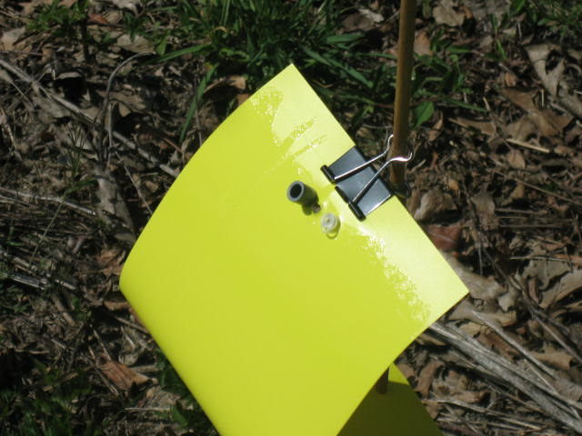
Figure 1: Mounting of pepper weevil 2-component lure onto sticky cards attached to a dowel. When placed in a field they were at approximately canopy-height. The assembly was wired when attached to a tree or to a fence near a loading dock. Cards were changed at least weekly depending on insect accumulation.

