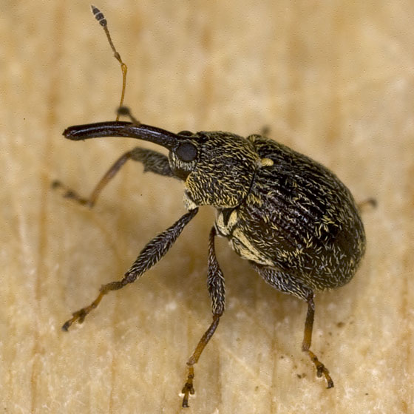

Figure 2: The photograph on the left, by the author, is the first pepper weevil trapped in 2012. The image on the right is courtesy of bugguide.net. The pepper weevil is a robust, somewhat oval insect. The coloration and hair patterns in these pictures are typical but coloration can vary. Actual size ranges from 2 to 3.5 mm. All pepper weevils, as well as others in the Anthonomus species such as the smaller, redder cranberry weevil, have a spur on the underside of femurs. These spurs, indicated by arrows in the figure, are a distinctive feature but sometimes are difficult to discern because of insect orientation and tendency to fold legs under when threatened (play dead).

