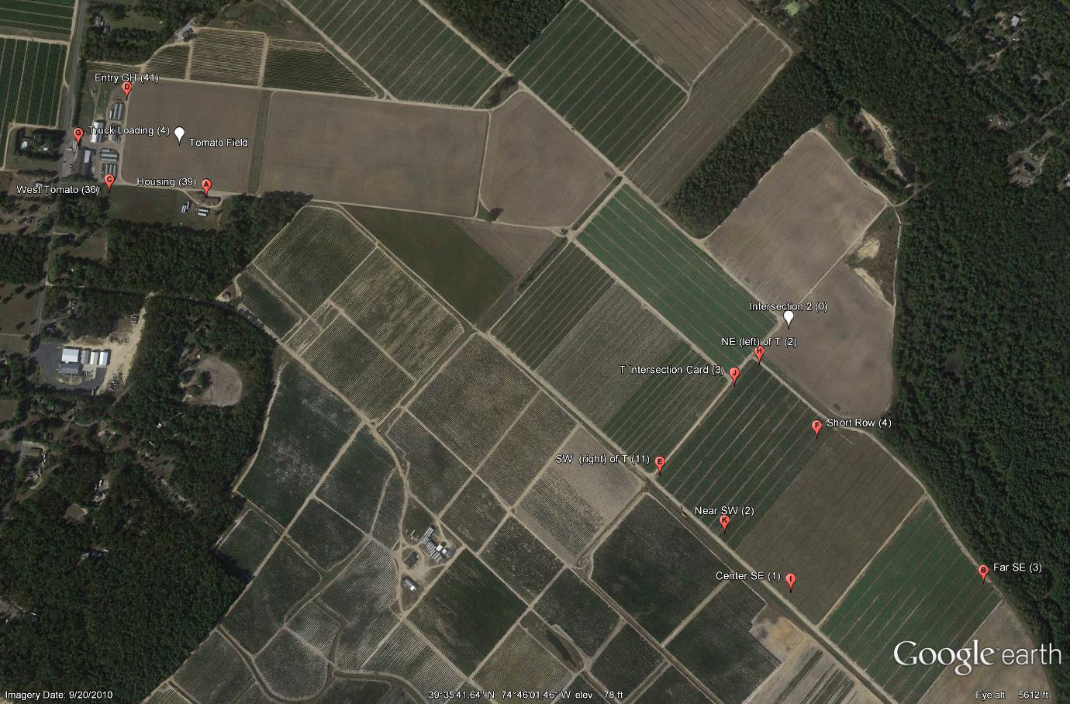
Figure 4: Farm 1 sky view shows the distribution of traps. Pepper fields are at lower right with traps indicated. Traps shown at upper left are other areas monitored including “hot spots” from 2011, housing and high traffic areas. The number following the location description is the number caught in the season. The letter inside the marker is the relative time of arrival. The white marker is a tomato field.

