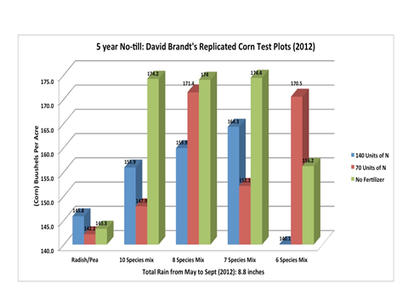

Information from Blended Plots from SARE Grant 2012-David Brandt Farm