Wind Crest Farm
Owner: John Salisbury, York County
Wind Crest Farm, owned and operated by John Salisbury, is a private facility in York County. John and his wife own three Rocky Mountain Horses which have access to five acres of pasture. John was introduced to the On – Farm Sustainable Research and Education Project (SARE) after completing a Penn State Environmental Stewardship short course.

Best Management Practice (BMP) Identified:
Increase desirable, perennial vegetation in pastures to provide nutrition for horses, and decrease weed populations.

Reasoning for BMP:
Perennial vegetative cover in the pasture was inadequate, leaving bare spots and opportunities for weed germination. Exposed soil increases the chance of erosion and gully formation, but also creates areas of mud, which can pose animal health problems. Increasing the concentration of desirable forage in pastures reduces hay and feed costs and provides an excellent source of nutrition.

Course of Action:
- Date Reseeded: Early Fall
- Equipment Used: Aerator, pull behind seed spinner, and arena drag
- Seed Mix: Tekapo Orchard Grass, Perennial Rye, Tall Fescue, Kentucky Bluegrass, White Clover
- Soil Tested: Yes
- Fertilizer: 200 pounds of 20 – 10 - 10
- Lime: 1 ton
- Procedure: Two weeks prior to reseeding, the pasture was aerated using a pull behind spike aerator. A spinner spreader was used to broadcast seed and an arena drag was used to pull soil over the seeds.

Results:
 | Before Renovating Pasture | After Renovating Pasture
Canopy Cover | 65% | 100%
Desirable Forage | 30% | 90%
Perennial Plant | 35% | 95%
Prior to reseeding, 65% of the pasture was covered with plant canopy canopy and 35% was bare ground. To reduce erosion a minimum of 80% of the pasture should be covered with a plant canopy. Only 30% of the pasture was covered with plants that provided nutrition for the horses; 35% of the pasture was covered with perennial vegetation with 65% being annual plants such as crabgrass and ragweed. After reseeding, the pasture quality and vegetative cover improved significantly. The canopy cover improved to 100%, with no bare spots. Desirable forage tripled, increasing from 30% to 90% in the pasture after being reseeded. Weed populations in the pasture reduced to 10% after reseeding.

Challenges:

On – Going Management and Additional BMPs:
John plans to continue improving his pastures through:
- Rotating horses to a new pasture after one week of grazing
- Mowing pastures frequently
- Utilizing a sacrifice lot when weather conditions are unfit for turnout
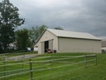Wind Crest Farm
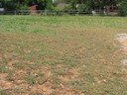Pasture prior to renovation
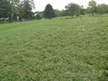Pasture after renovation
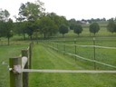Access lanes
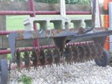Aerator
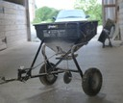Spinner Seader

