Summary of 2011 Cig results:
Measurements
June-Sept: 5 assessments  June 8, July 6, Aug 3, Aug 31,  Sept 22 | F (df), P  Month | F (df), P  Treatment | F (df), P  Interaction
Adult population (frames of bees) | 53.38 (4, 129), <0.0001) | 1.43 (3, 34). 0.2362 | 1.69 (12, 129), 0.0752
Sealed brood area (pupae) | 23.04 (4, 128), <0.0001) | 4.95 (3, 34), 0.0028 | 1.92 (12, 128), 0.0372
Open brood area (1-5th instar larvae) | 33.32 (4, 129), <0.0001 | 0.59 (3, 34), 0.6224 | 0.96 (12, 129), 0.4881
Total brood area (open + sealed) | 35.35 (4, 129), <0.0001) | 3.06 (3, 34), 0.0414 | 1.50 (12, 129), 0.1303
Pollen area | 10.65 (4, 129), <0.0001 | 11.38 (3, 34), <0.0001) | 7.35 (12, 129), <0.0001
Mean missing cell area | 6.98 (4, 118), <0.0001 | 3.06 (3, 34), 0.0412 | 1.51 (12, 118), 0.1309
Brood pattern | 5.60 (4, 117), 0.0004 | 2.35 (3, 34), 0.0901 | 1.61 (12, 117), 0.0967
Nosema spp. levels | 15.05 (4, 130), <0.0001 | 4.85 (3, 34), 0.0065 | 2.02, (12, 130), 0.0269
Varroa destructor levels | 64.18, (3, 96), <0.0001 | 1.49 (3, 34), 0.2358 | 1.09 (9, 96), 0.3761
Total returning foragers | 11.17 (2, 64), <0.0001) | 1.79 (3, 34), 0.1670 | 0.78 (6, 64), 0.5881
Percent returning pollen foragers | 7.68 (2, 64), 0.0010 | 6.42 (3, 34), 0.0015 | 1.09 (6, 64), 0.3808
Dead bees | 32.82 (3, 98), <0.0001 | 0.90 (3, 34), 0.4528 | 1.03 (9, 98), 0.4219
Consumption 48 hours | 36.64 (3, 98), <0.0001 | 2.98 (3, 34), 0.0450 | 2.30 (9, 98), 0.0216
Consumption 1 week | 29.06 (3, 98), <0.0001 | 3.07 (3, 34), 0.0407 | 2.74 (9, 98), 0.0068
Queen replacement (Date: ChiSquare, P value) | Aug 31-Sept 22: 8.02, 0.0456 | Total June-Sept: 3.20, 0.3625 | Sept 22-Jan 12: 6.26, 0.0998

Figure 1 Frames of bees
June-Sept: 5 assessments  June 8, July 6, Aug 3, Aug 31,  Sept 22 | F (df), P  Month | F (df), P  Treatment | F (df), P  Interaction
Adult population (frames of bees) | 53.38 (4, 129), <0.0001) | 1.43 (3, 34). 0.2362 | 1.69 (12, 129), 0.0752
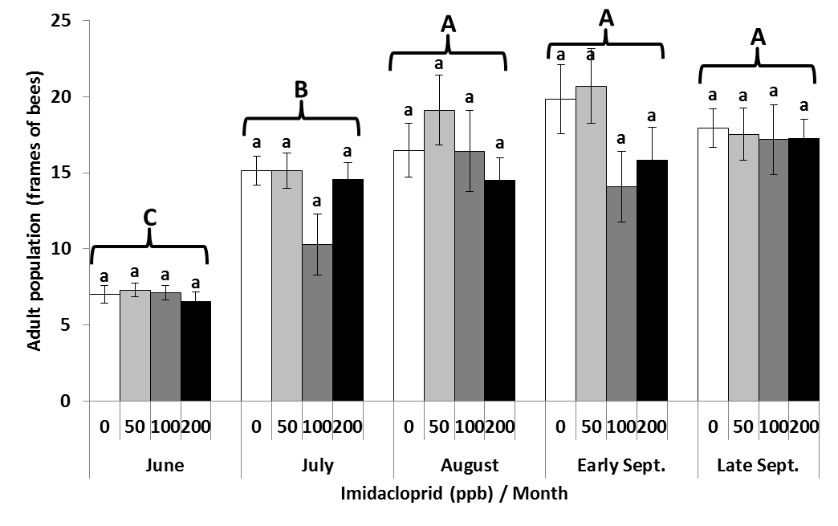
Figure 2 Sealed brood
June-Sept: 5 assessments  June 8, July 6, Aug 3, Aug 31,  Sept 22 | F (df), P  Month | F (df), P  Treatment | F (df), P  Interaction
Sealed brood area (pupae) | 23.04 (4, 128), <0.0001) | 4.95 (3, 34), 0.0028 | 1.92 (12, 128), 0.0372
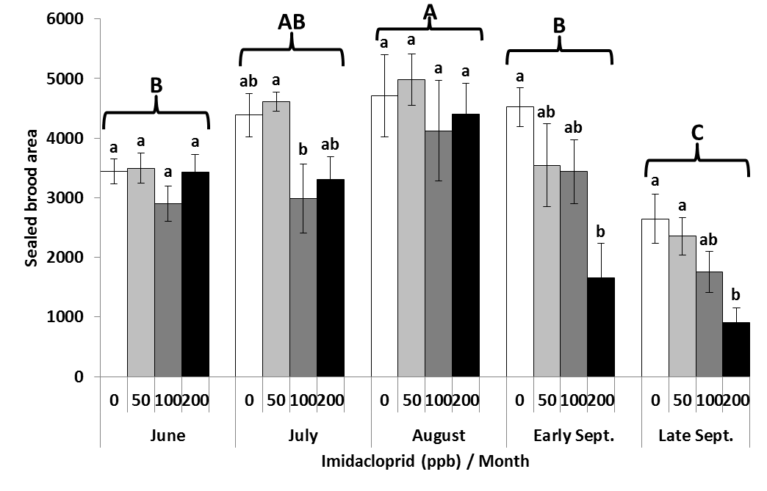
Figure 3 Total brood area
June-Sept: 5 assessments  June 8, July 6, Aug 3, Aug 31,  Sept 22 | F (df), P  Month | F (df), P  Treatment | F (df), P  Interaction
Total brood area (open + sealed) | 35.35 (4, 129), <0.0001) | 3.06 (3, 34), 0.0414 | 1.50 (12, 129), 0.1303

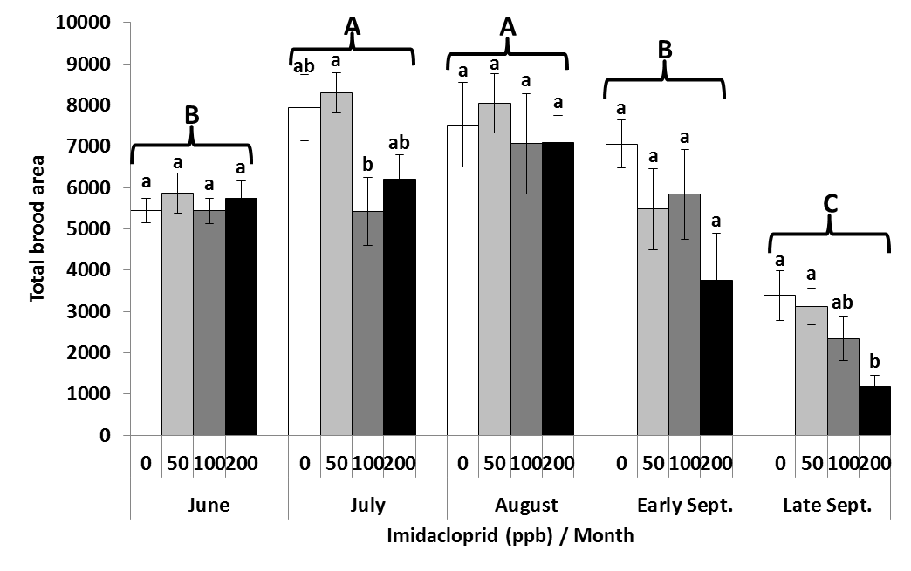
Figure 4 Pollen area
June-Sept: 5 assessments  June 8, July 6, Aug 3, Aug 31,  Sept 22 | F (df), P  Month | F (df), P  Treatment | F (df), P  Interaction
Pollen area | 10.65 (4, 129), <0.0001 | 11.38 (3, 34), <0.0001) | 7.35 (12, 129), <0.0001
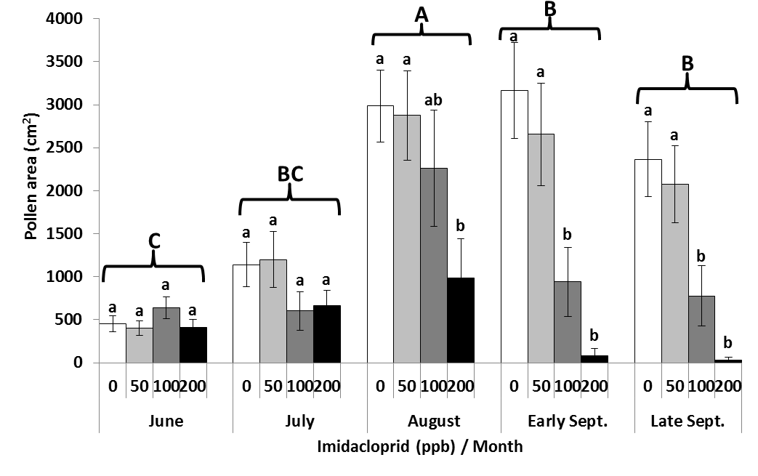
Figure 5 Nosema
June-Sept: 5 assessments  June 8, July 6, Aug 3, Aug 31,  Sept 22 | F (df), P  Month | F (df), P  Treatment | F (df), P  Interaction
Nosema spp. levels | 15.05 (4, 130), <0.0001 | 4.85 (3, 34), 0.0065 | 2.02, (12, 130), 0.0269
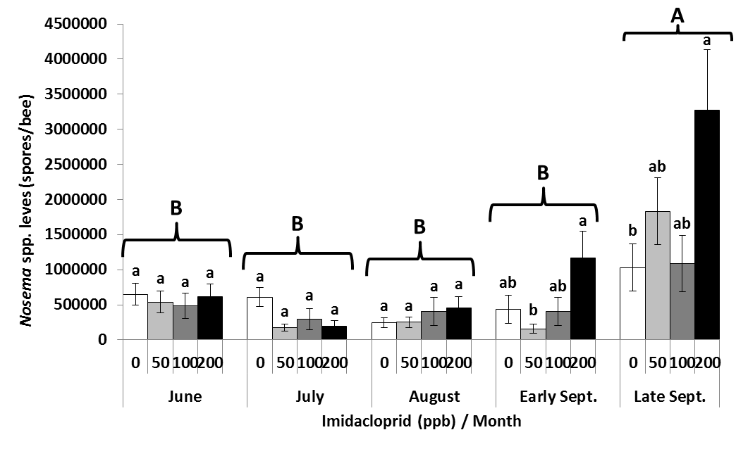
Figure 6 Returning foragers
June-Sept: 5 assessments  June 8, July 6, Aug 3, Aug 31,  Sept 22 | F (df), P  Month | F (df), P  Treatment | F (df), P  Interaction
Percent returning pollen foragers | 7.68 (2, 64), 0.0010 | 6.42 (3, 34), 0.0015 | 1.09 (6, 64), 0.3808

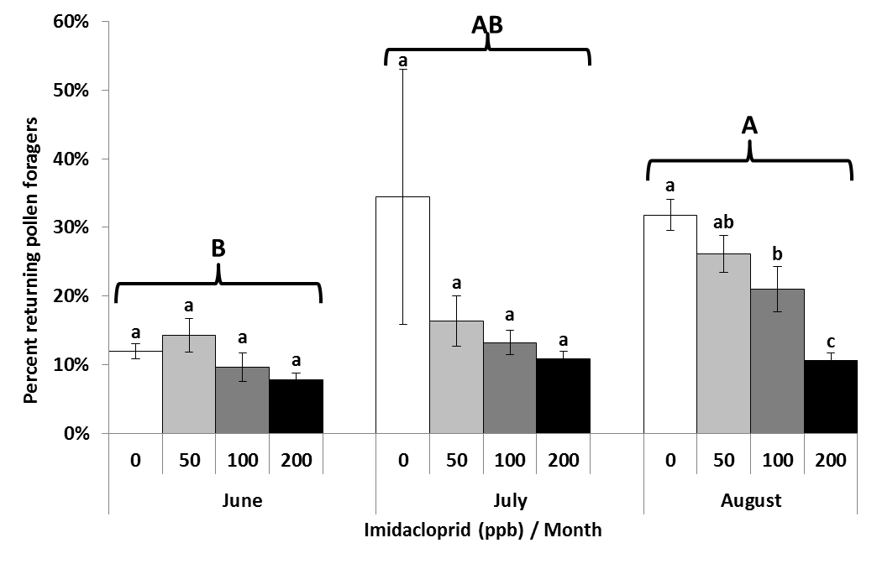

Figure 7 Colony consumption 48 hrs
June-Sept: 5 assessments  June 8, July 6, Aug 3, Aug 31, Sept 22 | F (df), P  Month | F (df), P  Treatment | F (df), P  Interaction
Consumption 48 hours | 36.64 (3, 98), <0.0001 | 2.98 (3, 34), 0.0450 | 2.30 (9, 98), 0.0216
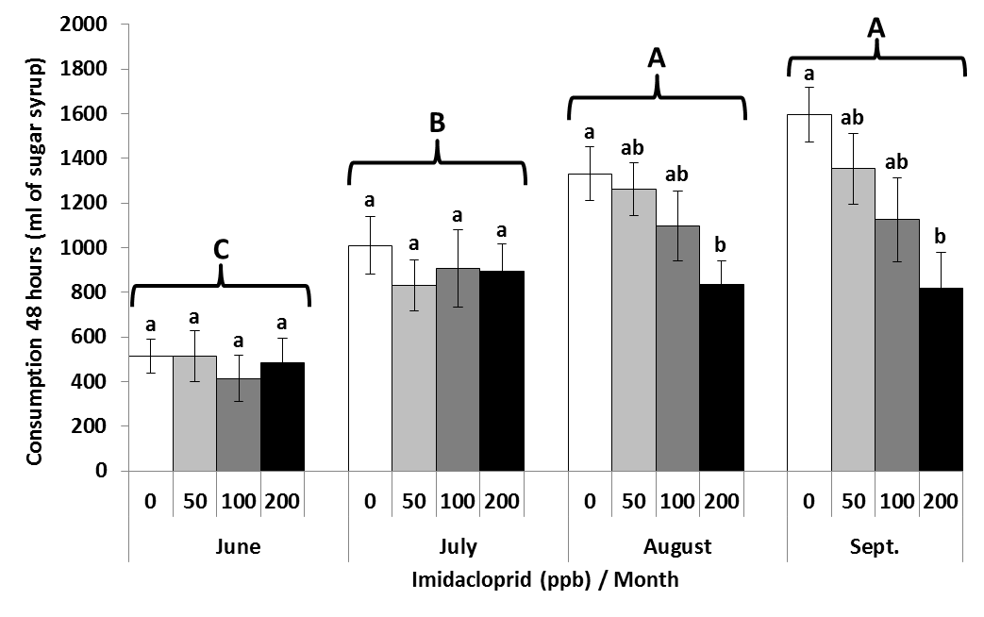
Figure 8 Queen replacement
June-Sept: 5 assessments  June 8, July 6, Aug 3, Aug 31,  Sept 22 | F (df), P  Month | F (df), P  Treatment | F (df), P  Interaction
Queen replacement (Date: ChiSquare, P value) | Aug 31-Sept 22: 8.02, 0.0456 | Total June-Sept: 3.20, 0.3625 | Sept 22-Jan 12: 6.26, 0.0998
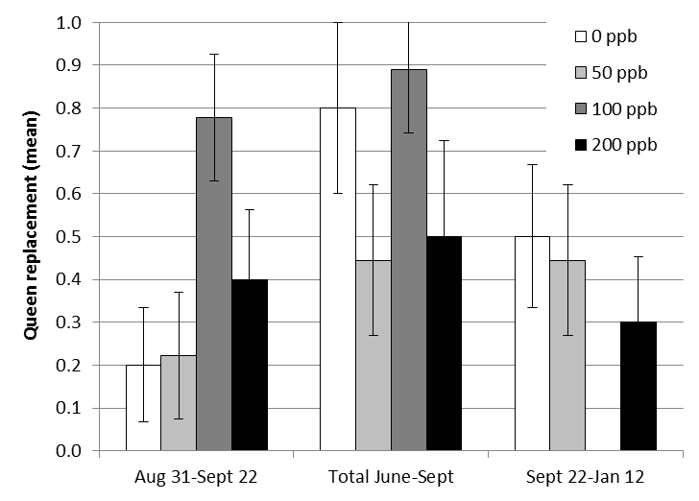

Figure 9
