ABSTRACT
Landrace chile peppers (Capsicum annuum var. annuum, family Solanaceae) are descendents of chile peppers historically taken through the Spanish and Portuguese trading routes in the time period of 1492 to 1590 (Andrews, 1984). The landrace peppers were also believed to be brought to New Mexico by the Spanish explorers from Mexico in the late 1500’s to early 1600’s. Landraces are defined as long term cultivation of the crop within a given farming system (Zevin 1998) and are grown and collected in Northern New Mexico by individual families. These specific “races” are tied to the land area they are grown for decades or hundreds of years. Zevin also describes landraces in general as having a high capacity to tolerate local biotic and abiotic stresses and have stable and intermediate yield levels even when grown under low-input agricultural systems. In recent genetic research, Bosland, et al, (2005) of New Mexico State University determined that landrace peppers from New Mexico also retained genetic characteristics similar to South American ancestral accessions. In high elevation villages such as Dixon and Chimayo, New Mexico the landraces peppers have retained morphological and potential medicinal characteristics of the original peppers. The peppers are also an important part of both the indigenous Native American tribes and Hispanic diet in New Mexico.
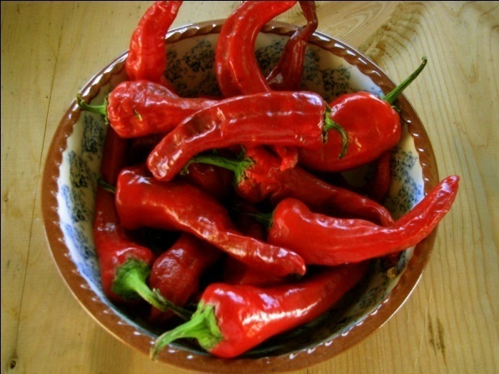
Bosland (New Mexico State University) had also estimated that as much as 21% of the New Mexican Heirloom landraces have been contaminated by gene flow from improved open-pollinated (OP) cultivars (Nabhan 2008) such as New Mexico “Sandia” or “Espanola Improved”. OP cultivars are homogenous and are bred using traditional plant breeding methods (Bosland 2000). According to Bosland, landraces are also heterogeneous, genetically diverse, and are well adapted to the locations where they have been cultivated. The landrace pepper seed banks and the nutritional source for traditional farmers are currently at risk of being lost and fewer traditional farmers are growing these peppers in New Mexico.
Overall our research focus is to understand the nutritional needs of peppers, seed and soil conservation, while improving sustainable organic practices in place for field ecology. With these goals we can share the information with local and regional producers to potentially improve their production practices.

Loretta Sandoval redasandoval@yahoo.com,
Zulu’s Petals Certified Organic Farm
Dixon NM

