Germination Trials May 2011
Purpose: To determine percent germination of the landrace (LR) and open-pollinated (OP) peppers for percent germination and stand uniformity for seedlings. Three replications (n=50) will be performed using seedling mix only (number 1-5) and seedling mix inoculated with mycorrhizae fungi (number 1M-5M).
Materials/Procedures:
Propagation mix: Black Gold Seedling mix no additives OMRI registered 70°F (warming mat), 100% humidity (covered with top and bottom for moisture retention).
4 seeds per cell (36 cells X 4 = 144 total) 72 cell speedling tray
Landrace Row 1-6 Anaheim, Joe E. Parker 7-12
Tray Number | Landrace Family/Accession | Notes:
1-1M Row 1-6 | “Canoncito” Field #7 original seed bank (2009) collected by Herrera 2010 from Campbell. | In field area 2 years
2-2M Row 1-6 | Tom Sena original ‘Velarde’ Estevan Arellano 2010 collected | In field area 2 years
3-3M Row 1-6 | Romolo and Estevan Greigo original seed bank | Approximately 150 years in same field area
4-4M Row 1-6 | “Canoncito” Field #7 original seed bank Campbell | 160 years in same field area
5-5M Row 1-6 | Fred Martinez 2010 ‘Dixon-Arellano) | Approximately 75 years same field area
1-1M Row 7-12 | Anaheim Turtle Tree Seed COOP 2010 Organic/BD
2-2M Row 7-12 | Joe E Parker Peaceful Valley
3-3M Row 7-12 | Anaheim Turtle Tree Seed COOP 2010 Organic/BD
4-4M Row 7-12 | Anaheim Turtle Tree Seed COOP 2010 Organic/BD
5-5M Row 7-12 | Anaheim Turtle Tree Seed COOP 2010 Organic/BD

Figure1: Tray setup for germination studies
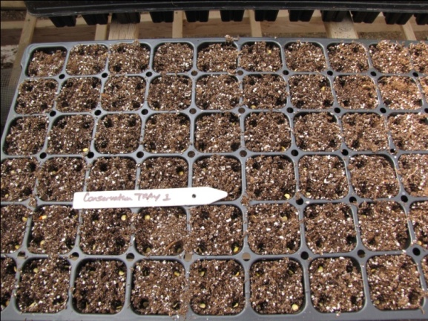
70F heating mat, 100% Humidity, Seed depth ¼ inch. For mycorrhizae (M) trials, seedling was inoculated with mix of fungi as listed Table 1. Mycorrhizae fungi was obtained courtesy Mycorrhizae (MycoApply®, EndoSoluble) contains 4 myco fungi, an organic slow release fertilizer, and kelp. Germination Studies Results 2011:
Tray Name | Sow Date | LR Total seedling count  Row 1-6 (X) | OP  Seedling count  Row 7-12 (X) | Date data taken | LR %Total Germination X/144 x 100 control row 1-6 | LR %Total Germination X/144 with row 7-12 mycorhizzae
Conservation 1 LR | 4/14/11 | 87 | 106 | 5/19/11 | 60 | 74
Conservation 1M OP | 4/21/11 | 100 | 100 | 5/19/11 | 70 | 70
Conservation 2 | 4/14/11 | 101 | 112 | 5/19/11 | 71 | 78
Conservation 2M | 4/21/11 | 127 | 120 | 5/19/11 | 89 | 83
Conservation 3 | 4/14/11 | 86 | 114 | 5/19/11 | 60 | 80
Conservation 3M | 4/21/11 | 101 | 96 | 5/19/11 | 71 | 67
Conservation 4 | 4/14/11 | 108 | 106 | 5/19/11 | 75 | 74
Conservation 4M | 4/21/11 | 116 | 104 | 5/19/11 | 81 | 73
Conservation 5 | 4/14/11 | 113 | 101 | 5/19/11 | 78 | 73
Conservation 5M | 4/21/11 | 123 | 87 | 5/19/11 | 86 | 61

