WSARE Project FW10-049

Title: "Pepper (Capsicum annum) Cultivation, Conservation, and Soil Ecology in Low-Input and Certified Organic Agricultural Systems"

Results for Capsicum Analysis

The results for the Capsicum analysis are shown in chart 1. The standard deviation between the three replicates for each sample was high and may be the result of the analysis method (GC-MS extraction) or dilution issue (10X). The Capsicum results for the landrace peppers in the control plots indicate that the levels increase for the transplants versus the direct-seeded which may indicate a stress response that is higher in the transplants then the direct seeded plots. The fertility treatment results indicate that the concentration of Capsicum for direct seeded versus the transplants are very similar and the concentration of Capsicum may be lower because the plants for the fertility treatment plots (mycorhizzae treated) had less overall plant stress than the control plots. This finding was surprising and would be an area that would require further study and comparison to 2012 data results once submitted and analyzed.

Chart 1: Capsicum-dihydrocapsicum ppm per gram dried pepper 2011 for Split-split plot and cooperator field areas (average of three replicates)
Capsicum-Dihydocapsicum ppm/gram dried pepper
Height measurements were taken in the plots when plants were at full maturity (September 2011-2012). The heights and number of plants present in each plot type (all three replicates combined) are shown in Table 1 and 2. The plant count data for 2011 for the fertility plots versus the control indicate that the fertility treatment (mycorrhizae application) increased survival of the seedlings. The data for 2012 for the plots were not as different and more plants survived in the control plot than in 2011.The heights for both the landrace and Anaheim plots were higher for the direct seeded plots in 2011. In 2012 the Anaheim plots were very similar in heights and landrace peppers heights were higher for the direct seeded plots only. The wilt present in both years was minimal (less than 2%).
Yield in split-split plots
The yield was measured in the split-split in 2011 and 2012. The data is shown in table 3 and Chart 2. The cooperator data will be submitted when the survey is given. The yield for the Anaheim plot (fertility) had the highest yield and weight by plant at near two pounds per plant versus the untreated control with approximately one pound per plant. The landrace plots also responded to the treatment mycorrhizae and had slightly higher yields than the control plot. The direct seeded landrace plots control versus fertility treatment yield had similar values regardless of the fertility treatment. The capsicum levels in chart 2 were higher in the control treatment plots for the landrace transplant plots. The direct seeded landrace plots had higher yield than the transplant plots for both years. The landrace seed is mass selected from direct seeded plants for many generations and using transplants may weaken the yield and the plant vigor overall. The Anaheim plots that were direct seeded and transplanted in the fertility treatment plots had the highest survival rate and also the highest yield.

Table 1: Height measurements 2011
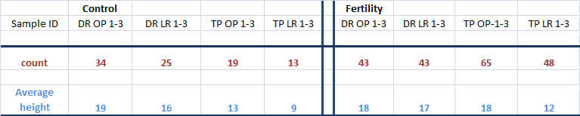
Table 2: Height Measurements 2012
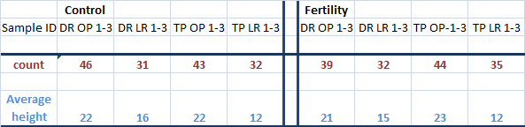
Table 3: Yield for peppers split-split plot Average fruit weight per plant
Calculation: total weight divided by number of plants of fruit at harvest
Note: *plants that have lower number of plants during harvest (than in height data) had plant die off or plant injury (first frost average Oct. 9-15 for field area)
 | Control (weight in pounds) |  |  |  | Fertility(weight in pounds)
Sample ID | DR OP 1-3 | DR LR 1-3 | TP OP  1-3 | TP LR  1-3 | DR OP  1-3 | DR LR  1-3 | TP OP 1-3 | TP LR  1-3
2011 (Oct 01 Harvest) | *31.4/33=0.95 | *16.3/21= 0.77 | 17.6/ 19=0.92 | *5.8/12= 0.48 | *46.3/42=1.1 | *27.2/40=0.68 | *110/61= 1.8 | 25.8/43= 0.60
2012  (Oct 08 Harvest) | 49.2/46 = 1.1 | 22/31= 0.71 | *54.6/42= 1.3 | 18/32=0.56 | *44/37=1.2 | *16.5/28=0.59 | 84.3/44=1.91 | *21.4/32=0.67

Chart 2: Yield comparison by type and year 2011-2012 Control versus Mycorhizzae/fertility treatment (same data as in Table 3)

