WSARE Project FW10-049

Title: "Pepper (Capsicum annum) Cultivation, Conservation, and Soil Ecology in Low-Input and Certified Organic Agricultural Systems"

**Original Objectives and Methods:**

*Compare each producer’s cultivation practices and individual landrace variety (LR var.) located at their farm sites (2 certified organic, 2 pesticide free).*The individual cooperators/farmers practices were observed and recorded by farm. Direct seed planting was conducted extremely early from April 10th-May 10th when ground temperatures were low (8-10°C) and germination took 3-4 weeks. The ability of these seed banks to germinate successfully in low soil temperature is a unique characteristic of the landrace peppers. Some participants soak the seed for 24-48 hours in compost tea before planting. When plots were observed the seedlings from the seeds that were presoaked in ‘compost tea’ were more vigorous and greener then control plots. No other fertilizer was added to the plots. In 2012 Campbell farm repeated this method and treated four 150 foot rows with compost tea (aged cattle manure) and 4 rows were untreated control (both 24 hour soaked either with tea of plain water) in 2012 and 2013. The same results were observed the rows that were treated with compost tea were vigorous and greener. In 2013 there was severe drought conditions and extreme heat. The acequia’s which supply the water for the farms are extremely low. Campbell’s field area for the peppers was approximately 4000 sf and the plants at the end of the field area (200 linear foot rows) only received minimal water. The USDA NRCS EQIP grant received by Sandoval and Campbell assisted in the use of the small amount water available in the ditch acequia system.

The participants harvested and dried pods in a variety of different techniques. Greigo farms hang the mature red pods 10 feet high in hanging mesh fencing under shade to protect the pods from rodents and the sun Picture 1.

Picture 1: Hanging peppers to protect pods from rodents

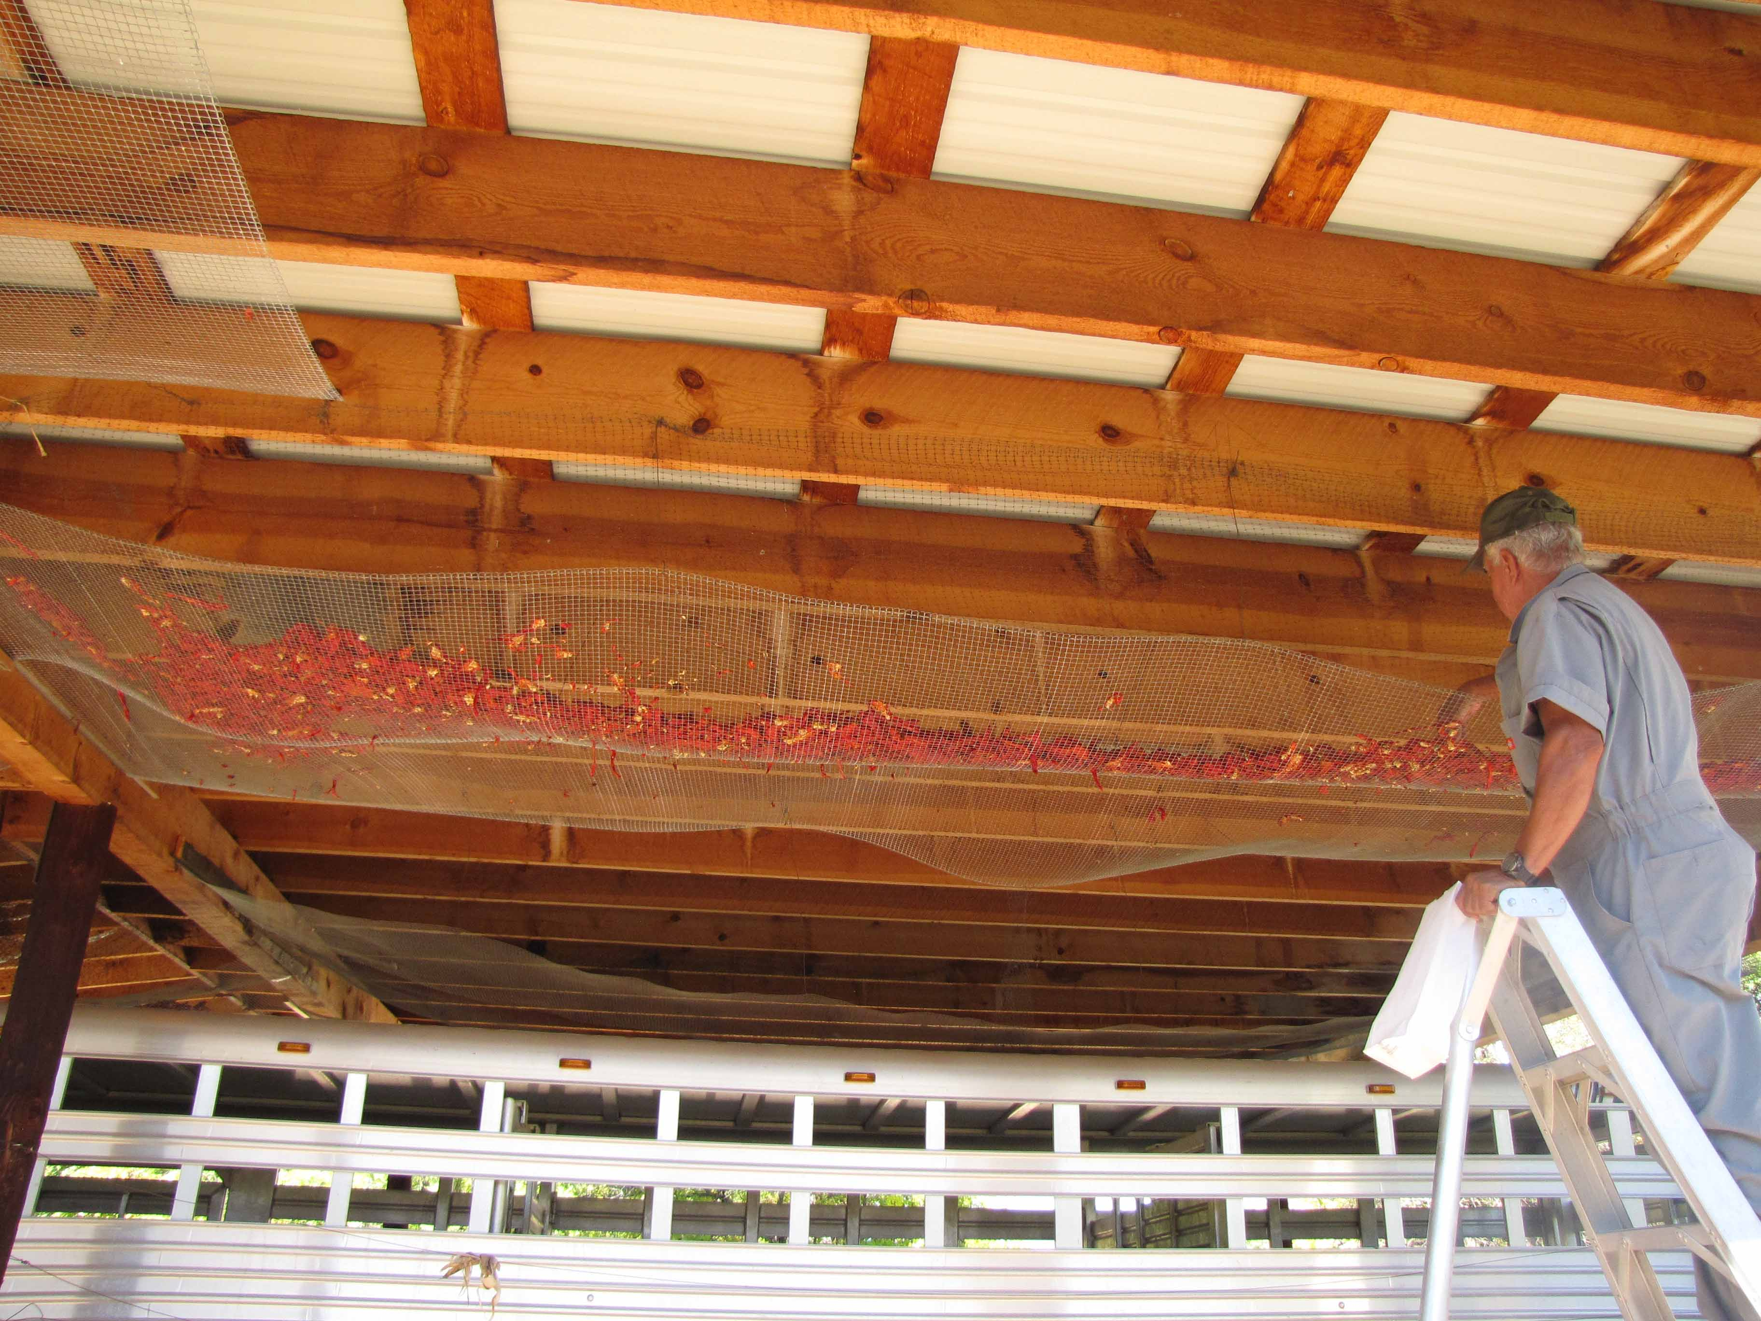

The seeds were removed before the drying process. Martinez farm place the pods on huge tarps that are pulled into the sun daily and returned into a large warehouse free of rodents. Campbell (Rancho Arco Iris) dry the peppers on flat racks placed on shelves under portals. Smaller growers such as the Herrera’s and Arellano in 2011-2012 create traditional ‘ristras’ to dry the pods. The pod drying process took approximately 6-12 weeks.

*Each seed collection will be propagated in the greenhouse to determine seedling uniformity and vigor. Propagation trials in the greenhouse will be replicated three times. The landrace seedlings grown in the greenhouse will also be transplanted in a row adjacent to each direct seeded field area to observe growth differences of direct seeded versus transplant (minimum 100 plants).*

Seeds from 2010 and 2011 were collected from each farm by randomly taking 2 ounces from their seed collections. The seeds were propagated in the greenhouse with sterile mix (perlite with sphagnum moss) and seed germination rates were recorded for both controls and mycorhizzae inoculated plots. Seed germination trials were conducted for each cooperator seed bank separately in 2011 and in 2012 cooperator seeds collected in 2011 were combined then propagated. Germination rates were recorded and are shown on table 1. The seedlings grown as transplants both years were used in the formal plots, each farmer seedling collection from the prior year were randomly added to the designated landrace plots.

Tray setup for germination studies in greenhouse: 4 seeds per cell (36 cells X 4 = 144 total) 72 cell seedling tray

Schematic 1: Tray setup for germination trials

|  |  |  |  |  |  |  |  |  |  |  |  |
| --- | --- | --- | --- | --- | --- | --- | --- | --- | --- | --- | --- |
|  |  |  |  |  |  |  |  |  |  |  |  |
|  |  |  |  |  |  |  |  |  |  |  |  |
|  |  |  |  |  |  |  |  |  |  |  |  |
|  |  |  |  |  |  |  |  |  |  |  |  |
|  |  |  |  |  |  |  |  |  |  |  |  |
|  |  |  |  |  |  |  |  |  |  |  |  |

Landrace Row 1-6 Anaheim or Joe E. Parker 7-12

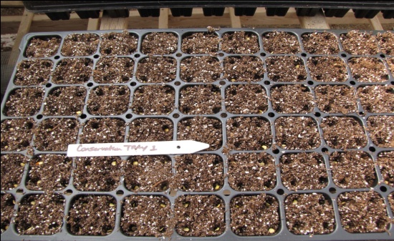

Picture 2: Seedling tray with seeds 2011

**Table 1 Germination Results 2011**

|  |  |  |  |  |  |  |
| --- | --- | --- | --- | --- | --- | --- |
| **Tray ID** | **Sow Date** | **Landrace Seedling count**  **Row 1-6** | **Anaheim**  **Seedling count**  **Row 7-12** | **Date data taken** | **Landrace%**  **Total Germination (x/144)** | **Anaheim%**  **Total Germination**  **(x/144)** |
| Conservation 1 Control Herrera | 4/14/11 | 87 | 106 | 5/19/11 | 60 | 74 |
| Conservation 1 mycorhizzae treated Herrera | 4/21/11 | 100 | 100 | 5/19/11 | 70 | 70 |
| Conservation 2 Control Arellano | 4/14/11 | 101 | 112 | 5/19/11 | 71 | 78 |
| Conservation 2 mycorhizzae treated Arellano | 4/21/11 | 127 | 120 | 5/19/11 | 89 | 83 |
| Conservation 3 Control Griego | 4/14/11 | 86 | 114 | 5/19/11 | 60 | 80 |
| Conservation 3 mycorhizzae treated Griego | 4/21/11 | 101 | 96 | 5/19/11 | 71 | 67 |
| Conservation 4 Control Campbell | 4/14/11 | 108 | 106 | 5/19/11 | 75 | 74 |
| Conservation 4 mycorhizzae treated Campbell | 4/21/11 | 116 | 104 | 5/19/11 | 81 | 73 |
| Conservation 5 Control Martinez | 4/14/11 | 113 | 101 | 5/19/11 | 78 | 73 |
| Conservation 5 mycorhizzae treated Martinez | 4/21/11 | 123 | 87 | 5/19/11 | 86 | 61 |

The mycorhizzae treated seedlings for the germination studies in the greenhouse for both the landrace and Anaheim peppers were more vigorous, larger, and greener seedlings as shown in Picture 3. The landrace seeds that were treated with mycorhizzae in the greenhouse germination studies had high germination rates than the control as shown in table 1. The Anaheim seedlings germination rate did not increase when seedlings were treated with mycorhizzae.

Picture 3: Germination studies Campbell landrace ‘Cañoncito’ 2011 and Anaheim with and without mycorhizzae (same seed lot for landrace and Anaheim)

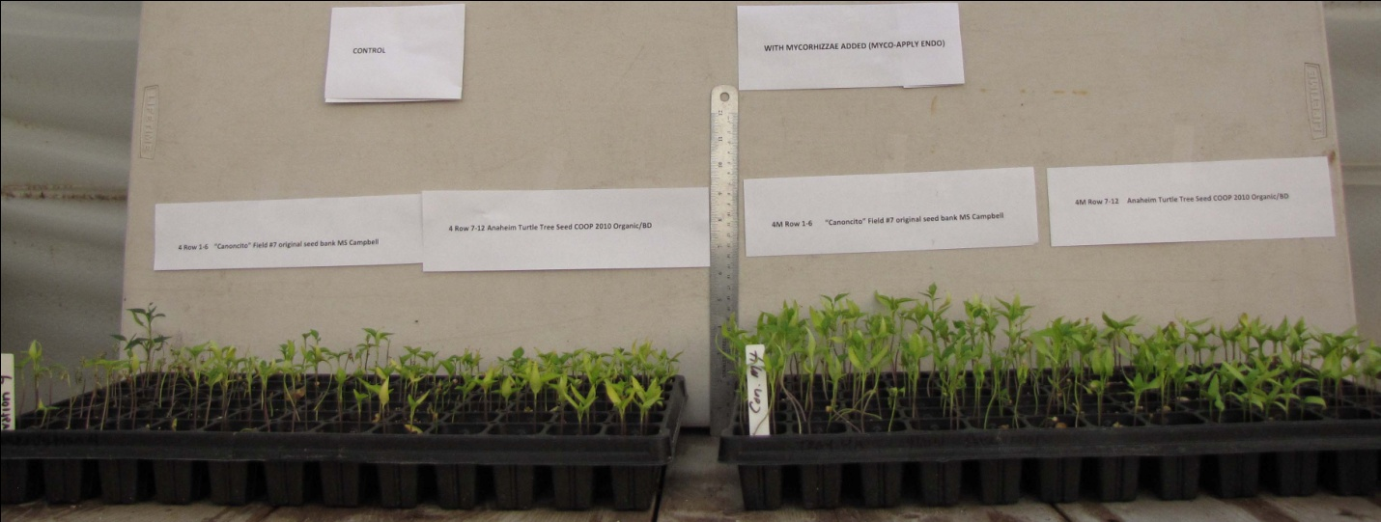

Landrace

Landrace

Anaheim

Anaheim

Mycorhizzae applied

Control no mycorhizzae

*Year 1 and 2: Measures for the farm site trials will include random sampling in the five field areas for fruit capsicum and antioxidant level testing, pod fresh weight (green) and pod dry weight (red), and pod counts per plant on 50-100 plants per field area. Disease prevalence, maturity dates, and vigor will also be recorded. Fertilizer treatments if any will be recorded for the season before and during the trials that each individual producer adds independently in their respective field areas. No suggestions will be made unless the producers request general information for cover crops or organic fertilizers before the trials begin. Any applied fertilizer treatments or other beneficial soil additives (Cover crops, Nitrogen, Phosphorus, Potassium, minor nutrients, humates, rhizobacteria or fungi) will be documented for each field area. These data would be collected for two seasons. Soil will be analyzed for baseline nutrient levels before the study begins.*

The capsicum analysis was performed for year 1 dried peppers (see chart 1) and the samples were freeze-stored for further testing. The landrace varieties have approximately 5-10 times the Capsicum levels as the Anaheim peppers. The lab that analyzed samples at New Mexico State University is allowing samples to be stored in stable conditions for any further analysis. The second year samples collected are dried and will be sent for capsicum testing in 2013. The landrace peppers are thin-skinned and dry faster than the Anaheim peppers. Testing was performed all at once when all peppers were properly dried. The vitamin C and antioxidant analysis could not been performed as of yet, due to the cost of testing being more expensive than anticipated ($50.00 per sample), first year cost for capsicum analysis of 42 samples @ 20.00 = $840 (original budget amount $560.00).

Soil analysis was conducted for formal block areas and other farm areas. The nutrient levels of all areas are low NP and average K available and pH is above 7.6 (see attached report for split-split plot area). Any amendments were recorded for all field areas. The fertilizer programs do not include mineral fertilizers of NPK and instead the farm areas are either planted with field peas, sugar snap peas, clover, in Spring of planting year or spread with goat or cattle manure (very light approximately ¼ inch depth or less) in Fall of prior year. Disease issues associated with peppers: Wilt disease for 2011 and 2012 was present in most cooperator field areas (5-10%) and formal plots areas (less than 3%). An interesting trend was noted in discussions with cooperators that indicated wilt was present in 2010 before the trials began, then with Serenade ASO treatment in 2011 with *Bacillus subtilis* (QST 710) wilt disease incidences decreased. Only one cooperator and Sandoval in the plot studies (Campbell) applied Serenade ASO in 2012 (was available to all cooperators) and wilt for all plots was less than 5%. Arellano commented that since we are in severe drought, wilt for our area has historically decreased and when we receive more moisture, the wilt has increased (conversations with his mother in the 1960’s). Campbell noted that she had less post-harvest fungal disease (blackening of peppers during drying) and Serenade ASO was applied when pods were green. It was not determined if this was the primary reason for low wilt incidence or a combination of cultural practices including 4 year rotation by plant family (Solanaceae) and isolating the peppers from other plant family members in the field. The dried landrace peppers had longer storage capacity and Campbell sold the dried pepper product from fall 2012 until July 2013 with less than 2% blackening of the pods noted. Griego (Romolo) landrace product also was sold commercially and had good color. The pods were extremely popular at market and Campbell had approximately 50 pounds dried with seed removed that sold for an average of $75.00 a pound (average price is 25.00 in region) when selling in 1 ounce packages as shown in picture 6. To give information to the public as the cooperators were marketing the pods, a handout was given out that had information about the WSARE grant and the project that the cooperators were involved with as shown in Appendix.

Picture 4: Dried landrace peppers 2012 Campbell

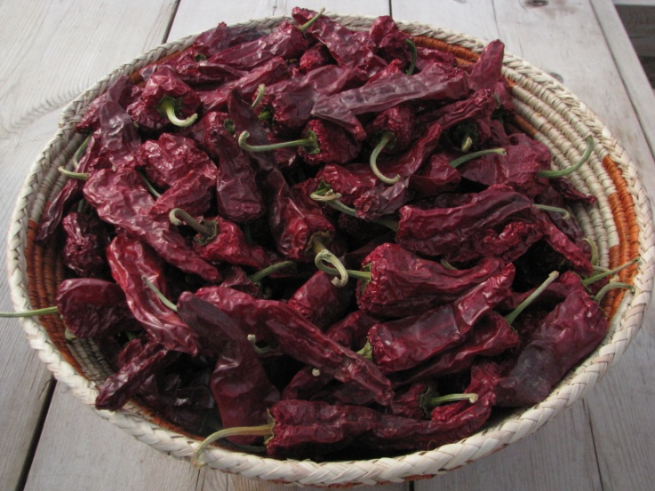

Picture 5: Griego (Romolo) pepper product (on right) 2011 Santa Fe farmers market

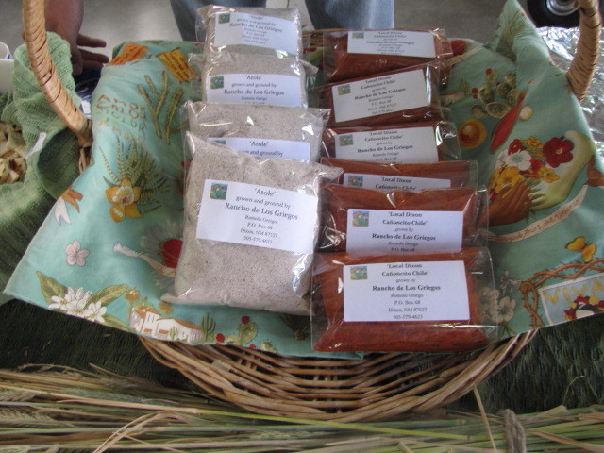

Picture 6: Campbell and Sandoval pepper product 2011

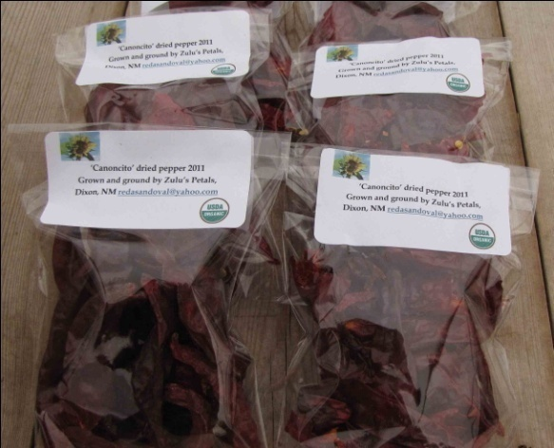

*Objective 2: To compare two pepper types in one field area, one landrace variety (LR var.) from composition of all seed collections used in Objective 1 and one open-pollinated (OP cv.) cultivar. Two fertility treatments will used: control (no inputs 2011), and a fertility program (cover crops and rock amendments P, K, micronutrients, beneficial mycorrhizae); two propagation treatments will be used (direct seed versus transplant). This results in a total of 8 treatments. Treatments combinations will be replicated three times using a split-split plot design. Main plot will be fertility program, propagation method will be subplot, and pepper type will be sub-sub plot. A pepper type sub-sub plot will be a single row of 20 plants in 20 feet (see plot designs in Appendix 1). Measures will be same as Objective 1.*

The split-split plot studies were conducted in 2011 and 2012 in Sandoval’s field area. The plots included a control plot with no fertility input and a fertility treatment that was treated with a commercial mycorhizzae (MycoApply ENDO) and rock amendments if needed (rock phosphate, greensand). The amendment was applied carefully and uniformly to the plot areas. The 2011 plot field area had high weed pressure (bindweed) that was labor intensive to keep weed free but had no other problems as far as field site. The plot was analyzed for nutrient levels and the soil report is in Table 1. Year 1 plot is ‘lower field’; year 2 is “middle field” on report. The pH was 7.7-7.9 and consisted of clay to clay loam or sandy loam. Seedling for the transplant plots (TP) were grown in the greenhouse as per attached report ‘seedling germination trials’. The direct seed (DR) plots for all participants including the split-split plot studies were sowed between May 15 and June 1 and depended on the ground temperature (above 48°F at 8 am). All direct seeded plots were sowed on the same day.

Table 1: Soil test split-split plot Sandoval field area



Schematic 2: Field setup split-split plot randomized within control or fertility treatment. Fertility and control plots placement in the designated area of the field were randomly selected.

|  |  |  |
| --- | --- | --- |
| CONTROL 12 PLOTS  ANAHEIM-6 PLOTS  3 DIRECT SEED  3 TRANSPLANT  LANDRACE-6 PLOTS  3 DIRECT SEED  3 TRANSPLANT | BUFFER AREA | FERTILITY TREATMENT  ANAHEIM-6 PLOTS  3 DIRECT SEED  3 TRANSPLANT  LANDRACE-6 PLOTS  3 DIRECT SEED  3 TRANSPLANT |

Picture 7: WSARE split-split plot 2011 Sandoval field 7/13/11(47 days) sow date 5/26/11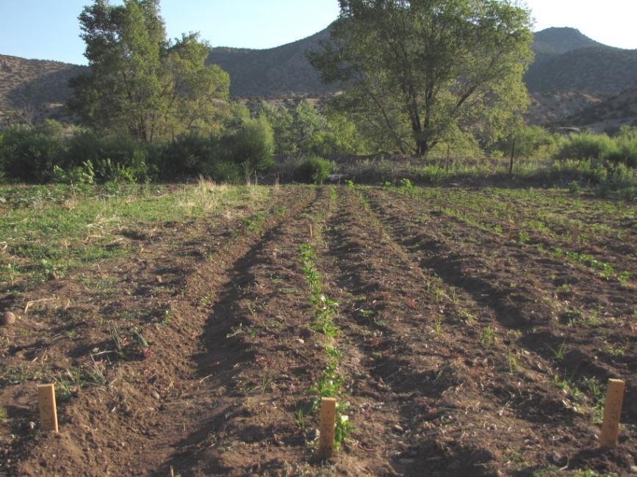

Picture 8: Split- split plot 7/13/11 47 days

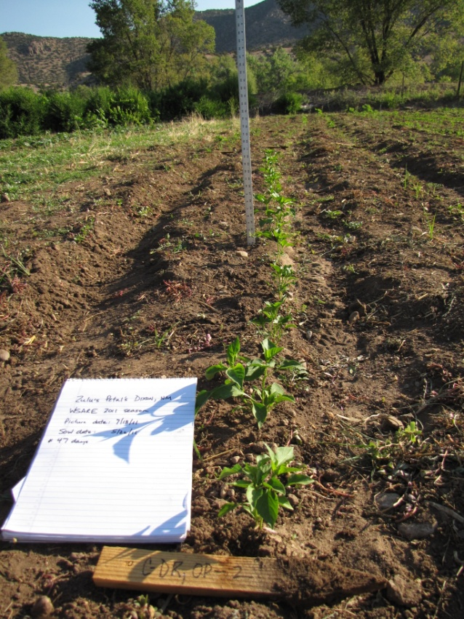

Picture 9: Split-split plot 2011 Sandoval field control versus fertility treatment 7/15/11

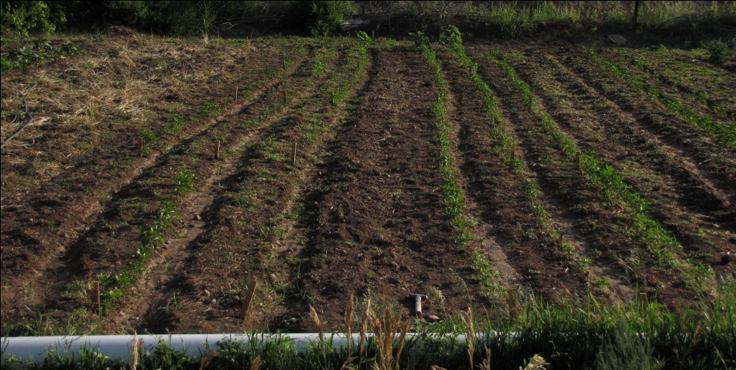

Fertility treatment

Control

Picture 10: Split-split plot 2011 Sandoval field control versus fertility treatment 8/15/11 (approximately 80 days)

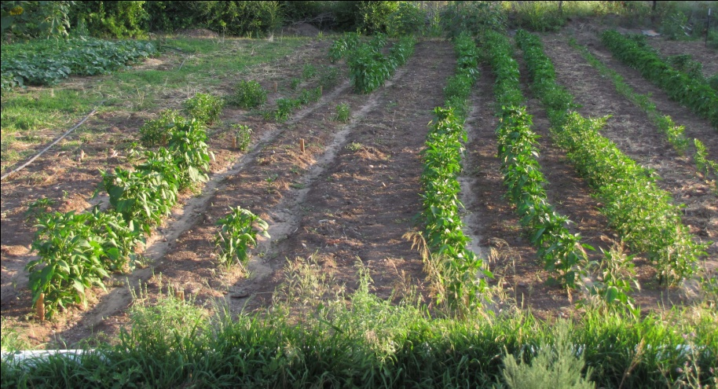

Fertility treatment

Control

The pepper plot in 2012 had less weed pressure since ryegrass and clover cover crop (20:80) were planted the year before. The field area in 2012 also had better drainage and soil was not as compacted as in 2011 clay loam area.

Picture 11: Split-split plot 2012 Sandoval field June 2012 (middle field area for soil test)

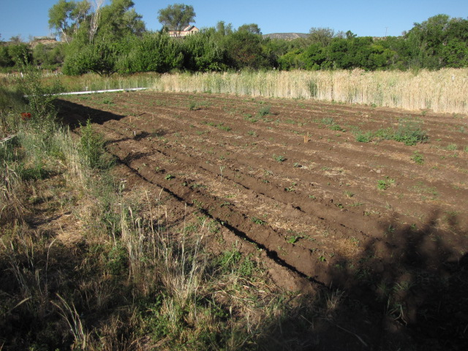

The results for the Capsicum analysis are shown in chart 1. The standard deviation between the three replicates for each sample was high and may be the result of the analysis method (GC-MS extraction) or dilution issue (10X). The Capsicum results for the landrace peppers in the control plots indicate that the levels increase for the transplants versus the direct-seeded which may indicate a stress response that is higher in the transplants then the direct seeded plots. The fertility treatment results indicate that the concentration of Capsicum for direct seeded versus the transplants are very similar and the concentration of Capsicum may be lower because the plants for the fertility treatment plots (mycorhizzae treated) had less overall plant stress than the control plots. This finding was surprising and would be an area that would require further study and comparison to 2012 data results once submitted and analyzed. Picture 5 also indicated a higher survival rate of the fertility plots versus the control plots for both the direct seeded and transplant plot areas. Plants were also in general healthier and had better color in the fertility treatment plots. The cooperator plot areas are shown in Pictures 12-15. In general the cooperators did not use any fertilizers in the field areas for the landraces with one exception of soaking the seed in well-aged compost for 24-48 hours (Herrera and Campbell) then planting the seed in a small area of the plot within their field area. The seedlings that were soaked in compost tea were overall greener and larger than the seedlings that did not have a pre-planting compost tea soak. No other fertilization was performed in these plots. The pH of the soil for the cooperator plots were high pH (7.7-7.8) and had very little NPK present. The difference in plant vigor with the manure tea treatment may indicate that a symbiotic relationship of the pepper plants with a fungi present in the compost that may have enhanced the uptake of nutrients. Further study needs to be preformed to indicate possible mutualism or symbiosis of the pepper plant and fungi present in the compost.

Height measurements were taken in the plots when plants were at full maturity (September 2011-2012). The heights and number of plants present in each plot type (all three replicates combined) are shown in Table 1 and 2. The plant count data for 2011 for the fertility plots versus the control indicate that the fertility treatment (mycorrhizae application) increased survival of the seedlings. The data for 2012 for the plots were not as different and more plants survived in the control plot than in 2011.The heights for both the landrace and Anaheim plots were higher for the direct seeded plots in 2011. In 2012 the Anaheim plots were very similar in heights and landrace peppers heights were higher for the direct seeded plots only. The wilt present in both years was minimal (less than 2%).

Yield in split-split plots

The yield was measured in the split-split in 2011 and 2012. The data is shown in table 3 and Chart 2. The cooperator data will be submitted when the survey is given. The yield for the Anaheim plot (fertility) had the highest yield and weight by plant at near two pounds per plant versus the untreated control with approximately one pound per plant. The landrace plots also responded to the treatment mycorrhizae and had slightly higher yields than the control plot. The direct seeded landrace plots control versus fertility treatment yield had similar values regardless of the fertility treatment. The capsicum levels in chart 2 were higher in the control treatment plots for the landrace transplant plots. The direct seeded landrace plots had higher yield than the transplant plots for both years. The landrace seed is mass selected from direct seeded plants for many generations and using transplants may weaken the yield and the plant vigor overall. The Anaheim plots that were direct seeded and transplanted in the fertility treatment plots had the highest survival rate and also the highest yield.

Chart 1: Capsicum-dihydrocapsicum ppm per gram dried pepper 2011 for Split-split plot and cooperator field areas (average of three replicates)

Capsicum-Dihydocapsicum ppm/gram dried pepper

Table 1: Height measurements 2011

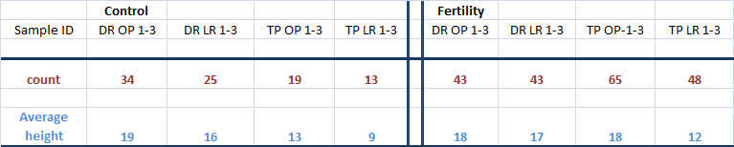

Table 2: Height Measurements 2012

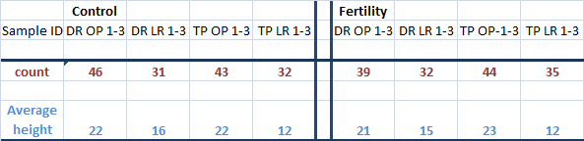

Table 3: Yield for peppers split-split plot Average fruit weight per plant

Calculation: total weight divided by number of plants of fruit at harvest

Note: *plants that have lower number of plants during harvest (than in height data) had plant die off or plant injury (first frost average Oct. 9-15 for field area)

|  |  |  |  |  |  |  |  |  |
| --- | --- | --- | --- | --- | --- | --- | --- | --- |
|  | **Control (weight in pounds)** | | | | **Fertility(weight in pounds)** | | | |
| Sample ID | DR OP 1-3 | DR LR 1-3 | TP OP  1-3 | TP LR  1-3 | DR OP  1-3 | DR LR  1-3 | TP OP 1-3 | TP LR  1-3 |
| 2011 (Oct 01 Harvest) | *31.4/33=**0.95** | *16.3/21**= 0.77** | 17.6/ 19=**0.92** | *5.8/12= **0.48** | *46.3/42**=1.1** | *27.2/40**=0.68** | *110/61= **1.8** | 25.8/43= **0.60** |
| 2012  (Oct 08 Harvest) | 49.2/46 = **1.1** | 22/31= **0.71** | *54.6/42= **1.3** | 18/32=**0.56** | *44/37=**1.2** | *16.5/28=**0.59** | 84.3/44=**1.91** | *21.4/32**=0.67** |

Chart 2: Yield comparison by type and year 2011-2012 Control versus Mycorhizzae/fertility treatment (same data as in Table 3)

Picture 12: Estevan Arellano plot 2011-12; area: 500 sf

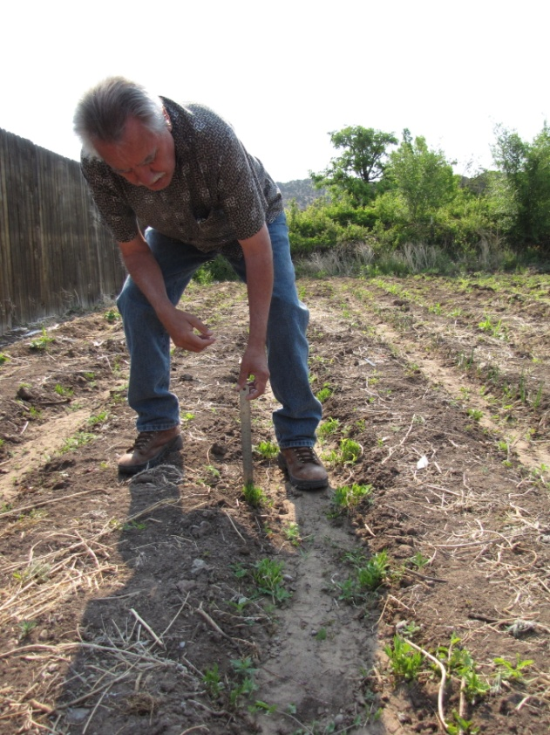

Picture 13: Martinez Plot 2012; 2000 sf

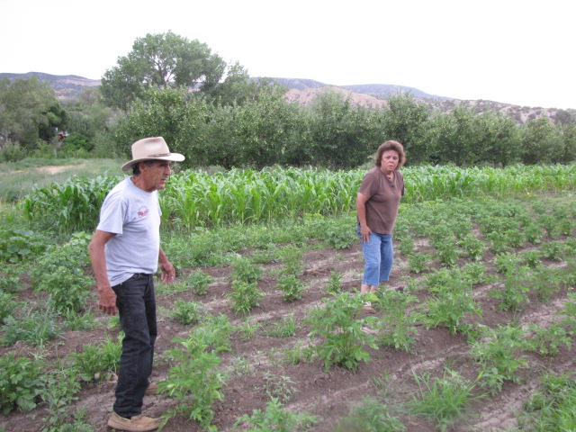

Picture 14: Campbell plot 2012 3000 sf

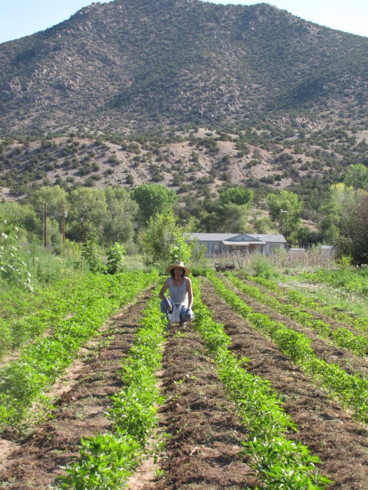

Picture 15: Griego plots 2011-2012; 2 acres total each year, three field areas

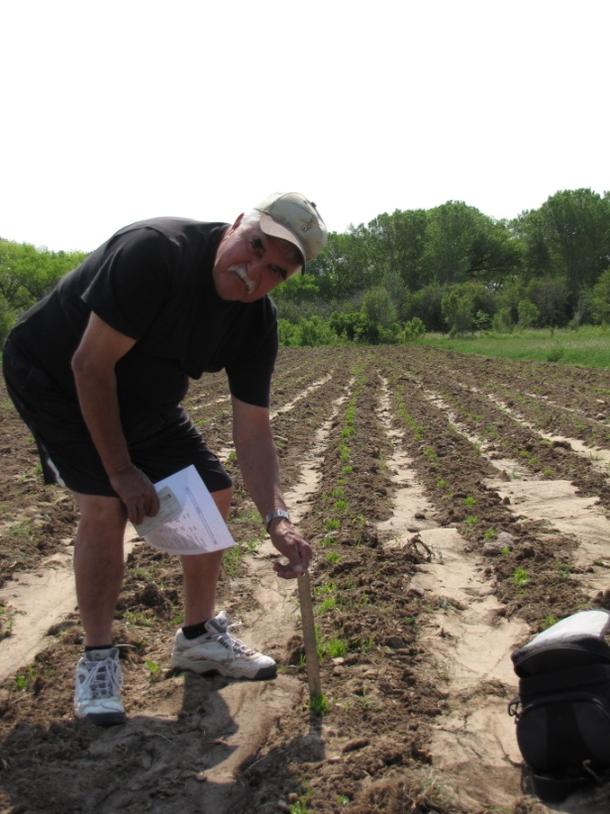

There was severe drought for both growing seasons in New Mexico (2011: less than 7” rain/season, 2012: 4” rain/ season) in addition to high winds and intense heat. Plots were flood irrigated once weekly on a strict schedule and timing approximately 0.5 inches. As stated in the experimental design, 8 treatments and three replicates were done. See schematic 2 for split-split plots in field area.

In both 2011 and 2012 the split-split plot (Anaheim and Landrace accessions) with both transplanted seedlings and direct seeded seedlings had poor to strong growth. The landrace (designated LR) that was direct seeded (DS) in the ‘fertility treatment’ plots and the ‘control’ were very similar plant size and germination %, but the transplanted landrace (LR, TP) seedlings were weaker, less upright, less vigorous plants and performed poorly both in the control plots (no nutrients)and the fertility (mycorhizzae applied) treatment areas. The ‘Anaheim’ (designated open-pollinated OP) direct seeded plants and transplants had a similar trend as the landraces. The direct seed plants were also more upright and vigorous. The root structure of the direct seeded plots for both the landraces and the Anaheim’s had a taproot in the center and the transplant plot plants had more of a fibrous root structure. The direct seeded Anaheim’s were more vigorous for both the control and the fertility plots however the transplants were smaller and less vigorous plants (see height data 2011-2012). Disease issues were minimal with less than 5% wilt on any plot. The direct sown seed for both the landrace and Anaheim plots had low germination (50% or less) as compared to the greenhouse germination trials which had germination rates of 60-89% (seed germination trial). Since the landrace seeds were a composite of all participants’ seeds, the source of the poor germination (a specific landrace accession) in the field was not known. However, the Anaheim results had a similar trend of poor germination for direct seeded plots versus fair to good germination for greenhouse studies. The percent germination for the landraces and Anaheim’s was not performed for field studies; this may be performed in further studies to determine germination rate. Overall four seeds were sown 1 foot apart in plot areas 20 foot long. The transplant plots also each had 4 seeds per foot (80 plants possible per plot area).

Peppers were harvested in October for the split-split plot trials and placed in cardboard boxes in a greenhouse for the drying process (no direct sun under shade cloth with good ventilation). The cooperators started harvesting the peppers in late August for green and left specific pods on the plants for seed depending on individual specific criteria (pod color, health, vigor). The landrace peppers turned red and dried very quickly in less than 4 weeks and the Anaheim pods dried in 10-12 weeks or longer. The Anaheim pods were cut open to expedite the drying process after several weeks.

Another interesting trend was seen comparing pod red maturity of the fertilization treatment direct seed and transplant plots. The pods from the direct seeded plots reached red maturity after harvested during drying (darker red versus orange) than the transplanted plots. The fertility treatment plots matured faster for the same pepper type than the transplant plots and the pods turned red with and had mature seeds (picture 1-2 seeds not shown). The landrace fertility transplant plots also turned red and the seeds were dark yellow (not shown) and reached full maturity versus immature seeds in the pods (picture 3-4). The Anaheim direct seed plot fertility treatment also matured faster than the Anaheim transplant fertility treatment (picture 5-6). The direct seeded control landrace plot also matured faster than the control transplant landrace plots (picture 7-8). These findings were seen in 2012 however the differences were not as stark as 2011 field plot results. The field area in 2012 had clover and cover crops prior to planting and the field area may have had more nutrients available or was less stressful for the plots, however this area of research needs further study.