Appendix A:

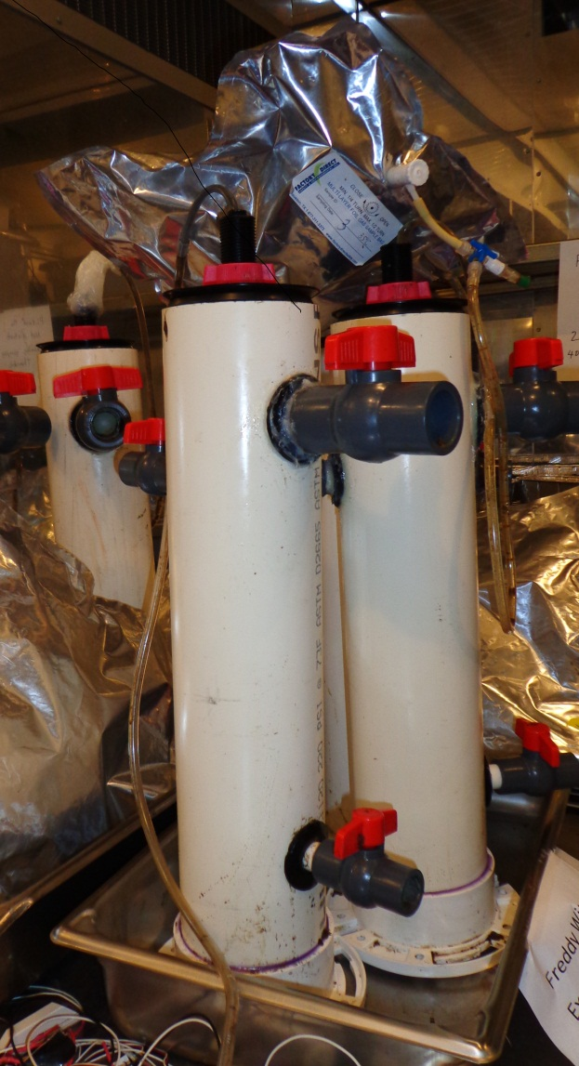
Figure 1: Anaerobic digestion reactors (approximately 3.5L in volume) used to incubate sediments from wetland sites 1 and 2, leachate from landfill sites 1 and 2, and mesophilic digestate from BARC digester.

Table 1: Feeding regimen for reactors incubating various sources of inoculum.
Modified from Bull et al., 1983 and Bardulet et al., 1990.
Days | Total COD Loading Rate (kg/m³/day) | Methanol COD (kg/m³/day)
0-9 | 0.1 | 0.05
10-19 | 0.25 | 0.125
20-24 | 0.5 | 0.25
25-29 | 0.5 | 0.125
30-34 | 0.75 | 0.1875
35-39 | 0.75 | 0
40-49 | 1 | 0
≥50 | 1.3 | 0

