Appendix B:

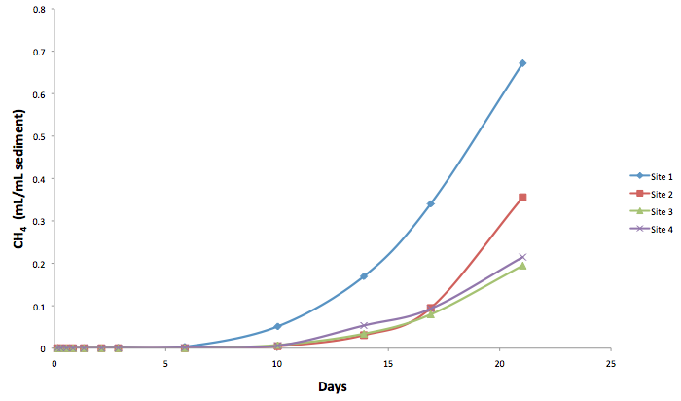
Figure 1: Cumulative methane production for the specific methanogenic activity tests conducted on sediments from 4 wetland sites located in Maryland. Description of sites can be found in text.
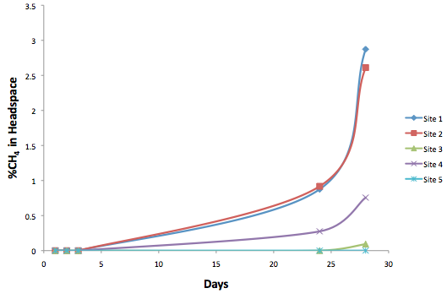
Figure 2: Percent methane for the specific methanogenic activity (SMA) tests conducted on leachate from 5 landfill sites located in Maryland and Virginia. Description of sites can be found in text.

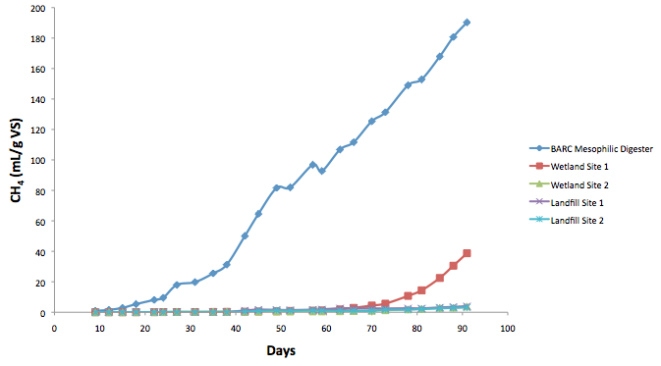
Figure 3: Cumulative methane production (mL/g VS) measured from the incubation of inocula at 15°C.

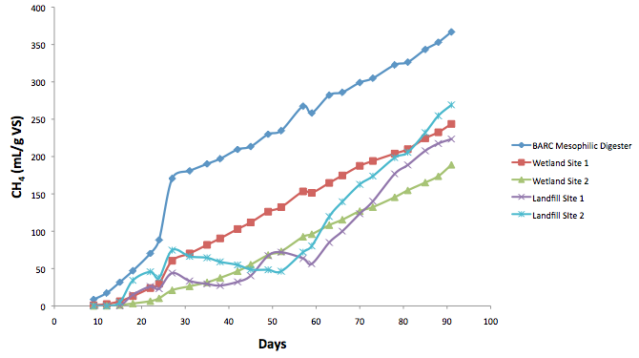
Figure 4: Cumulative methane production (mL/g VS) measured from the incubation of inocula at 25°C.

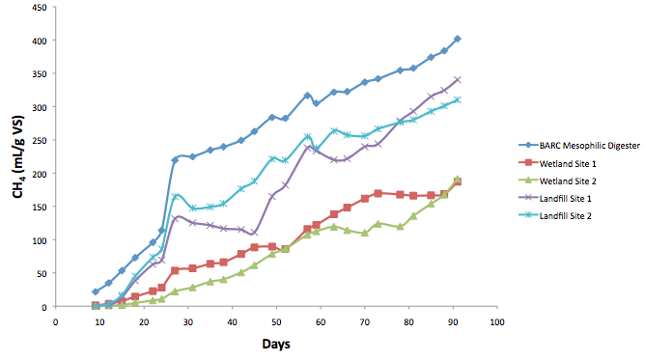
Figure 5: Cumulative methane production (mL/g VS) measured from the incubation of inocula at 35°C.

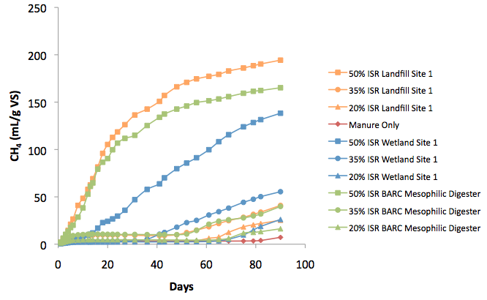
Figure 6: Cumulative methane production (mL/g VS (manure)) measured for the biochemical methane potential (BMP) tests at 25°C using different inoculum source and inoculum to substrate ratio (ISR) (w/w). Inocula used for this BMP test had been incubated for 3 months.

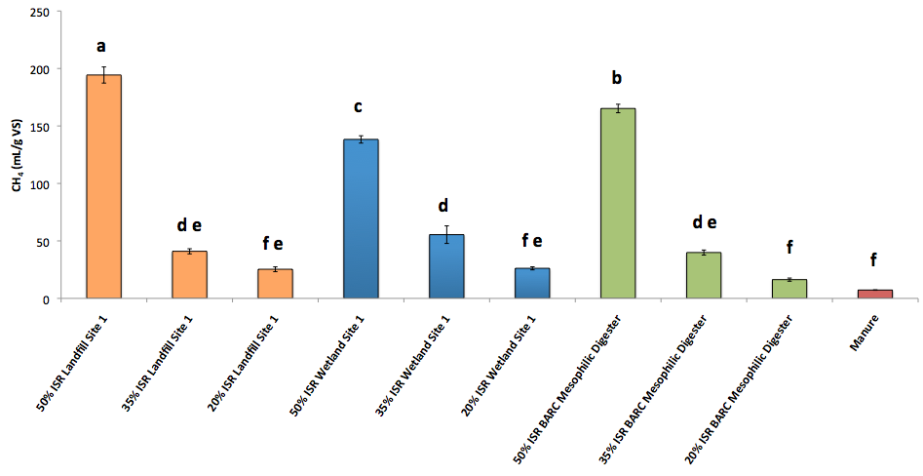
Figure 7: Total methane production (mL/g VS (manure)) measured for the biochemical methane potential (BMP) tests at 25°C using different inoculum source and inoculum to substrate ratio (ISR) (w/w). Inocula used for this BMP test had been incubated for 3 months. Different letters indicate significant differences (p<0.05) between groups from Tukey-Kramer analysis.

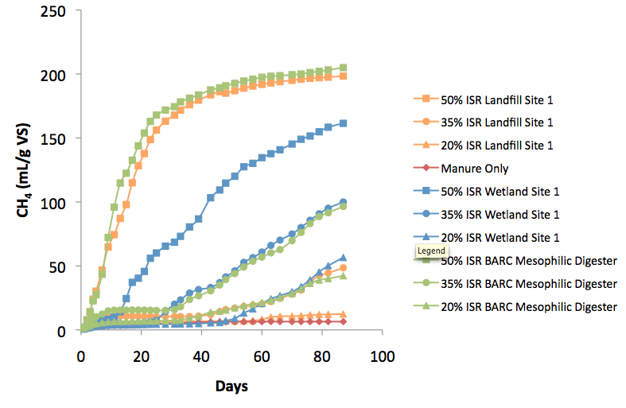
Figure 8: Cumulative methane production (mL/g VS (manure)) measured for the biochemical methane potential (BMP) tests at 35°C using different inoculum source and inoculum to substrate ratio (ISR) (w/w). Inocula used for this BMP test had been incubated for 3 months.

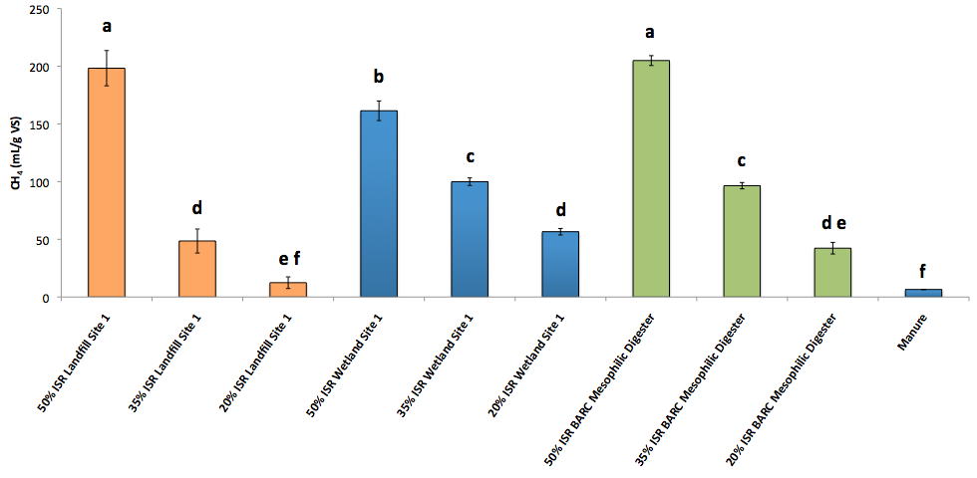

Figure 9: Total methane production (mL/g VS (manure)) measured for the biochemical methane potential (BMP) tests at 35°C using different inoculum source and inoculum to substrate ratio (ISR) (w/w). Inocula used for this BMP test had been incubated for 3 months. Different letters indicate significant differences (p<0.05) between groups from Tukey-Kramer analysis.

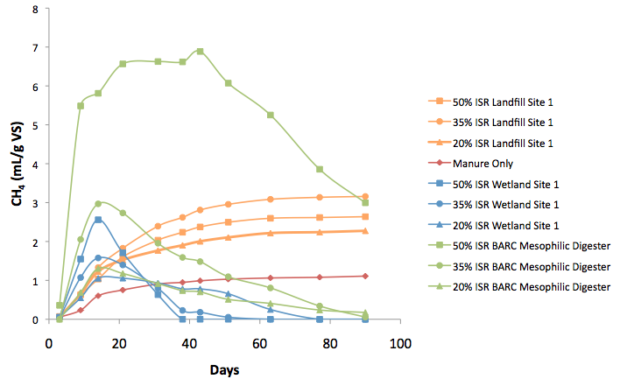
Figure 10: Cumulative methane production (mL/g VS (manure)) measured for the biochemical methane potential (BMP) tests at 15°C using different inoculum source and inoculum to substrate ratio (ISR) (w/w). Inocula used for this BMP test had been incubated for 3 months. Fall in cumulative values was due to higher rate of methane production by the inocula control than the corresponding treatments.

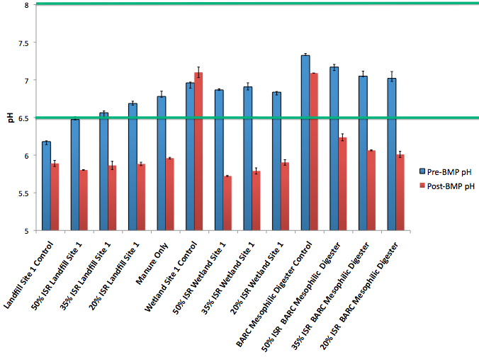
Figure 11: pH values of pre- and post biochemical methane potential (BMP) mixtures using different inocula and inoculum to substrate ratio (ISR) (w/w) at 15°C. All inocula used had been incubated for 3 months. Green lines indicate the range of pH values acceptable for anaerobic digestion (Seadi et al., 2008).

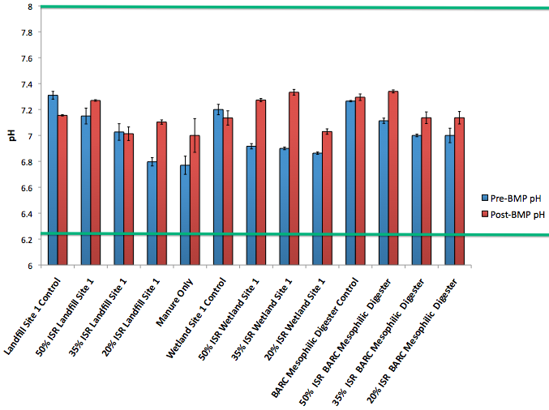
Figure 12: pH values of pre- and post biochemical methane potential (BMP) mixtures using different inocula and inoculum to substrate ratio (ISR) (w/w) at 25°C. All inocula used had been incubated for 3 months. Green lines indicate the range of pH values acceptable for anaerobic digestion (Seadi et al., 2008).

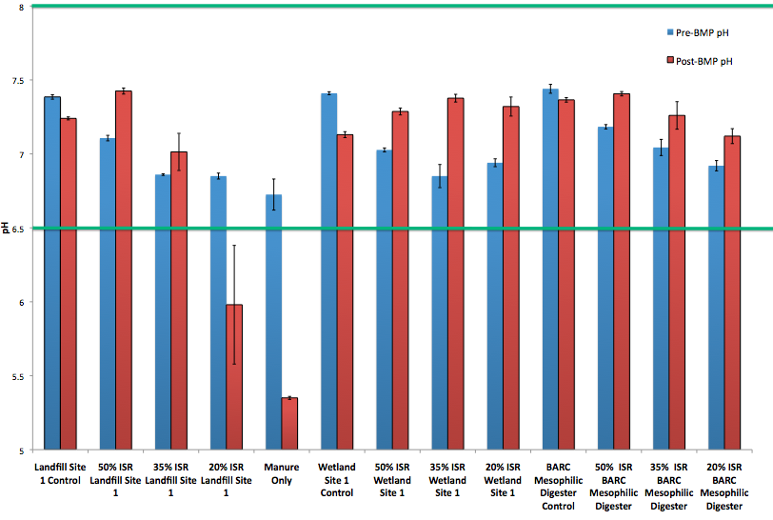
Figure 13: pH values of pre- and post biochemical methane potential (BMP) mixtures using different inocula and inoculum to substrate ratio (ISR) (w/w) at 35°C. All inocula used had been incubated for 3 months. Green lines indicate the range of pH values acceptable for anaerobic digestion (Seadi et al., 2008).
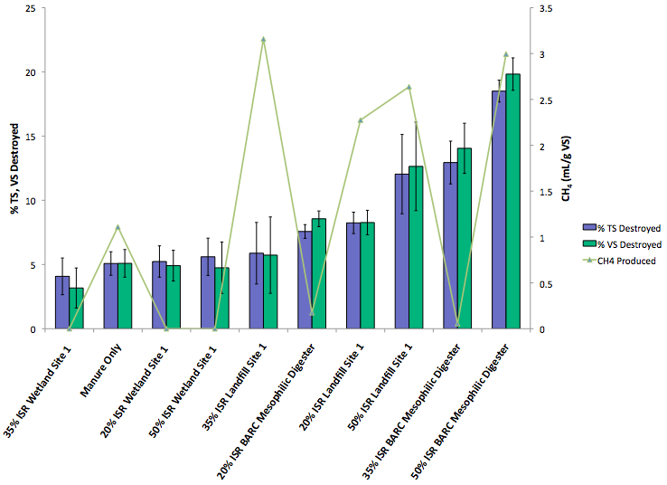
Figure 14: Percent of manure total solids and volatile solids destroyed and their relationship to manure production (mL/g VS (manure)) for the biochemical methane potential (BMP) tests at 15°C. The treatments had different inocula that had been incubated for 3 months and inoculum to substrate ratio (ISR) (w/w).

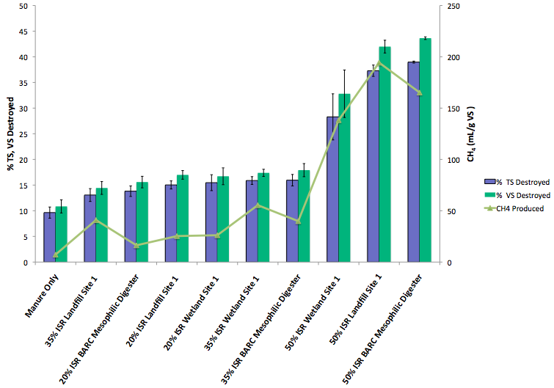
Figure 15: Percent of manure total solids and volatile solids destroyed and their relationship to manure production (mL/g VS (manure)) for the biochemical methane potential (BMP) tests at 25°C. The treatments had different inocula that had been incubated for 3 months and inoculum to substrate ratio (ISR) (w/w).
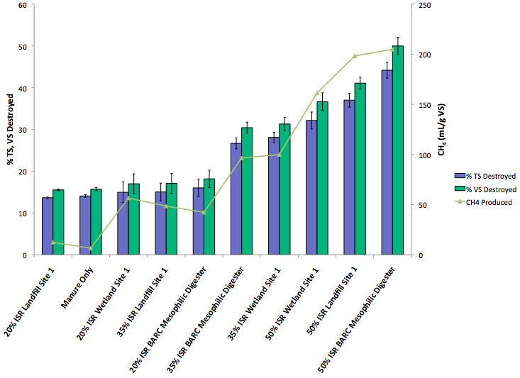
Figure 16: Percent of manure total solids and volatile solids destroyed and their relationship to manure production (mL/g VS (manure)) for the biochemical methane potential (BMP) tests at 35°C. The treatments had different inocula that had been incubated for 3 months and inoculum to substrate ratio (ISR) (w/w).

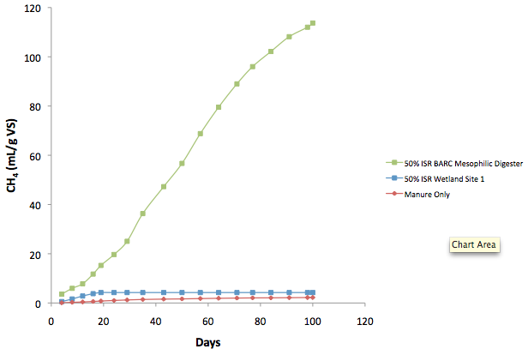
Figure 17: Cumulative methane production (mL/g VS (manure)) measured for the biochemical methane potential (BMP) tests at 15°C using different inoculum source and inoculum to substrate ratio (ISR) (w/w). Inocula used for this BMP test had been incubated for 6 months.
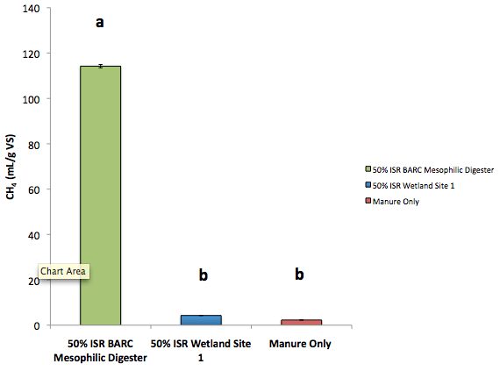
Figure 18: Total methane production (mL/g VS (manure)) measured for the biochemical methane potential (BMP) tests at 15°C using different inoculum source and inoculum to substrate ratio (ISR) (w/w). Inocula used for this BMP test had been incubated for 6 months. Different letters indicate significant differences (p<0.05) between groups from Tukey-Kramer analysis.

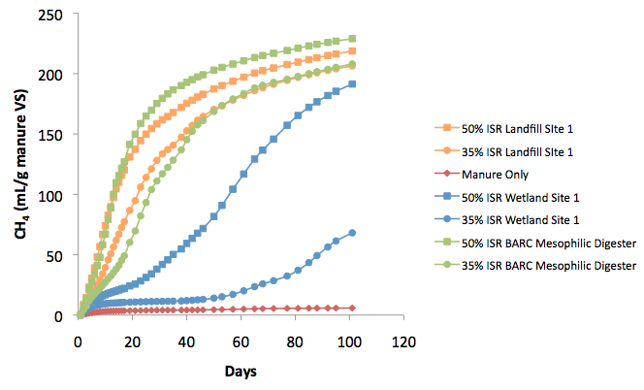
Figure 19: Cumulative methane production (mL/g VS (manure)) measured for the biochemical methane potential (BMP) tests at 25°C using different inoculum source and inoculum to substrate ratio (ISR) (w/w). Inocula used for this BMP test had been incubated for 6 months.

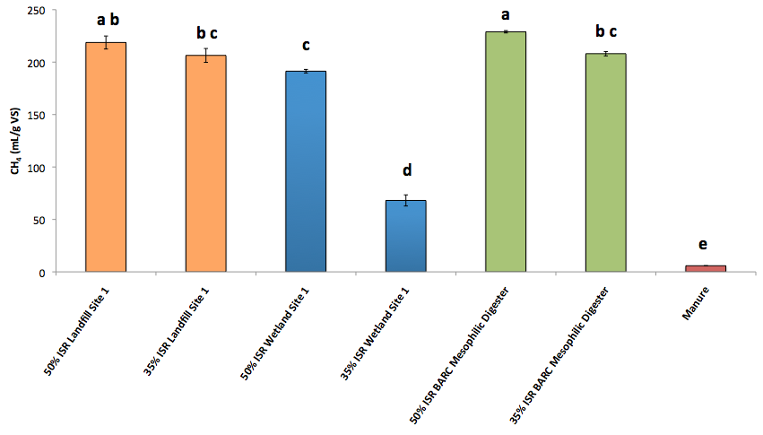
Figure 20: Total methane production (mL/g VS (manure)) measured for the biochemical methane potential (BMP) tests at 25°C using different inoculum source and inoculum to substrate ratio (ISR) (w/w). Inocula used for this BMP test had been incubated for 6 months. Different letters indicate significant differences (p<0.05) between groups from Tukey-Kramer analysis.

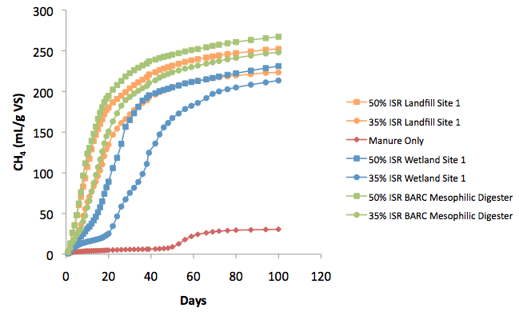
Figure 21: Cumulative methane production (mL/g VS (manure)) measured for the biochemical methane potential (BMP) tests at 35°C using different inoculum source and inoculum to substrate ratio (ISR) (w/w). Inocula used for this BMP test had been incubated for 6 months.
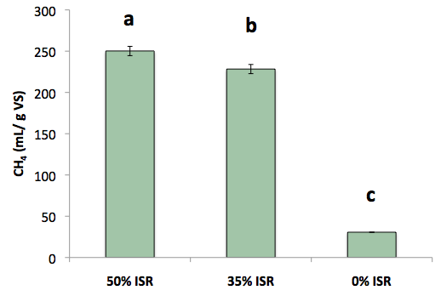
Figure 22: Total methane production (mL/g VS (manure)) measured for the biochemical methane potential (BMP) tests at 35°C using different inoculum to substrate ratio (ISR). Inocula used for this BMP test had been incubated for 6 months. Different letters indicate significant differences (p<0.05) between groups from Tukey-Kramer analysis.

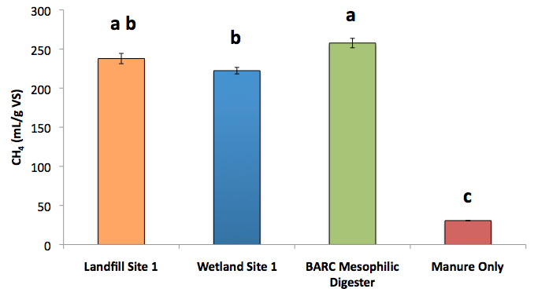
Figure 23: Total methane production (mL/g VS (manure)) measured for the biochemical methane potential (BMP) tests at 35°C using different inoculum source. Inocula used for this BMP test had been incubated for 6 months. Different letters indicate significant differences (p<0.05) between groups from Tukey-Kramer analysis.

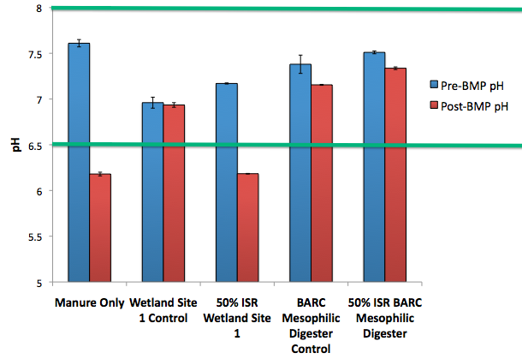

Figure 24: pH values of pre- and post biochemical methane potential (BMP) mixtures using different inocula and inoculum to substrate ratio (ISR) (w/w) at 15°C. All inocula used had been incubated for 6 months. Green lines indicate the range of pH values acceptable for anaerobic digestion (Seadi et al., 2008).

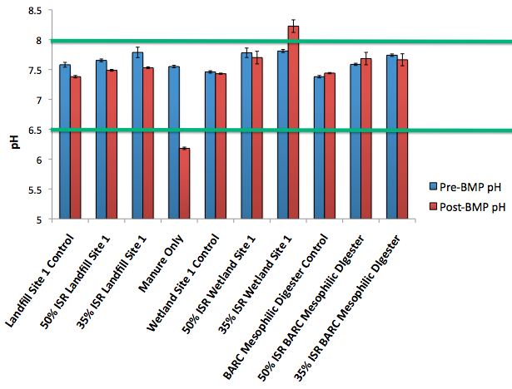
Figure 25: pH values of pre- and post biochemical methane potential (BMP) mixtures using different inocula and inoculum to substrate ratio (ISR) (w/w) at 25°C. All inocula used had been incubated for 6 months. Green lines indicate the range of pH values acceptable for anaerobic digestion (Seadi et al., 2008).

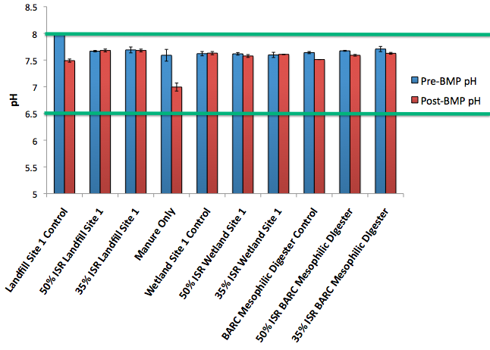
Figure 26: pH values of pre- and post biochemical methane potential (BMP) mixtures using different inocula and inoculum to substrate ratio (ISR) (w/w) at 35°C. All inocula used had been incubated for 6 months. Green lines indicate the range of pH values acceptable for anaerobic digestion (Seadi et al., 2008).

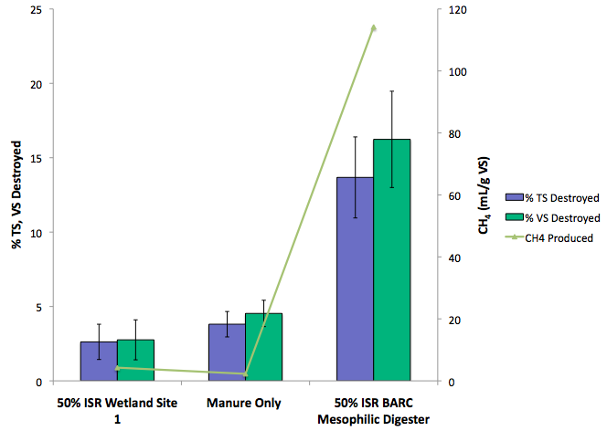
Figure 27: Percent of manure total solids and volatile solids destroyed and their relationship to manure production (mL/g VS (manure)) for the biochemical methane potential (BMP) tests at 15°C. The treatments had different inocula that had been incubated for 6 months and inoculum to substrate ratio (ISR) (w/w).

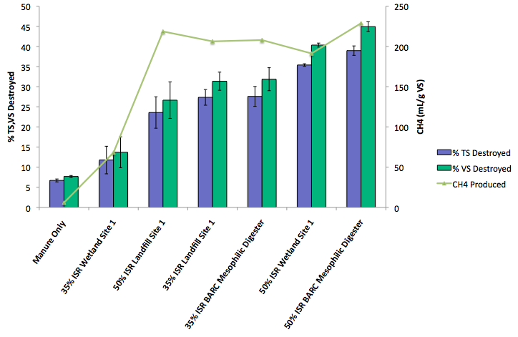
Figure 28: Percent of manure total solids and volatile solids destroyed and their relationship to manure production (mL/g VS (manure)) for the biochemical methane potential (BMP) tests at 25°C. The treatments had different inocula that had been incubated for 6 months and inoculum to substrate ratio (ISR) (w/w).

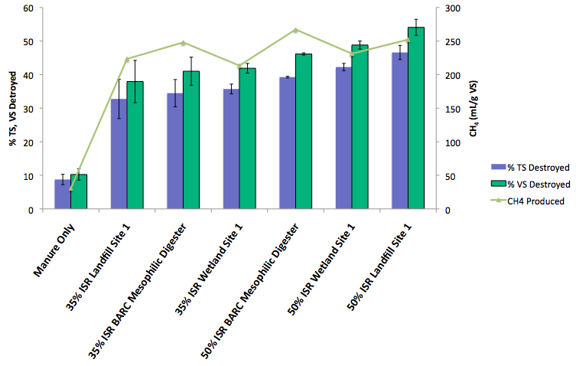
Figure 29: Percent of manure total solids and volatile solids destroyed and their relationship to manure production (mL/g VS (manure)) for the biochemical methane potential (BMP) tests at 35°C. The treatments had different inocula that had been incubated for 6 months and inoculum to substrate ratio (ISR) (w/w).

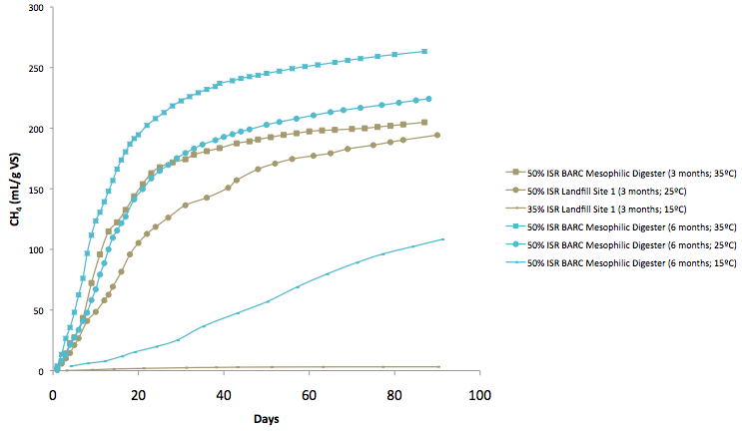
Figure 30: Comparison of the highest methane (mL/g VS (manure)) producers at each temperature for the two BMP experiments that used inocula with two different incubation times (6 months and 3 months). ISR refers to inoculum to substrate ratio (w/w).

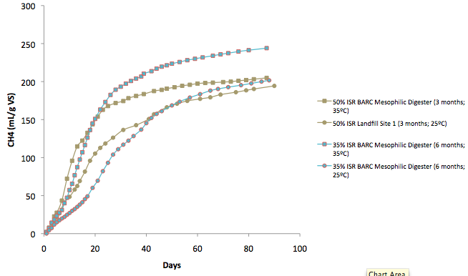
Figure 31: Comparison of methane (mL/g VS (manure)) produced by treatments that had 35% inoculum to substrate ratio (ISR) (w/w) at 25°C and 35°C in BMP 2 (using inocula incubated for 6 months) with the highest methane producing treatments at the same temperatures that had 50% ISR in BMP 1 (using inocula incubated for 3 months).

