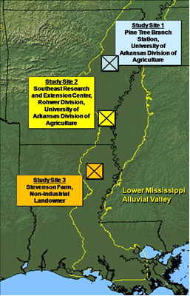
Figure 1. Location of study sites in LMAV.
Figure 1. Location of study sites
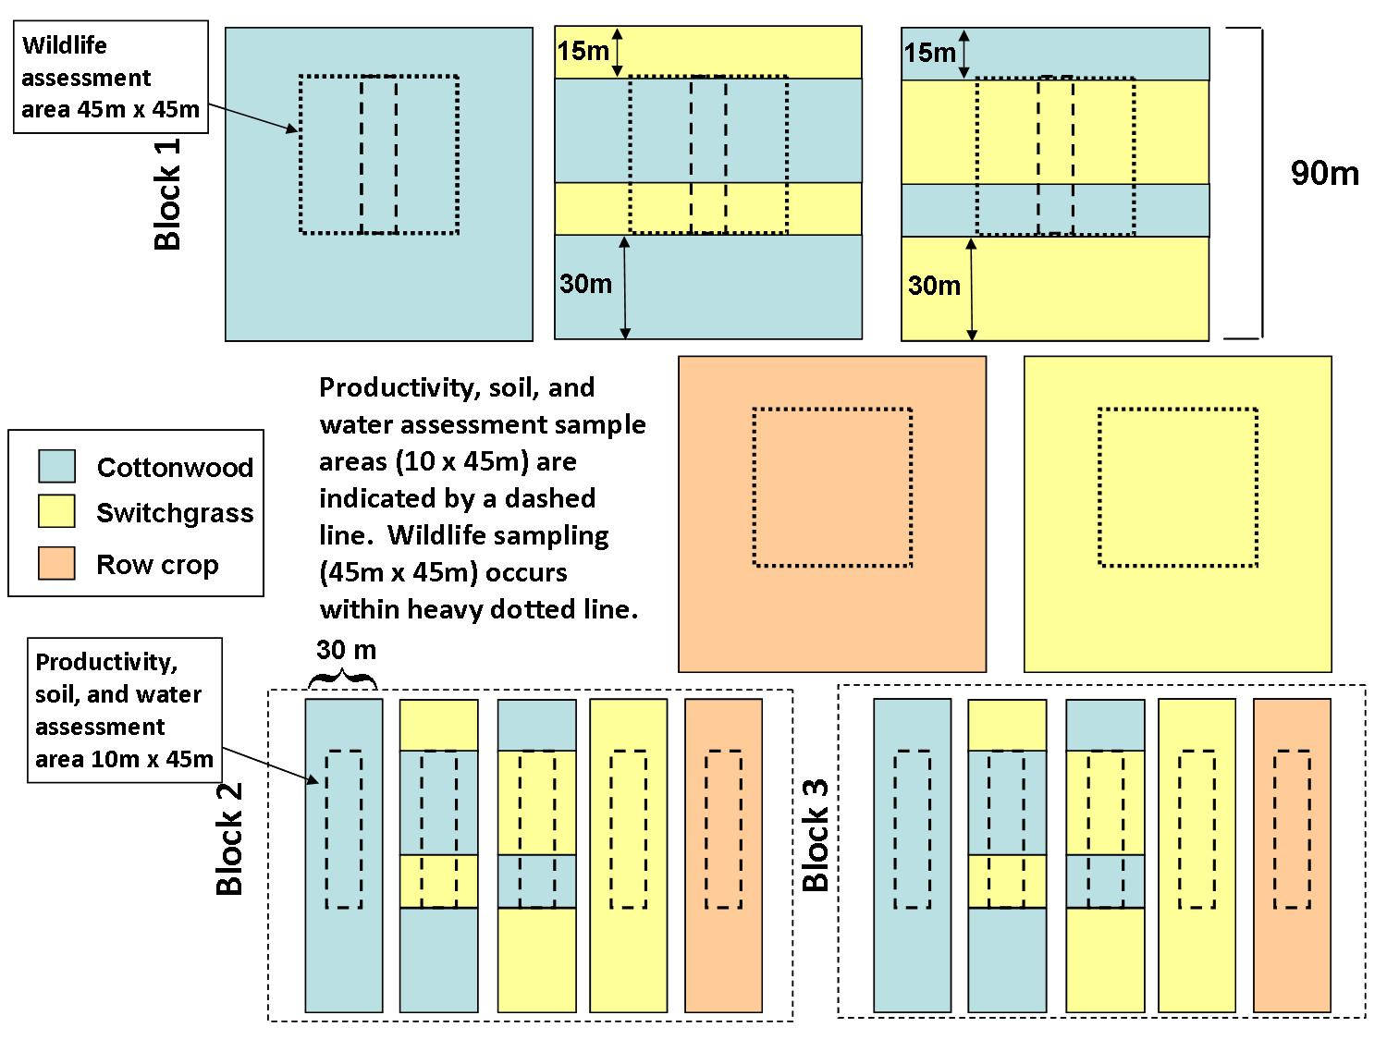
15
Figure 2. Schematic of plots, three replications at each study site.

