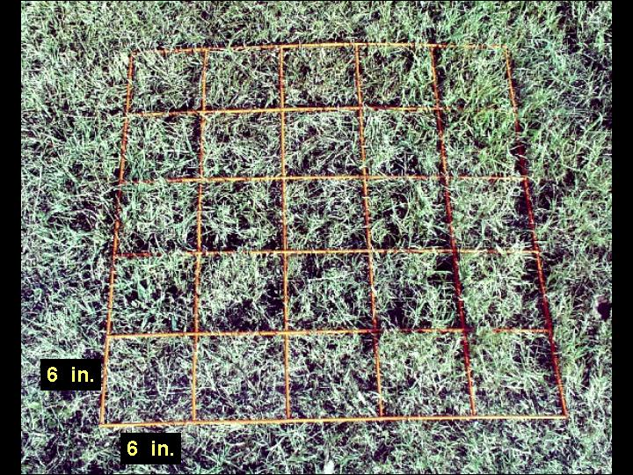
Figure 3. Grid quadrate where each cell is 6 x 6 in. (15 x 15cm) and 25 cells/quadrat.

