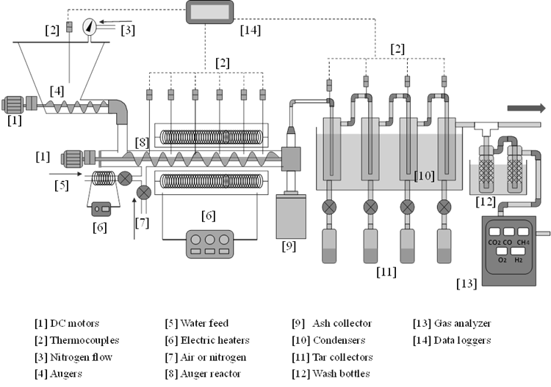
* Items labeled with the same number are similar.

Figure 4. A schematic drawing of the auger gasification system.

