LNE09-289: Using Canopy Management to Reduce Fungicide Use and Improve Fruit Composition In White Wine Grapes
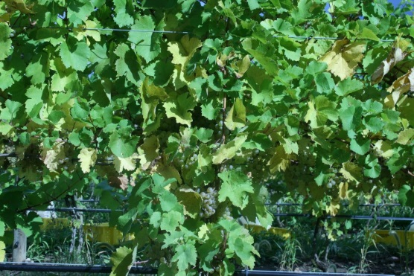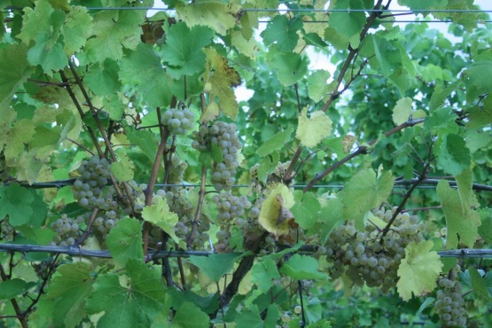
Figure 1: upper: a Riesling canopy subjected to no leaf removal or shoot thinning. Lower: a Riesling canopy subjected to shoot thinning and heavy leaf removal. Note fewer leaves in fruiting zone of right canopy, resulting in better spray penetration.

