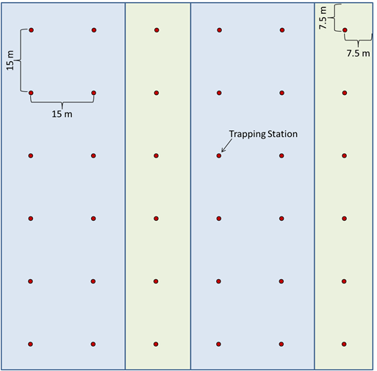
Figure 6. Trap placement (black dots) within a CW treatment plot. Trapping stations used for vegetation sampling are indicated with boxes. The vegetation plots were placed randomly but distributed proportionally within this combination plot.

