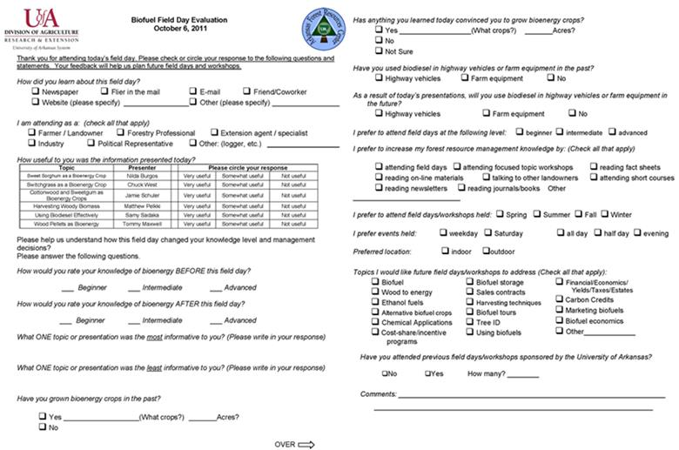Figure 7. Example of post meeting survey given to attendees.
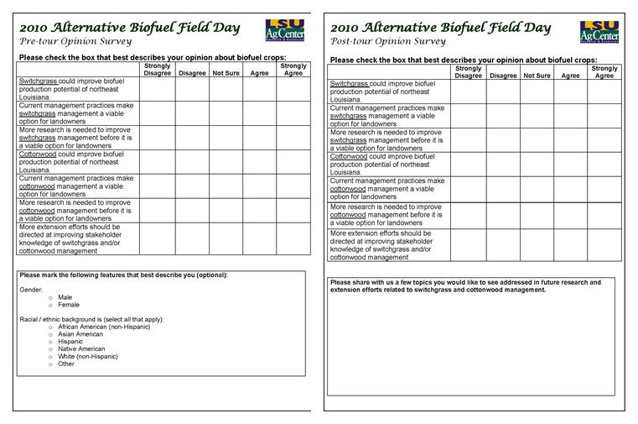
Figure 8. Example of pre- and post-meeting surveys given to attendees.

