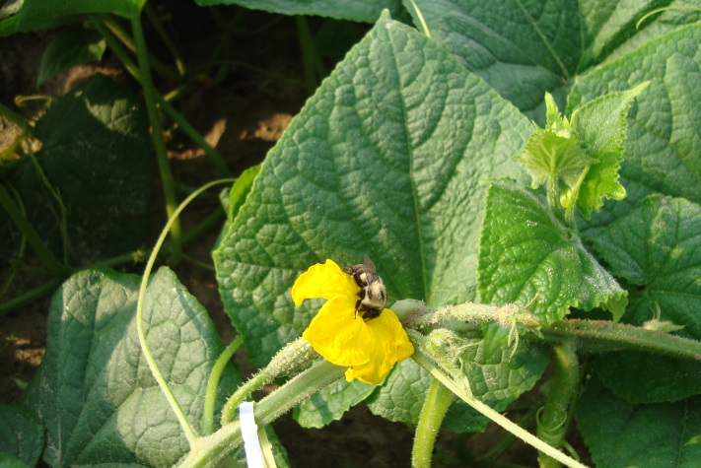
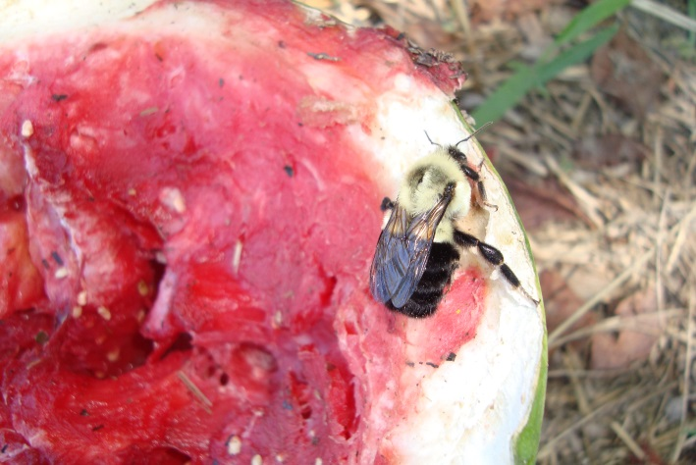
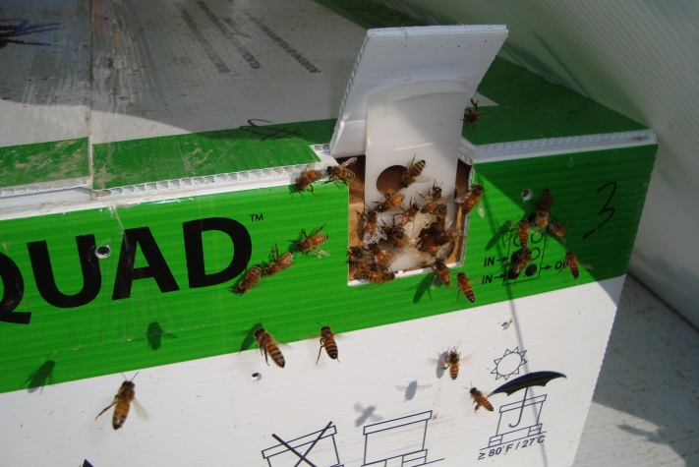
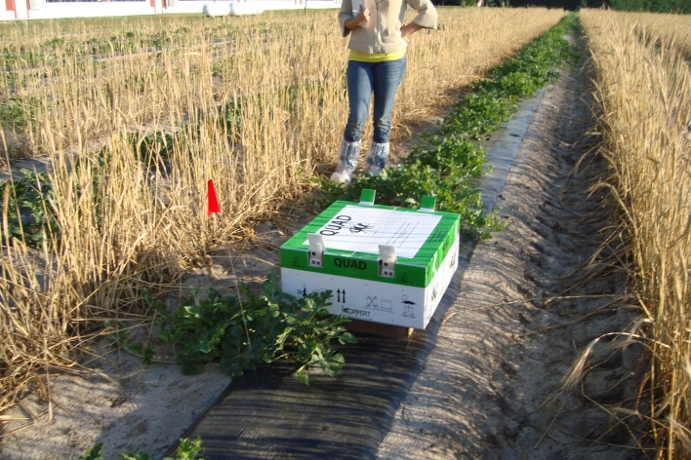
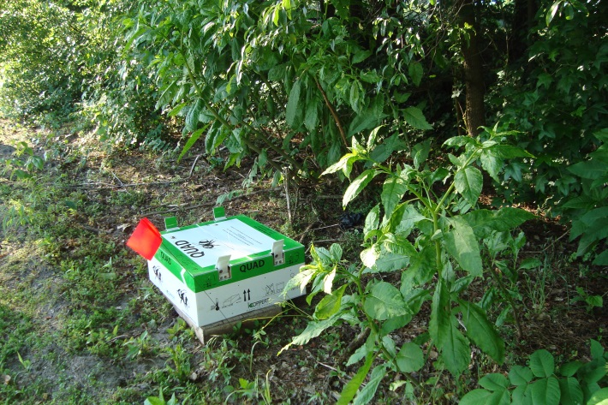
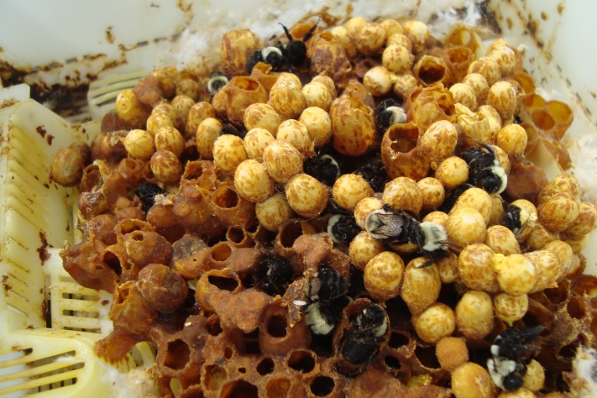
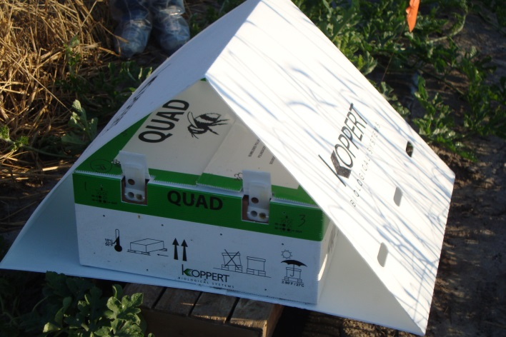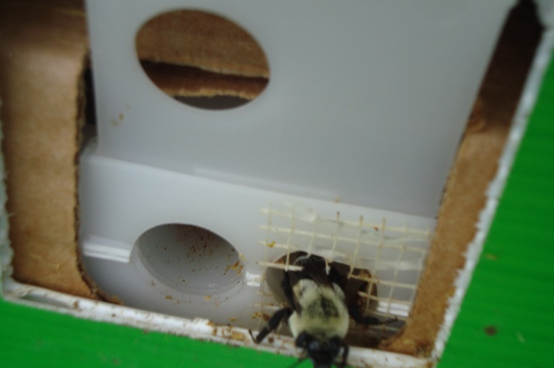
A
A
G
E
F
B
H
G
A
F
E
D
C
B
Figure 1. Pictures from the field sites in Southern Delaware. A. Quad in sun placement B. Quad in natural shade placement C. A-frame shade structure D. Bumble bee entrance to quad E. Bumble bee brood clump F. Bumble Bee quad being robbed out by honey bees G. Bombus impatiens on watermelon fruit H. Bombus impatiens on a cucumber blossom

