West Virginia Sheep Producers’ Reproductive Management Survey
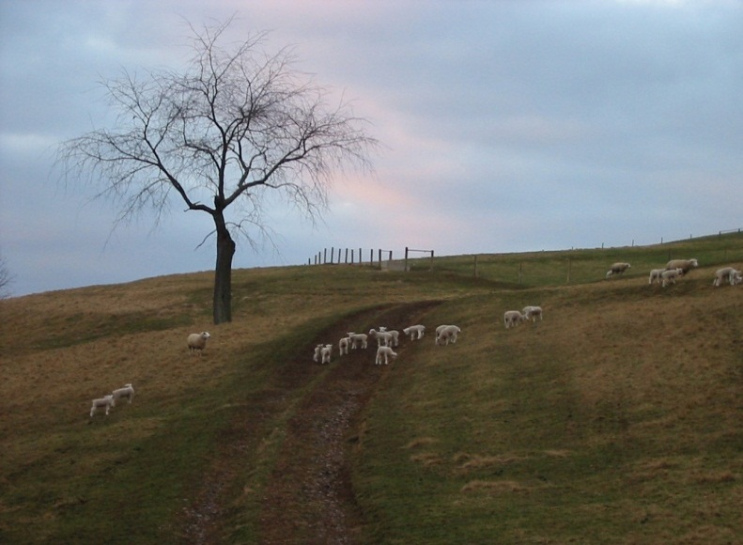
Dear WV Sheep Producer:

West Virginia University is conducting a survey of sheep producers to collect information that will be used to help improve viability of sheep enterprises in West Virginia. The survey will help identify your needs and concerns, and gives you the opportunity to express your opinion regarding out-of-season breeding. The information provided will be used to analyze and evaluate socio-economic factors that influence producers’ decisions to adopt out-of-season breeding.
Please take a few minutes to complete and return the attached survey. The survey should be completed by or on behalf of the primary farm owner. Participation is voluntary and the information that you provide will be kept as confidential as legally possible for individual producers. If you do not feel comfortable answering a particular question, please omit it and continue with the rest of the survey. This survey is being conducted by:
West Virginia University West Virginia Small Ruminant Project
Davis College of Agriculture, Natural Agricultural Sciences Building
Resources & Design P.O. Box 6180
Division of Animal and Nutritional Sciences Morgantown, WV 26506
P.O. Box 6108, Morgantown, WV 26506 (304) 293-1946
(304) 293-2004
Respectfully yours,

Kellie D’Souza, Graduate Student Dr. Marlon Knights, Associate Professor
Davis College of Agriculture, Davis College of Agriculture,
Natural Resources & Design Natural Resources & Design
304-376-1020, kdsouza@mix.wvu.edu 304-293-1946, marlon.knights@mail.wvu.edu
West Virginia Sheep Producers’ Reproductive Management Survey
1) What is your gender (primary farm operator)? Male Female
2) What is your age (primary farm operator)? Under 30 30-44 45-60 Over 60
3) Which animals have you had experience raising? Dairy Sheep Poultry
Beef Goats Swine
Other __________________________
4) What animals are currently being raised on your farm? Dairy Sheep Poultry
Beef Goats Swine
Other _____________________
5) What is the size of your breeding flock (sheep) at present?
Less than 20 head 20-49 head 50-99 head
100-249 head 250-500 head More than 500 head
6) How many years have you raised sheep? Less than 2 2-5 6-10 More than 10
7) How satisfied are you with the productivity of your ewes (pounds of lamb sold for each ewe
per year)?
Very satisfied Satisfied Dissatisfied Very dissatisfied
8) How satisfied are you with the profitability of your sheep business?
Very satisfied Satisfied Dissatisfied Very dissatisfied
9) What is your highest level of educational attainment (primary farm operator)?
Less than high school degree
High school degree or equivalent (e.g., GED)
Some college but no degree
Associate degree
Bachelor degree
Graduate degree
10) What is your annual household income?
Less than $50,000 $101,000 - $150,000 ⇨ More than $200,000
$50,000 - $100,000 ⇨ $151,000 - $200,000
11) What percentage of your gross household incomes comes from sheep
production?
Less than 25% 25% - 50% 51% - 75% 76% - 100%
12) What is your farming status (primary farm operator)? Full-time Part-time
13) In which county in West Virginia is your farm located? ____________________________
14) How do you access agricultural information to enhance your farm decision-making?
Sources | Yes | No
Radio
Newspaper
Internet
Bulletins
Friends
Extension agents
Social media (e.g. Facebook)
Others

15) How many times do you contact an extension agent for agricultural advice in a period of
one year?
None Few Many Unsure
16) Do you belong to a farmer organization? Yes No (Go to # 18)
17) In the period of one year, how many times do you attend meetings for the farmer
organization(s) in which you are involved?? ___________
18) How has the size of your breeding flock changed during the past 3 years?
Increased (Go to # 19) Decreased (Go to # 20) Stayed the same (Go to # 20)
19) If you answered ‘Increased’ to Question 18, please rate the following factors according to
the degree of influence it has had on your decision to expand. Responses for degree of
influence are 1= Strong Influence; 2= Moderate Influence; 3= Weak Influence; 4= No
Influence. Please check the appropriate boxes.
Factor | Degree of Influence
 | 1 = Strong | 2 = Moderate | 3 = Weak | 4 = None
Personal Preference
Labor Availability
Production Costs
Predator Losses
Forage Availability
Manage Risk
Even-out Income
Available Capital or Financing
Available Facilities
Lamb and Wool Prices
Health of Producer
Time to Retirement
Debt
Technical Advice and Support

20) If you answered ‘Decreased’ or ‘Stayed the same’ to Question 18, please rate the following
factors according to the degree of influence it has had on your decision not to expand.
Responses for degree of influence are 1= Strong Influence; 2= Moderate Influence; 3=
Weak Influence; 4= No Influence. Please check the appropriate boxes.

Factor | Degree of Influence
 | 1 = Strong | 2 = Moderate | 3 = Weak | 4 = None
Personal Preference
Labor Availability
Production Costs
Predator Losses
Forage Availability
Manage Risk
Even-out Income
Available Capital or Financing
Available Facilities
Lamb and Wool Prices
Health of Producer
Time to Retirement
Debt
Technical Advice and Support

21) How do you intend to change the size of your breeding flock over the next 3 years?
Increase Stay the same
Decrease Unsure

22) Current technology affords sheep producers the options of lambing in the spring and/or fall
months. Given this option under your present farming circumstances, indicate your
preference for lambing months.
Spring lambing (Go to # 23) Fall lambing (Go to # 24) Both (Please answer #23 & 24)

23) If you chose ‘Spring lambing’ or ‘Both’, please rate the following factors according to the
degree of influence it has had on your decision. Responses for degree of influence are 1=
Strong Influence; 2= Moderate Influence; 3= Weak Influence; 4= No Influence. Please
check the appropriate boxes.

Factor | Degree of Influence
 | 1 = Strong | 2 = Moderate | 3 = Weak | 4 = None
Higher Market Prices
Less Labor Required
Lower Feed Cost
Less Predator Losses
Increased Stocking Rates of Ewes
Increased Stocking Rates of Lambs
Lower Internal Parasite Losses
More Efficient Use of Farmer’s Time
More Available Markets
More Available Forage
Higher Profitability
Make Use of Barn Space

24) If you chose ‘Fall lambing’ or ‘Both’, please rate the following factors according to the
degree of influence it has had on your decision. Responses for degree of influence are 1=
Strong Influence; 2= Moderate Influence; 3= Weak Influence; 4= No Influence. Please check
the appropriate boxes.

Factor | Degree of Influence
 | 1 = Strong | 2 = Moderate | 3 = Weak | 4 = None
Higher Market Prices
Less Labor Required
Lower Pasture Costs
Less Predator Losses
Increased Summer Stocking Rates of Ewes
Increased Summer Stocking Rates of Lambs
Lower Internal Parasite Losses
More Efficient use of Farmer’s Time
More Available Markets
More Available Forage
Higher Profitability
Make Use of Barn Space

25) Please rank the following marketing methods used for your lambs in order of importance,
with 1 being most regularly used and 5 being least used.
_____ Local auctions
_____ Out-of-state auctions
_____ Electronic methods
_____ Direct farm gate
_____ Direct send to consumer
26) What percentage of your lambs are sold during the following months?
__________ January – March
__________ April – June
__________ July – September
__________ October - December
27) Have you ever heard the term out-of-season breeding? Yes No Unsure

28) Would you be willing to attend a meeting to discuss out-of-season breeding?
Yes No Unsure
29) Have you ever been invited to attend meetings to discuss out-of-season breeding?
Yes No (Go to # 33)
30) How many times? ________
31) Did you attend? Yes No (Go to # 33)
32) How many times? ________
33) Do you currently attempt to breed ewes out-of-season? Yes No (Go to # 37)
34) What percentage of your ewes are bred during the following months?
__________ January – March
__________ April – June
__________ July – September
__________ October - December
35) Please rank the following reasons for your participation in out-of-season breeding in order
of importance, with 1 being most important and 8 being least important.
_____ Higher prices for fall-born lambs
_____ Lower feed cost
_____ Less loss of lambs due to predation (coyotes/dogs/bears)
_____ Production of show lambs
_____ More convenient
_____ Meet a specific market
_____ Lower lamb loss due to internal parasites or less deworming required
_____ Encouragement from university or extension agents
36) How satisfied are you with the results from out-of-season breeding?
Very satisfied Satisfied Somewhat satisfied Not satisfied
37) If you have NOT participated in out-of-season breeding, please rank the following
reasons why you have not participated in order of importance, with 1 being most important
and 6 being least important.
_____ No economic advantage
_____ Too technical
_____ Not satisfied with results
_____ Not convenient
_____ Too much uncertainty in terms of results
_____ Does not fit my forage production program
38) What is your view on the requirements of practicing OSB, as compared to conventional
breeding? (Please check all that apply)
 | Management time | Cost | Knowledge | Labor | Land | Other (Specify)
More
Equal
Less
Don’t know

39) How familiar are you with practices necessary for high fertility in out-of-season bred ewes?
Very familiar Somewhat familiar Not familiar Unsure

40) Do you currently do any of the following on your farm?
Activity | Yes | No
Pregnancy Diagnosis of Females
Estrous Synchronization
Use CIDRs
Conduct Breeding Soundness Exams on Males
Flush Females
41) What other areas of sheep production, management or marketing would you like additional
information or training on in the future? Please specify below.

42) Please add any other comments or suggestions you would like to share with us relative to
sheep production on your farm.

THANK YOU FOR YOUR PARTICIPATION!

