Karyssa Bowron
February 15, 2012
NSCI 450

The Effectiveness of Bleaching Processes on Culinary Oils

Abstract
Crude vegetable oils contain impurities that can cause culinary oils to have a bad taste or odor. One of the treatment processes for removing these impurities is bleaching. In this experiment, high-oleic safflower oil and canola oil were treated with 1, 3 and 5% of Oil-Dri Perform bleaching clay by weight of oil as recommended by the company. The physio-chemical properties (Acid number, PetroOxy, absorbance and GC-MS analysis) of each sample of treated oil were then analyzed and compared to a control. The results of this experiment showed that bleaching clay indeed diminished some impurities found in the oil and that 3% of bleaching clay by weight of oil was the most efficient percentage in treating crude vegetable oils.

Introduction
Crude vegetable oils, oils that have been pressed from seeds and have undergone no refining procedures, contain impurities such as soaps pigments, trace metals and fatty acids.¹ These impurities can affect the viable uses of the oils, such as cooking oil, food products, plasticizers, cosmetics, cleaners, adhesives and coatings. Impurities also limit the conservation of the oil.¹
Bleaching clay is used in the treatment of crude oil, during bleaching, pigments and other unwanted compound or impurities are absorbed on solid materials. Neutral clays used for bleaching are excellent metal absorbents, able to decrease the levels of chlorophyll and colour bodies, to remove soaps and phospholipids and to minimize free fatty acid increase during bleaching.² The bleaching of crude oils can reduce or eliminate some of the original impurities. Thus, the bleaching procedure is a vital step in the oil refining process in order to improve storage life, taste and other qualities.
The objective of this experiment was to determine the most efficient amount of bleaching clay by percent weight of oil. This study used the bleaching clay Oil-Dri Perform (Chicago, IL), on two types of crude oil, high-oleic safflower and canola. The results from this experiment will help determine which of the two bleaching clays was more efficient and the optimal percentage of that bleaching clay by weight of oil. This information is useful to producers because it provides a better understanding of the bleaching process and can prevent the waste of excess bleaching clay used in a refining procedure. As well it will provide information on producing better oils for consumers. The information can be useful to consumers because this provides consumers with information regarding the process of treating oils and what impurities were taken out of the crude oil to make the final product.

Methodology
High oleic safflower and canola oils, obtained from the Montana State University – Northern Bio-Energy Center, were each treated with 1%, 3% and 5% Oil-Dri Perform bleaching clay mass by weight of oil. For each treatment, one hundred grams of oil was used. All samples were heated to 60°C for one hour and stirred at 350 rpm with a magnetic agitator. After one hour the oils were removed from the heat and cooled to room temperature. Once the oils cooled to room temperature, they were vacuum filtered using a Buchner funnel and Whatman filter paper (2.7 µm pore size) to remove the clay from the samples. Once the clay was removed, a series of tests was conducted on the bleached oils to compare the physiochemical properties of the oil. These tests included gas chromatography and mass spectrophotometry (GC-MS) analysis to determine fatty acid content, petro-oxy test to determine the oxidation number, spectrometer graph analysis to determine the content of pigments, and acid number test. The results of these tests were compared to values of an untreated control sample of each oil. Soxhlet extraction was also used to extract the contents absorbed in the used bleaching clay and components of the extract were determined through GC-MS.

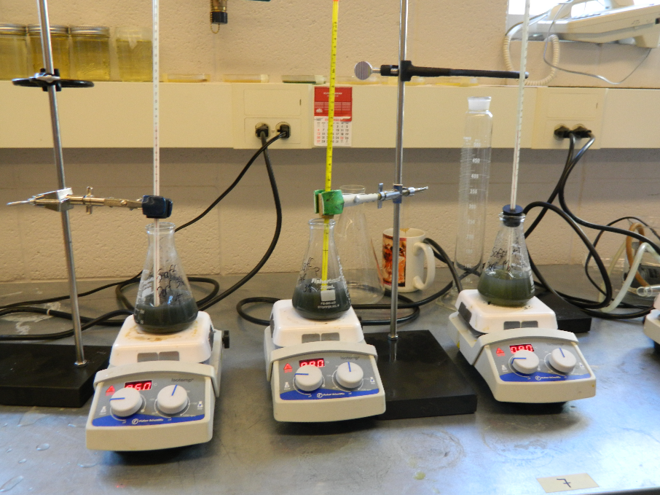
Figure 1. Lab-scale bleaching setup used in this study.

Gas Chromatography-Mas Spectrophotometric Analysis
The composition on the oil and extracts were analyzed using GC-MS. Ten milligrams of the sample were diluted by adding 1 mL of heptane and mixing the solution at 60ºC with a small magnetic agitator at 700rpm for 4 hours. The prepared samples were injected into Agilent 7890A gas chromatograph equipped with Agilent 5975C inert mass spectrometry with Triple-Axis Detector and HP-5MS gas chromatograph column. The inlet temperature was set to 250ºC. The carrier gas was helium at a flow rate of 1 mL/min and a splitless injection mode was used. The temperature of the oven was initially at 100ºC and held for 3 min, increased to 170ºC at a rate of 25ºC/min, and to 260ºC a rate of 2ºC/min and maintained for 5 min.

Acid Number
Fifteen grams of each treated sample of oil was mixed with 60 mL of titration solvent (5:495:500) by volume of water, toluene and isopropyl alcohol solution. The mixture was then titrated with 0.1N potassium hydroxide in isopropyl alcohol using the Mettler Toledo T50. The acid number was then calculated based on the number of milligrams of potassium hydroxide needed to reach potential.

Mg KOH/g = (mmols x 56.1) / mass of sample

Oxidation
For PetroOxy, 5 mL of treated sample was inserted into the machine using a pipette. The oxidation was determined by the length of time the sample took to complete oxidize.

Spectrophotometry
To determine the amount of pigment taken out of the oils after bleaching, 9 mL of sample was mixed with 1 mL of n-Hexane (a ratio of 90:10) and transmittance was measured at 450 nm using Spectro20. Pure n-hexane was used as the blank. The following formulas were used to determine the absorbance and absorbance efficiency once the transmittance was measured.

Absorbance = - log( Transmittance)

Absorbance Efficiency = (A_{Control}-A_{Sample}) / A_{Control}
Where A= Absorbance

Soxhlet
The used bleaching clay was analyzed using Soxhlet extraction. For the Soxhlet extraction, used bleaching was compared to fresh clay and weighed. Using 5 g of sample and 100 mL of hexane the extract was extracted for 16 hours using Soxhlet extraction. After, the hexane was boiled off; the residue was analyzed using GC-MS.

Results and Discussion
Acid number
Prior to bleaching the safflower oil, the oil had an extremely high acid number (Figure 2). The machine was unable to reach potential for bleaching percentages 1 and 3%, and thus unable to accurately measure the real value. However, the only values for safflower oil that reached potential were samples treated with 5% by wt. of Oil-Dri Perform. These values, however, were not significantly lower than the maximum value. Though the higher concentration of bleaching clay may have taken out some of the acidic components of the oil, the acid value was still quite high. It can be inferred from this that Oil-Dri Perform bleaching clay had a minimal effect on the acid number of high-oleic safflower oil.

Figure 2. Effects of Perform Bleaching Clay on Safflower Oil Acid Number

Prior to bleaching the Canola oil, the canola oil had a relatively low acid number. This number was lowered with all concentrations of bleaching clay, though the percentage of bleaching clay that lowered the acid number the most was 3% of Oil-Dri Perform. The decrease in acid number was not significant, though a high acid number in culinary oils is not desirable and therefore the lowered acid number is a small benefit.

Figure 3. Effects of Perform Bleaching Clay on Canola Oil Acid Number

Oxidation
The control value of PetroOxy for high-oelic safflower oil was initially quite high. The oxidation originally took 23 minutes and 42 seconds. After the treatment with Oil-Dri Perform bleaching clay at 1%, the value of the oxidation did not change significantly. However, at higher concentrations, 3% and 5%, the oxidation values dramatically decreased (Figure 4). In canola oil, the original value of oxidation by PetroOxy was also quite high. However, after being treated with 1% of bleaching clay, the PetroOxy value decreased drastically. The control value of untreated canola was 22 minutes and 51 seconds, though after being treated with only 1% of clay, the oil lost most of its stability and averaged only 13 minutes and 52 seconds. The stability continued to decrease as the concentration of bleaching clay increased. From this, it can be inferred that the bleaching clay is taking out some of the oils’ valuable antioxidants including vitamin E and γ-tocopherol.³ The loss of some oxidative stability would be difficult for companies to market such unstable culinary oils as this extremely reduces the shelf life of the oils. However, it is possible to add artificial antioxidants to the oils, such as vitamin E, once they have been treated.

Figure 4. Effects of Perform Bleaching Clay on Oil PetroOxy

Absorbance
The colours of the clay dramatically changed after bleaching. (Figures 5 and 6) The original samples of high–oleic safflower and canola oils were extremely yellow in colour. After bleaching, the oils were almost colourless. The oils were a translucent yellow and, after treatment, lost a considerable amount of pigment. The wavelength that was initially absorbed most was 450 nm. Canola initially having almost no transmittance at 450 nm, after being treated with clay, transmitted 90% with 3% and 5% concentrations. Safflower, which also had a transmittance value less than 50%, was increased to 96% with 3% concentration and 99% with 5% concentration. The results suggest that the bleaching clay is taking out pigments that absorb the 450 nm (Figure 7). Some pigments that absorb wavelengths in this area are xanthophylls, carotenoids, and chlorophylls a and b.⁴

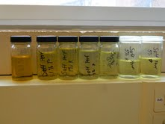
Figure 5: Visual Effects of Perform Bleaching Clay on High-Oleic Safflower Oil

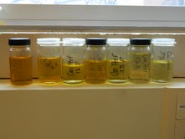
Figure 6: Visual Effects of Perform Bleaching Clay on Canola Oil

Figure 7: Effects of Bleaching Clay on Absorbance at 450 nm

GC-MS Analysis
The results of the GC-MS analysis were extremely variable and thus no conclusions can be drawn from the results. The variability of the results could have been caused by contamination during the preparation of the derivatized oil, or unknown components of the clay that may not have been completely filtered from the sample.

Soxhlet Extraction
The used bleaching clay could not be analyzed using Soxhlet extraction. For the Soxhlet extraction, used bleaching was compared to fresh clay and weighed. Using 5 g of sample and 100 mL of hexane the extract was extracted for 16 hours using Soxhlet extraction. After, the hexane was boiled off, no oil or residue was obtained from the fresh clay. On the other hand, the oils extracted from the used clay did not contain any components that may have been absorbed and concentrated during the bleaching process.

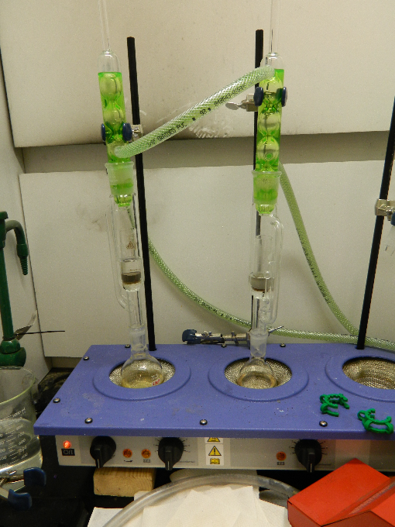
Figure 8. Lab-scale Soxhlet Extraction

Conclusion
In regards to acid number, 5% concentration of bleaching clay was the only concentration that reduced the acid number in safflower and 3% concentration of bleaching clay was the most effective at reducing acid number in canola. It can be inferred that Oil-Dri Perform bleaching clay had minimal effects on high-oleic safflower oil and very little effect on canola oil.
After performing PetroOxy, it was evident that some of the valuable antioxidants that help increase storage life of culinary oils had been removed. Vitamin E or γ-tocopherol could have been some of these substances. Bleaching clay severely reduced the PetroOxy value of canola and the result was continually worsened as the concentration of bleaching clay was increased. However, in high-oleic safflower oil, 1% bleaching clay concentrations did not affect the PetroOxy value of the oil, but 3% and 5% both showed diminishing effects.
After bleaching both canola and safflower oils, some significant differences were noticed. Bleaching clay was efficient in removing pigments that absorbed 450 nm in both canola and safflower oils. Though 5% did absorb more pigments than 3%, it was not a significant amount and because of the cost of the clay, 3% is would be more efficient to use in regards to absorbing pigments in both canola and high oleic-safflower oils.
With respect to the GC-MS analysis, the samples may need further purification which small particles of the clay may have affected the analyses. An alternative method may have to be used to yield consistent results.

References
- J.P. Nguetnkam, R. Kamga, F. Villieras, G.E. Ekodeck, and J.Yvon. (2007) Assessing the bleaching capacity of some Cameroonian clays on vegetable oils. ScienceDirect. Applied Clay Science 39 (2008) 113-121
- M. Rossi, M. Gianazza, C. Alamprese, and F. Stanga. (2002) The role of bleaching clays and synthetic silica in palm oil physical refining.
- Dr. Roman Przybylski. Canola Coucil Of Canada.
http://www.canolacouncil.org/uploads/Chemical7-12.pdf
- Kathryn Thompson, Meredith Stewart, and Juan Rodriguez. (2008) Light Absorption and Color in Biomolecules.
http://www.centenary.edu/attachments/biophysics/bphy304/06a.pdf

