Effects of Bleaching Processes on Oil Properties of Safflower and Canola Oil for Culinary Applications
Paige Richardson

Abstract
Canola and safflower oils were bleached with Natural Oil-Dri bleaching clay and examined for effectiveness in culinary applications. Three concentrations of bleaching clay at 1, 3 and 5% by weight were used to determine the effects of the components, shelf-life and acidity, identify the components left in the clay after bleaching and investigate the effects of using different clay grades The composition of the acidity, oxidative stability, and pigments removed were determined through GC/MS analysis, acid number, PetroOxy and spectrophotometer, respectively. A soxhlet extraction method was also used to investigate the composition of the oil remained in the used clay. These tests should show how the clays affect the oil and what clay is the most effective. Based on all the results, 3% Natural bleaching clay would be the most effective and efficient to use.

- Introduction

Many vegetable oils are consumed directly, or indirectly as ingredients in food. Edible oils have been subjected to the bleaching process for hundreds of years. Raw oils like Canola and Safflower contain impurities that can affect the quality. Impurities like fatty acids, phospholipids, trace metals and pigments (carotenoids, chlorophylls, etc.) can affect the oxidative deterioration, bleachability and uses of the oils^{.1} The bleaching process is a very important step in making these oils effective in culinary use and removing these contaminants that can negatively impact the appearance, taste or stability of the final product.
Oil contains impurities that can affect the overall quality. Through bleaching, these substances (chlorophyll and color bodies) can be reduced and/or eliminated thus producing better tasting oil. Some types of bleaching clays that can be acquired for this process are Natural, Supreme, and Perform. The two bleaches used in this project will be that of Natural and Perform. Canola and high-oleic safflower oil will be treated with each of the bleaching clays. Perform 6000 is said to be the most active product offering a combination of performance and fast filtration.² Some of the benefits and features of the Perform 6000 include outstanding color and chlorophyll removal from canola and soybean oils, removal of soaps and phospholipids and excellent metal adsorption. Perform 60000 can remove all of these things at a much lower clay dosage. The second type of clay we are going to look at is B80 Natural. B80 Natural is a naturally active bleaching and clarifying adsorbent and does not contain mineral acids or other chemical compounds, which can damage oil.³ Like the Perform 6000; B80 Natural has excellent adsorption ability and can remove soaps and phospholipids.³

There is no information on using Natural bleaching clay on safflower and canola oil. The general objective for this project is to investigate the effectiveness of commercial clay (Natural) in bleaching high-oleic safflower oil and canola oils for culinary applications. B80 Natural is going to be the main clay of study, using 1%, 3%, and 5% of the clay by weight of oils to determine what effects the different clay concentrations have on the components, shelf life and acidity of the oils. After the bleaching is complete, the analysis of the used bleaching clay will identify what components are absorbed.

2. Materials and Method

2.1 Experiment
High-oleic safflower oil and canola oil, both produced from the pressing facility at the Bio-Energy Center, Montana State University – Northern, were used in all of the experiments. For each treatment, 100 ml of oil was used. Three concentrations, namely, 1, 3, and 5 % by weight of oil mass, of B80 Natural Bleaching Clay (Oil-Dri, Chicago, IL) were added to each kind of oil, thus obtaining 24 treatments and two controls. The oil and clay slurry were heated to 60 degrees C and mixed at 350 rpm for one hour. It was then cooled to room temperature and vacuum filtered with a Buchner funnel and using Grade 50 with 90 mm diameter Whatman filters. Each treatment was tested for acid number and oxidative stability and components like type of fatty acids and pigments was as well determined.
2.2 Gas Chromatography and Mass Spectrophotometric Analysis for Fatty Acid Profile
Ten microliters of the oil was derivatized with 10 µl NaOH-methanol solution and the mixture was then diluted by adding 1 ml of hexane. The diluted oil with Na OH-methanol solution was then heated and stirred at 80 degrees C for about four hours. The derivatized oils were injected into Agilent 7890A gas chromatograph equipped with Agilent 5975C inert mass spectrometry with Triple-Axis Detector and HP-5MS gas chromatograph column. The inlet temperature was set at 250 degrees C. The carrier gas was helium at a flow rate of 1ml/min and a splitless injection mode was used. The temperature of the oven was initially at 100 degrees C was held for 3 min, increased to 170 degrees C at a rate of 25 degrees C/min, and to 260 degrees C at 2 degrees C/min and was maintained for 5 min.
2.3 Analysis of Oil Properties
The acid number of the control and the bleached oil was measured using ASTM D664 method. T50 Mettler Toledo was used to measure the acid number of the oil.
To test the oxidation stability of each of the samples, PetroOxy was used. The test temperature was set at 140 degrees C, the pressure at 700 kPa and the sample size was 5 ml.
The oil left in the bleaching clay during treatment was extracted from the clay through soxhlet extraction. Five grams of used bleaching clay was extracted with 100 ml of hexane for 16-18 hr in a Soxhlet apparatus. After that hexane was boiled off, the residue was then analyzed by GC/MS.
A dial spectrophotometer was used to investigate the pigments present in the crude oil and removed during bleaching process. Control samples of canola and safflower were analyzed at wavelengths of 430-455 nm and 585-630nm. The wavelengths of 450, 630 and 610 were chosen because these were the peaks found after graphing the results from the first wavelengths. The controls for each oil were analyzed at these wavelengths at 50:50 oil to solvent ratio or 90:10 ratios. The solvent in this case was n-hexane. Each sample was diluted with a certain amount of solvent and tested for one or more of the chosen wavelengths.
Picture 1-4 Machines Used For Experiments
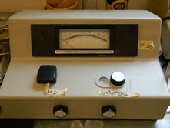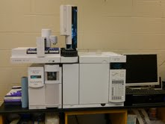
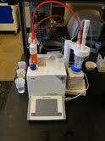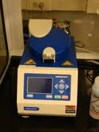
Pictures 1 through 4 show all of the machines that were used in the testing. The top left picture is the Spectrophotometer and it was used to analyze the oil and different wavelengths. The top right picture is the GC/MS, used to look at the fatty acid profile. The bottom left picture is Acid Number, used to measure the acid number of the oils. Finally, the bottom right photo is PetroOxy. It measures the shelf life and oxidation stability of the oils.

3. Results and Discussion
A quick sensory evaluation of the oil can be done after the oil has been bleached with the three concentrations of bleach. There was a significant change in the both the safflower and canola color after bleaching. Both oils had a slight change in aroma but were hard to detect. Table 1 shows a summary of the evaluation for each sample. The graph uses a numbering system of 1 through 10. For color, 10 was considered dark and 1 was considered light. It was found that the higher the concentration of bleach the lighter the oil became. The aroma did not change dramatically throughout the different samples. The samples were ranked on aroma also by the number system as 1 being no smell to 10 being a strong smell.

Table 1. Sensory Evaluation of Safflower and Canola Oil at Different Levels of Bleaching Treatment using Oil Dri Natural Clay
Tests | High Oleic Safflower |  |  |  | Canola
 | Control | 1% | 3% | 5% | Control | 1% | 3% | 5%
Oil Color | 10 | 4 | 2 | 1 | 10 | 7 | 3 | 3
Oil Aroma | 10 | 7 | 6 | 6 | 10 | 8 | 7 | 7

Figure 1a and Figure 1b shows the acid number for each of the samples that were treated with the bleaching clay. Safflower control had an acid number of 4.936. As each sample was tested for the acid number, the graph shows a very small decrease in the acid number the higher the concentration of clay. The acid number is very important when looking at the degradation of culinary oils. Chemical components that make up culinary oils can break down over time and become more acidic. Increase acidity in culinary oils is not a good thing. This can affect the taste, quality and may even cause health problems. In studying this graph you can see safflower oil treated with Natural bleaching clay at 1% is the least acidic of all three concentrations. There was so little difference between the three amounts and the control. Thus, it can be concluded that the bleaching process using Natural grade did not have a great effect on the acid number.
Fig. 1a Effects of bleaching of oil on Acid Number

Figure 1b Effects of bleaching of oil on Acid Number

The PetroOxy test was used to look at the shelf life and oxidation stability of oil after the bleaching process. Figure.2 shows the effect of bleaching clay on shelf life of treated oil. Canola and safflower controls were tested and found to both be around 22 and 23 mins. Looking first at safflower natural there is a large decrease in the stability when looking at the control as compared to the three concentrations. The bleach has a large effect on the stability and shelf life of the safflower oil. The same goes for canola oil treated with the three concentrations. One percent affects the oxidation stability by only decreasing the time by three minutes as compared to 3 and 5% which decreases the time by 12 to 15 minutes. As you can see by the graph the shelf life and stability is greatly affected differently by the bleaching of the oil because the antioxidants are being removed from the oil by the bleach.
Fig. 2 Effects of bleaching oil on PetroOxy
450 nm on the spectrophotometer showed a great deal of change in the percent change of absorbance. Figure 3 shows this change for both safflower and canola treated with natural bleach. Since 450 nm was the preferred wavelength of study, the pigments that were likely to be removed were chlorophyll b and other pigments like carotene and xanthophyll. Based on the graph and the numbers gathered from the spectrophotometer it is assumed that the bleaching process helped to remove these pigments and impurities that can cause problems with taste and can affect the appearance (turn a green or possibly orange color).
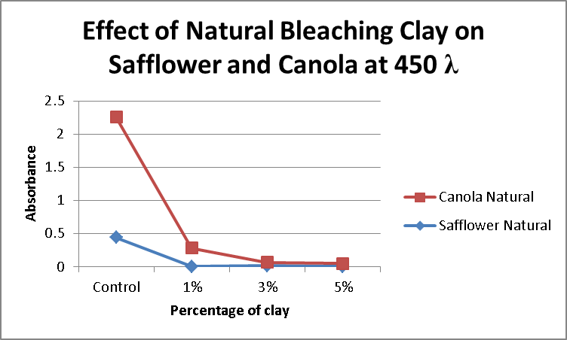
Fig. 3 Percent change in absorbance at 450 nm

The oil extracted from the used bleaching clay was not different from the crude canola and bleached canola oil. It is possible that the trace amounts of impurities in the crude oil were not detected by the GC/MS. It is also a possibility that the pigments such as chlorophyll are just too big and not volatile enough to be gasified at the temperature of the analysis.
Picture 5 and 6 Safflower Natural (left) and Canola Natural (right)
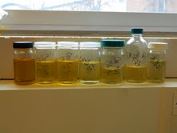
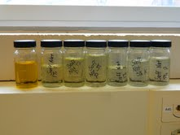
4. Conclusion
Gathered data shows many different ideas to which bleaching clay is most effective in culinary oils. Based on the spectrophotometer results it is seen that 3 and 5 % concentrations on canola oil removes more pigments than 1%. For safflower oil, all of the concentrations remove about the same pigments. Acid number does not seem to be largely affected by any of the three concentrations of clay. Shelf-life and oxidation stability are important in culinary oils. The PetroOxy test showed that the bleaching clay decreases the shelf-life and stability no matter the concentration of clay. Adding artificial anti-oxidants to the bleached oil may help to prolong shelf-life. Bleaching of oil has many positives but it also has a few negatives. Bleaching should to be done to improve the taste and appearance of the oil because that is what the consumer looks for. It is only to what degree of bleaching is the most affective and looking at the results 3% would be the recommended percent.

5. References

[1]. J.P Nguetnkam, R. Kamga, F. Villieras, G.E. Ekodeck, J.Yvon (2007) Assessing the bleaching capacity of some Cameroonian clays on vegetable oils.
[2.] Oil-Dri Corporation of America, Pure-Flo: Perform 6000 2007
[3.] Oil-Dri Corporation of America, Pure-Flo: B80 Natural 2007
[4.] What is the Acid Number? http://www.wisegeek.com/what-is-the-acid-number.htm
[5.] Effects of degumming and bleaching on physiochemical properties of crude sunflower oil.
ABITOGUN A. S1. OSHODI² A.A.
1. DEPARTMENT OF SCIENCE LABORATORY TECHNOLOGY,RUFUS GIWA POLYTECHNIC,
OWO, ONDO STATE, NIGERIA.
2. DEPARTMENT OF CHEMISTRY, FEDERAL UNIVERCIY OF TECHNOLOGY, AKURE, ONDO
STATE, NIGERIA.

