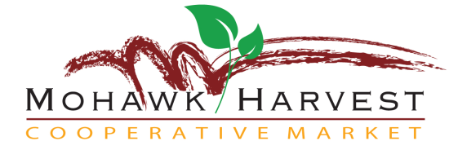

30 North Main Street, Gloversville, NY 12078 518-706-0681 manager@mohawkharvest.org

"As consumer, producer and farmer members of a cooperative, we are committed to the creation of a healthy, sustainable community by providing wholesome foods, empowering artisans and fostering lifelong learning."

July 8, 2013

Mohawk Harvest has a proven track record for tapping the retail demand for local foods. Now we are working to expand the reach of local foods by adding a new service for local restaurants, food services, and institutions that purchase fresh produce: Local Produce Micro-Distribution.

Why are we doing this? We believe in the economic value and culinary quality of local foods. Every dollar spent locally “multiplies” seven times in the local economy. And better yet, “eating local” tastes so much better. Sourcing locally means a fresher and tastier product. A tomato or raspberry picked at the right moment for flavor means they travel thirty miles rather than three thousand.

Consumers say they care about local foods and that offers us all a powerful marketing opportunity at affordable prices.

Our local farmers produce a large quantity of high quality, in-season fresh and storage produce at very reasonable prices and we have the logistical expertise to fill your orders. We will be taking and filling orders twice per week and delivering fresh produce right to your door.

Need something unique like Asian eggplant varieties? Give us advance notice and we will try to locate it among our network of growers.

I look forward to meeting to discuss ways we can help bring local foods into your business.

Sincerely,

Christopher Curro

General Manager