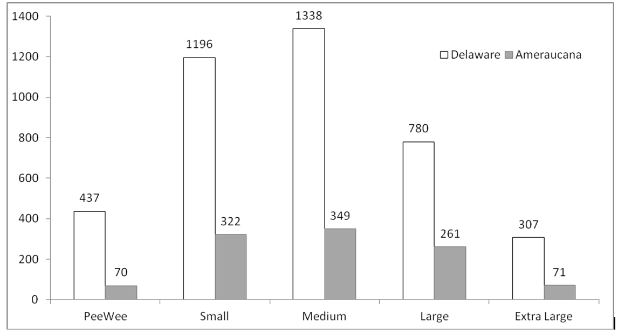
No. of eggs per breed based on USDA egg size

