Table 4-1: Length of survey respondents’ farm internships

Length of time that survey respondents participated in a farm internship, Northeast US, 2012-2013
Length of Internship | Number  of cases | Percentage  of sample
Less than 1 month | 1 | .8
1-3 months | 20 | 15.2
3-5 months | 18 | 13.6
6-12 months | 69 | 52.3
1 year | 9 | 6.8
2 years | 6 | 4.5
3 years+ | 4 | 3.0
Other | 5 | 3.8
Total | 132 | 100

Table 4-2: Products grown by study participants during a farm internship

Farm products grown and raised on farms where participants worked, US Northeast Region and Pennsylvania, 2012-2013
Instrument | Number  of cases | Percentage  of sample¹
Survey
Ornamentals | 29 | 22.0
Dairy | 23 | 17.4
Meat | 56 | 42.4
Fruit | 66 | 50.0
Vegetables | 121 | 91.7
Seeds | 17 | 12.9
Eggs | 9 | 6.8
Other | 15 | 11.4
Total | 132 | -
Interviews
Vegetables | 24 | 96.0
Meat | 2 | 8.0
Dairy | 4 | 16.0
Flowers | 1 | 4.0
Total | 25 | -
Farm Journal | 1 | 4.0
Vegetables | 4 | 66.7
Meat | 2 | 33.3
Dairy | 1 | 16.7
Herbs and Flowers | 1 | 16.7
Total | 6 | -
¹Percentage does not add to 100 since respondents were given
option to choose more than one product

Table 4-3: Remuneration received by survey and interview participants during a farm internship

Remuneration that survey and interview respondents received in exchange for labor on sustainable farms, US Northeast Region and Pennsylvania, 2012-2013
Type of Remuneration | Survey (%) | Interview (%)
Food | 85.6 | 100.0
Housing | 67.4 | 60.9
Stipend | 62.1 | 69.6
Hourly Wage | 27.3 | 8.7
Educational Classes | 30.3 | N/A*
On-farm training | 68.9 | N/A*
Number of cases | 132 | 23
*interview participants were not asked to report whether education and on-farm training were included in their remuneration package

Figure 4- 1
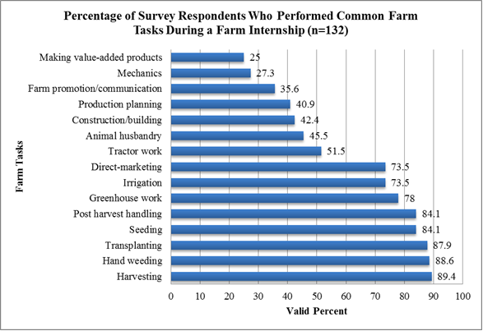

Figure 4- 2
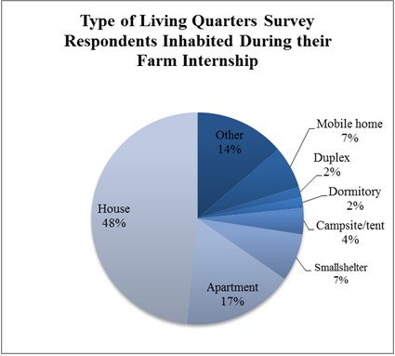

An error in survey development created overlapping categories for respondents to report the length of time they spent on farms. Therefore, participants answering the question “For how long was your internship/apprenticeship” may have selected different categories according to their interpretation of the question. Survey respondents who participated in multiple internships were not given opportunity to respond for each internship they held. Instead, they were asked to respond according to the internship most representative of their experience as a farm intern. Therefore “N” represents the number of people who completed the survey, not the number of internships or apprenticeships held by participants.

