Fertility Correlations with Elevation  Before and After a Saturation  1=May 3, 2012: after snowmelt  2=Oct 18, 2012: before Saturation  3=April 5, 2013: before saturation  4=July 4, 2013: after saturation  *The closer the value is to zero, the closer the relationship is for that particular element and elevation.  Notes: |  | This Research and Field Day Made Possible by:  Questions or Comments? Please feel free to e-mail Lindsey Ruhl at lruhl@uvm.edu or visit  www.floodedsoils.wordpress.com |  | Cover Crops to Cope with the Effects of Flooding on Soil Fertility  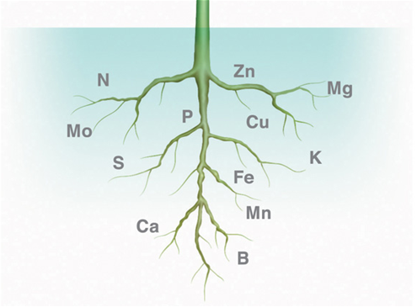
Two Ways Flooding Affects Soils |  | Known Cover Crop Remediation |  | Experimental Cover Crops
Soil Fertility Loss  Nitrogen (N)  N becomes mobilized during flooding and is lost to the atmosphere as N_{2,} or leached as nitrite (NO₂₎ and nitrate (NO₃)  Phosphorus (P)  Phosphorus is one of the slowest geochemical processes. Phosphorus forms a strong bond with iron. In anaerobic soils, the iron is reduced and releases P. The P may than be leached.  Potassium (K)  Potassium is water soluble. The amount of potassium in the soil solution is in equilibrium with exchangeable pools of K ions bound to the soil. |  | Super-Hero Powers!  Hairy Vetch is the most cold tolerant of all the vetch species. It’s nodules are able to are able to convert atmospheric nitrogen to ammonium (NH₄).  White Lupine acidifies the rhizosphere, and mobilizes phosphorus with its proteoid roots. Phosphorus deficiency can result in a 10-15% yield reduction.  Mixes  Weed Suppression: rye, crimson clover, and hairy vetch  Mycorrhizal Colonization and P Uptake:  rye and oats |  | Arethusa Farm: May 10, 2013  Average Concentration in Treatments  Adam’s Berry Farm: May 3, 2013  Average Concentration in Treatments  Average Concentration and Plot Placement
Mycorrhizae Loss  Mycorrhiza is a fungus that has a symbiotic relationship with plants. If the amount of active roots decrease, as they can under flooded conditions, the mycorrhiza loses abundance. In flooded soils, a combination of decreased available P and lowered mycorrhizae colonization can cause noticeable P deficiency.  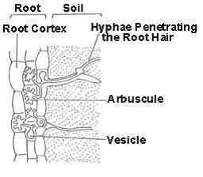 |  | Mycorrhizae Colonization  Winter Rye  This hardy grain is an excellent host for mycorrhizae because it is able to provide living root matter during the winter.  Mycorrhizae  The fungus increases the ability of roots to uptake nutrients. One study shows that cassava plants without mycorrhizae depleted phosphorus in the soil 1-2 mm and with mycorrhizae 20-40 mm from root surfaces.  