Figures
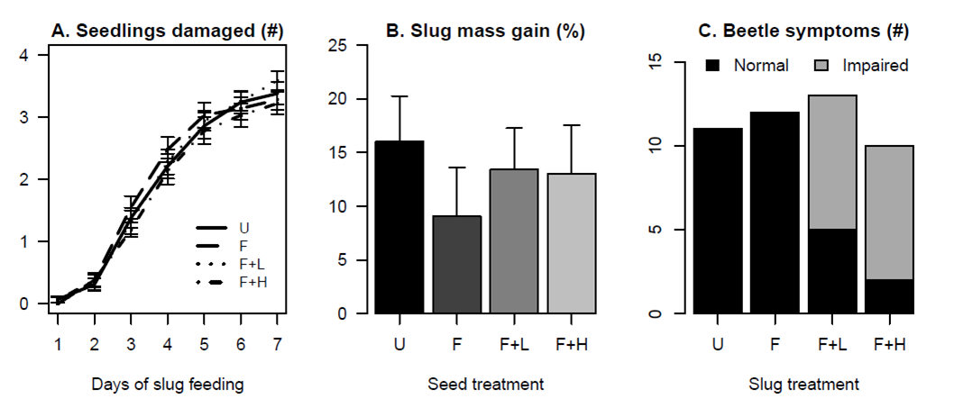
Figure 1. Results from the soybean laboratory experiment. Key to seed treatments: U = untreated; F = fungicide-only; F+L = fungicide + low rate thiamethoxam; F+H = fungicide + high rate thiamethoxam. Error bars represent one standard error.

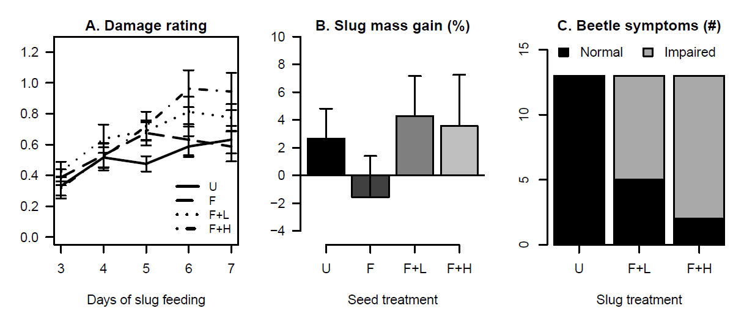
Figure 2. Results from the corn laboratory experiment. Key to seed treatments: U = untreated; F = fungicide-only; F+L = fungicide + low rate thiamethoxam; F+H = fungicide + high rate thiamethoxam. Error bars represent one standard error.

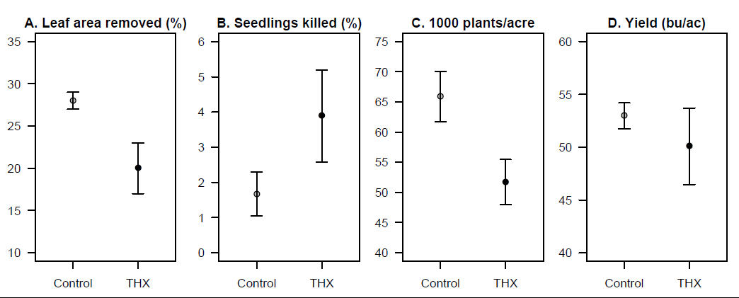
Figure 3. Crop-related results from the soybean field experiment. Control = untreated seeds; THX = seed treated with fungicides plus high rate thiamethoxam. Error bars represent one standard error.
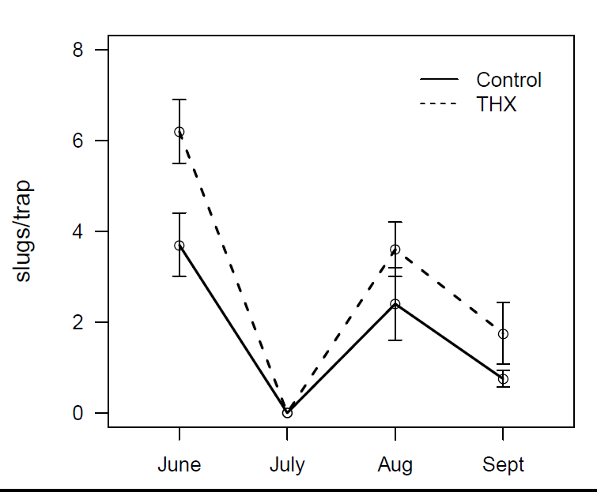
Figure 4. Slugs captured in pitfall traps in the soybean field experiment over the season. Error bars represent one standard error.
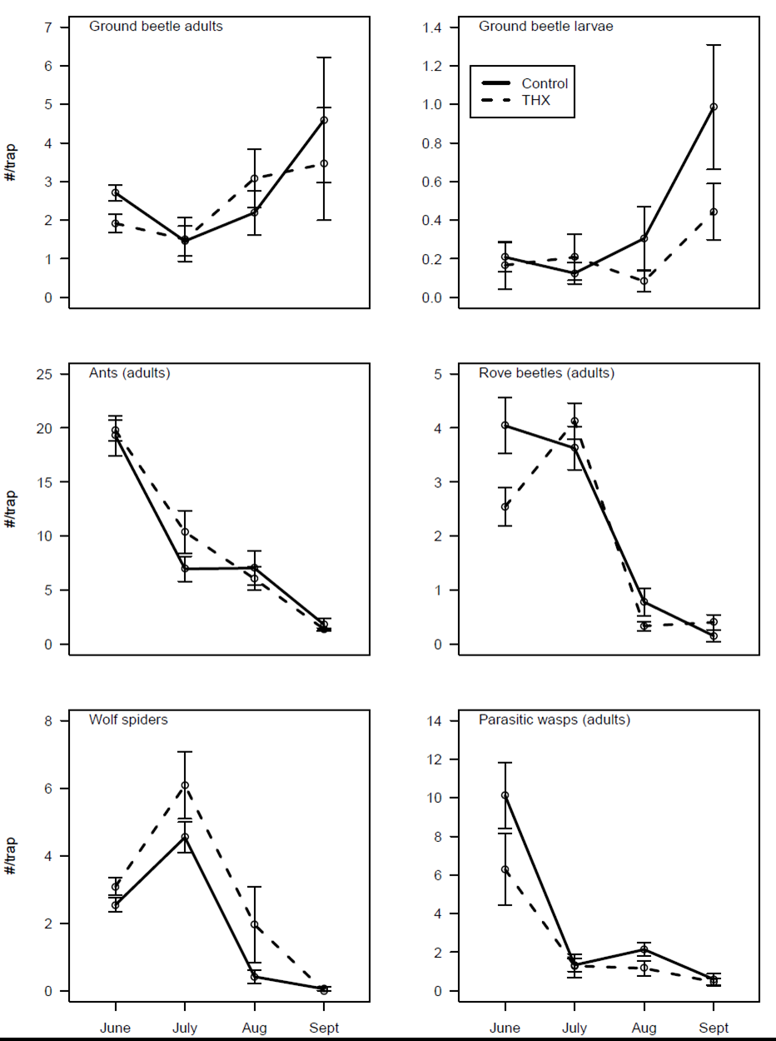
Figure 5. Natural enemies captured in pitfall traps in the soybean field experiment over the season. Error bars represent one standard error.

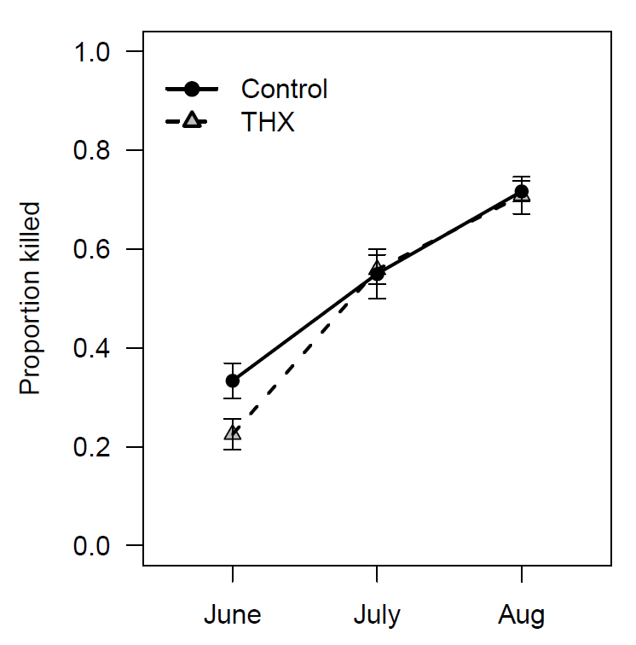
Figure 6. Predation on sentinel waxworm caterpillars over the course of the season in the soybean field experiment. Error bars represent one standard error.
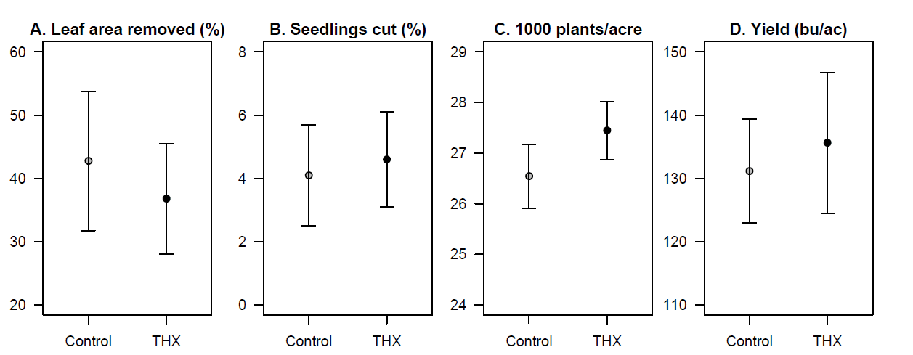
Figure 7. Crop-related results from the corn field experiment. Control = fungicide-treated seeds; THX = seed treated with fungicides plus high rate thiamethoxam. Error bars represent one standard error
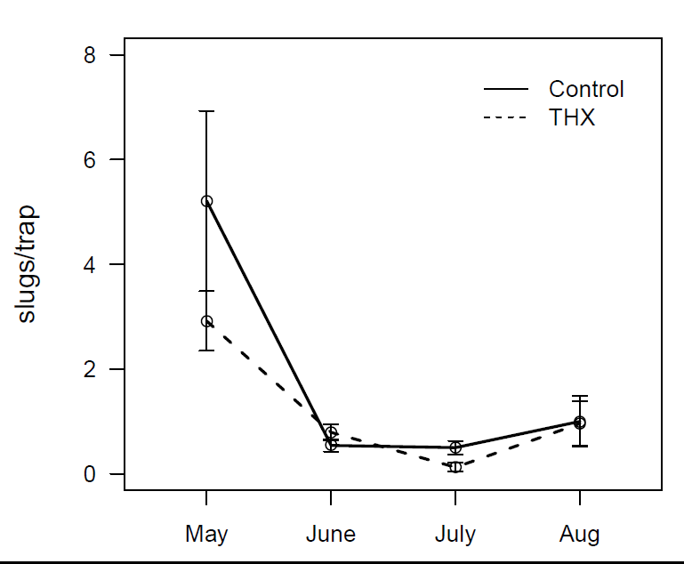
Figure 8. Slugs captured in pitfall traps in the corn field experiment over the season. Error bars represent one standard error.
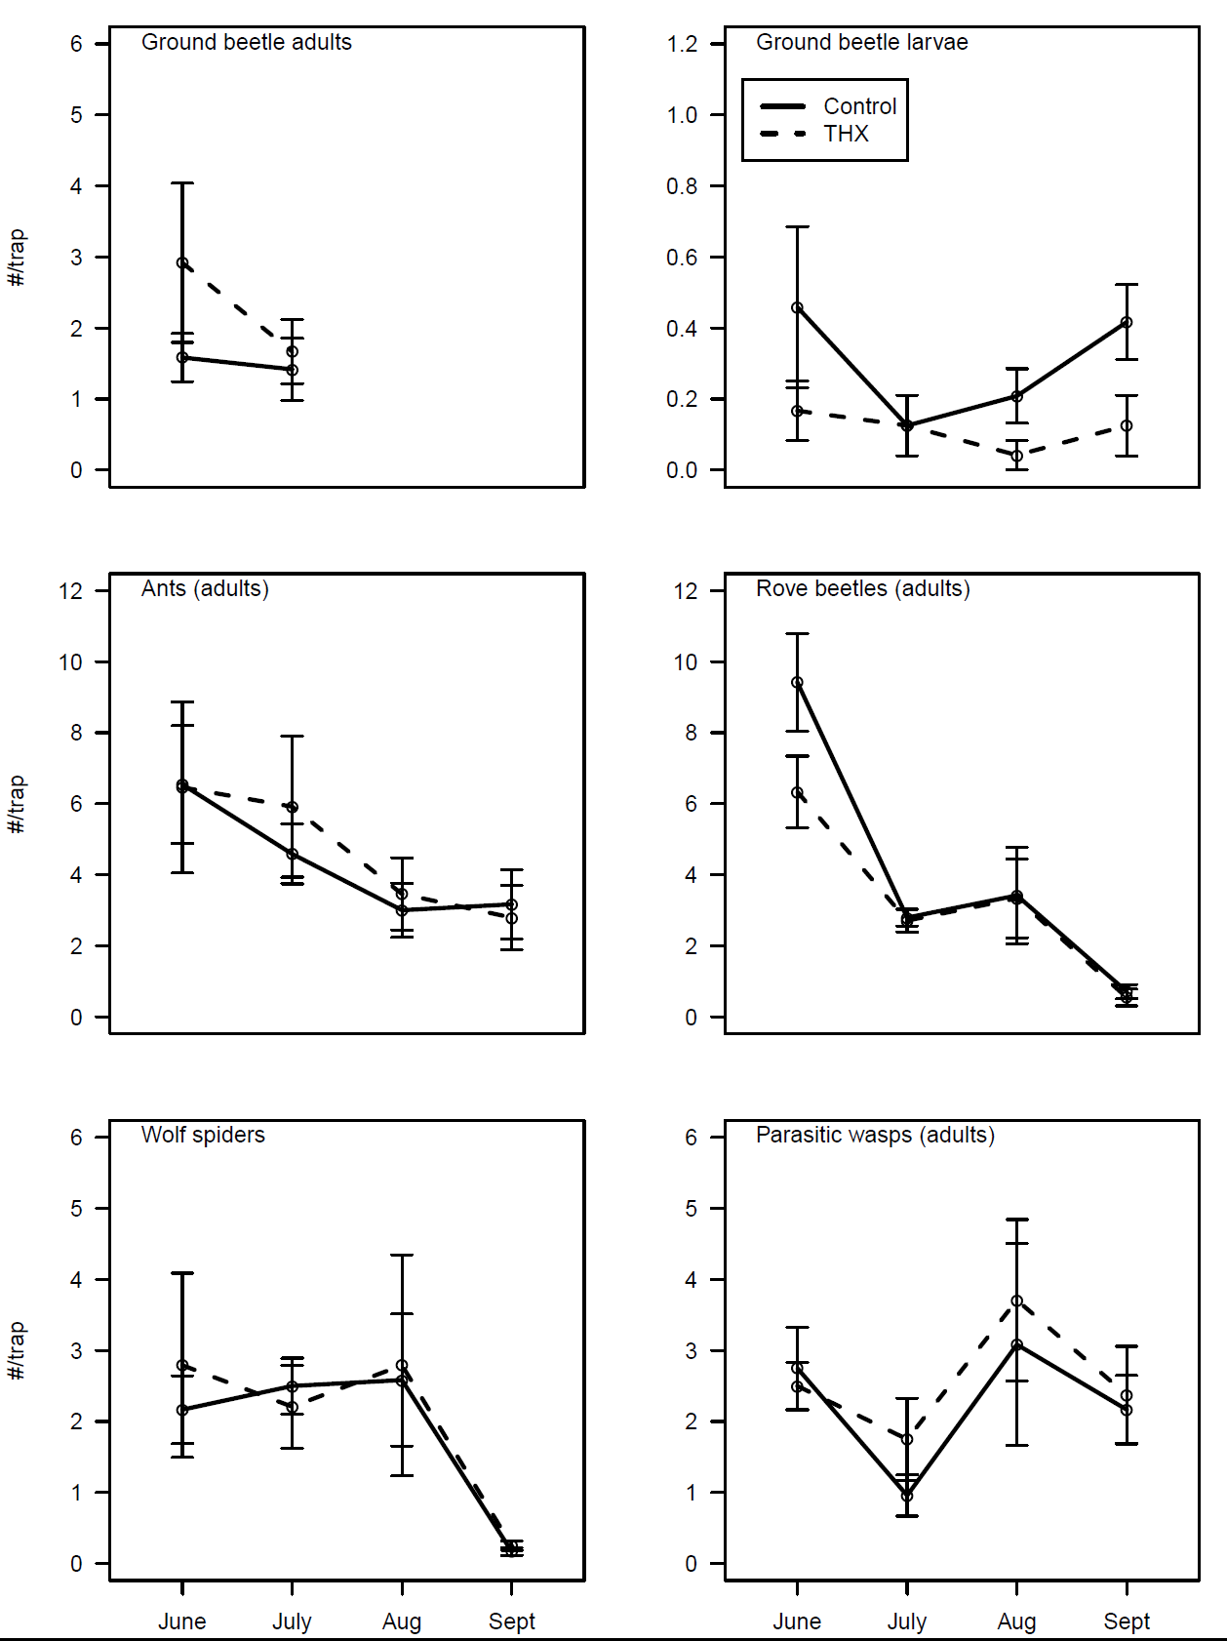
Figure 9. Natural enemies captured in pitfall traps in the soybean field experiment over the season. Error bars represent one standard error.
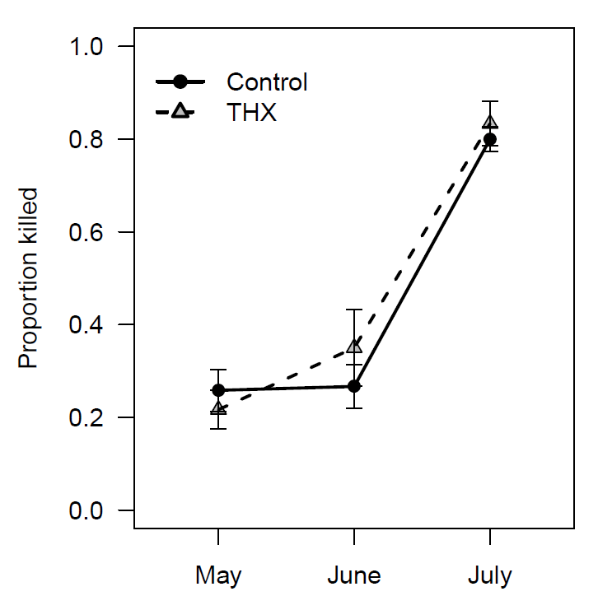
Figure 10. Predation on sentinel waxworm caterpillars over the course of the season in the corn field experiment. Error bars represent one standard error.

