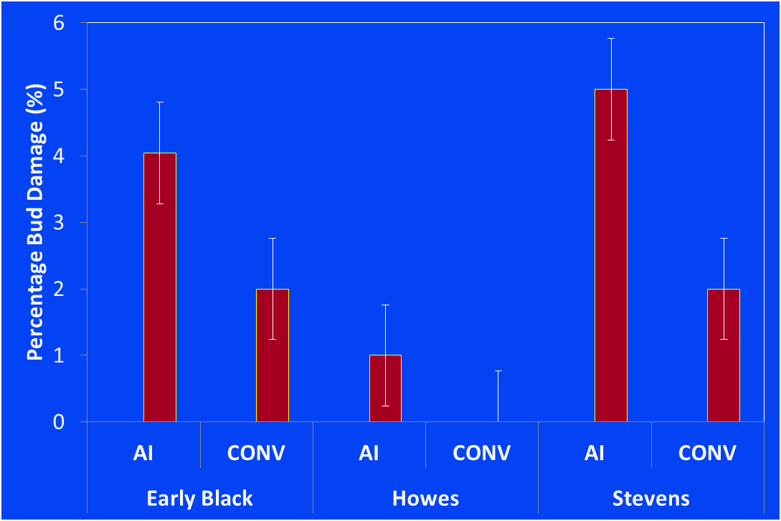
Fig 3: Bud damage for three cultivars under two frost protection methods towards the end of
the 2013 frost season

