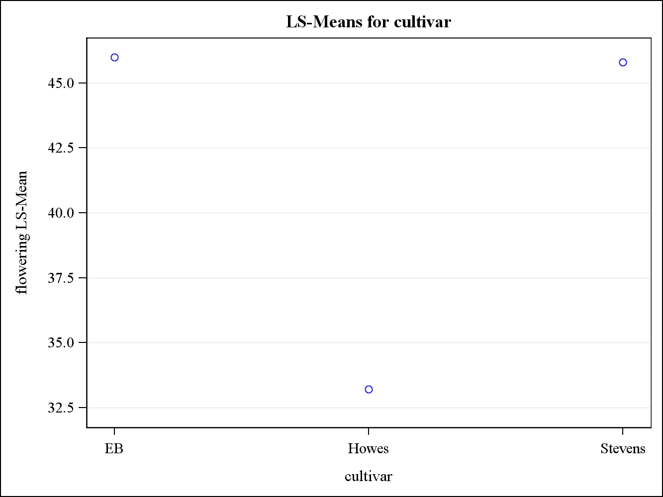

Fig 4: Shows the average number of uprights (flowering density) for three cultivars