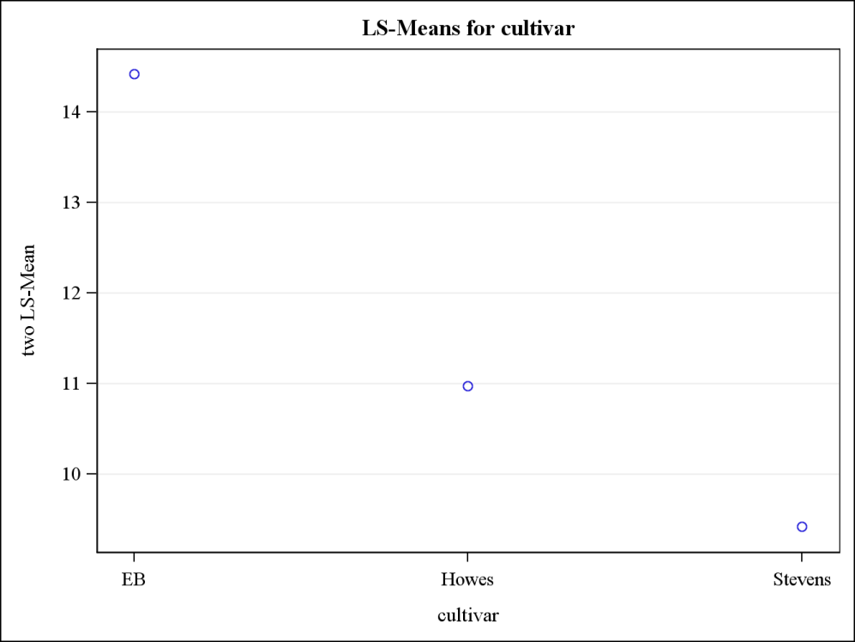
Fig 5: Average number of uprights with two berries for three cultivars

