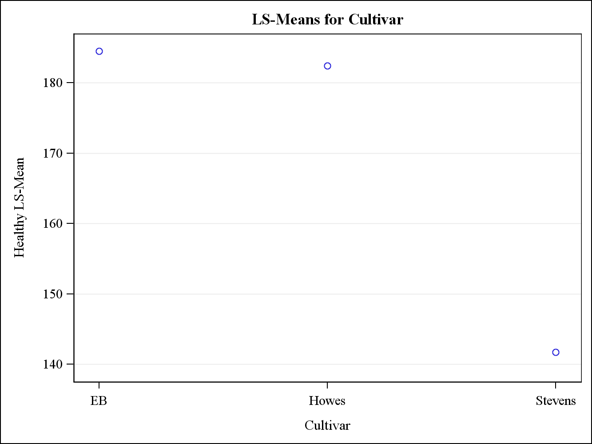
Fig 6: Average yield estimate (healthy berries) for three cultivars

