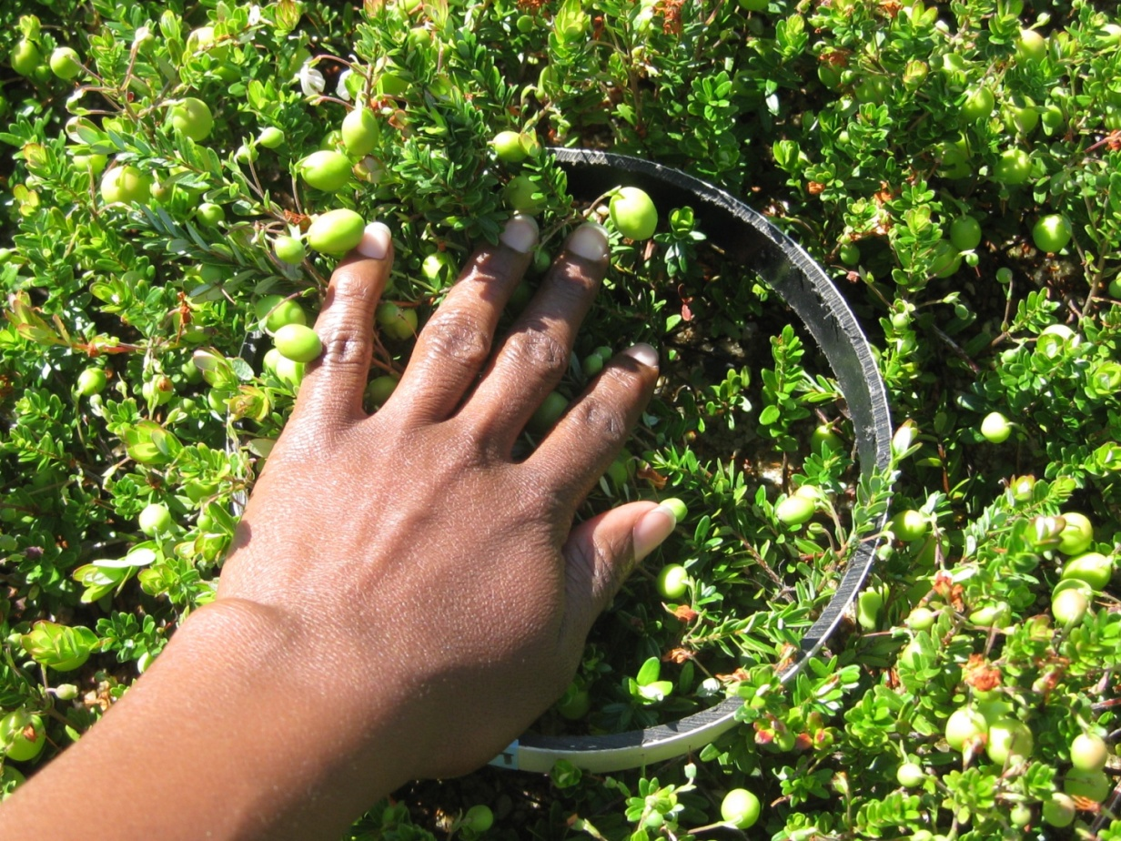
Image 3: Ring used for flower and berry count density

