Novel Approaches to Improve Energy Efficiency in Northern New England Greenhouses

Project coordinator: Bruce L. Parker
Address: University of Vermont Entomology Research Laboratory
661 Spear Street, Burlington, VT 05405-0105
Date: December 31, 2013

Appendix
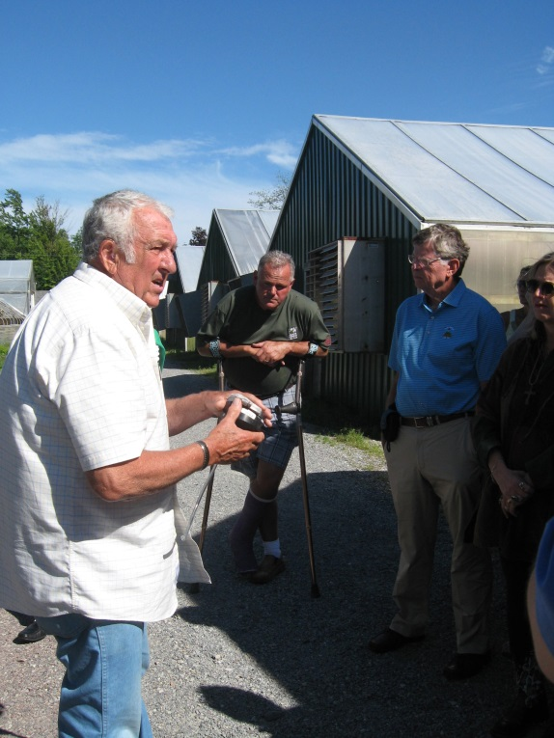
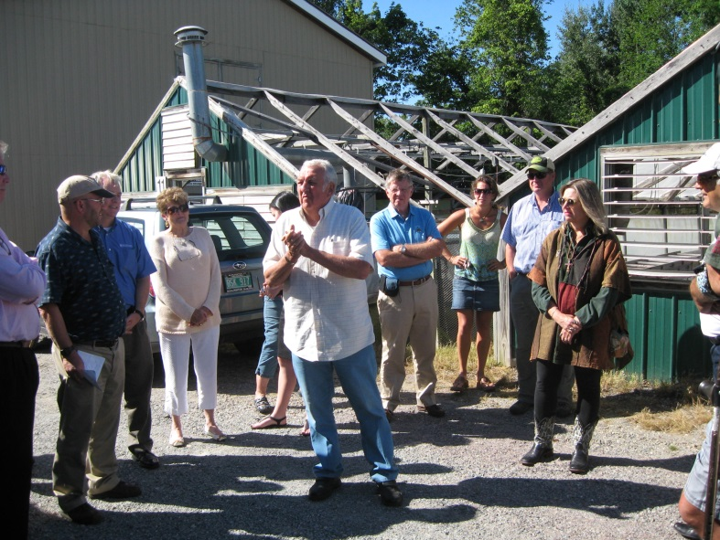
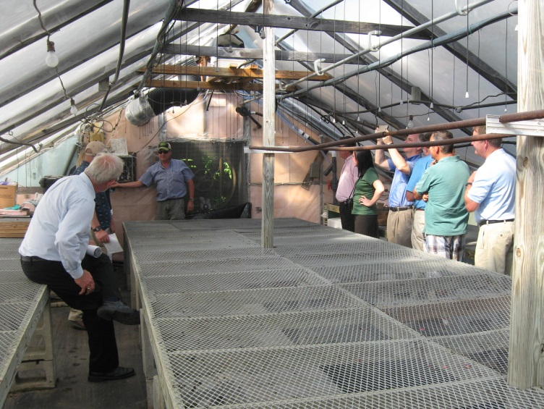
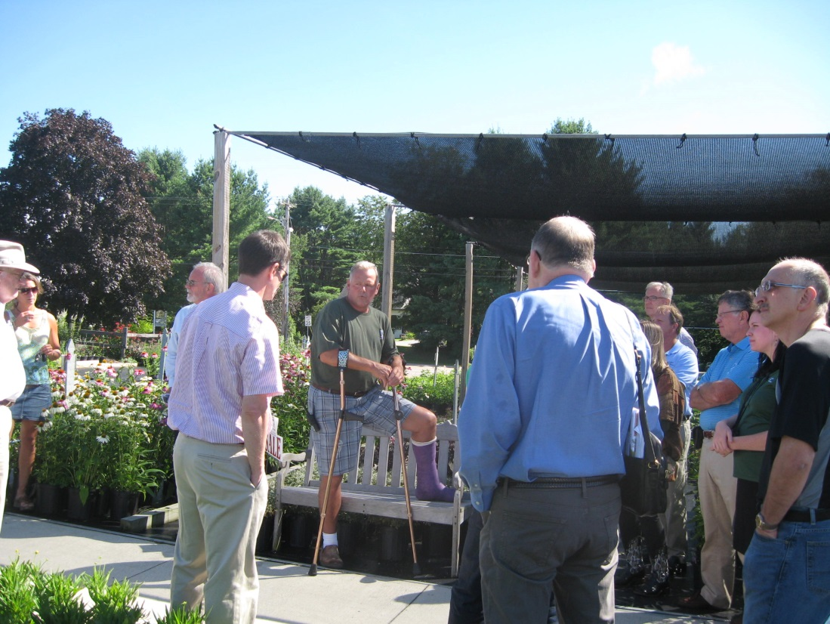
Fig. 1. Demonstration of the Bubble insulation System for the Board of Directors of the American Floral Endowment, a national organization of the floriculture industry, July, 2013. This board is made up of leaders in the industry, including both those from the private industry, academia and USDA specialists. The vice president of Claussen’s greenhouses, Chris Conant, gave a presentation to the group about his operation, which the group found most impressive. They also were given an explanation of the bubble greenhouse system and were treated to a live demonstration. All were fascinated by this novel approach to greenhouse energy conservation.

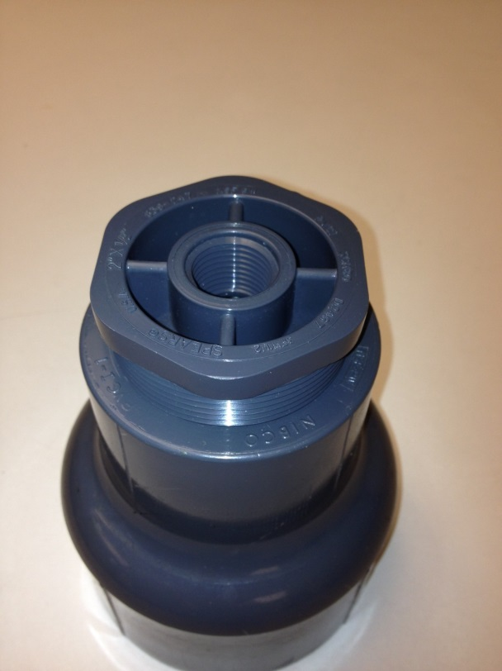
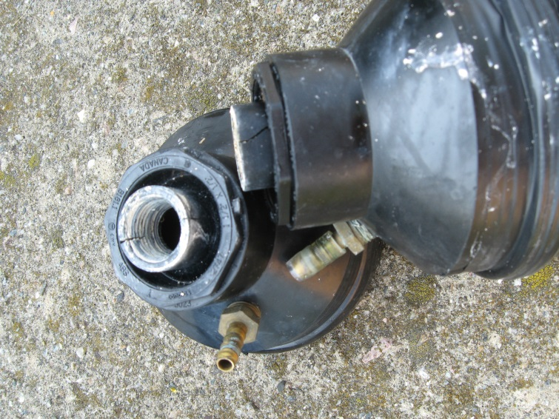
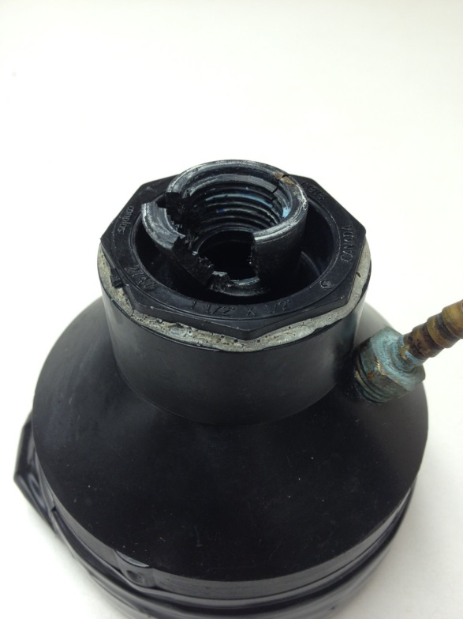
Fig. 3. Proposed new generator design.

Fig. 2. Cracked foam generator, Sept. 2012 (left). These generators were replaced with generators that were not cracked. In Sept. 2013, many of these not only cracked but also broke apart (right). This was likely a result of natural degradation of the plastic over time by UVM light and heat. It demonstrates why a sturdier generator needs to be designed.

