Field day survey

Two field days were held in August 2012, to educate potential aronia growers about the crop, its production, research being conducted as part of this current project, and marketing. The field days were held in Storrs CT (9 August 2012) and Monmouth ME (16 August 2012). In fall 2013, a survey was conducted via Survey Monkey, to assess the impact of these events after one year. For this report, results of the two field days are combined.

Responses were solicited from the 42 people who had registered for either of the two field days. A total of 22 (52.4%) people responded. Of these, 10 (45.5%) had attended the Storrs CT field day; 8 (36.4%) had attended the Monmouth ME field day; and 4 (18.2%) had registered but not attended a field day.

Field day attendees reported a high level of learning, as shown in Figure 1. At least 75% of respondents indicated that, for every category of learning, the amount they learned met or exceeded their expectations.

Figure 1. Amount of information attendees learned at field days.
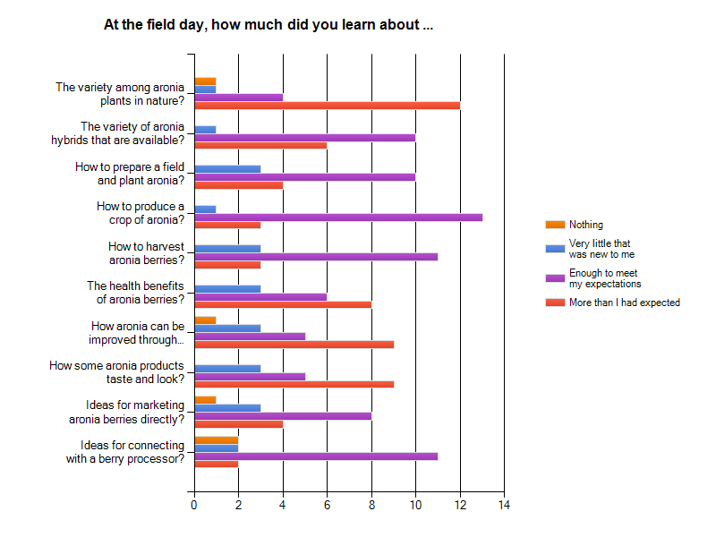

Of the 18 field day attendees, 16 (88.9%) learned enough to make a decision about planting aronia. Of those, 10 (55.6%) planted aronia after attending the field day. Those individual plantings ranged in size from one plant to 10 acres. The 8 attendees who have not yet planted aronia cited these reasons: no available land (3 attendees), the market is not strong enough to take this risk (2) and still considering but have not yet planted (3).

Note: several attendees indicated that they would be interested in future field days.

Website assessment

A website (http://umaine.edu/agriculture/home/aronia/) was developed as part of this project. It presents information about aronia plant description and taxonomy; a literature review of culture and harvest of aronia; a literature review of the food and nutraceutical uses of aronia; a bibliography of aronia literature; a list of sources of aronia plants; and hotlinks to many web-based aronia resources.

The website’s success has been assessed in two ways.

First, Google Analytics provided information about web traffic. This site was created on 22 December 2010. As of 20 November 2013, there were a total of 13,287 pageviews.

Second, a survey was conducted of identified website users. The website presents visitors with the option to enter their contact information, in order to receive announcements of field days, website updates, and personal consultations via email. In fall 2013, the 35 individuals who had signed up for this service were surveyed through Survey Monkey, in an effort to assess the effectiveness of the website. A total of 13 people responded. Of these, 4 (30.8%) had visited the website once; 6 (46.2%) had visited the website 2-5 times, and 3 (23.1%) had visited the website more than 5 times.

Addressing the usefulness of the individual pages of the website, respondents indicated that 10 found the introductory page somewhat or very useful; 9 found the literature review about how to grow and harvest aronia fruits somewhat or very usefl; 8 found the literature review about food and nutraceuticals somewhat or very useful; 7 found the list of nurseries that sell aronia plants somewhat or very useful; and 9 found the links to other aronia wevbsites somewhat or very useful.

Of the 12 people who reported how they used the website’s information, 9 respondents (75%) used information from the website for their personal use; 5 (41.7%) used the information to decide whether or not to grow aronia; 3 (25%) used it to improve their existing aronia crop production.

Some of the website visitors grow aronia. Of the 9 who responded, 3 (33.3%) grow aronia for personal use; 3 (33.3%) grow it commercially for use as a food; 1 (11.1%) grows aronia commercially for nutraceutical use; and 3 (33.3%)do not grow aronia.

Of the respondents who currently grow aronia, there is a wide range of planting size. Two very small-scale growers reported 3 and 5 plants. Four larger (small-scale commercial size) growers reported 100, 150, 310 and 500 plants. Two large-scale growers reported 13 acres and 18 hectares. A ninth respondent indicated no plants currently, but plans for 3 acres of aronia.

One-on-one consultations through website connection

One service offered to people who submitted their contact information through the website was access to one-on-one consultation. Seventeen (48.6%) of the 35 people who submitted contact information requested one-on-one consultation, via email or telephone. Primary topics covered during those consultations were:
- Pollination of aronia flowers
9 Sources of aronia plants (these requests prompted uploading and updating of
nursery source list on the website)
- Research results about susceptibility of aronia to spotted wing drosophila
- Source of aronia seeds
- Indepth cultural information including crop system design, production, harvest
- Research results about nutraceutical benefits of aronia fruits
- Availability of value-added aronia products
- Request for future field days to address advanced aronia topics

